Newsletter
Issue 28: Autumn 2016

Affiliated to the Mammal Society

CONTENTS:

Published Quarterly Since 2009

WELCOME!
…to Shropshire Mammal Group Newsletter 28!
So Autumn is here, after not such a bad summer, a few wet spells, some unseasonal chilliness at times but overall a pretty decent amount of sun and warmth. We now have the deer rut to look forward to, and for those of us planning to visit the coast,
Welcome from the Editor 1
Contents 1
Note from the Chair 2
Corporate members 2
Shropshire Mammal Group: the fourth year-2013 3

the grey seal breeding season will be underway soon, while inland mammals like Exploring the darker side 5

squirrels, other rodents, badgers and pine martens are gorging on fruit and nuts, stashing food in preparation for winter.
More from the hedgehog garden 6
The hill above my house 7

I’m so pleased with this season’s Newsletter; yet again I’ve been very proud to Mammal Eyewitness: ‘Weasy does it!’ 8
receive and publish some truly excellent and inspired pieces of writing on our The Cardiff University Otter Project 9

Shropshire mammals and those beyond our county boundaries. I love to showcase the work of new contributors, so it’s wonderful to receive a first-hand account of the amazing work of the Cardiff University Otter Project, straight from the keyboard of Shropshire’s own Dr Eleanor Kean. I’ve known Eleanor’s parents for many years and
Galloway: scats and shrews 11
Because it makes scents! 12
A cure for boardom 13

it is great to hear of a local person helping to make such a substantial contribution Good hare days! 14

to our knowledge of one of everyone’s favourite mammals. I hope that this will be the first of many articles that Eleanor may be willing to write for the SMG Newsletter in the years to come.
Pine marten den boxes 15
Taxonomic musings on a charred mustelid 16
Review Section: Trail camera update 17

I am also delighted to receive a first article from my friend Martin George, on behalf Review Section: Spotting counterfeit cameras 18

of SMG Corporate Members, CJ Wildlife, who have generously donated some den boxes for the Shropshire Pine Marten Project. Martin explains the background behind the den box strategy which has been adopted in Europe to combat possible marten damage to cars, property and, er, high-tech scientific equipment. A really interesting read, but don’t panic - we must remember that the habits of the UK’s Martes martes are very different to those of the European Martes foina! Our friend Louise Viljoen is also published for the first time, with a special appeal for help with her bat carcass detection dog initiative.
Elsewhere there are some equipment reviews plus a Mammally Lane retrospective from 2013. A plethora of articles also, from much loved contributors Andrew Fusek Peters, Tim Preston, Dave Lewis, Stuart Edmunds (of course), and another dispatch from the hedgehog gardens of Brian Hogbin. Great to see the return of Jack Riggall too, with his really boaring article, heheh! Finally, Tris Pearce brings us probably the most exciting and in-your-face Mammal Eyewitness article the Newsletter has ever seen! That article’s a true multi-media experience as in addition to the words there is an amazing Facebook video which YOU JUST HAVE TO WATCH WITH THE SOUND UP! All credit to Tris for being so quick with the compact camera to get that stunning sequence; what a lesson to us all!
For anyone planning a weekend in Snowdonia next month, there’s a world-beating lineup of speakers at the ‘Rewilding’ themed North Wales Mammal Group Autumn Symposium, to also include a choice of afternoon practical workshops. See you there, maybe? No shared lifts I’m afraid - my car will be full of bones!

Have an awesome Autumn, and look out for your next SMG Newsletter in your mailbox just before Christmas (Contributions needed / Get scribing!)

Ric Morris ric_morris@hotmail.co.uk
North Wales Mammal Group autumn symposium 19
Diary dates for forthcoming events 20
And finally… 20
REMEMBER!
There’s something of a theme of bodies and cadavers in a few articles in this issue; Cardiff University want your dead otters, Louise is appealing for bats and Dave’s rotting down a mink. But remember that Ric Morris is still working on the bones ID book, and should you have picked up any old mammal skulls or bones on walks which are still knocking around in the garage or shed and no longer wanted, then he will be delighted to take them off your hands; or simply borrow them for measurement & photography. Even common mammals are potentially of great interest as there may be unusual pathology. Don’t worry if you don’t know what they are, he likes a challenge.
Just contact Ric via Facebook (Ric Maurice), Twitter (@Skull_Bloke) or via the email address at the foot of each page.
Thanks in advance.

Follow us on Facebook at https://www.facebook.com/groups/shropshiremammalgroup/ We’re also on Twitter: @Shropsmammals
If you spot a mammal in Shropshire, please record it via bit.ly/SMGrecord or email Lorcán Adrain at SMGrecord@gmail.com Articles and photos for the next issue of the SMG Newsletter to Ric Morris, Editor, at ric_morris@hotmail.co.uk please

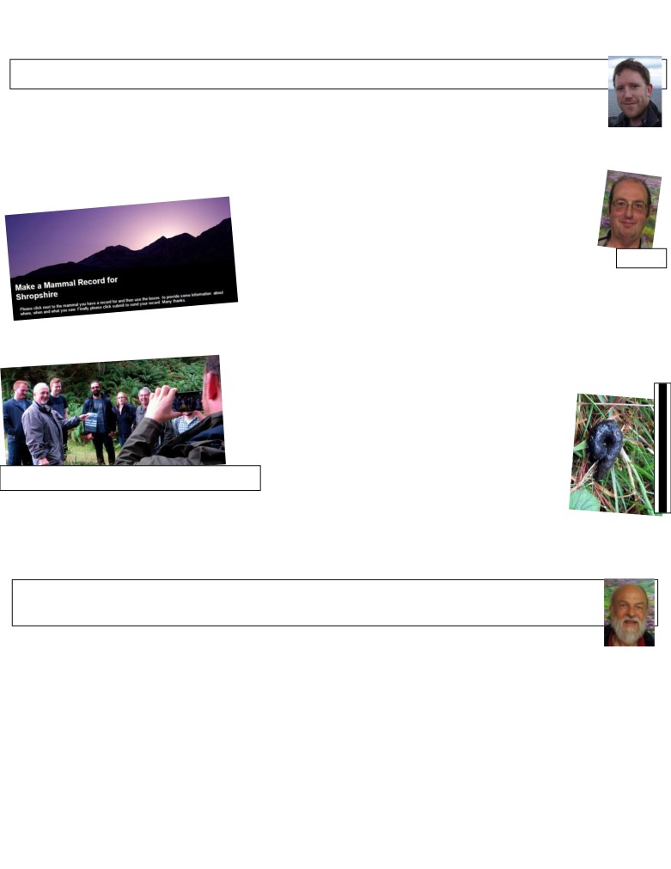

Shropshire Mammal Group Newsletter Issue 28 Autumn 2016
Note from the Chair by Stuart Edmunds, SMG Chair
In 2016 there has so far been a slight improvement in the numbers of some our declining mammal species being
recorded. There have been above-average numbers of dormice being found in nest boxes at various sites in the
Shropshire Hills. The pine martens appear to be thriving and are in greater number than first anticipated, as I’ll
explain later. And hedgehog numbers have been picking up, with more being recorded in gardens on trail cameras ☺ and on roads ☹ than in previous years.
We continue to gather records from all corners of the county and have now collected over 10,000 mammal records to put towards the first Shropshire Mammal Atlas thanks to our County Mammal Recorder Lorcán Adrain’s hard work. But more records are still needed. Making a mammal
record isn’t as daunting as it sounds; all you need is to send in the time, place, evidence (seen, trapped, trail camera, etc) and grid reference. My advice would be to write records up as soon as you
can, or email them to SMGrecord@gmail.com while they are fresh in
your mind. It is much easier doing that than leaving it until you have 12 Lorcán months’ worth of records to type up!
We are keen to find out what members would most like to get out of their membership of Shropshire Mammal Group. Although we are a local recording to be more than that; to raise awareness of mammal conservation and to give
people the opportunities to watch and record mammals in the wild. Please complete our short member survey here to tell us what you think and what your expectations of membership are.
Last September (2015) was a quiet month on the pine marten front; one marten showed up on cameras. In contrast, this September has proven to be the most active month for pine marten activities so far. A scat hunt at the start of the month resulted in a group of us finding the most reliable looking (and smelling) pine marten scats. Luna the scat detection dog then found further scat a couple of weeks later and not too far from the original scat. And if that wasn't exciting enough, I then picked up a never-before-seen-on-camera pine marten at a site with no previous evidence of martens,

Scat hunt crew: Sam, Dave, Tom, Ben, Katy, Paul, unknown, Stu’s ear. Pic Tris Pearce
which now gives us a total of four definite individuals living in south Shropshire. We still need to get these scats and a couple of other previous possibles analysed to find out

whether our martens are here naturally, or if they have been ‘unofficially’ transported down from Scotland
at some point in time. But for now, it is just incredible to know that no longer do we have to travel many miles to enter the realm of these wonderful elusive mammals; they are here, within our own county borders!

Stuart Edmunds

Corporate members of Shropshire Mammal Group
by Malcolm Monie, Membership Secretary
Shropshire Mammal Group is grateful to its corporate members for their support. Pearce Environment Ltd
Whitchurch Community Water Vole Project Shropshire Wildlife Trust - Ellesmere Branch Ricoh Ltd
Keith Roberts and Son, Lower Wallop Farm
Meres and Mosses Landscape Partnership Scheme / Nature Improvement Area The British Hedgehog Preservation Society
CJ Wildlife Malcolm Monie

Follow us on Facebook at https://www.facebook.com/groups/shropshiremammalgroup/ We’re also on Twitter: @Shropsmammals
If you spot a mammal in Shropshire, please record it via bit.ly/SMGrecord or email Lorcán Adrain at SMGrecord@gmail.com Articles and photos for the next issue of the SMG Newsletter to Ric Morris, Editor, at ric_morris@hotmail.co.uk please
Mmmm…. At last! Pic Tris Pearce

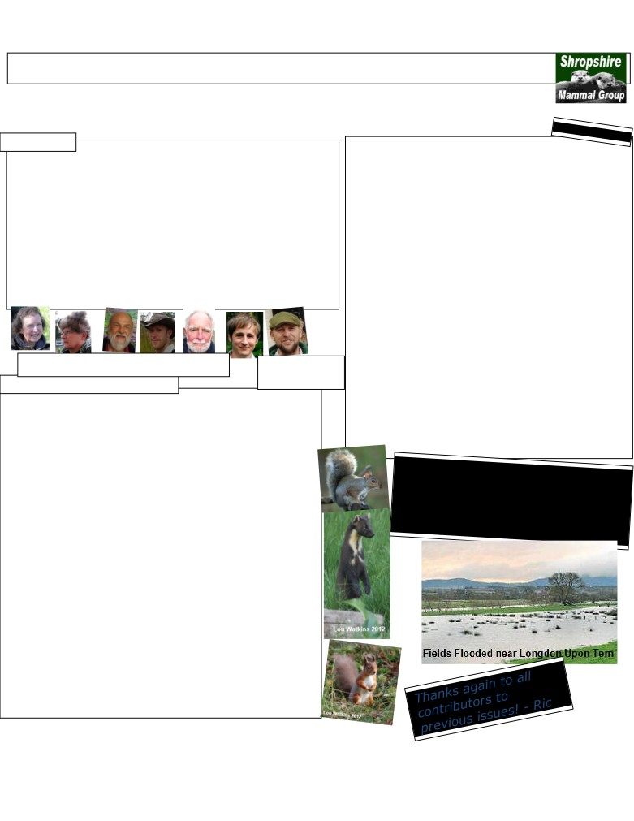

Shropshire Mammal Group Newsletter Issue 28 Autumn 2016
Shropshire Mammal Group- the fourth year: 2013
Continuing our look back through the SMG Newsletter archive, we turn to the fourth year of our group’s existence. Issues reviewed here are SMGN14 to 17. There was a change of Newsletter editor, Holly Shingler, who went on to serve seven issues in the role. There were also other big changes afoot as the incoming Chair Stuart reports in
his Notes!

From SMGN14
Notes from the Chairman
2013 has seen the most notable change in committee structure since the group began in 2009, with a new officer role being created & three new members joining the committee. We welcomed Jayne Richards & Martin Noble onboard & now also have a new newsletter editor; Holly Shingler who has offered to take over my editing duties for the year. After 2 years of dedication to the role of chairman, Malcolm Monie stepped down as chair of the group at this year’s AGM, leaving myself to take over & continue the good work that Malcolm has done. Malcolm will continue to work with the group as a committee member & will still be involved with SMG at events, talks & meetings. John Mackintosh has passed recording duties to Gareth Parry* after 20 years of dedication to the role of County Recorder, but will continue to support the group in the role of Treasurer, taking over the role from Pauline, who has done a sterling job of keeping the group’s finances in order since the group began. Alan Reid also opted to step down as a committee member this year & we all thank him for his work with the group on events. After a year of growth in 2012, Shropshire Mammal Group will continue to expand throughout 2013, particularly as we increase our partnership bonds with The Mammal Society. We are now proud to be able to offer joint membership of SMG and The Mammal Society, which offers reduced TMS subscription costs to all of our members. In addition, we are proud to be hosting The Mammal Society’s Regional Seminar on November 2nd at Walford College & we hope that many of you will be able to attend. There will also still be a number of events & surveys to come along to, as we continue to build a picture of mammal distribution in Shropshire & give further opportunity for everyone to develop their mammal recording (and spotting!) skills. Stuart Edmunds March 2013

All change: Jayne, Martin, Malcolm, Stu, John, Gareth, Alan. *Please note that Lorcán
(Pauline & Holly not pictured, sorry! No images available ☹) Adrain is the current
County Mammal Recorder!
Ric
Edited from original article in SMGN14
Martens vs Greys
Since the first Grey Squirrels Sciurus carolinensis were released in London parks around 1876 and subsequently on the Woburn Estate by the Duke of Bedford, their spread across the UK has been prolific. … With a high breeding rate (grey squirrels will happily breed twice a year and have an average brood size of 3-5 kittens) and territorial nature, the population explosion and conquering of our native woodland was inevitable, unfortunately at the cost of our own native wildlife. The increase in the number of greys has led to a displacement of the red squirrel Sciurus vulgaris in the majority of England & Wales, with small populations holding steady on the islands of Brownsea, Anglesey and in the north of the country. Grey squirrels are much more adaptable than our native reds and their size and aggressive nature often allows them to push reds out of a territory, where they out-compete the reds for space and food. In addition, they have immunity to parapoxvirus, but carry the virus into red populations and thus were responsible for a massive reduction in reds through disease spread. …
In Scotland, a tree-dwelling predator still inhabits the potential habitat of any greys wishing to take new territory. In fact, pine martens Martes martes have expanded their range across Scotland, recently found thriving in Perthshire and across to Aberdeenshire. A marten was recently caught on a camera trap just a few miles outside Edinburgh and 50kms beyond their usual range.
I had often wondered if the reason for the slower spread of greys into Scotland was due to the presence of an agile predator. New research conducted by Galway University in Ireland now suggests that this is extremely likely. Pine martens are perfectly evolved to live and hunt in trees and for years have lived alongside red squirrels, which in turn have adapted to out-manoeuvre the arboreal hunters. Grey squirrels however are less agile due to their larger size and bulk, making them easy quarry for a mammal with the agility of a pine marten. The research conducted in Ireland, where greys are present but have not always displaced reds, involved the analysis of hundreds of pine marten scats, of which a large percentage contained the remains of grey squirrels. This coincides with the reporting of a huge reduction in the grey squirrel population of central Ireland, where pine martens have begun to flourish and red squirrel numbers have risen dramatically.
At present, there are an estimated 5 million grey squirrels in England with the population constantly expanding. [As of March 2013] Pine martens are officially classed as present in England, but in such low densities (estimated to be 140 by VWT) that they would have little impact on the abundant grey squirrel population. The reintroduction of predators into the wild has and always will be a contentious issue, but without huge numbers of squirrels being eradicated by constant culls, the release of pine martens could be the only way to impact the invasion of the non-native greys. Research is ongoing to test the viability of this idea and is further strengthened by studies at the University of Lyon, which indicated that pine martens in the central regions of France require only 12% tree cover in their 2-3km wide territories. In England with our lowly 7% national tree cover, this adds new hope to the possibility of having a once prolific predator present to keep a control of a mammal which is causing devastation to our woodlands and native fauna at an astonishing rate.
Stuart Edmunds
2012-2013 winter weather & its effects.
Our recent winter weather has greatly impacted on our wildlife and the recent flood issues caused me to think a lot about the sudden changes which face wildlife and what affects this causes. Gray (2013) reported that 2012 has been recorded as the second wettest year on record and the result will be seen in our wildlife numbers for some time to come as well as potentially causing permanent damage to already vulnerable species; the added strain of our so far wet year of 2013 also isn’t helping matters. Extreme wet weather does not only have a direct impact on habitats and current population but also the future population in regards to numbers, not to mention the increased difficulty in finding food, which during the best times of year can still be a difficult task. In recent months, the deluge of rain has greatly reduced the abundance of our wildlife which will have a knock-on effect on the amount of species available to reproduce this year (Gray, 2013).
With the weather fluctuating between mild and cold, the impact this is having is causing serious confusion for hibernating species, such as hedgehogs. The main worry is that with wildlife waking up too early, there will not be enough, or any for the matter available to eat meaning that these animals will not be able to keep their energy levels up until spring arrives; another factor is that should the weather turn again, as it has done, they may not even survive. As we may all know hedgehogs are already in decline; this will only exacerbate the situation further.
Sir Bob Watson (2012), chief scientist for DEFRA, stated that flooding is the greatest threat to the UK posed by climate change. I found this highly startling, especially after reading that within the report in which this was stated it was recorded that the UK is facing approximately 700 threats as a result of climate change (Jowit, 2012). Currently, the typical threats which are facing wildlife as a result of climate change include: * Changes in wildlife migration;
* Alterations in species communities due to the inability to move fast enough to thrive;
* Sewer overflow polluting the coast lines; * Changes in the soil; * Erosion caused by heavier rain; * Changes in fish stock. (Jowit, 2012).
Flooding, like most things, can bring both positive and negative issues. A positive point can be the dispersal of seeds, helping plants to colonise in other habitats; however, a negative can be loss of a food source. Insects and spiders are typically washed away in flash floods resulting in the creation of a poor feeding area for both birds and bats (Bourton, 2008). With all the flooding that has taken place, bank dwelling species have particularly been hit hard. Burrows have been flooded or completely destroyed; species such as water voles and otters have left their habitats due to the rising waters. Essex Wildlife Trust reported that throughout the high rainfall a high number of otter fatalities were caused by road traffic accidents due to them fleeing their habitats for safer grounds (Gray, 2013).
Holly Shingler

Follow us on Facebook at https://www.facebook.com/groups/shropshiremammalgroup/ We’re also on Twitter: @Shropsmammals
If you spot a mammal in Shropshire, please record it via bit.ly/SMGrecord or email Lorcán Adrain at SMGrecord@gmail.com Articles and photos for the next issue of the SMG Newsletter to Ric Morris, Editor, at ric_morris@hotmail.co.uk please

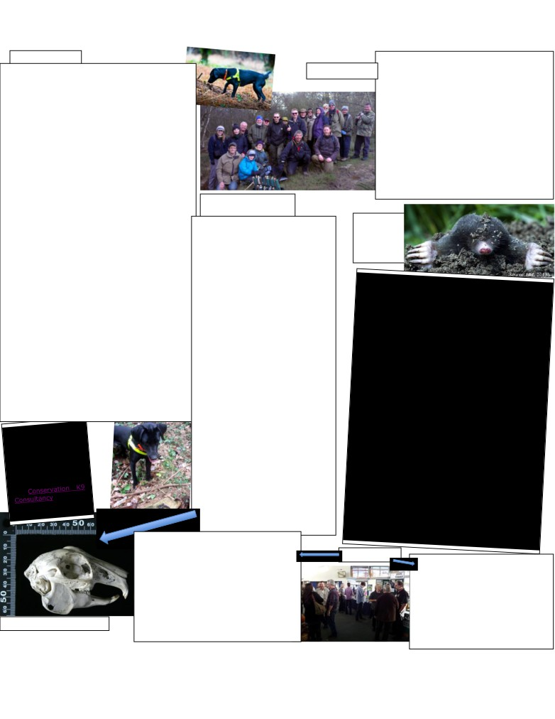

Shropshire Mammal Group Newsletter Issue 28

From SMGN15

Autumn 2016
Catherton Common Survey, 27 April 2013
Prior to the small mammal survey at Catherton Common with

Introducing Conservation Dogs Pine Marten Scat Sniffer Dog Luna...
Luna is a 4 year old Black Labrador who has been with her trainer Louise Wilson since she was 14 weeks old. Luna was bred as a working dog, but sadly her initial placement did not work out, so it was after this, that she was offered to Louise. Since her first days with Louise it was evident that although Luna was very unsure of human contact, and very nervous, she had a great working ability and loved playing with a tennis ball making her a perfect candidate for a detection dog. However, her nervy temperament made her unsuitable for a Wagtail Specialist Detection Dog. Louise, recognising Luna’s suitability as a conservation detection dog, chose to use her in conservation searches instead, and specifically as a Pine Marten Scat Detection Dog.
After contacting many wildlife organisations, offering to train and handle her as a Pine Marten Scat Detection Dog to help with their ongoing pine marten surveys, Louise and Luna went operational as a scat detection dog in March 2011 with her initial operation to detect pine marten scat in Scotland with the Vincent Wildlife Trust.
To ensure that Luna was could detect the right scent, both wild pine marten scat and captive pine marten scat was used for training purposes.
From SMGN15

Edited from original article in SMGN16
the Shropshire Wildlife Trust, it is fair to say that the weather was truly appalling. While putting out a selection of small
mammal traps the night before, we were caught out by sudden heavy downpours that flattened much of the grass habitat that I planned to survey. he brook running through the reserve and down to Cramer Gutter doubled in size during those storms, leaving me with limited safe places to install small mammal traps! Setting 40 traps in such awful conditions left me with
little hope of a productive trapping session, so I was unsurprised when we caught only 2 wood mice on the day. Fortunately, the weather improved for the event itself and the 20 keen
participants that came along enjoyed the excitement of checking footprint tunnels and camera traps, despite few signs of mammal activity.
With thanks to Shropshire Wildlife Trust for allowing us to run the event on their reserve.
Stuart Edmunds.

Luna also had to be trained to recognise the difference between fox and pine marten scat.
Whilst some people remain sceptical about the use of sniffer dogs in a conservation project role, it is unquestionable that dogs have an amazing olfactory capability. Dogs have up to 250,000,000 scent receptors compared to humans 5 million which enables them to detect scents that we humans can merely dream of finding so quickly and easily. If you are looking for an animal, a plant, a scent, a drug, a body, it is indisputable that a dog trained to detect that scent can find it quicker, than its human counterparts. As the dog sees with its nose, it can build up a fascinating picture of the area that it is searching, ignoring smells that it is not interested in, and finding those it is interested in with great aplomb.
Using dogs in a conservation role also offers the added benefit in that they can cover vast areas of ground, be that dense bush, open fields, buildings, or vehicles. If you are looking for a scat in a forest, or a track in an open field, you have to have a lot of feet and eyes on the ground to effectively search that area ... or a damn good nose!
Whilst not every search that Luna takes part in may detect pine marten scats, she is an invaluable weapon in the conservation groups’ arsenal, as her keen sense of smell detects many an item that would have easily gone unnoticed to even the most experienced conservationist, with finds such as, badger sets, animal carcasses and other scats.
Sniffer dogs can be trained to recognise up to 15 scents at a time, and plans are underway to train Luna to detect other mammal signs, such as hedgehogs, and owl pellets.
Edited from a longer pine marten article written by Stuart Edmunds
Bones of the Order Lagomorpha
There are a number of unique features of a lagomorph skull which means it really cannot possibly be mistaken for a mammal of a different order. The dental formula for all UK species is: i2/1, c0/0, pm3/2, m3/3 x2; making 28 teeth in all. The most striking skull feature is undoubtedly the distinctive lattice-like fenestration of the maxilla bones, those parts of the skull on which the cheek teeth are rooted. This fenestration feature is present in all three species [rabbit, brown and mountain hare] and occurs in no other UK mammal species. The second point you’ll notice, not exclusive to lagomorphs, of course, is the large diastema, or gap between the incisor teeth and the premolar cheek teeth. The diastema is present in most herbivorous mammals, but at the front of the lagomorph skull are found four incisor teeth; the front two being a similar proportion to rodents but grooved and without the orange colouring. Set behind them are a near vestigial pair of tiny peg-like incisors, invisible from the front of the mouth of the living animal. The groove running around the outer surface of the first incisors is another feature which is not shared with rodents.
The final unique point of the skull itself is the presence of remarkable bony processes above the orbits, or eye sockets. These resemble great bony eyebrows and vary pretty widely in size and shape between individuals of the three species. However no other British mammal skull has anything like these.
The lagomorph mandible too, is easily recognisable, with a really distinctive, almost circular angular process, a slim, near rectangular shaped angular process and the articulation point with the skull is, unusually, right on the top and anterior corner of the angular process rather than the half way down the ramus and at the rear. The diastema is again present on the mandible, and the lower incisors are chisel shaped at the tip, rather than pointed as in rodents.
Ric Morris
Edited
from
original article in SMGN16

Mammal Recording… With Gareth Parry moving away from Shropshire to take on his new role as Head of

Rabbit skull Oryctolagus cuniculus
Community Programmes with the Gloucestershire Wildlife From SMG17
Trust, we wish him all the best in his new role and future. It has been a pleasure helping Gareth out on a few projects. His knowledge & planning skills will be missed.
Gareth took on the role of County Recorder last year replacing John.
I have been asked to take over the position as County Recorder. The first thing I needed to do was to create a new email address that can be used purely for records. Can you please make a note of smgrecord@gmail.com and update your email with this new address.
Lorcán Adrain
On November 2nd 2013 we hosted the Mammal Society’s Regional Seminar at Walford Campus and had an impressive turn-out of almost 100
people on the day. The speakers varied from our very own Malcolm Monie, Ric Morris, and Paul Roberts to Vincent Wildlife Trust and Shropshire Wildlife Trust staff. Tris Pearce gave a thought-provoking view of the current badger situation in England and very kindly sponsored the event,
Special thanks go to Tris and Paul O’Hagan at Walford College whose support for the seminar helped to make the day a huge overall success.

Follow us on Facebook at https://www.facebook.com/groups/shropshiremammalgroup/ We’re also on Twitter: @Shropsmammals
If you spot a mammal in Shropshire, please record it via bit.ly/SMGrecord or email Lorcán Adrain at SMGrecord@gmail.com Articles and photos for the next issue of the SMG Newsletter to Ric Morris, Editor, at ric_morris@hotmail.co.uk please

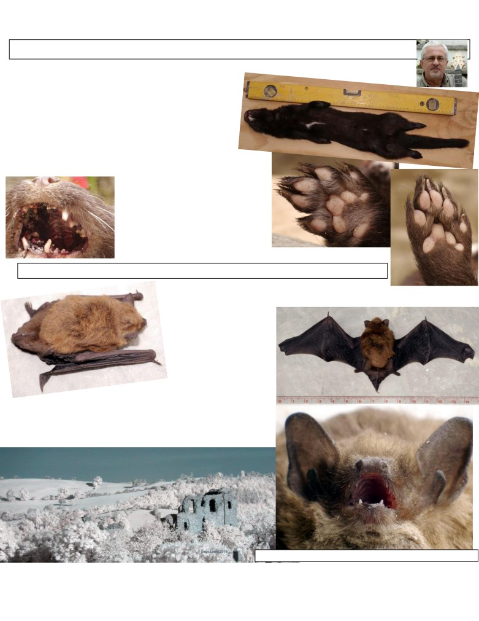

Shropshire Mammal Group Newsletter Issue 28 Autumn 2016
Exploring the Darker Side Words and photos by Dave Lewis
The Summer season (for me) has been dogged by a mixture of variable weather, even more variable opportunities and interruptions from work (no justice eh?)
It is fortunate, indeed then, that occasional happenstances lift the spirit and allow for some serious tinkering. En-route to west Wales I recently came across a road-kill mink in remarkably good condition (apart from it being dead, of course). This was bagged-up and brought home, photographed and is currently being the foodstuff for all manner of crawlies, which, hopefully, will eventually leave
the skeleton in one piece. To ensure it wasn’t ‘liberated’ by
other vagabonds it was secured in a stainless steel mesh and covered. It sounds a tad macabre, and no doubt to the squeamish or sensitive it is, but it should provide a
wonderful addition to our museum of curiosities and for study. Our esteemed editor bagged a certain part (not the skull!) so that will be available the next time we meet up… or I could post it… I’m not quite sure what the Post Office counter lady would say when I reply to her query: “For security purposes, may I ask what’s inside your package?” Hmmm!

Dave’s mink, Neovison vison. Adult male, 65cm nose to tail. Weight: 1139g. Detail showing dentition, front and rear paws. Road-kill, August 2016.

Locally, too, a Soprano Pipistrelle was discovered (again dead) on a local path, so that is having the same treatment. All good study material for the winter months.
So, indoor tinkering & fiddling have been at the forefront of the activities
this season. I converted a point & shoot camera to infra-red and have had a
lot of fun with that. It’s y out on loan to an
e & natural history
photographer, so I will be following his progress and see what happens. The IR camera fiddling is part of an ongoing project to build an IR remote auto-trigger flash rig. Most, if not all, of the bits have been acquired and the assembly is well underway. Testing & field trials began in late August and continue through September so

Dave’s Soprano Pip, Pipistrellus pygmaeus and a Clunusual view of his local castle in IR.
Follow us on Facebook at https://www.facebook.com/groups/shropshiremammalgroup/ We’re also on Twitter: @Shropsmammals
If you spot a mammal in Shropshire, please record it via bit.ly/SMGrecord or email Lorcán Adrain at SMGrecord@gmail.com Articles and photos for the next issue of the SMG Newsletter to Ric Morris, Editor, at ric_morris@hotmail.co.uk please

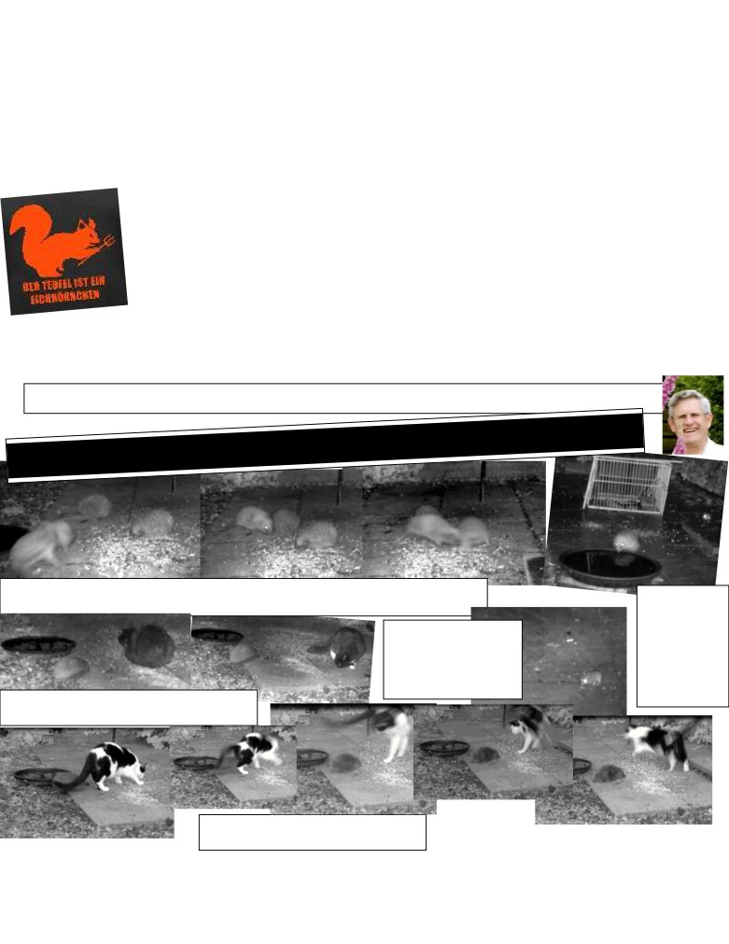

Shropshire Mammal Group Newsletter Issue 28 Autumn 2016
will keep the updates coming via the Facebook Shropshire Mammal Group page. We may even have some results! Success, however, is usually a well-littered path of disasters and failures, but we get there in the end and the journey is a lot of fun.
With a keen eye on available materials and a keener eye on the cost outlay (the office-lab-workshop still requires a BIG SORT-OUT; to date, it’s been a dumping ground for my sundry stuff after the house move) the main job is to get a seriously sturdy work surface (wall, rather than floor-supported) so I can start the process of mounting some of the photo gear into place. A domestic equivalent to an optic bench is the end point.
Out of the domestic box, our local haunts are still well-peppered with camera trapping activity. The elusive pine martens remain as nomadic and vagrant as ever, but at least we get good footage and pics of roe deer and mice. The Germans have a saying ‘The Devil is a Squirrel’, and there’s some valid
credence to this!

Ah, the squirrels! They keep popping up on the traps all over the place, mostly performing selfies in front of the lens, but that’s where the food traces are, so we can’t really blame the little cherubs. The varied visitors to the latest site include robins, thrushes, blackbirds, squirrels (grrr!) woodmice and nondescript blurry things which have the effrontery to move when the picture is being taken. Honestly, some animals…
It was, however, brilliant to hear about the water-voles being re-located to Malam, Yorkshire. I’m always on the look-out for some likely local spots for them, alas no such luck around Clun. There’s some wonderful posting from folk on the group’s Facebook site. I’m so pleased to have found so many talented people. Cheers folks.
Dave Lewis August 2016
More from the hedgehog garden Screen grabs from Brian Hogbin’s video clips

From a sequence entitled Best Fight, we start with four hedgehogs in view before one goes very ferociously for another. They
scuffle until they both fall out of the camera’s field of view to the left at 9 seconds elapsed. At 27 seconds the aggressor returns A lovely clip entitled
(think it’s the same one, rather difficult to tell!) to bully the other two in turn. H drinks + Mouse.
We can see the
hedgehog’s tongue
In Two mice out & about, we lapping up the
meet two frantic wood mice keen water and rippling
to explore the slabs with the reflection. At
characteristic excitement, their 17 seconds a wood
eyes streaking as they reflect the mouse emerges to
infra-red illumination throughout the right of screen,
the clip. Only rarely do they fusses about a bit
stand still! and sits quietly till
A hedgehog approaches a cat sitting quietly. It’s obviously aware the clip ends.
of the hog as it gets up and moves to a respectful distance. There’s no flamboyant jumping in the air… this time.

This spectacular sequence made the national press and it
shows an intrepid hedgehog scaring the wits out of a Clips by Brian Hogbin; captions by Ric
very agile and flexible cat!

Follow us on Facebook at https://www.facebook.com/groups/shropshiremammalgroup/ We’re also on Twitter: @Shropsmammals
If you spot a mammal in Shropshire, please record it via bit.ly/SMGrecord or email Lorcán Adrain at SMGrecord@gmail.com Articles and photos for the next issue of the SMG Newsletter to Ric Morris, Editor, at ric_morris@hotmail.co.uk please

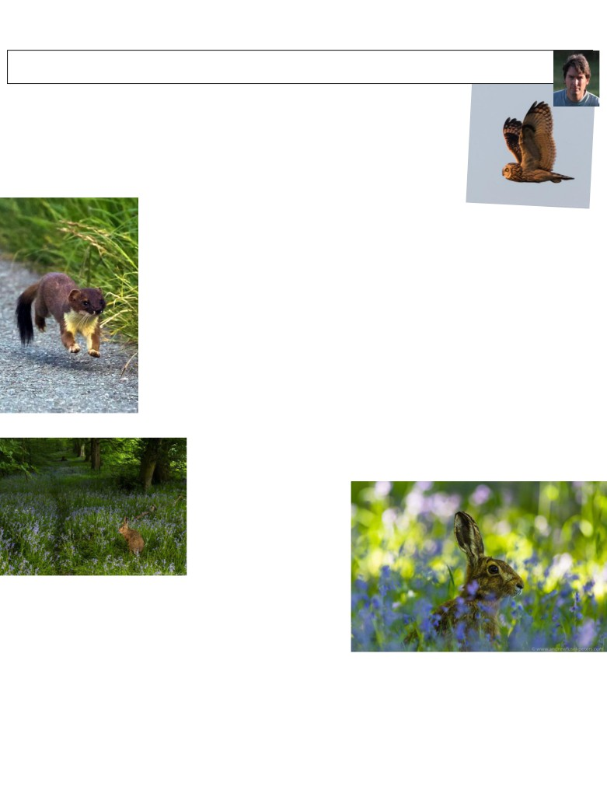

Shropshire Mammal Group Newsletter Issue 28 Autumn 2016
The hill above my house Words & photos by Andrew Fusek Peters
(first published on NearbyWild.org.uk)
Four years ago, when I was still working as a children’s author, if you had told me that I would hug nearby hedgelines, crawl through muddy fields, and stand in sad imitation of a tree in order to photograph hares, stoats and short eared owls, I would have laughed.
The hill above my village was for long walks, dreams, poetry, stops to chat to locals and enjoy the view over the Shropshire valleys I have lived in all my adult life. A breakdown and recovery from severe clinical depression in my mid-forties changed everything. Coming through, aside from getting professional help, one of the big healing factors was nature. In my case, this was and continues to be the spread of Shropshire upland and valleys in a ten mile radius from my house.

I had of course seen hares, and badgers, as my occasional short night time companions,
flared and frozen by the beam of headlights. I knew, subconsciously, that the hawk I recently clocked at over 45mph diving along the ancient drover’s route that dips into my village and then makes its way to London (the old crumbling stone at the corner still says ‘London 167 miles’) was a sparrowhawk. But wildlife was a speck at the corner of my eyes, there but not noticed. The camera, and my education in using it transformed the landscape and my very reading of nature deepened. The first day this happened was when I asked a wildlife photographer how he managed to get such excellent shots of hares. I was told that the human form is a threat {no surprises} but crawling and thereby presenting a less dangerous silhouette can do the trick. It did. Suddenly, hares stopped running away. They preened a few yards in front of me, even went to sleep. Quietness and moving slow is about respect to the species that cling on, that live alongside us in an uneasy relationship.

I began to imbibe field craft. A hedge is a photographer’s best friend, and even a humble metal gate somehow acts like Harry Potter’s cloak. As you get closer, there is the possibility of wonder. Here, in all its whiskered or winged glory, is greatness beyond my creativity. And engaging
with wildlife made me listen to local voices - farmers, conservationists, walkers. The hare is hounded. Round here, coursing happens, late night lamping by men (always men) is about pitting vast headlights and knowledge that an animal freezes, against smallness and
vulnerability. This is not fieldcraft, but massacre and numbers are a fraction of what they were. I see the fragility of it, and hope that my pictures may carry politics within - the showing of beauty a reflection that there is much to lose.

There is hope. I came out darkness, the sense of wanting to end it all. Such an
overpowering illness as this put great stress on my family. When I am folded into the great burnished gold of sunset lying on the feathers of the short-eared owl, or hardly breathing as a stoat
bounds towards me, this hill above my house is a haven of hope that wilderness lies within us. We must cherish it, protect it, celebrate it, fight for it.
Earlier this year, I began to study the local mammal tracks on my
hill, and worked out that the hares were running through the woods, where the bluebells also ran riot. In my head, I could see a vision of hare among all that pomp of purple colour. And the next day (I wish this happened more often), I was in the woods with my kit when three hares ran past, a quick glimpse, then gone. But in that group, I knew there was a fourth, who five minutes later came ambling up the path. I knew by now that if you were still enough, a hare could
nibble its way towards you and not even see you. This hare did, as I kneeled almost in prayer, silent shutter, my camera shaking with excitement, hoping that one shot was sharp. I sent it to BBC Springwatch and Chris Packham said that it “…encapsulates spring, gratuitously bluebelly!”
Andrew Fusek Peters
www.andrewfusekpeters.com Twitter: @2peters
Follow us on Facebook at https://www.facebook.com/groups/shropshiremammalgroup/ We’re also on Twitter: @Shropsmammals
If you spot a mammal in Shropshire, please record it via bit.ly/SMGrecord or email Lorcán Adrain at SMGrecord@gmail.com Articles and photos for the next issue of the SMG Newsletter to Ric Morris, Editor, at ric_morris@hotmail.co.uk please

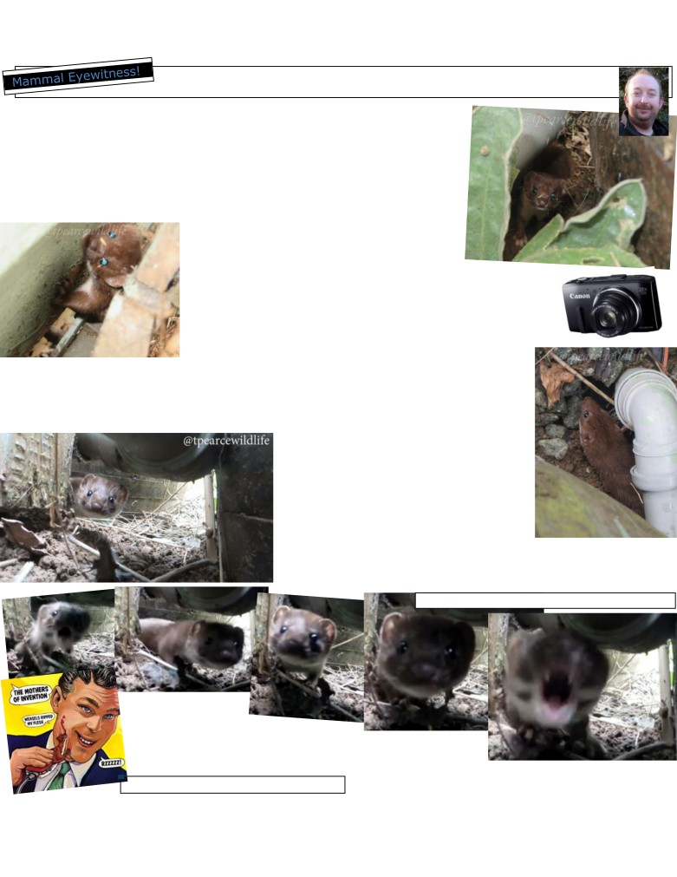

Shropshire Mammal Group Newsletter Issue 28 Autumn 2016
‘Weasey does it!’ Words, photos and filming by Tris Pearce

I am no stranger to mustelids and with weasels, I normally get at least one encounter every year, where I have to help one in need, this normally involves me having to pick it up and I always get bitten for my efforts to help.
One Sunday afternoon in August, I heard a strange squeaking and hissing noise, so I went to investigate. It turned out one of our cats had trapped a young weasel at the side of the house, between the wall and an oak barrel water butt. I scared off the cat and then attempted to check to see if our mustelid friend was ok, he seemed to be fine, but although having more than one escape route, he was not for going.
I could not leave it there for fear of one of the cats
taking another go at it, so carefully I tried to shoo it
away, first with the back of my hand and with my
track record I knew there was a bite looming; it dived
at my hand but did not bite. Realising this was not a good idea I
tried just to get it to move backwards into the more open space. When my wife came over to see what was happening, the weasel broke cover, in the open yard we both thought he would then be running away and be fine, but he decided to sit on my wife’s foot! I had never seen this before, so went for the small compact Canon SX280 (other makes are available) camera in my pocket as I went for the photos he moved back into the area beside the house and water butt again.
We thought they may live under there, so I got on all fours and looked for a hole, as weasel had seemed to have gone, then I hit ‘that smell’! He came at me from nowhere, hissing and surging forward, so quick as a flash I got the small compact camera flicked to video mode and rested it on the ground and weasel did not disappoint. For a few seconds he made the camera and me quite the focus of his attention. A few seconds later he ran off.
I would point out that this was a defensive tactic used by the weasel, he was not too stressed by the ordeal, but seemed more interested in pouncing and lunging than making good his escape. He would have been cat meat if I had not have stepped in to assist. Sadly the last weasel I had was taken from the cat and had broken back legs!
I love these small mustelids and it is always a pleasure to see them in these close quarters. We are lucky to have polecat, stoat and weasel here, but they are so elusive and rarely seen.

Additional screen grabs from Tris’s clip show just how close the weasel got to the lens!

There is a video for
members to view on
the SMG Facebook page.

Tris Pearce
Here’s what could have happened… Frank Zappa / Bizarre Records
Follow us on Facebook at https://www.facebook.com/groups/shropshiremammalgroup/ We’re also on Twitter: @Shropsmammals
If you spot a mammal in Shropshire, please record it via bit.ly/SMGrecord or email Lorcán Adrain at SMGrecord@gmail.com Articles and photos for the next issue of the SMG Newsletter to Ric Morris, Editor, at ric_morris@hotmail.co.uk please

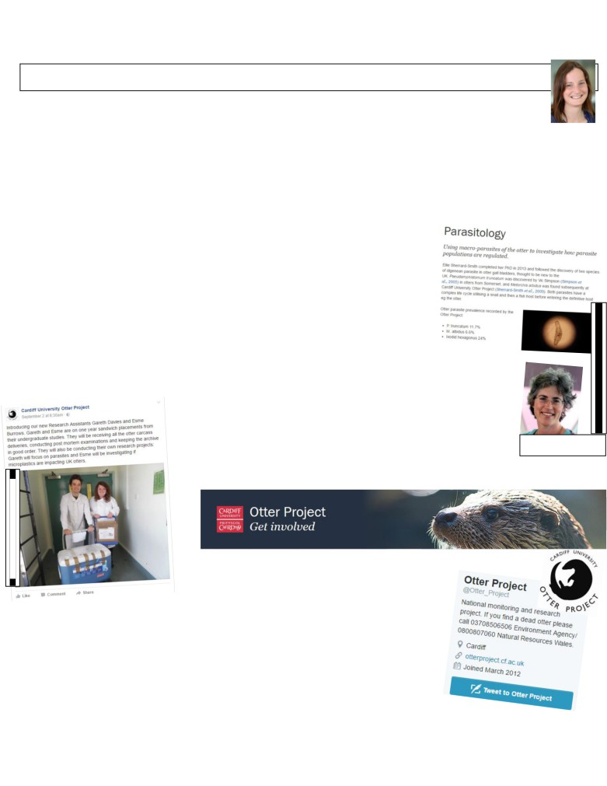

Shropshire Mammal Group Newsletter Issue 28 Autumn 2016

The Cardiff University Otter Project by Dr Eleanor Kean

What we do
We receive approximately 200 otters each year, which are found dead across England, Wales and Scotland.
Dead otters can be reported by anyone and the Environment Agency, Natural Resources Wales or International
Otter Survival Fund in Scotland coordinate collection, temporary freezer storage and delivery of the carcass to Cardiff. We perform a detailed post mortem examination in which we record key information including; sex, age and reproductive status, plus any abnormalities (e.g. cysts or tumours, which are then sent to Shrewsbury for analysis at the Animal and Plant Health Agency), and we remove a large number of samples for our archive. Our archive allows us to retrospectively analyse organs as new questions are asked, methods develop or funds become available. The large sample size, 20+ year time-series and extensive geographic coverage make the Cardiff University Otter Project excellent for analysis of spatial variation and trends over time. After the post mortems are completed we send the report to the corresponding reporting organisation and member of the public, providing a first alert of any sign of ill health in the population, as well as highlighting problem areas of otter mortality, especially on roads.

Why otters?
Otters are at the peak of the freshwater food chain in the UK and act as an environmental “sentinel” - meaning they are an indicator of threats (such as pollutants, disease, parasites etc.) that may affect the health of wildlife, livestock, domestic animals and even humans. Otters are also protected under UK and EU legislation……for now. They are still recovering from near extinction and are classed at near threatened. They are vulnerable to threats from disease, emerging pollutants, declining fish stocks and road traffic accidents.

Our research, past and ongoing…
Our research is diverse including; looking at pollutant levels in otter tissues in order to
highlight potential risks to human and wildlife health, how spraint is used to communicate, analysis of population genetics across the UK, screening of otters for parasites, and looking at micro-plastic levels in otters and their subsequent effects.

Who we are
The Project is headed by Dr Elizabeth Chadwick at Cardiff but was formerly based in the mid-Wales field centre at Newbridge-on-Wye not so far away

from Shropshire. I am second in command, with a local link to Shropshire; my parents are based in Stiperstones and I often work remotely writing up papers from there. Dr Juliet Hynes is researching emerging

Dr Elizabeth Chadwick
Pic: CUOP

contaminants, and we have two PhD students and two sandwich year placement students.

How you can get involved
1) Report dead otters - wherever you are, not just in Shropshire! Call Environment Agency in England on or NRW in Wales on 0800 807 060 and ask for your nearest
conservation or biodiversity officer. In Scotland call the International Otter Survival Fund on 01471 822 487
2) Usually we are only interested in dead otters but occasionally we have research projects that require volunteers to collect spraint. When this happens it is at specific locations and will be posted on our website and social media.
3) Follow us on Facebook or Twitter and check our website for research updates. This helps with grant applications! Since DEFRA cutbacks, we are no longer funded by the EA and NRW so are always on the lookout for funds.

Follow us on Facebook at https://www.facebook.com/groups/shropshiremammalgroup/ We’re also on Twitter: @Shropsmammals
If you spot a mammal in Shropshire, please record it via bit.ly/SMGrecord or email Lorcán Adrain at SMGrecord@gmail.com Articles and photos for the next issue of the SMG Newsletter to Ric Morris, Editor, at ric_morris@hotmail.co.uk please
http://www.cardiff.ac.uk/otter-project
Screengrab & pic: CUOP Facebook page

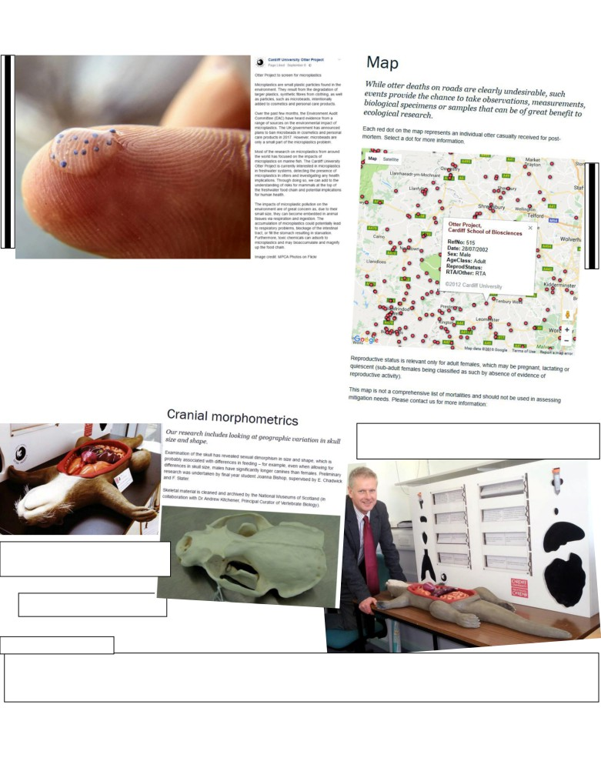

Shropshire Mammal Group Newsletter Issue 28

Shropshire otters
Since the project began in 1994, and at time of writing, we have received over 2800 otters, 57 of which have come from Shropshire. This is low given the size of the county but given the primary cause of death is road traffic accidents, it is likely due to the low traffic volume in Shropshire. It could also be differences in recorder effort so please do report any dead otters to the Environment Agency. You can see where in Shropshire by looking at our online map http://www.cardiff.ac.uk/otter-project/research/map The numbers don’t exactly match because there is a delay in updating the online map. There have been a few lactating females, but no pregnant females or juveniles. This is not unusual.
Dr Eleanor Kean

Model otter used at public engagement events. (I want one of these!)
Pic: CUOP Facebook page

My favourite piece of research…
Screengrab: CUOP website

More about Eleanor…

Autumn 2016

Colin Riordan, President and Vice-Chancellor of Cardiff University finally meets Colin the de-constructable otter!
Pic: CUOP Facebook page

Dr Eleanor Kean has been researching otter ecology at Cardiff University for the past 8 years, specialising in the otter’s sense of smell and also the effects of pollution. She is also heavily involved in engaging with the public and policy makers, ensuring river based research is shared and useful outside of academia.

Follow us on Facebook at https://www.facebook.com/groups/shropshiremammalgroup/ We’re also on Twitter: @Shropsmammals
If you spot a mammal in Shropshire, please record it via bit.ly/SMGrecord or email Lorcán Adrain at SMGrecord@gmail.com Articles and photos for the next issue of the SMG Newsletter to Ric Morris, Editor, at ric_morris@hotmail.co.uk please
Main image credit: MPCA Photos (Flickr) used under Creative Commons
Screen grab of map: CUOP website

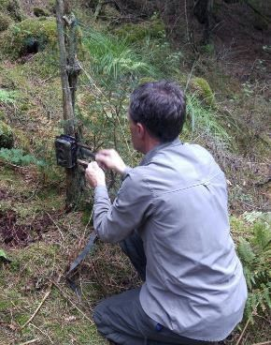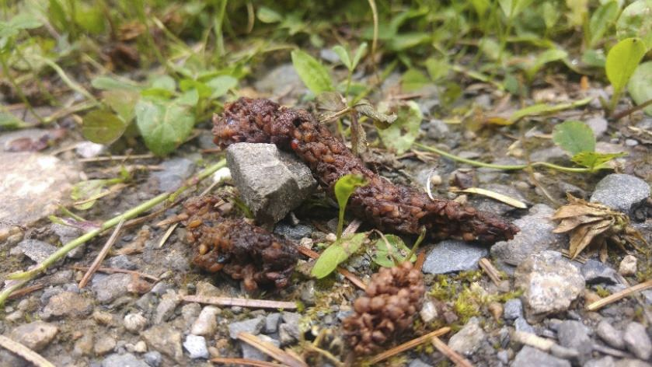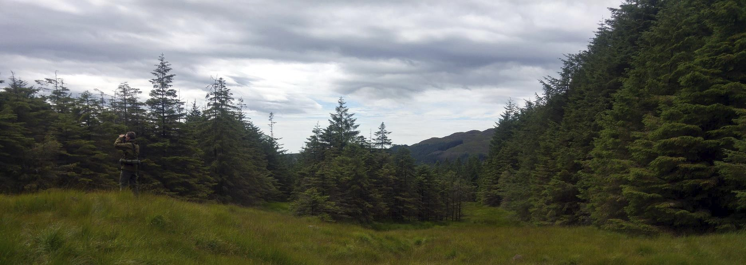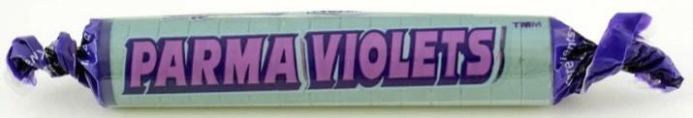

Shropshire Mammal Group Newsletter Issue 28 Autumn 2016
Galloway: scats and shrews Words and photos by Stuart Edmunds

By July 2016, it had been quite a while since I had last encountered a pine marten scat (that hadn’t been frozen
for several months), so a scat refresher trip to Galloway Forest was in order to (excuse the phrase) get my nose
back in. I have been conducting weekly scat searches in Shropshire with little joy other than finding fox and
badger scat, so it was my intention to revisit a Galloway site which on my previous I had described as “scat central”.

In Scotland, pine marten studies have concluded that martens leave scats along forestry tracks as route and territorial markers. On day one in Galloway Forest, hopes for finding marten signs were considerably dashed when we discovered that over 50% of the forest park has been felled since my last visit. Fortunately, some limited tracts of coniferous plantation have been left alone and as predicted, there were still numerous pine marten scats for us to find along the Forestry Commission Scotland gravel tracks.

Galloway forest panorama, with Dave Pearce, discoverer of the Shropshire Pine Marten, far left. Below right: Dave sets a camera trap that later produced a poor image of a marten

During the trip, I walked along many of those tracks and along the way, and a good number of scats were studied. Every single scat was positioned in the centre of forestry vehicle tracks where a central line of grass and vegetation persisted; never on the exposed stone on either side. It was very apparent why the local martens used the tracks to wander around their huge territories too: the surrounding forest was either too heavily covered in ground flora to traverse, and too boggy to make transience possible for pine martens. In comparison, the woodland in Shropshire is often too dark to allow ground vegetation to grow and is often on steep slopes, on which it would be impossible for bogs to form. So, our Shropshire martens are unlikely to be using paved tracks when they can remain in the safe cover of the trees and
off the beaten track.

The big question on everyone’s lips at this point is: what does pine marten poo actually smell like? Various literature states that pine martens produce sweet smelling droppings, comparable to freshly cut hay and sometimes like Parma Violet sweets. Having had a sniff of at least 20 scats in Galloway, I came to my own conclusion: their scat smells very similar to otter spraint. Not a bad whiff like badger, mink, fox and polecat, but definitely quite sweet and herbal smelling. If anyone would like to decide for themselves, I did bring some samples back and they are now sat in my freezer. The scats we found consisted exclusively of berry

Lovely scat!
seeds (wild raspberry and strawberry) and beetle elytra. It is possible that the high fruit content adds to the sweet aroma at
this time of the year.

Follow us on Facebook at https://www.facebook.com/groups/shropshiremammalgroup/ We’re also on Twitter: @Shropsmammals
If you spot a mammal in Shropshire, please record it via bit.ly/SMGrecord or email Lorcán Adrain at SMGrecord@gmail.com Articles and photos for the next issue of the SMG Newsletter to Ric Morris, Editor, at ric_morris@hotmail.co.uk please

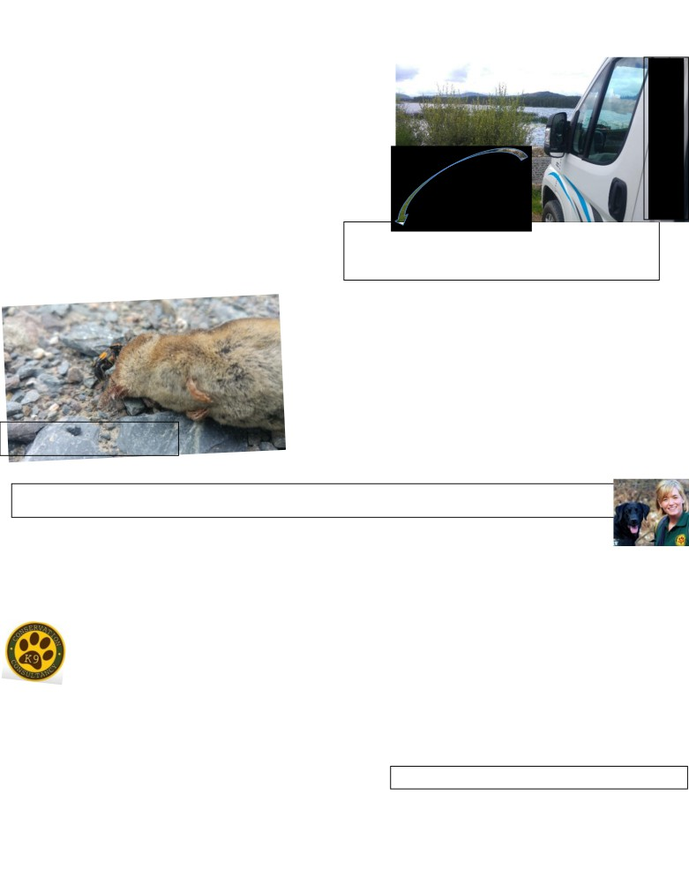

Shropshire Mammal Group Newsletter Issue 28 Autumn 2016
On one of the tracks, around a mile off any frequently used roads, we came across a deceased light-coloured shrew. Finding a dead shrew isn’t that unusual; shrews are often hunted and killed by cats, foxes and martens but then spat out due to their nasty flavour. On this occasion however, my attention was caught by some movement under the shrew. Two Sexton, or burying beetles were working in unison to push the carcass to the soft ground at the edge of the track. So fascinated by the impressive show of strength was I that I took several close up photos and a video of the beetles in action. The weather then closed in, so we opted to move the shrew to the track edge to help the beetles out and we made a 2 mile dash back to our vehicle. It wasn’t until getting back to base and zooming on the images that I realised something startling. The shrew

had white teeth. Our native shrew species all have red-tipped teeth. This shrew appeared to be a non-native white-toothed shrew and could be the first mainland record of the species. White-toothed shrews, native to mainland Europe, have been wreaking havoc in Ireland,
Charles Parley was a long-serving local forester employed by the Forestry Commission. His commemorative stone reads: “In memory of the late Charles Parley, Forester in charge of the Bennan, 1947 - 1970. The afforested panorama visible from this point is its own testimony to his boundless enthusiasm, energy and loving care. Above all he is remembered for his kindly nature which made it a pleasure to work with and for him.” Who knows what he may have done for pine martens over the years!

where they have quickly spread north from ports on the south coast, displacing the native pygmy shrews along the way.
These non-native shrews are not recorded as present in England or Scotland and this could be the first confirmed record on these shores. But by the time I had realised this and attempted to retrace my steps to the corpse, the light was fading and the rain continued. Without
the body, it is impossible to verify the identity of the shrew, but word has now been passed on to recording groups in the area and attempts will be made to live-trap shrews in Galloway to see if any more white-tooths show up. To conclude this tale, I offer this advice: if you find

Greater white-toothed shrew Crocidura russula or lesser WT shrew Crocidura suaveolens?
We’ll never know now…
a dead shrew (or any other mammal that you aren’t sure about) ALWAYS bag it up, take it home and put it in the freezer. You never you have discovered a UK first (and risk facing the full wrath of a certain

local bone collector who is always on the look-out for new specimens)! Stuart Edmunds
Because it makes scents! An appeal by and on behalf of Louise Viljoen
Conservation K9 Consultancy are on the track and trail of many of our native species, whether it's searching for
scats, nests, animal signs and even carcasses! But now they need your help- Louise Viljoen (formerly Wilson) has
been working with Shropshire Mammal Group and Shropshire Wildlife Trust for several years now assisting Stuart Edmunds in his Great Shropshire Pine Marten Scat Hunt!

In 2015, Louise took leave of absence from work and moved to South Africa to start a family, however the great British weather and amazing UK scenery lured her back. Now she has launched her own Wrexham-based innovative venture of Conservation K9 Consultancy- continuing to work and volunteer for wildlife organisations, she has new rescue dogs in training for new and
wonderful projects!

However she needs your help - after bring one of the first trainers to train and operate a bat carcass detection dog in the UK, Louise now needs to acquire more bat carcasses. As many different carcasses of native and non-native bat species, genders and ages as possible are needed to help with some amazing new detection dog projects. Please note
that only bats that have died accidentally or of natural causes will be accepted, and importantly none that have been illegally killed or anaesthetized (which could potentially affect the dogs’ reactions to the bodies). With a new bat license (Ref 73171:OTH:POS:2016) having been issued by Natural Resources Wales, she is now in the search! CAN YOU HELP?
Please contact Louise for more details and information on 07746 410976 or email viljoenk9consultant@gmail.com . Thank you.
Louise Viljoen

Professional Dog Trainer Specialist Dog Handler DipHE Animal Behaviour & Welfare
Conservation K9 Consultancy is a trading name of Lev International Ltd.

Follow us on Facebook at https://www.facebook.com/groups/shropshiremammalgroup/ We’re also on Twitter: @Shropsmammals
If you spot a mammal in Shropshire, please record it via bit.ly/SMGrecord or email Lorcán Adrain at SMGrecord@gmail.com Articles and photos for the next issue of the SMG Newsletter to Ric Morris, Editor, at ric_morris@hotmail.co.uk please
One of many stunning lochside views
which can be enjoyed
.
i i
NX 64734 70036,
Dumfries and Galloway.

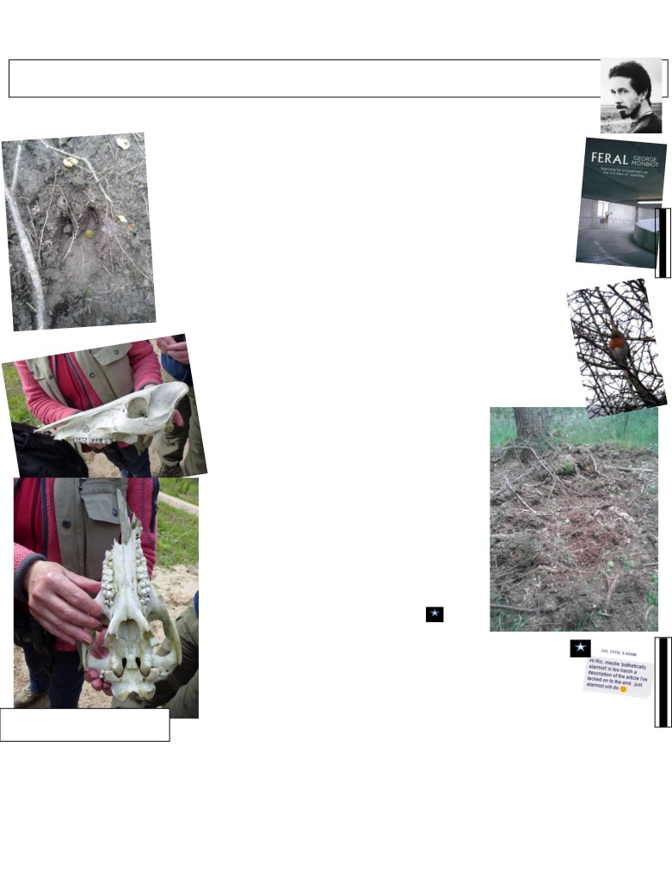

Shropshire Mammal Group Newsletter Issue 28 Autumn 2016
A cure for boardom Words and photos by Jack Riggall
except where otherwise credited

I recently had the pleasure of camping out in The Forest of Dean, home to one of the populations of wild boar that have escaped from farms, hoping to see them & gain a bit of insight into species reintroduction (albeit a bit of a messy one). I’d first seen ten of them in the area - mainly piglets - on
20th June 2011 when hitch-hiking through the area, quite a shock when I didn’t know they existed in the country at that point in time!
Since reading ‘Feral’, George Monbiot’s fascinating & inspiring book on rewilding that praised wild boar, I’ve wanted to learn more about them first-hand, and how they change the ecosystem for the better. Their impact was visible straight away
- the foraging is extensive, they roam widely. Though I explored only a small part of the woods, everywhere I looked there were patches of turf that had been uprooted as the boar searched for roots & bulbs, stretching out on to the roadside verges and into Cinderford Linear Park. After hearing one or two wild boar on a trail when sitting in a tree after dusk on the first night, a large boar jumped out of the bracken in front of me in the morning and ran down the main track; I don’t know exactly how big (I wish I could have watched it for longer), but bigger than I expected! The stated dimensions vary; the PTES Mammals Handbook from 2010 says shoulder height can be up to 1.7m, but the UK Wild Boar Trust says they reach a max height of 1m.
On to the improvements; Monbiot describes the relationship with the wild boar has with the robin in particular, which follow them through woodland ecosystems to gorge on the invertebrates that are exposed by
the foraging. I imagine there to be many species that are able to take advantage of this habit in a similar manner. The foraging & wallows also create ecological niches for many other species in a
constant state of flux; I could see areas that were ‘recovering’ from the wild boar’s activities. A central theme to my own training as a countryside manager
is that having a mosaic of habitats/stages of succession (call it structural diversity if you want) is precisely what is needed for biodiversity to flourish, and this, it seems, is exactly what wild boar are providing as they reclaim their former role in the UK’s woodlands. I’m glad to have caught even a brief glimpse of the wild boar, and would recommend exploring the area to anyone interested in mammals & ecosystem restoration. Failing that, reading the Rewilding Britain website and/or Feral for more information is a must!

N.B: Wild boar are not the monsters they are made out to be. William Langley wrote an article in The Telegraph on 25/04/2015 under the alarmist heading Beware The Boars: “They charge at 30mph, have
razor-sharp tusks, live in a forest near you and now they've started attacking humans. A dispatch from the front line of the boar war.” They are still fairly large wild animals, though. Sleeping on the ground in their territory may cause slight anxiety, needs caution & respect!

The Social Aspects of Wild Boar in the Forest of Dean, by John S. Dutton,
Hayley T. Clayton and Sian M. Evans, published as a Forestry Commission Project
Massive boar skull found by Linda and Keith
Offord in the forests of Estonia, May 2016. Report in November 2015 is also well worth reading.
Both photos: Linda Offord
Jack Riggall

Follow us on Facebook at https://www.facebook.com/groups/shropshiremammalgroup/ We’re also on Twitter: @Shropsmammals
If you spot a mammal in Shropshire, please record it via bit.ly/SMGrecord or email Lorcán Adrain at SMGrecord@gmail.com Articles and photos for the next issue of the SMG Newsletter to Ric Morris, Editor, at ric_morris@hotmail.co.uk please
Jack being cautious.
www.monbiot.com

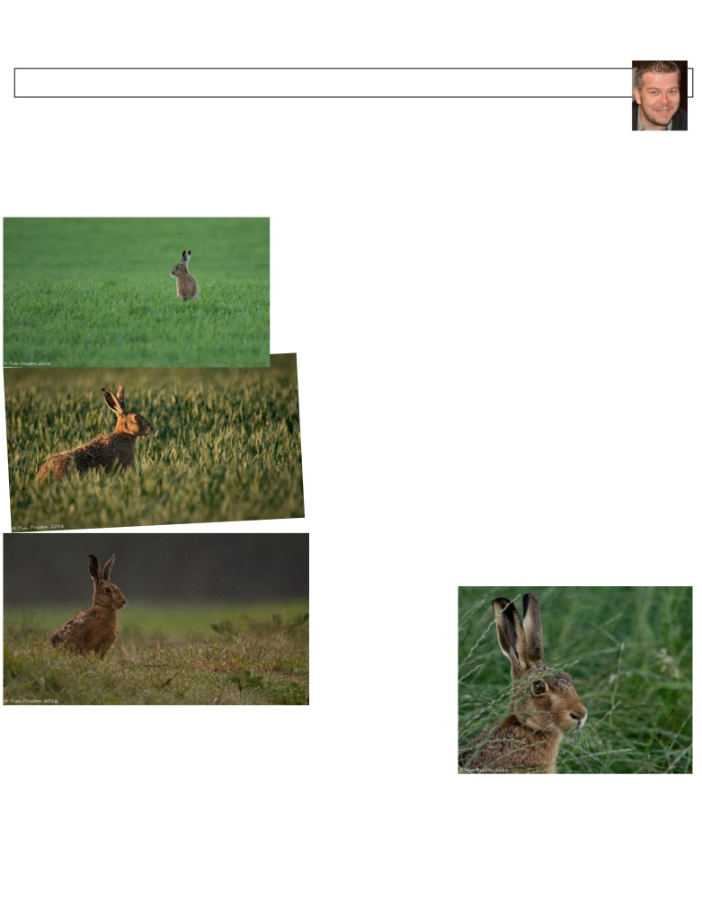

Shropshire Mammal Group Newsletter Issue 28 Autumn 2016
Good hare days! Words and photographs by Tim Preston
Brown Hares had always been a bit of a mystical creature to me, I had always enjoyed other people’s photographs of them, especially Mark Sisson and Andrew Fusek Peters and more recently Robin Bennett, but I had never, ever seen one myself.

Early in the year I attended a talk by Mark Sisson in Wellington in which he shared some stunning photos of afore-mentioned hares. At the end of the talk I plucked up the courage to ask him about hare photography. Mark kindly recommended a book, Wildlife Photography Field Skills and Techniques by Paul Hobson. An excellent book with a whole chapter pretty much dedicated to hares. How to locate them, their habits and field craft techniques to use once you had found them.
First I had to find them! I had no idea where to start but I was determined to stay within a few miles of my home in Telford. Many, many, many hours & evenings were spent trundling around my local lanes in search of my mystical creature. A couple of weeks passed with no luck, I was pretty much ready to give it up as a bad job. Surely, I couldn’t fail at the first hurdle.
One night just as the sun was setting a tatty blue 4x4 pulled across the lane in front of me and blocked my path. My initial thought was that I about to get car jacked! The driver jumped out and approached my door,
I cautiously wound down the window “Lost something lad?!” was the opening line…
Turned out this was the local farmer who owned the land around the lanes I was watching. Apparently he had been observing me for days driving back and forth. His curiosity had obviously gotten the better of him. After a friendly chat and explaining to him that I
wasn’t scoping out his property for anything too sinister he completely out of the blue offered to take me to what he called “The hare field”. I was astounded, not only did he take me an exact spot I had driven past on many an occasion but he pointed hares out in the field to me too.

No wonder I had never seen one, it was a mere brown mound that ked nothing more than a clod of soil. At sunrise and sunset these little brown lumps come to life. This is where my fascination with these fantastic creatures really began. My evenings also turned into early mornings, often leaving the house before sunrise. My wife couldn’t understand my obsession. The farmer had very kindly given me permission to
go onto his land. I spent hours lying on my belly in dewy, damp or wet grass and I have witnessed some fantastic sunrises.
I will not forget the first time I got to within a few
feet of one, it knew I was there. It was looking directly at me but didn’t bolt. I think it was as fascinated by the fat bloke lying in the grass as I was with him.
Unfortunately the grass grew quicker than I could develop my techniques but now I know where they are and how to get close to them I now have a challenge
for spring next year, hopefully I can hit the ground running. I did get some photos I was extremely pleased with though. I can’t wait until next year. I would also love to add some badgers and foxes to my photo collection too but I’m not sure
my better half would be too happy. Tim Preston
Follow us on Facebook at https://www.facebook.com/groups/shropshiremammalgroup/ We’re also on Twitter: @Shropsmammals
If you spot a mammal in Shropshire, please record it via bit.ly/SMGrecord or email Lorcán Adrain at SMGrecord@gmail.com Articles and photos for the next issue of the SMG Newsletter to Ric Morris, Editor, at ric_morris@hotmail.co.uk please

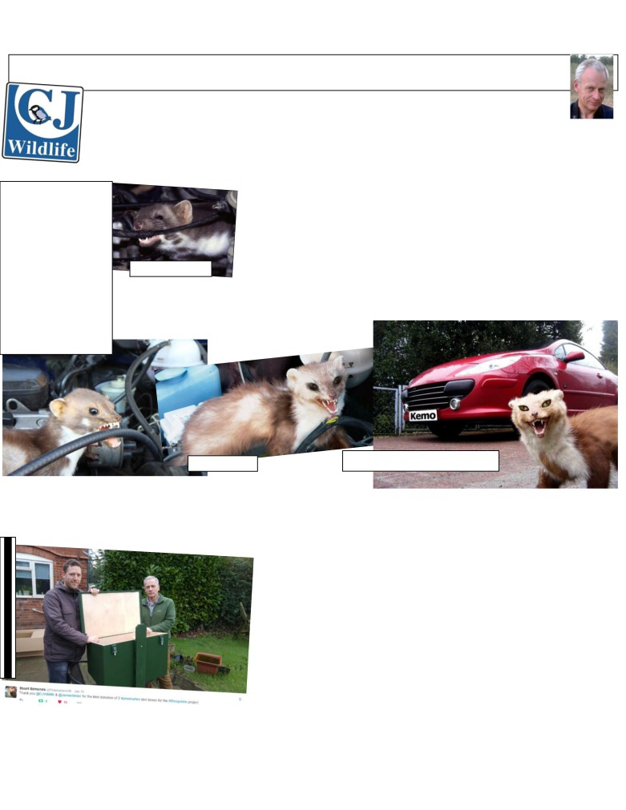

Shropshire Mammal Group Newsletter Issue 28 Autumn 2016
Pine Marten Den Boxes by Martin George, of SMG Corporate Members CJ Wildlife
Images sourced by Ric

Although a local company, we also trade in eight European countries outside the UK, with a separate
headquarters in the Netherlands for mainland Europe business. Across the North Sea, beech martens,
also known as stone martens, (Martes foina) can cause considerable damage to houses, outbuildings and vehicles, so a local mammal society approached us to provide a den box as a non-lethal potential solution to the problem.
A combination of increased car ownership and house building in rural areas and, some experts speculate, a move to safer, fish oil-based lubricants for control cables, has seen a noticeable

A Google image search for pine marten damage or
marten damaged cars throws up some pretty
surreal results, many from European websites. Some of these images are
vaguely plausible while many others appear to
have been especially Vaguely plausible….
posed with taxidermy martens, themselves
increase in reports of damage to vehicles from the mid-1970s onwards. The problem has three annual peaks: in the spring, when young martens establish their own territories and explore potential food items by biting them; during the breeding season in July and August, when the martens scent mark loafing areas such as engine bays, provoking an aggressive response when the car is moved to another marten’s territory; and in winter, largely as result of the creatures seeking winter shelter sites, particularly ones that may initially be quite warm.

prepared with varying degrees of skill, and then posed… er… ‘creatively’. Several seem to be photoshopped to appear intentionally hilarious...
Photos sourced by Ric
Typical damage includes severed cables (they can allegedly slice through a starter motor lead in one bite); chewed insulation and protective gaiters, and punctured pipes. The pipe damage may not be obvious until the car is some distance into its
journey, resulting in overheating and occasionally major engine damage.

This one has to be my particular favourite… Frankly bizarre… www.reichelt.de

In Belgium the Flemish Motoring Association VAB, a Belgian equivalent
to the AA or RAC, say that the problem of damage to cars caused by beech martens isn’t universal but mainly occurs in three provinces. Apparently "It is a limited and local problem, but three out of ten breakdown calls to VAB are as a result of beech marten damage”, so in the affected areas the problem can be severe. Elsewhere in Europe it’s estimated that around 180,000 cars are damaged in Germany every year, at an annual cost of €50-70 million. With martens causing
such widespread problems it’s no surprise that an industry has developed to try and defeat them, often using ways that range from unpleasant to lethal, which is why the Dutch
mammal society contacted my colleagues in the Netherlands to see if providing alternative accommodation could be a solution. The idea is that a den site is placed away from outbuildings and parked cars to give the martens a safe refuge that keeps them out of trouble.
A pine marten enthusiast in the Scottish Highlands was very interested in the beech marten den boxes that we sell in other markets, and felt that the design would be ideal for pine martens. At around the same
time I happened to be talking to Stuart about the Shropshire Pine Marten Project, so giving the den boxes a test run in pine marten country in our home county seemed like an obvious move. I just hope a marten moves into our design ahead of the box design which is being used locally by the Vincent Wildlife Trust!

Follow us on Facebook at https://www.facebook.com/groups/shropshiremammalgroup/ We’re also on Twitter: @Shropsmammals
If you spot a mammal in Shropshire, please record it via bit.ly/SMGrecord or email Lorcán Adrain at SMGrecord@gmail.com Articles and photos for the next issue of the SMG Newsletter to Ric Morris, Editor, at ric_morris@hotmail.co.uk please
From @PineMartensUK Twitter account

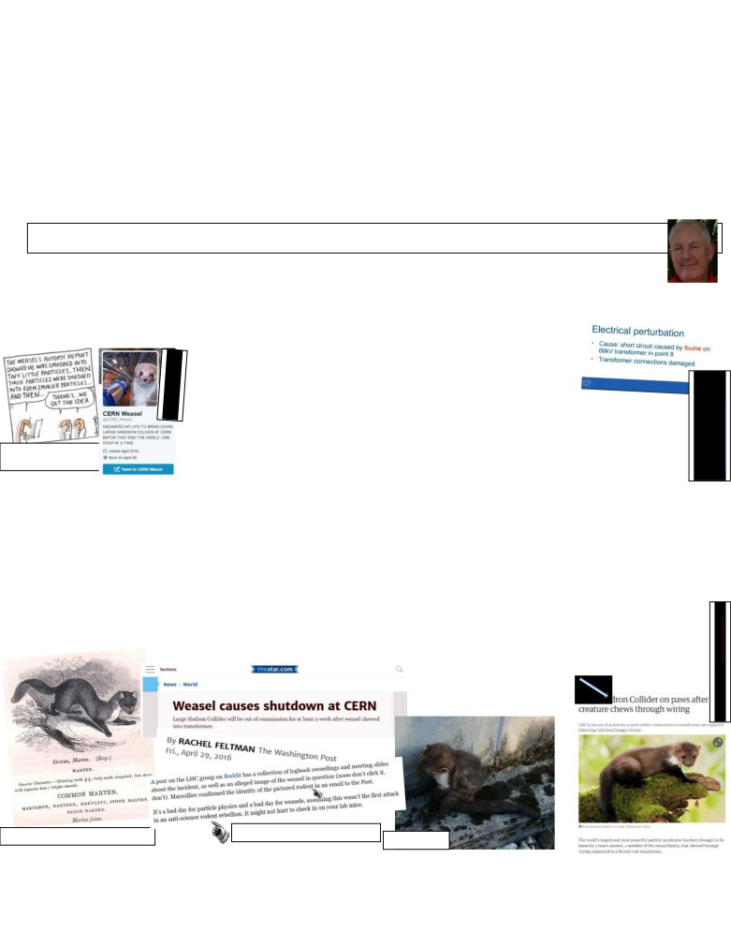

Shropshire Mammal Group Newsletter Issue 28 Autumn 2016
Apart from antisocial behaviour in suburbia, the martens can occasionally do far more significant damage, such as the one that brought the world’s largest and most powerful particle accelerator to its knees by chewing through wiring connected to a 66,000-volt transformer. The Large Hadron Collider, which discovered the Higgs boson in July 2012, was out of action for a week in April while engineers repaired the damage and removed the carbonised remains of the marten. Managers at Cern, the European nuclear physics laboratory that runs the Collider, commented that “it was not the best week for the LHC”.
Cern is one of the largest scientific sites in Europe, being likened to a medium sized town, and the Collider occupies a 17-mile tunnel. So far our attempts to sell them sufficient den boxes to safeguard this massive infrastructure, essential for our understanding of the conditions that prevailed at the birth of the universe, have been unsuccessful, but we live in hope that, if the Shropshire martens move in, Stuart may be able to put in a good word for us!
Martin George
Taxonomic musings on a charred mustelid by Ric Morris

I wouldn’t have thought to mention this rather old news had it not been for Martin’s very interesting article touching on marten
damage, above. But the taxonomic confusion that has arisen from the reports of the unfortunate mammal at Cern is interesting.
. It had been widely reported that the culprit was a “weasel” but as with many aspects of popular journalism, one is never sure whether or not the name is being used accurately. As members of Shropshire Mammal Group, we are of course familiar with the difference between Mustela nivalis and Martes martes, although we may be less confident about Martes martes vs Martes foina. So was the term ‘weasel’ being used in its specific sense, or in a familial sense? (Notice I didn’t say ‘generic’ there).

For an answer, I combed the internet to read the various UK and international
press reports. Rather disappointingly there were a whole string of articles
that had been illustrated with library photographs of weasels, stoats, bad
taxidermy weasels and stoats, cartoon weasels and stoats, and lots of quotes
from physicists and PR people claiming the animal was a “tiny weasel”; “definitely” a “weasel” from the “forests” or “countryside”… well you get the idea. Generally, a bit vague. By now I was almost convinced the culprit actually was Mustela nivalis.

http://www.smh.com.au Cartoon Matt Goulding
So why I am I so bothered about the taxonomy here? Because in research for my bones ID book I am finding that scientific names are changing with bewildering speed. The original point of scientific taxonomical names was to provide a single name for a species that could be traced back, and compared

to a type specimen. This would in theory eliminate the ambiguity of local names, or national names in a variety of different languages;
it would ensure that scientists from all over the world knew exactly what species was under discussion. From time to time, names alter and I understand (in theory) the Principle of Priority, whereby the first formal scientific name given to an animal or plant taxon is the name that takes priority as the valid or correct name. But even this seems fluid. The riparian mammal that I have known almost all my life as Arvicola terrestris is now apparently Arvicola amphibius. Some logic there, admittedly; it never made much sense that the UK’s water vole was terrestris. And suddenly I am reading of Mus domesticus as well as Mus musculus for the house mouse, with the domesticated pet or lab mouse being Mus musculus domesticus. Dogs are apparently now Canis lupus familiaris (effectively a sub-species of the wolf) rather than Canis familiaris. When did THAT happen! Gosh I have only just got used to Myodes rather than Clethrionomys. I guess it is inevitable that now DNA genome mapping is commonplace, traditional taxonomy is being modified at an ever increasing rate, but where do we search to find the most up to date taxonomic terms? And I don't mean Wikipedia!

But back to the Cern weasel. While researching this piece, I saw an article attributed to a Washington Post reporter which alluded to the offending weasel being a rodent. Now THAT is sloppy journalism. It seems to have been corrected on the Washington Post’s own website (“rodent” was changed to “animal”) but the syndicated article in its original form is evidently still out there.

In the end I just did the sensible thing and asked Martin;
he directed me to the Guardian website. Seemples! (no-wait- that’s a meerkat… isn’t it?)
Ric Morris

Martes foina in happier times (i.e. 1874)

Screengrabs from www.thestar.com Photo: Cern

Follow us on Facebook at https://www.facebook.com/groups/shropshiremammalgroup/ We’re also on Twitter: @Shropsmammals
If you spot a mammal in Shropshire, please record it via bit.ly/SMGrecord or email Lorcán Adrain at SMGrecord@gmail.com Articles and photos for the next issue of the SMG Newsletter to Ric Morris, Editor, at ric_morris@hotmail.co.uk please
At least they got it right on
the Cern log… before they
were quoted by the press.
http://indico.cern.ch
Screengrab: The Guardian

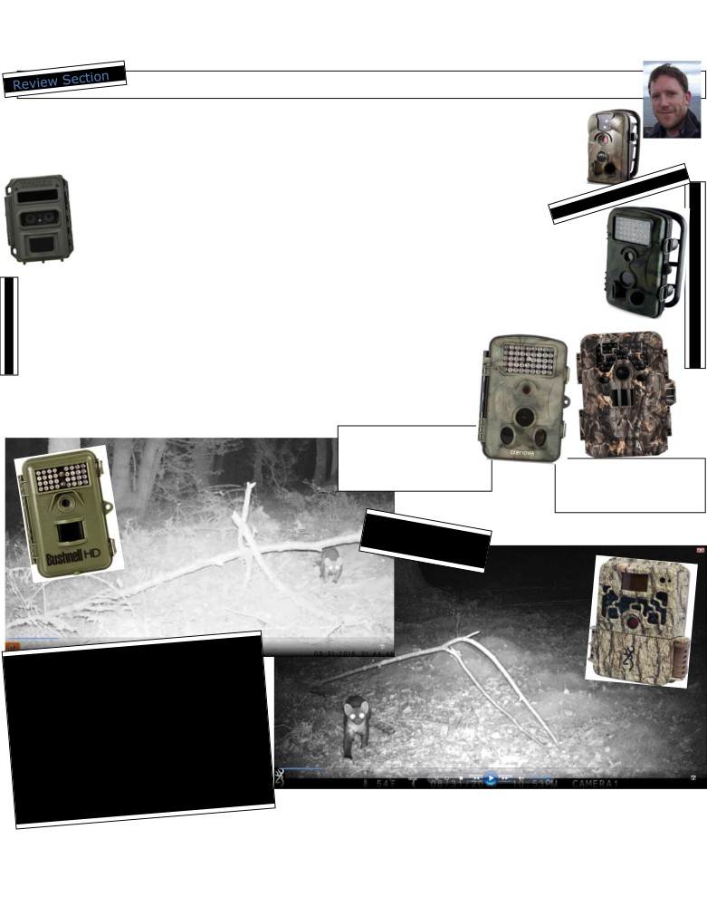

Shropshire Mammal Group Newsletter Issue 28 Autumn 2016
Trail camera update by Stuart Edmunds
I have been conducting some research on cheaper trail cameras this month to find an alternative to the Ltl Acorn, of which I had previously used plenty. The Acorns do lack decent video quality, but at £70 each, they were a good cheap option for getting mammal records. Unfortunately, after just a few uses, the majority of them began to malfunction: the screens stopped working and the on/off switch would no longer move to set-up mode to enable the settings to be changed.
Choosing the right trail camera depends on your intentions for its use. The cheaper models are designed for short term outdoor use, usually for people to view the wildlife in their own back gardens. The more expensive models (leading up to the Reconyx
Ultrafire at £475) are equipped with stronger water-tight seals and improved on-off switches.
There are a number of other models available for a similar price to the Ltl Acorn, namely Maginon (from Aldi!), Crenova and Tech.Bean. The general feedback in online reviews is that they are functional for basic use, but deteriorate faster than the slightly more expensive models. With that in mind and because the pine marten project requires cameras that can be left out for weeks at a time in harsh weather, I opted to test a Bushnell Natureview (£115) and a Browning Strikeforce (£119) (see screenshots below: Bushnell left and Browning right).
So far I have been impressed with the trigger speed, video quality and improved durability of both. The Browning in particular has improved quality and fast trigger speed, while being less dependent on lithium batteries which can cost a fortune. Amazon.co.uk continues to be the cheapest option for buying trail cameras, but there are increasing numbers of counterfeit Acorns, so it is well worth doing your research and reading lots of reviews before splashing out!
The Crenova- its casing is
practically identical in
appearance to the Maginon

but what’s the technology inside like?

Follow us on Facebook at https://www.facebook.com/groups/shropshiremammalgroup/ We’re also on Twitter: @Shropsmammals
Tech.Bean: kind of a visual cross between Darth Vadar, Hannibal Lector… and, um… Mr Bean.

Stuart Edmunds

If you spot a mammal in Shropshire, please record it via bit.ly/SMGrecord or email Lorcán Adrain at SMGrecord@gmail.com Articles and photos for the next issue of the SMG Newsletter to Ric Morris, Editor, at ric_morris@hotmail.co.uk please
The Maginon- also available in grey.
Reconyx Ultrafire

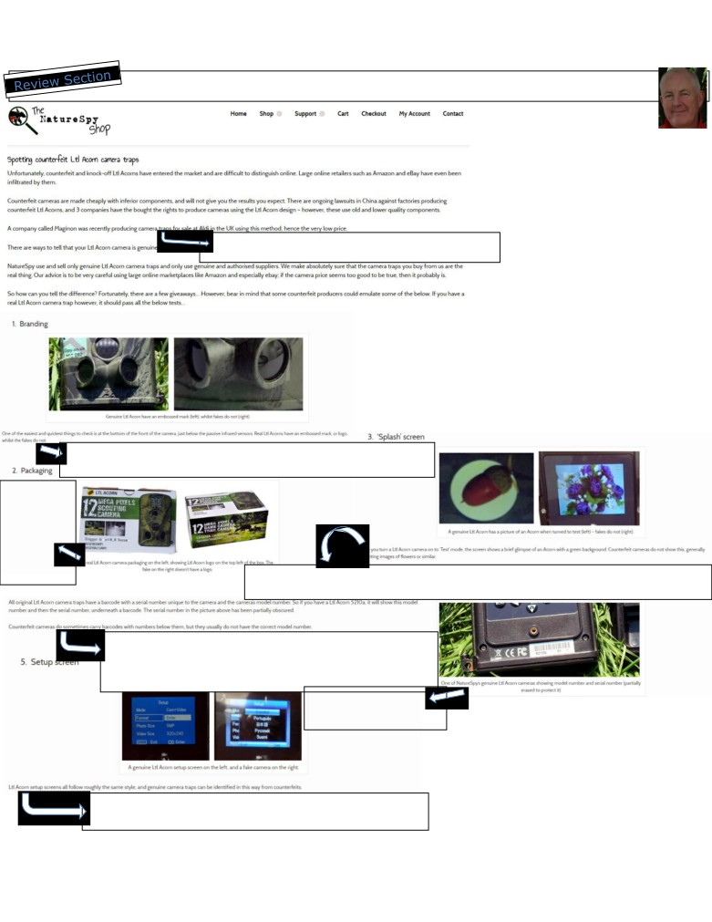

Shropshire Mammal Group Newsletter Issue 28 Autumn 2016
Spotting counterfeit cameras a very brief guide compiled by Ric Morris

I feel something of a fraud
claiming authorship of this article,
and that is a most inappropriate frame of mind for a piece on fake goods, so I will just emphasis that I have only compiled it. Rest assured that I’m not giving out any trade secrets here and the advice is strictly confined to Ltl Acorn trail cameras; all the information content is reproduced verbatim & in its
entirety via screenshots made on

*Please note that this wording emphasizes that although they use older technology, Maginon cameras are still legitimate products made under licence.*
September 6th 2016 from the NatureSpy Shop website who shall be held responsible for all its own content. Richard Morris and

Shopshire Mammal Group offer this information in good faith; they accept no liability for inaccuracies, and no detriment is implied against any bona
fide retailer or supplier in the UK, the EU or elsewhere in the world. Information in arrowed text boxes duplicate wording from the screen shots for improved readability of tiny, faint or pale text, or may clarify a point which may otherwise be misunderstood.

This information is similar to that hosted on the Ltl Acorn’s own website, but the text here is, quite frankly, a little more coherent and grammatical. Links to the pages are: Nature Spy Ltl Acorn.

“Genuine Ltl Acorns have an embossed mark (right) whilst fakes do not (right). One of the easiest and quickest things to check is at the bottom of the front of the camera, just below the passive infrared sensors. Real Ltl Acorns have an embossed mark or logo which the fakes do not.”

“A real Ltl Acorn
camera
packaging on the left,
showing Ltl
Acorn logo on the top left of the box. The fake on the right doesn’t
have a logo” “A genuine Ltl Acorn has a picture of an Acorn when turned to test (left)- fakes do not (right). When you turn a Ltl Acorn
camera on to ‘Test’ mode the screen shows a brief glimpse of an acorn with a green background. Counterfeit cameras do not show this, generally presenting images of flowers or similar”

“All original Ltl Acorn camera traps have a barcode with a serial number unique to the camera and the camera’s model number. So if you have a Ltl Acorn 5210a it will show this model number and then the serial number underneath a barcode. The serial number in the picture has been partially obscured. Counterfeit cameras do sometimes carry barcodes with numbers underneath them but they usually do not have the correct model number”
“One of NatureSpy’s genuine Ltl Acorn cameras showing model number and serial number
Bear in mind that as this info is in the public

(partially erased to protect it)”

“A genuine Ltl Acorn setup screen on the left and a fake camera on the right. Ltl Acorn setup screens all follow roughly the same style, and genuine camera traps can be identified in this way from counterfeits.”
domain, counterfeiters’ techniques will improve accordingly, and some of these indicators of authenticity may be adopted by the fakers! Nonetheless it will give readers a flavor of what to look out for when buying. And remember the words of Grandmaster Flash & the Furious Five,
often quoted by the Shropshire TS Enforcement team: “It’s a jungle sometimes, it makes me wonder how I keep from going under”.
Ric Morris

Follow us on Facebook at https://www.facebook.com/groups/shropshiremammalgroup/ We’re also on Twitter: @Shropsmammals
If you spot a mammal in Shropshire, please record it via bit.ly/SMGrecord or email Lorcán Adrain at SMGrecord@gmail.com Articles and photos for the next issue of the SMG Newsletter to Ric Morris, Editor, at ric_morris@hotmail.co.uk please

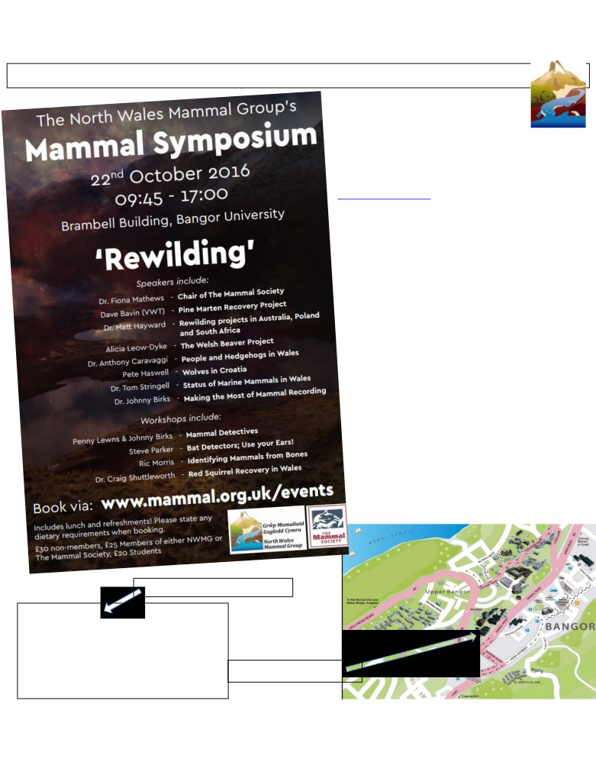

Shropshire Mammal Group Newsletter Issue 28 Autumn 2016

North Wales Mammal Group’s Autumn Symposium by Ric Morris
I want to give some good publicity to this
exciting event which takes place next
nth, at the start of National Mammal
ek. It is just a short drive from
opshire… well… a couple of hours’ drive, through utiful scenery, or preferably an eco-friendly train rney away.
, if you can’t make the Mammal Society’s own tumn Symposium, to be held in London on esday 15th November (oooh… all the way to
ndon, mid-week, the trains’ll be packed, hmmm) en this will make an excellent alternative. NWMG hosting an impressive line-up of heavyweight
eakers with particular relevance to Welsh ammals- Dr Fiona Mathews, Mammal Society hair of course, Dr Johnny Birks and Dr Craig
huttleworth are perhaps some of the better-nown academics, but David Bavin will also be alking about the VWT pine marten eintroductions and there will be presentations on
eavers, wolves and (to us in Shropshire) the omparatively unfamiliar marine mammals. Dr Anthony Caravaggi will also be a familiar name to Newsletter readers as he wrote a piece for
SMGN25, Winter 2015 (The Day of the
Hedgehog)
I already know from Facebook that at least one other SMG member will be attending, so there will be two familiar faces to greet you if you
fancy joining us. Plus you will get the rare opportunity to get hands-on with my bone collection! (Ooo-er! Other workshops are also
available…)

Book early!
Ric Morris

Wasn’t sure… had to look it up.

Symposium:
1. A meeting or conference for discussion of a topic, especially one in which the participants form an audience and make presentations.
2. A collection of writings on a particular topic, as in a magazine.

3. A convivial meeting for drinking, music, and intellectual discussion among the ancient Greeks.
www.thefreedictionary.com
Brambell Building is no.38 on this map, a convenient walk from the station.

Follow us on Facebook at https://www.facebook.com/groups/shropshiremammalgroup/ We’re also on Twitter: @Shropsmammals
If you spot a mammal in Shropshire, please record it via bit.ly/SMGrecord or email Lorcán Adrain at SMGrecord@gmail.com Articles and photos for the next issue of the SMG Newsletter to Ric Morris, Editor, at ric_morris@hotmail.co.uk please

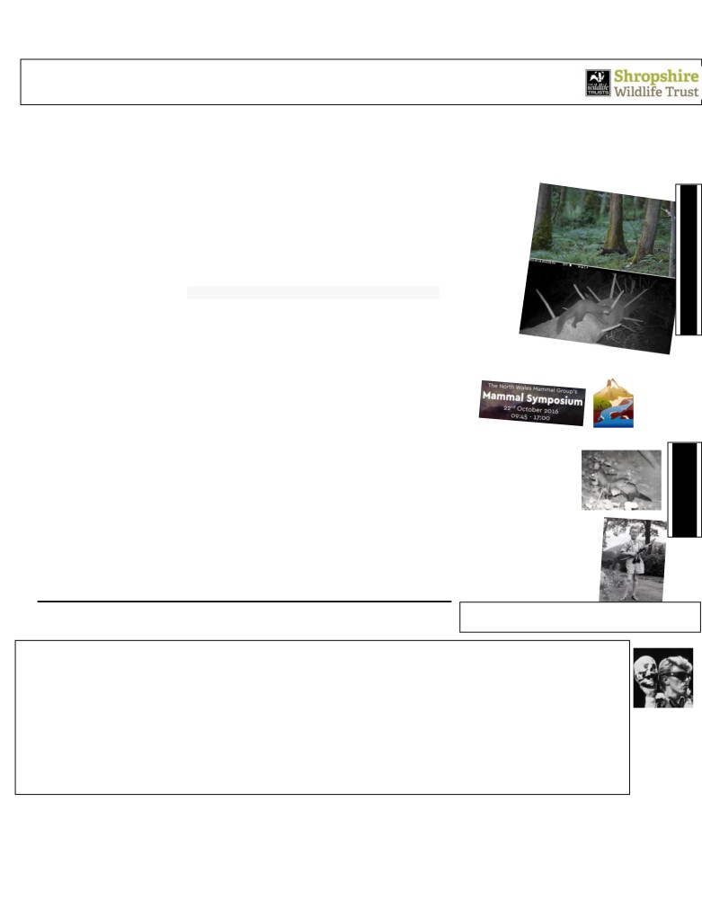

Shropshire Mammal Group Newsletter Issue 28 Autumn 2016
Diary dates for forthcoming events Mostly from the local branches
of Shropshire Wildlife Trust
No bespoke activities for the Shropshire Mammal Group in the immediate future, but always worth keeping a close eye on the SMG Facebook page and the Shropshire Pine Marten Project page, as Stuart is likely to organise scat hunts at fairly short notice- this will often be weather dependant as there is little point in searching for scats after a period of heavy rain. So given all the media interest in our pine martens over recent months, Stuart is undertaking a programme of talks and presentations, on the round eared carnivore- all are hosted by Shropshire Wildlife Trust local groups throughout the county during the autumn.
____________________________________________________________________________________________________________
Pine Marten Adventures with Stuart Edmunds
When? Wednesday 19th October 2016.
Where? Hightown Community Room, Clun, SY7 8JG

When? Thursday 10th November 2016.
Where? Ludlow Mascall Centre, Lower Galdeford, Ludlow SY8 1RZ

When? Tuesday 15th November 2016.
Where? Methodist Church, Watling Street South, Church Stretton, SY6 7BG

When? Wednesday 14th December 2016.
Where? Methodist Church Room, Castle Street, Oswestry SY11 1LF
All events open at 7.00pm for 7.30pm start, all welcome at cost of £3 entry,
including light refreshments. (£2 entry fee for Shropshire Wildlife Trust members)
____________________________________________________________________________________
North Wales Mammal Group Autumn Symposium
When? Saturday 22nd October 2016
Where? Brambell Building, Bangor University, Bangor, Gwynedd LL57 2UW Description: See page 19.
________________________________________________________________________
Polecats and their remarkable comeback
When? Tuesday 8th November 2016.
Where? St Andrews Church Hall, Church Aston, Newport TF10 9JG
Description: Lizzie Croose of the Vincent Wildlife Trust will give a talk on polecats. Hosted by SWT Newport branch, times & entry fees as above
________________________________________________________________________ Confessions of a Teenage Skull Collector with Ric Morris
When? Wednesday 9th November 2016.
Where? Whitchurch CoE Infant & Nursery School, off Station Road, Whitchurch, SY13 1RJ
Description: Ric’s bones talk featuring tall tales of his 70s hair and denim, plus Armand Denis fixation, & perennial fave legends of the Trafalgar Square Pigeon and Shergar’s skull.
Hosted by SWT Whitchurch branch, times & entry fees as above.
The pre-teen skull collector pictured in 1966 with Armand Denis fixation in

And finally…
full flow. Accessoried with plastic crocodile, 4/6d from Chester Zoo. Pic: Cecil Morris

Wow, a big sigh of relief from your editor, another great issue is hitting your inboxes and already I’m brimming over with great ideas for SMGN29. Huge thanks to everyone who has supported SMG over the last three months; in particular to those members and volunteers who have staffed the SMG displays at Fur and Feather, Hawkstone Park in July, who have helped make the Longden Road mammal trapping and the Pam’s Pools events a success in July & August, and to Jayne and Samantha who spoke to so many members of the public at Merefest earlier in September. So don’t forget to send in your mammal records* (yeah, me included, I know!) and try to get to a few of Stu’s PM talks if you can; it really is great to see those pine marten clips on a big screen, believe me.

*Yes we all love checking our wildlife cameras and live traps but remember Lorcán can also use road kill and cat kills for mammal records. If you’re not sure exactly what the splatter is, then grab a photo (yeah, bit gruesome maybe!) and send that along to SMGrecord@gmail.com or even post it on Facebook, we’re not squeamish. And finally I urge you to let us know what you think of SMG’s activity and events by completing the member survey here. Don’t forget to say nice things about the Newsletter!
All the best for the Autumn months. Ric Morris

Follow us on Facebook at https://www.facebook.com/groups/shropshiremammalgroup/ We’re also on Twitter: @Shropsmammals
If you spot a mammal in Shropshire, please record it via bit.ly/SMGrecord or email Lorcán Adrain at SMGrecord@gmail.com Articles and photos for the next issue of the SMG Newsletter to Ric Morris, Editor, at ric_morris@hotmail.co.uk please
Pine marten 2015, Dave Pearce
Pine marten 2016, Stuart Edmunds
Mustelids dominating
the talks programme
this autumn. Pic Stu

