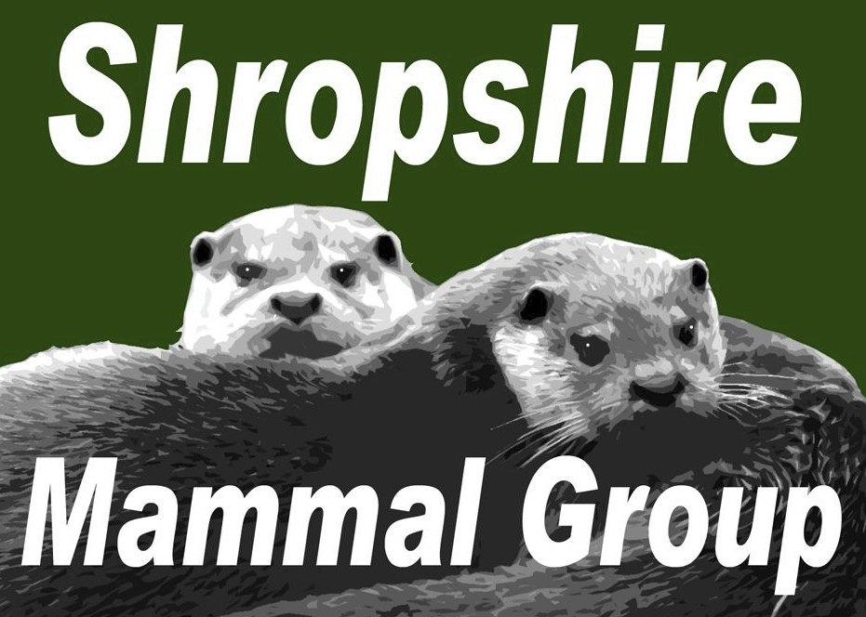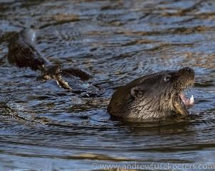
Newsletter
Issue 22: Spring 2015

Affiliated to the Mammal Society
WELCOME!
…to the latest Shropshire Mammal Group newsletter. First of all a big thank you to everyone who paid such kind compliments about Issue 21, my first in the editor’s chair.

Published Quarterly Since 2009

CONTENTS:
Welcome from the Editor 1
Contents 1
Note from the Chair 2

The experience of laying out that issue was an enjoyably steep learning curve Mysterious Mammals 3
for me, and I trust that readers will find this issue a little more polished. Camera Traps- Which one should I buy? 5
Membership Matters! 7
One of the biggest stories in the last Newsletter was that of the otter family Corporate Membership List 8

which was seen so obligingly playing around the English Bridge in Shrewsbury. Since then, the focus of the county’s otter watchers has moved some considerable way downstream- we have had recent reports of some awe-inspiring sightings in Bridgnorth, and some really excellent photographs and clips have been appearing on Facebook and Twitter, so please do have a look at the SMG Facebook page and enjoy those.
The excellent Hide’n’Squeak project ended during February, but thanks to the Heritage Lottery Fund and of course the hard work of committee member Sara Pearce & others- plus our Chairman Stuart Edmunds, we now have a
Starting a College Mammal Society 8
A Hare Raising Day of Learning! 9
George E Pearce ‘The Badger Man’ 11
Mammal Eyewitness 12
…including Cheshire Stoat Encounter! and Taking Refuge Wildlife Crime… the ‘Promotion of Persecution’? 14
Photos from ‘Hide’n’Squeak’ 14
A Talk with Gordon Buchanan 16
Diary Dates for forthcoming events 18

large amount of high-specification equipment to enable us to live trap and And Finally… 19
camera trap Shropshire’s mammals to our heart’s content. You can read more

about Hide’n’Squeak on the Mammal Society’s 60 for 60 blog here. One of the greatest highlights of the Hide’n’Squeak Showcase day at Preston Montford was the sheer joy and amazement of all concerned when we turned up not one, not two, but THREE otters in the same clip from a camera set on the banks of the Severn just a few days earlier. Were they the English Bridge otters? Who knows!
But it’s NOT all about otters! In the rest of the newsletter we have an excellent and thought provoking article by Dr John Mackintosh on the way in which our own expectations and perceptions can lead us to optimistically record ‘mystery mammals’; Stuart’s detailed buyer’s guide to wildlife camera traps; a heartfelt tribute to the remarkable life of local badger expert George
E. Pearce; Facebook and Twitter roundup (I promise not to mention weasels or woodpeckers!) and much, much more. Finally, as ever please bear in mind that all views and opinions expressed in the Newsletter are and shall be those of the individual contributors and not necessarily reflective of Shropshire Mammal Group policy unless otherwise stated.
With very best wishes for the Spring! Ric Morris ric_morris@hotmail.co.uk
Remember! The Mammal Society’s Student Conference and Annual Conference at
Lancaster University runs from March 27 to 29, 2015- if you haven’t booked yet you should definitely hurry, and if you open your SMG
email late, you may have already missed it…

So why not console yourself with a visit to Bishop’s Castle Town Hall to see Andrew Fusek
Peters’ amazing photography exhibition ‘In Wilderness is Paradise Now’ which runs until
18th April.

Bridgnorth Otter by Andrew Fusek Peters, from his exhibition.

Follow us on Facebook at https://www.facebook.com/groups/shropshiremammalgroup/ We’re also on Twitter: @Shropsmammals
If you spot a mammal in Shropshire, please record it via bit.ly/SMGrecord or email Lorcán Adrain at SMGrecord@gmail.com Articles and photos for the next issue of the SMG Newsletter to Ric Morris, Editor, at ric_morris@hotmail.co.uk please

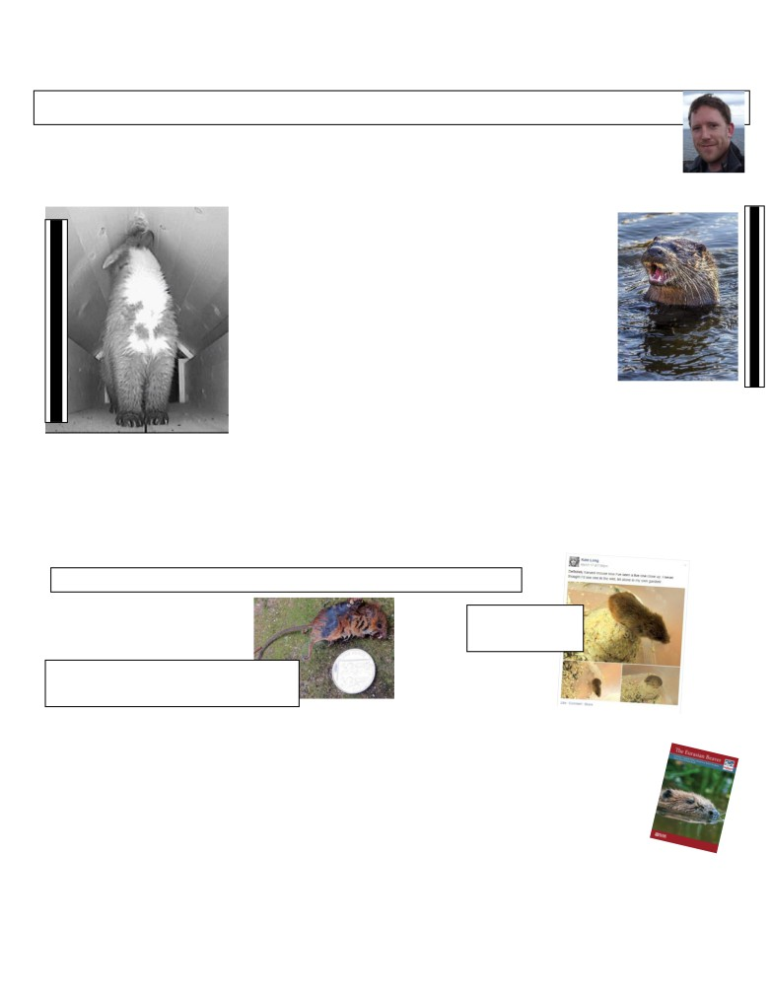

Shropshire Mammal Group Newsletter Issue 22 Spring 2015

Note from the Chair by Stuart Edmunds, SMG Chair
It was my intention to write an article all about my amazing close encounters with wild otters in Scotland
for this edition of our newsletter, but over the last few weeks, otters have become an increasingly regular
sight here in Shropshire. Driving 400 miles to experience the joy of seeing an otter hunting in the kelp now
seems extreme, when I could have perhaps just driven to Bridgnorth, where the local otters have been on show every morning.

But one thing I wouldn’t be able to replicate in Shropshire was the experiences I was fortunate to have with pine martens. Feeling that a research trip to Ardnamurchan was necessary, which would help me to test a few new marten recording techniques to use here, I set off on the long road north with camera traps and a homemade ‘mammal tunnel’ loaded into my car, to set up on my arrival on Scotland’s west coast. The aim was to attract a marten into the 4 feet long tunnel with some bait attached to the ceiling, allowing us to view individual marten bibs. And it was a great success, with 7 different pine martens visiting during 5 nights at a location where locals thought only 2 martens were present.

With the discovery of a pine marten being made in Cornwall last week [mid-March],
maybe I might be fortunate to attract a Shropshire marten into the mammal tunnel now. But I won’t get my hopes up too much!
But it isn’t the mustelids that should really be taking the limelight this month. Some other fascinating news came in from Whitchurch, just days ago of a pair of harvest mice being discovered by member Kate Long, in her birdseed container. The many books I have read and courses attended about harvest mice have taught me to look for harvest mice in fields, reeds and hedges for our smallest rodent, but not once were gardens or birdseed containers mentioned. Kate’s discovery just demonstrates how little we still know about our native mammals- one of the many reasons that so many of us in Shropshire are driven on to discover more.
Read more about Kate’s small mammal spotting on page 12. Ric

…or alive!
☺

Wanted…. Harvest mouse records, dead… ☹

(An extra note from the chair!) New book on Eurasian Beavers released into bookstores!
Beavers have made the press on a regular basis this year, with a pair even being found living just a
few miles over the border in Wales. After a 400 year absence from the UK due to overhunting, it looks like the return of the beaver is becoming widely accepted and to coincide with the increased interest, The Mammal Society has produced a new handbook The Eurasian Beaver and it is well worth a read. This book presents a case for our future coexistence with beavers by providing factual information and covering the biology, behaviour and ecology of the Eurasian beaver. There is an interesting section on beaver field signs, which when compared to other mammals, are quite hard to miss! The book is priced £9.99 and is available directly from The Mammal Society.

Follow us on Facebook at https://www.facebook.com/groups/shropshiremammalgroup/ We’re also on Twitter: @Shropsmammals
If you spot a mammal in Shropshire, please record it via bit.ly/SMGrecord or email Lorcán Adrain at SMGrecord@gmail.com Articles and photos for the next issue of the SMG Newsletter to Ric Morris, Editor, at ric_morris@hotmail.co.uk please
Ardnamurchan pine marten by Stuart Edmunds
Bridgnorth otter by Andrew Fusek Peters

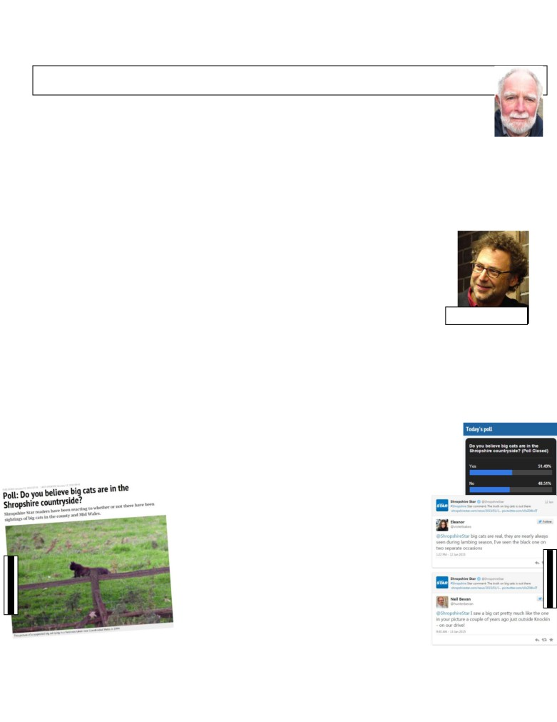

Shropshire Mammal Group Newsletter Issue 22 Spring 2015

Mysterious Mammals by Dr John Mackintosh

The mysterious mammals of the title are those that are not in any way odd or peculiar in their native habitat,
but are rather frequently reported in unexpected places. The type specimen is of course the ‘big cat’. According
to the Encyclopaedia of Mammals this is a group of seven species, lion, tiger, jaguar, cheetah and three sorts
of leopard. The remaining thirty species of cat are all ‘small cats’, which is a little confusing as pumas belong
to this group and they can be substantially bigger than a leopard. The best term is probably ‘large cat’ that could cover anything from European lynx size upwards. Encounters in this range seem to be fairly common as one website reports that the BBC claimed that there had been an astonishing 1000 UK sightings of large cats in a single year. Such sightings are or course controversial and it is very important to stress from the beginning that it is probable that only a very small minority are deliberately fabricated. Most people will have seen what they reported and much of the problem probably lies in the physiology of human vision and perception.

Most people believe that they have a pretty high resolution view of the world around them, but this is something of a delusion. In his book The Drunkard’s Walk: How Randomness Rules our Lives, the American physicist, author and screenwriter Leonard Mlodinow described the information leaving the retina for the brain as “a shaky, badly pixilated picture with a hole in it”. There is a high resolution bit, but it is about the size of your thumbnail at arm’s length. The picture seen is a software product. It is assembled in the brain from a series of images resulting from the scanning action of our eyes together with some input from memory. The result is usually very serviceable, but the use of information that is already known can lead to problems. There have been quite a few demonstrations that even uncomplicated things such as a series of readings from a thermometer can be biased if there is an expectation of

what the figures will show. In more complex processes such as species recognition both expectation and first impressions can produce a dramatic and lasting effect.
Leonard Mlodinow

I have experienced two very relevant incidents. The first was when we were living in a suburban situation and we had an agitated call from a neighbour who said that there was a big cat in a tree at the bottom of our garden and it might be dangerous. Naturally I went down the garden to look and there was a cat in the tree lying along a branch in leopard like pose. It was, though, our cat, definitely domestic in size if not entirely in appearance.
The second was a phone call received during my time as County Mammal Recorder reporting not a big cat but a gigantic squirrel more than a metre tall. Fortunately the animal was in sight during the call, on top of some hawthorn trees that were visible through the recorder’s kitchen window. When I asked how much the branches were bending there was an exclamation and the animal clearly shrank to normal size. This episode was particularly interesting as the illusion of exceptional size persisted for some time with the animal in sight and only went when the observer was given an extra point of reference. Both observers clearly ‘saw’ what they reported, but it does show that even in good viewing conditions, eyewitness testaments can be unreliable.

So are there any big cats living in the British countryside? There
have indeed been escapes or releases and a small number of large cats captured or shot, but there is a lack of other evidence. Large cats are substantial animals so remains should be found now and then. Their size means that they are heavy and much of the British countryside is soft so incontrovertible records of tracks should be available. The photographs that have been submitted have not been good, poor light and distance will not help, but there are a lot of cameras about. In this connection the Shropshire Star published a picture in January 2015 along with a poll testing belief in “big cats in the Shropshire countryside”. Taking into account the animal’s profile, camera angle and the apparent size of the vegetation it was sitting in, it looks like a perfectly ordinary mog. In spite of this 50% of the people that responded classed themselves as believers.

Follow us on Facebook at https://www.facebook.com/groups/shropshiremammalgroup/ We’re also on Twitter: @Shropsmammals
If you spot a mammal in Shropshire, please record it via bit.ly/SMGrecord or email Lorcán Adrain at SMGrecord@gmail.com Articles and photos for the next issue of the SMG Newsletter to Ric Morris, Editor, at ric_morris@hotmail.co.uk please
Shropshire Star
Shropshire Star

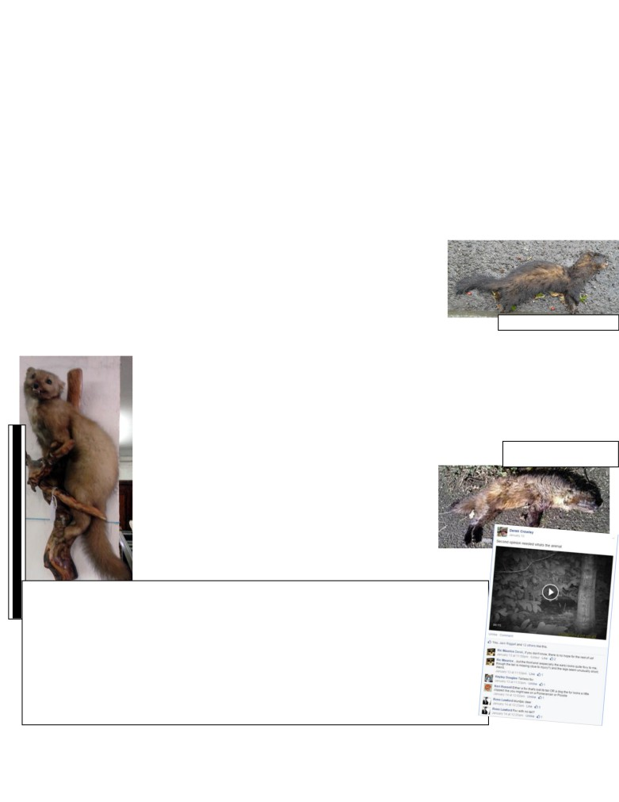

Shropshire Mammal Group Newsletter Issue 22 Spring 2015

The main reason that it is supposed that large cats are about is the discovery of partially eaten bodies of farm animals and investigations are being carried out to see if the source of the damage in a sample of these is likely to be a cat. This is bound to be difficult as predators are opportunistic in how they bring down their prey so that finding a taxon specific feature is not easy. The distance between the canine tooth punctures has been suggested as cats, size for size, have a broader bite than dogs. Breeds such as Bull Mastiff, however, are large and short faced, so must overlap for this criterion with most cats that might be found. Size of prey is not a help as wolves (moderate sized dogs) bring down caribou. The feature that might be more likely to be distinctive would be the nature and pattern of claw marks.

There is another odd feature about the reports; far too many of the animals are black. Although there are melanistic jaguars, serval and particularly leopards the vast majority of cats in the wild, large or small, are not black and the excess in reports may be more linked to mythology than to real animals.
Other mammals also make mysterious appearances well outside their known range. Both wildcat (Scottish) and red squirrel have been reported in Shropshire, again probably the result of some misperception together with an amount of misleading evidence. Large domestic tabbies can be difficult to separate from true wildcat and grey squirrels with quite a lot of reddish hair occur, although their tail usually gives them away.

More interesting is the pine marten which has been reported in Shropshire quite a few times and in this case there has been a great deal of skilled and dedicated investigation of the sites from which the reports have come to try and find supportive evidence. That this so far has been unsuccessful is perhaps not surprising as field signs are hard to find even in areas where there is a well-established pine marten population. However where
the evidence for the report was a dead animal that could be examined it was found to Road casualty polecat- Ric Morris
be that of a different species, mostly polecat. Indeed the last authenticated marten corpses in the
County were from individuals shot well over a century ago. It can also be argued that the distribution of the reports, scattered both in time and geography, are difficult to fit to any notion of a continuing population and the alternative suggestion that it might represent repeated migration from a Welsh source is also rather unlikely. The species, if not extinct in Wales, is thinly spread and such a population would not generate the pressures to stimulate migration. A marten road kill was found near Newtown and DNA evidence showed it to be a British animal unlike some other pine marten casualties that were found to be transatlantic in origin. Those animals must have been releases or escapees and so establishing the provenance of the Newtown animal is critical information. It might be resolved by stable isotope analysis, which is a technique that can

reveal the recent history of a corpse and even where it originated. It has, for example, shown archaeologists that some of the fallow deer remains found at Fishbourne Roman Palace came from an individual
born and bred at that site in the first century AD. I am not aware of any investigations of this sort on pine martens.

In summary it looks as though casual sightings, even in quite large numbers, are not reliable indicators of the presence of mammals and most exotics only occur accidentally and for short periods, but it is, of course, possible that the increasing use of trail cameras will show that these deductions are wrong.
John Mackintosh

Thought provoking stuff there, John- and to further illustrate his point, look no furthe than Derek Crawley’s post to the Mammal Society’s Facebook page on January 13 this year, when he asked for a second opinion on a piece of camera trap footage. Opinion ranged from fox (without tail), one of various obscure dog breeds, muntjac, Chinese water deer, sheep, tongue-in-cheek mythical beast… much good-humoured debate and over eighty comments during a period of almost three weeks. And that discussion wa all over peoples’ perceptions of what had been ‘impartially’ captured by a camera trap We see what we want to see… or what we think we want to see… Oh- and (as suggested in the second ever comment) it was a tailless fox, and Hayley Douglas agreed (Editor smugly breathes on fingernails, rubs on lapel). A tailless fox, eh? Allegedly… Unless you think differently? Hmmmm… John??
Ric.
Follow us on Facebook at https://www.facebook.com/groups/shropshiremammalgroup/ We’re also on Twitter: @Shropsmammals
The Newtown area road casualty pine marten- Olly Amy

If you spot a mammal in Shropshire, please record it via bit.ly/SMGrecord or email Lorcán Adrain at SMGrecord@gmail.com Articles and photos for the next issue of the SMG Newsletter to Ric Morris, Editor, at ric_morris@hotmail.co.uk please
Taxidermy pine marten in a Church Stretton antique shop- Ric Morris

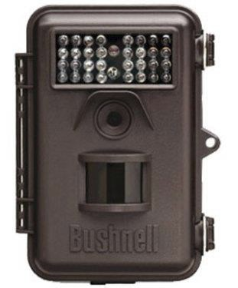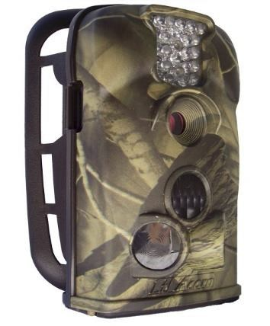

Shropshire Mammal Group Newsletter Issue 22 Spring 2015

Camera Traps- Which one should I buy? by Stuart Edmunds

I have been using camera traps for a number of years now. Inspired to buy my first by the BBC
documentary Lost Land of the Tiger in 2009, where camera traps gave a tantalising glimpse of previously
unseen tigers in Bhutan, I have since spent a good chunk of my hard earned cash on an ever-improving
range of camera trap technology. Back in 2009, the range was limited and Bushnell always came out on top in online reviews (they were also the manufacturer of choice in the above documentary). Other manufacturers such as Spypoint and Hawke had been producing camera trap technology for years before, but many of them were the size of a microwave and difficult to deploy discreetly. It was a Bushnell Trophy Cam 119425 that I opted for to get my adventure into the world of camera trapping (or trail-camming) off to a start.

In comparison, in 2014 around 30 new models of camera trap were released on the market by several different
manufacturers. In the UK, the most popular makes are Spypoint, Bushnell, Acorn and Stealth Cam, whereas the US market includes Moultrie, Reconyx, Primos and Browning. It is fair to say that the market is becoming saturated with options and for those people wanting to buy their own camera trap, the choice is becoming increasingly difficult to make on which model is best. As a guide, I have listed the manufacturers and models that I have used over the last few years below with some pros, cons and recommendations.

Bushnell Trophy Cam 119425c (now 119436)
No longer produced but available occasionally on Ebay for £50-£80.

Durability: This Bushnell was my first and is still fully functional after 5 years of use. Battery life: Takes 8xAA batteries and records around 100 hours of footage on one set.
Trigger: Motion sensor covers and 45 degree area and triggers in 1 second. Sensitive to any movement, so prone to false triggers but detects movement over 40ft away.
Quality: Photos are 3mp and video resolution is standard. No option to control LED brightness, so over exposure is common.
My view: Reliable, good on batteries and perfectly usable quality of footage. The updated version is 119436.
________________________________________________________________________
Acorn Ltl 5210A
Price: £90-£105.00

Durability: Plastic hinges are prone to snapping, but despite numerous bumps, the device still works perfectly.

Battery life: Takes 8xAA batteries and records around 50 hours of footage on one set.
Trigger: Very reliable and less prone to false triggers than the above Bushnell model. Triggered by movement up to 20ft away.
Quality: Daytime film quality is low resolution but night time footage is comparable to the Trophy Cam.

My view: The best cheaper model. Although the quality isn’t of BBC standard, it is perfectly adequate for basic
mammal monitoring. The Maginon trail cam, which is available from Aldi is produced using the same specifications and is a worthwhile contender.

Follow us on Facebook at https://www.facebook.com/groups/shropshiremammalgroup/ We’re also on Twitter: @Shropsmammals
If you spot a mammal in Shropshire, please record it via bit.ly/SMGrecord or email Lorcán Adrain at SMGrecord@gmail.com Articles and photos for the next issue of the SMG Newsletter to Ric Morris, Editor, at ric_morris@hotmail.co.uk please

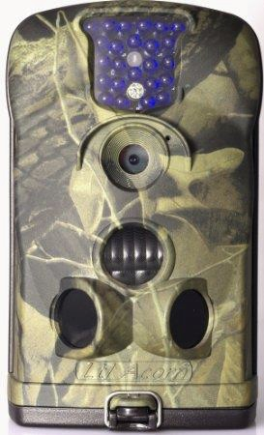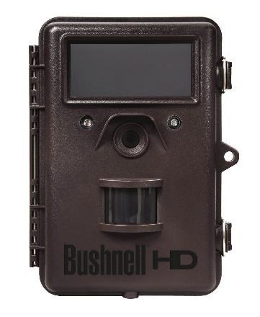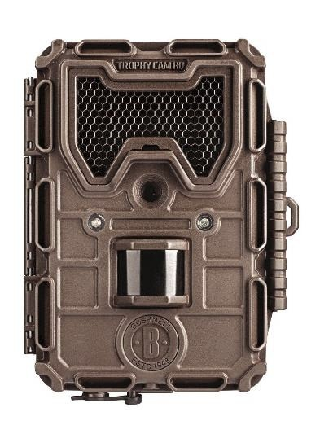

Shropshire Mammal Group Newsletter Issue 22 Spring 2015

Acorn 6210MC 940nm
This HD model is an upgrade on the 5210A, with no-glow infra-red and the addition of a
fold-down screen which can be viewed from the front when the camera has been installed. This makes positioning and testing much easier.

Price: £130-£150

Durability: Extremely durable and very weatherproof; mine has also survived submergence in a flooded brook!

Trigger: Trigger is 1 second at a distance of 30ft.

Batteries: Takes 8x AA and runs for the same time as the 5210A.
Quality: Daytime video is HD standard, but the no-glow LEDs have reduced the quality of night time footage and photographs, which are grainy.

My view: This was my first camera trap with the option of altering LED brightness, but the
quality is actually poor in comparison to the cheaper 5210A.
_______________________________________________________________________________________________

Bushnell Trophy Cam HD 2012
The first of the Bushnells to utilise no-glow technology in the UK market, there are two versions; one with a colour LCD viewer and the other with an analogue viewer.

Price: Was £270 at time of release.

Trigger: 0.7 seconds from 45ft.

Batteries: 12x AA which record over 150 hours of video.

Quality: The no-glow technology on the 2012 model is basically a darkened Perspex screen over the LED panel, which hides the glow without affecting night time quality. Daytime film is very clear.

My view: The HD 2012 is again prone to false triggers and despite the high quality of
footage when the subject is from 3m-5m, all close ups are over-exposed even with the LED control set to low. Because of this, care must be taken to make sure the camera is deployed at least 2m from the trail to be monitored. _______________________________________________________________________________________________
Bushnell 119677
An update on the 119425, with redesigned housing and camouflage, plus added control over LED brightness.
Price: Depending on supplier, expect to pay between £150 and £230 (eBay prices). Trigger: Claimed to have a ‘faster triggering speed of 0.2 sec’. Batteries: 4-8 AA batteries: minimum of 4 required for operation. Quality: 5 megapixels interpolated to 8 MP
My view: I am still testing mine, but there still appears to be an issue with over exposure on subjects closer than 2m.

Follow us on Facebook at https://www.facebook.com/groups/shropshiremammalgroup/ We’re also on Twitter: @Shropsmammals
If you spot a mammal in Shropshire, please record it via bit.ly/SMGrecord or email Lorcán Adrain at SMGrecord@gmail.com Articles and photos for the next issue of the SMG Newsletter to Ric Morris, Editor, at ric_morris@hotmail.co.uk please

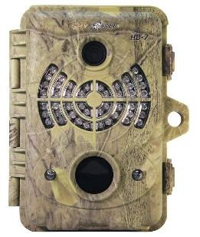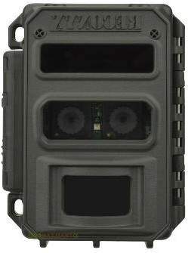

Shropshire Mammal Group Newsletter Issue 22 Spring 2015

Other models used:

Spypoint HD7

Pros: Easy to set up with a useful “distance dial”, to control LED brightness, the HD7 produces the clearest footage of any of the other camera traps I have used around the same price (£200).

Cons: The lowest sensitivity I have used on camera traps due to the limited angle of the
PIR motion sensor. This model requires a subject to pass directly in front in order to trigger, so I often find that they have failed to trigger when there is clear evidence of activity directly in front. Would recommend this model for use on larger mammals.

_______________________________________________________________________________________________

Reconyx Ultrafire

Pros: Amazing quality photos and video, with clearest night time quality of all models tested. Very reliable trigger speed and two lenses; one daylight, one infrared which means there is no need for a moving filter to click when the camera is triggered at night. The Ultrafire also automatically adjusts exposure depending on the proximity of the subject.

Cons: The supplied bungee strap for attaching the camera to trees is awkward to use and the cost of £476 makes this model inaccessible to most wildlife watchers.

Membership Matters! by Malcolm Monie, Membership Secretary

A big thank you to the 64 individuals and groups who have joined or renewed for 2015. There are however,
at the time of writing, still 46 of last year's members who have not yet renewed their Shropshire Mammal
Group subscription for 2015. We hope that you will decide to rejoin. The easiest way to do so is to go to the JOIN page on the group's website: http://shropshiremammalgroup.com/join-2/ where you will be given the option of paying by cheque, internet banking or BACS transfer, or by setting up a direct debit using GoCardless. Renewal was due in January for anyone who joined before 1st October last year. If renewal is not made by 31st March I'm afraid we will have to remove those members from the current membership list which will mean, amongst other things that you will not receive your wonderful newsletters!*

Up until now, all membership renewals have been due in January. From now on, new members will renew on the
anniversary of joining. This is to accommodate to considerable number of dual memberships with the Mammal Society. These now number 24!

*Editor’s note: As far as is known, rumours of a thriving grey market trade in counterfeit and bootleg copies of the SMG Newsletter are entirely without foundation. That is mainly because I have just made the rumour up.

Follow us on Facebook at https://www.facebook.com/groups/shropshiremammalgroup/ We’re also on Twitter: @Shropsmammals
If you spot a mammal in Shropshire, please record it via bit.ly/SMGrecord or email Lorcán Adrain at SMGrecord@gmail.com Articles and photos for the next issue of the SMG Newsletter to Ric Morris, Editor, at ric_morris@hotmail.co.uk please

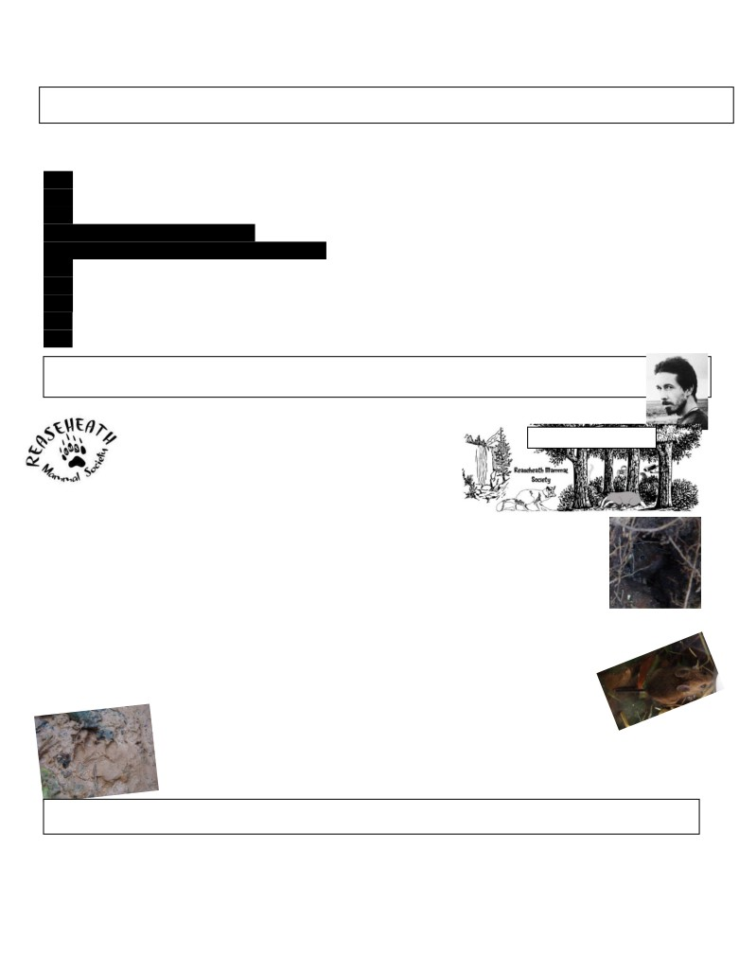

Shropshire Mammal Group Newsletter Issue 22 Spring 2015

Corporate Members of Shropshire Mammal Group

Shropshire Mammal Group is grateful to its corporate members for their support.
Field Studies Council - Preston Montford Field Centre
Pearce Environment Ltd
Whitchurch Community Water Vole Project
- Ellesmere Branch

Shropshire Bat Group Ricoh Ltd
Meres and Mosses Landscape Partnership Scheme The National Trust (Shropshire Hills)
The British Hedgehog Preservation Society
Starting a College Mammal Society by Jack Riggall

In 2014, staff and students at Reaseheath College, Cheshire, collaborated to establish Reaseheath Mammal Society. The primary focus of the
group is to improve the mammal recording effort Facebook page banner
around campus. Due to the variety of courses offered at the college there is equipment available for a range of ecological surveys, such as trail cameras, Longworth
traps and bat detectors (alongside good old fashioned
tracking!). All occurrences (be it sightings, footprints or faeces) are
logged with the environmental record centre for Cheshire, rECOrd. This data can be used to boost knowledge through publications; distribution maps of species to promote recording have been created. The society aims to also provide better recognition of the value of the site as Biodiversity Action Plan (BAP) mammals such as brown hares, otters & polecats are now confirmed as present. A key part of this is the resulting benefit to both wildlife and local knowledge from what we do in the field as opposed to classroom based conservation. Other sightings such as hedgehogs were additionally logged with Hedgehog Street’s Hibernation Survey.

So in addition to recording, what can the creation of a group like this do for students? Well, it provides a platform for students to share information on local groups and events and getting to know the natural history of the area. Some RMS members joined local badger & mammal groups as well as accompanying freelance ecologists on surveys elsewhere in the county. It is also an opportunity for joining the wider conservation & recording community and building contacts. Finding and understanding field signs left by mammals create connections to the natural world that books
often fail to do; though of course studying mammal ecology texts is also
crucial. Finally, it also helps to develop organisational and social media skills.
Photos from our surveys and trailcam footage we obtained were regularly
shared on the Facebook page as is the promotion of mammal conservation campaigns, events and news from the local area and as well as from around the world. It really is something that I’d recommend all students of countryside colleges to get involved in, and record as much as possible!

A version of this article also appeared in Mammal News, Spring 2015. As Jack’s leaving Reaseheath shortly, he’s
now handed over admin of the Facebook page and log in details for the rECOrd account and website to Tom Wright.

Follow us on Facebook at https://www.facebook.com/groups/shropshiremammalgroup/ We’re also on Twitter: @Shropsmammals
If you spot a mammal in Shropshire, please record it via bit.ly/SMGrecord or email Lorcán Adrain at SMGrecord@gmail.com Articles and photos for the next issue of the SMG Newsletter to Ric Morris, Editor, at ric_morris@hotmail.co.uk please

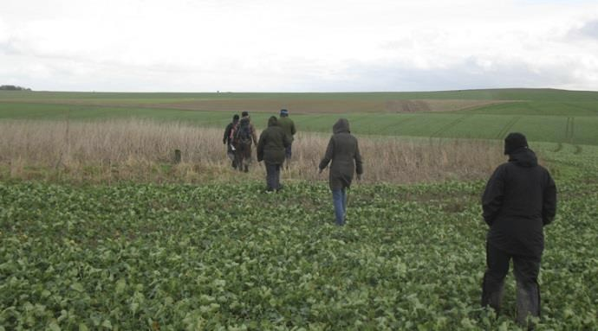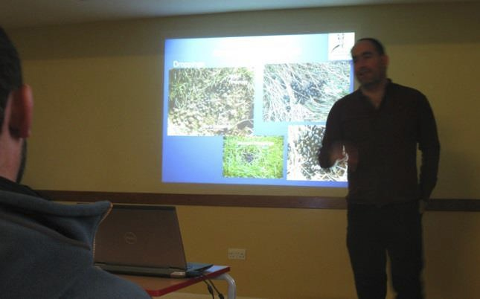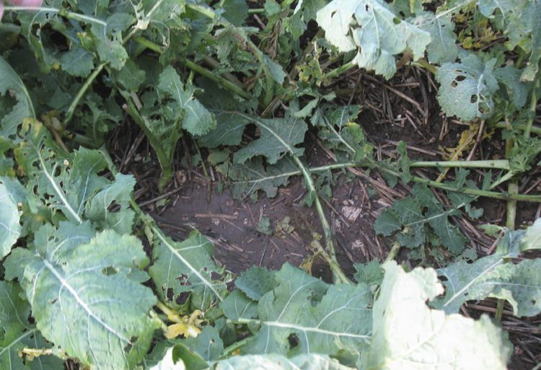

Shropshire Mammal Group Newsletter Issue 22 Spring 2015

A Hare Raising Day of Learning! Words & photos by Andrew Barrett

Wiltshire Brown Hare Survey Day: 10th January 2015, 10am to 2pm
There are many great opportunities for learning new skills in this world for all us mammal lovers. Groups and societies filled with knowledgeable people who
run workshops are a great opportunity to get out, meet new people and learn new skills. I was lucky enough to find this event, local to me, during the Christmas break. The Wiltshire Mammal Group ran a Brown Hare (Lepus europaeus) survey workshop, which fell on a cold and very windy January day.

The day began with a presentation by Mark Satinet about the ecology of hare, ID skills and signs to look for when looking for them. He also showed us other signs that might potentially get confused with hare, such as deer and sheep faeces.
We split into two groups for the afternoon, one group with Mark and the other (my group) with Gareth Harris and Lisa Wade, both regular surveyors who
have worked a lot with the Wiltshire Mammal Group. Mark Satinet giving his talk on the hare’s
The survey was to take place on two adjoining grid ecology and survey. Yes, that is poo on
squares on the Wiltshire Downs. the screen.

Landowners’ permission is important to have for this survey!

Hares are largely nocturnal animals and during the day will lie up in a form. A form is a shallow depression which looks like the mark made if you kneel in the mud. The hare lie in this so their eyes remain above earth, and they have a near 360 degree vision so will spot any predator approaching.

A hare’s layup, or form, well hidden in the crop- still warm!

Follow us on Facebook at https://www.facebook.com/groups/shropshiremammalgroup/ We’re also on Twitter: @Shropsmammals
If you spot a mammal in Shropshire, please record it via bit.ly/SMGrecord or email Lorcán Adrain at SMGrecord@gmail.com Articles and photos for the next issue of the SMG Newsletter to Ric Morris, Editor, at ric_morris@hotmail.co.uk please

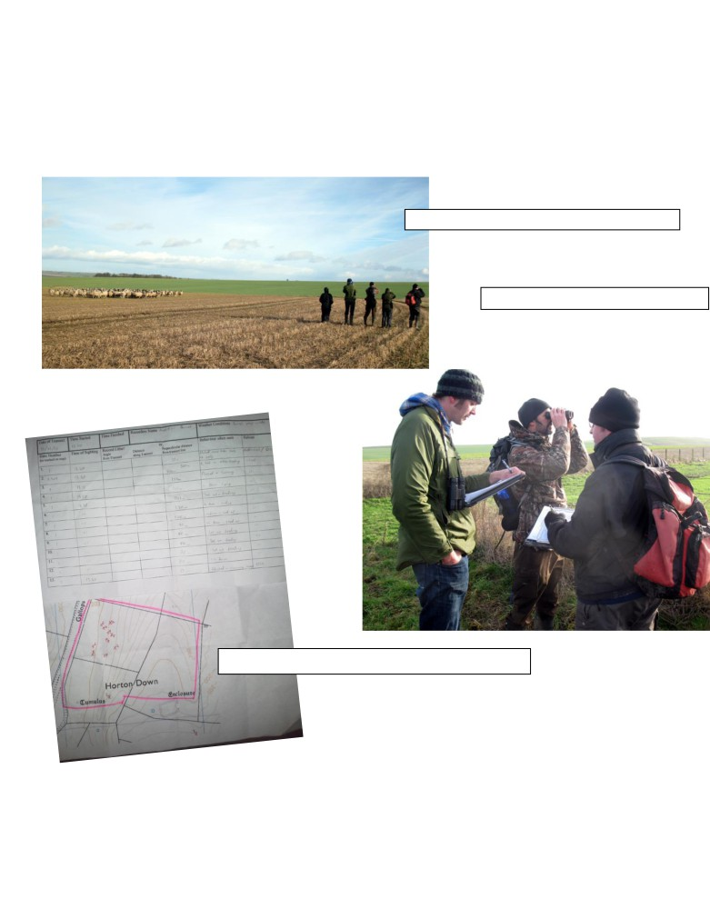

Shropshire Mammal Group Newsletter Issue 22 Spring 2015

Shortly after starting the survey walk we disturbed a hare only a few feet away, which got up and took off up the hill; the speed was marvelous and very exciting. This was our first hare of the day, and we were able to find the form from which it had sprung. Throughout the survey we saw a total of 13 hares, most of them laid up on the south facing slope catching the sun but out of the wind and which could only be viewed from across the valley, with binoculars. We also saw two groups of roe deer and a wide variety of birds. We finished the day gathered together in the farm yard comparing notes. Everyone had seen hares and had all enjoyed the day. Simon Smart is co-ordinating activities and getting landowners’ permission so we can do further surveys.

Some animals we just don't need to use binos to see!

(Below) Gareth Harris, Simon Smart & Andy Davis

A total of 13 hares spotted, recorded and sent to the atlas.

This link is to the Wiltshire Mammal Group page with a PDF of instructions on how to conduct a hare survey.
http://wiltshiremammals.wordpress.com/publications/brown-hare-surveys/

Follow us on Facebook at https://www.facebook.com/groups/shropshiremammalgroup/ We’re also on Twitter: @Shropsmammals
If you spot a mammal in Shropshire, please record it via bit.ly/SMGrecord or email Lorcán Adrain at SMGrecord@gmail.com Articles and photos for the next issue of the SMG Newsletter to Ric Morris, Editor, at ric_morris@hotmail.co.uk please

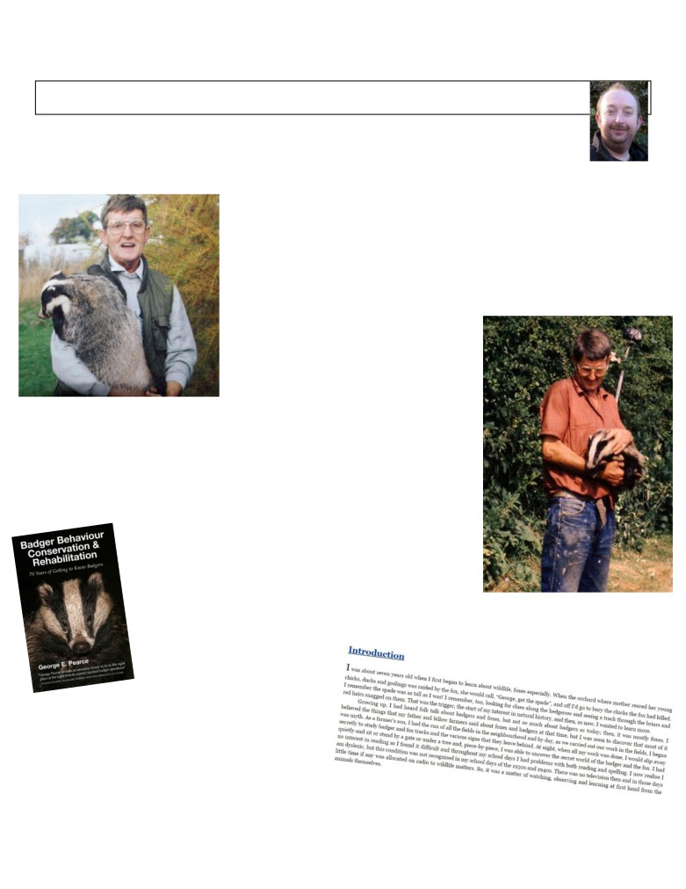

Shropshire Mammal Group Newsletter Issue 22 Spring 2015

George E. Pearce- ‘The Badger Man’ 1932-2015 by Tris Pearce

George was born and brought up on a Shropshire mixed livestock farm. He always had a keen interest in wildlife and particularly mammals, he was seven years old when he started studying wildlife. He had to keep his interest in wildlife a secret as the majority of the people where he lived opposed wildlife. When he heard them talking about badgers and foxes he believed what they said at first until George discovered from watching wildlife himself, that that most of it was untrue.

He spent a lifetime studying animal behaviour. He spent the first 60 years of his life in farming, first in cattle, then pigs, but in 1991 he changed direction and made his life time hobby of studying wildlife an occupation and became one of the first badger consultants, this coincided with increased legal protection of badgers, which was needed due to the horrendous cruelty the animals were subjected to.

A decade earlier he set up a wildlife rehabilitation centre at the farm, working closely with the RSPCA rehabilitating injured and orphaned wildlife. All sorts came through the door, from a sparrow to a buzzard, a mouse to a badger. George and his family released over 60 foxes and 100 badgers during
this time and many other mustelids. Many bird species including owls and birds of prey were also cared for. He always felt very privileged to have worked so closely to so many different animals.

George has been a proud member of the Mammal Society for over 50 years, he helped to set up the Shropshire Badger Group in the 1980s and was a speaker on many occasions giving illustrated talks around the UK. He was an expert witness for the police and RSPCA and was considered to be one of the leading badger experts in the country.

He had a book published, something he was very proud of: Badger Behaviour, Conservation & Rehabilitation. 70 years of Getting to Know Badgers. He always felt pleasure from being able to pass on knowledge. Sadly he did not have time to complete his second and third books which he was writing with his daughter Pam.

George passed away on 24th February and leaves his wife Cris, daughters Julia and Pam, son Tris, as well as grandchildren and great-grandchildren. Every sympathy to the family in their loss.

George’s book is
available from Amazon and other retailers in print and e-book
versions. You can preview a few pages on Amazon here, via the ‘Look Inside’ facility. It has a 4.7 out of 5 star readers’ rating, with 14 five star reviews.

Follow us on Facebook at https://www.facebook.com/groups/shropshiremammalgroup/ We’re also on Twitter: @Shropsmammals
If you spot a mammal in Shropshire, please record it via bit.ly/SMGrecord or email Lorcán Adrain at SMGrecord@gmail.com Articles and photos for the next issue of the SMG Newsletter to Ric Morris, Editor, at ric_morris@hotmail.co.uk please



Shropshire Mammal Group Newsletter Issue 22 Spring 2015

Mammal Eyewitness! Mammal encounter stories by various authors

Sometimes a mammal encounter can take place unexpectedly and out-of-the-blue, as with Andy Bishop’s once-in-a-lifetime sighting of a hunting stoat. But as Kate Long describes, you can make your own luck too.
To set the scene for Andy’s story first… He’s a friend and former colleague who had first-hand experience of my mammal and bones enthusiasm during the years we worked together at the Shirehall. He was witness to the infamous ‘Dead Mole in the Filing Cabinet Incident’ (the second of two ‘dead mole incidents’ for which I became notorious) and he also once had polecats nesting under his shed.
I received a text message from him on 31st January 2015 with the bare bones of this story, but due to intermittent poor mobile reception (yeah, thanks, EE!) I wasn’t able to make a proper phone conversation to enjoy the full details until an email arrived a couple of days later…
Cheshire Stoat Encounter! by Andy Bishop

Good morning Richard, Further to the brief conversation on Saturday, here are the facts: Joseph, Harriet and I were at Beeston Castle, the lower part near where the (rather
disappointing) caves are. Walking beyond the caves on the path parallel to the perimeter wall we came across a rabbit that looked to have a problem with its leg, it was limping and was not capable of getting away from us as we walked towards it. We stopped and marvelled at the rabbit for a brief while (making sure that Harriet’s attempts to stroke it were firmly but politely addressed - “Don’t touch it, it’s probably got fleas!”) I heard a rustling in the bracken, but put this down to being the family of the rabbit rather than anything more sinister…
We continued our walk for a couple of minutes, but upon realisation that there was nothing of any interest, we turned about face and made back to the castle (“Can we go to the shop, please, please, please?” - you get the picture) As we walked we saw the rabbit once again, this time on the opposite side of the path, looking a bit more worse for wear. When we walked past it, there was clearly blood on its face. Sensing something amiss, we walked on, but just by chance I turned to look at the rabbit one last time and saw a stoat run across the path.
Years of working with you kicked in and I advised the children to be silent as nature in all its savage beauty was about to be played out in front of our eyes. About a minute later, the stoat emerged from the bracken and leapt on the rabbit, twisting all over it, it dragged it by the neck into the undergrowth, we heard a reasonably loud “squeak” (not sure from which creature) then we left - Joseph was a bit upset.

As this was not in Shropshire, I did not bother with the grid reference! Hope all is well
From Andy’s description I reckon SJ 538 591 is probably close enough!

Taking Refuge Words and photos by Kate Long

Early Spring is always an anxious time for the dedicated water vole fan. Each year, some colonies come back as strongly as ever, some might disappear, while others decide to shift themselves along the water course and pop up where you didn’t expect them.
I’m currently watching the banks of the stream for Pringles-tube-sized burrows and starry paw prints, which mean at least some voles have emerged. Any day now, that ought to be. Then, when latrines and piles of feed start to show, I can set up my fishing stool and wait with my camera to get the first shots.
But how to get my small mammal-fix in the meantime? Glimpses of wood mice exiting guiltily as I open the bird food bin are all I’ve had for months now. The hedgehogs aren’t awake, and even the garden rat seems to have packed up and left. And it’s still too cold to leave out Longworth traps overnight. Which means, I if I want to photograph mice, voles and shrews, there’s only one place I can go. So I take myself to a tatty old bit of brownfield on the edge of town. I discovered the site a few years ago when I was taking part in the Big Butterfly Count, and it seethes with wildlife. Best of all, someone has put down corrugated tin refugia at regular intervals around the edge, near the tall grass.
Follow us on Facebook at https://www.facebook.com/groups/shropshiremammalgroup/ We’re also on Twitter: @Shropsmammals
If you spot a mammal in Shropshire, please record it via bit.ly/SMGrecord or email Lorcán Adrain at SMGrecord@gmail.com Articles and photos for the next issue of the SMG Newsletter to Ric Morris, Editor, at ric_morris@hotmail.co.uk please

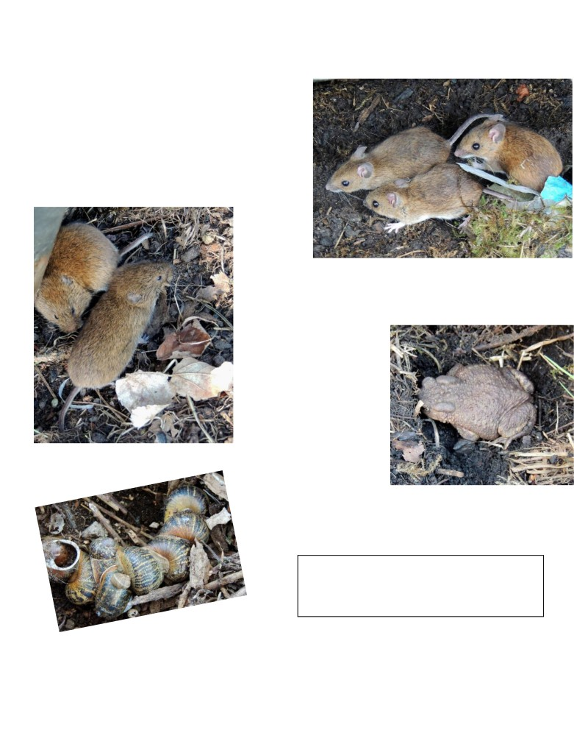

Shropshire Mammal Group Newsletter Issue 22 Spring 2015

Post-winter, some of the sheets are hard to find as they’ve
become overgrown with brambles. Before I touch any refugia, I have my camera primed, with the lens cap velcroed to the underside to stop it swinging into my downwards-pointing shot.

Cautiously I lift up the first. Three glossy adult wood mice with long, long tails are sitting together in the middle of the square. They’ve landscaped the area with their runs and nest material, and made it pretty cosy. For maybe twenty seconds we eye each other, and I take several snaps before they slip back down into their burrows. I lower the tin carefully and move on.

Under the
next sheet, a couple of field voles nestle in a similar sort
of set up. Despite the skittish nature of the species, this pair makes no attempt to flee. I get a good, close look at their short tails, their blunt noses and half-hidden ears. Often the fur of field voles appears greyish, but these are more of a nut brown. On such brief acquaintance, it’s only the tail length that makes me certain of ID.

Most of the refugia are home
only to ants or centipedes or
hibernating snails, but the
penultimate one today harbours a toad, who’s too cold even to twitch a leg. I let him be, and go to the last sheet.

And crikey, what’s that tiny,
pointy-nosed blur which dashes out? It’s a common shrew, keen not to be photographed thank
you, because he’s on an urgent mission to catch more food.
I go home feeling revived. It’s been a good haul of sightings, and a boost during these cool, bare days. I
shan’t be disturbing these
little beasts now for months, but I might go again mid-summer and see how they are getting on, and then again perhaps in the autumn.
In the meantime, it’s back to the stream to wait for my water voles. They shouldn’t be too long now.
Kate Long is a Whitchurch-based novelist.
http://www.katelongbooks.com/

She blogs about water voles and other wildlife in
About a Brook. http://staggsbrook.blogspot.co.uk/

Follow us on Facebook at https://www.facebook.com/groups/shropshiremammalgroup/ We’re also on Twitter: @Shropsmammals
If you spot a mammal in Shropshire, please record it via bit.ly/SMGrecord or email Lorcán Adrain at SMGrecord@gmail.com Articles and photos for the next issue of the SMG Newsletter to Ric Morris, Editor, at ric_morris@hotmail.co.uk please

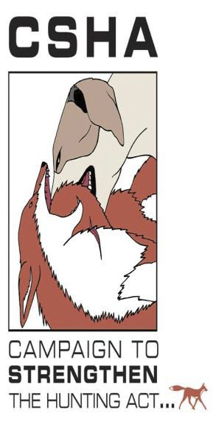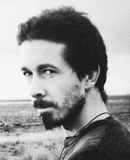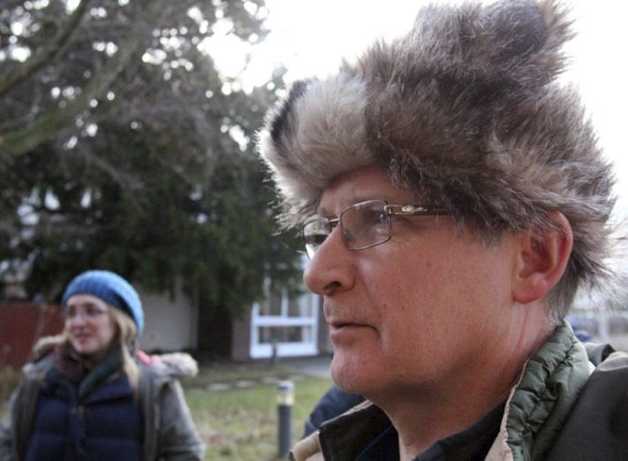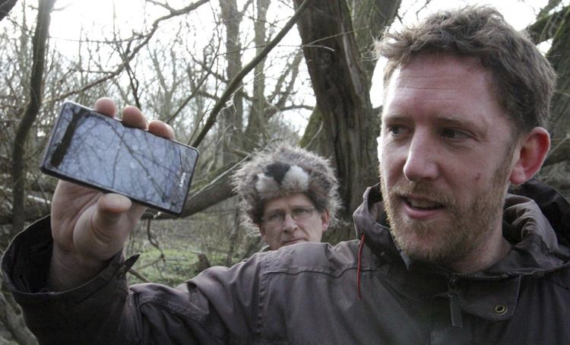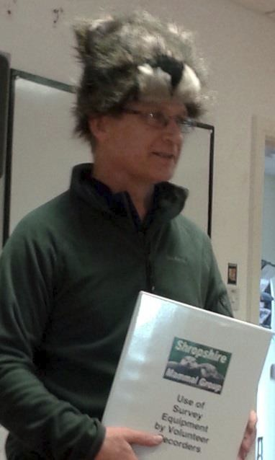

Shropshire Mammal Group Newsletter Issue 22 Spring 2015

Wildlife Crime… the ‘promotion of persecution?’
A personal view by Jack Riggall

It’s been a while since I’ve been to Shropshire to see the River Kings- the famous English Bridge otters, but I thought I’d treat Ric’s latest invite to write a few words for this issue of the Newsletter as an opportunity to comment a little on badger crime, as wildlife crime has been playing on my mind for some time. We all know about the badger cull, in my opinion, a failure on its own terms, but the hidden impact of this is a promotion of persecution - and not just for badgers. The potential for this was noted in a risk register published by DEFRA in 2010 years before the cull began, under the heading of a ‘long-term post project risk’ with a high likelihood (where high is defined as significantly greater than a 50:50 chance). This likelihood has since become reality as there were 198 incidents of badger crime in 2010 which more than tripled in 2013 (697 including 150 counts of badger baiting) according to The Badger Trust’s reports, so I dread to think how 2014 fared. An article I read earlier this year in the Gloucester Citizen dated 30/12/2014 quoted a former city councillor as he called for a cull of ‘seagulls’ because DEFRA had also culled badgers. The reasoning here is appalling and for me, this serves as a warning for those who care, demonstrating that they need to be more vocal about protecting wildlife and make compassion a keystone of conservation, so that intolerance can be, ironically, stamped out. I am perhaps preaching to the converted in this newsletter but I believe we can all help to do this by supporting or volunteering with the many organisations that combat wildlife crime - RSPCA, RSPB, Black Fish, Badger Trust, Hunt Saboteurs Association or The Campaign to Strengthen the Hunting Act (CSHA).
Photos from Hide’n’Squeak 7th February 2015 by Ric Morris

I absolutely could not resist taking this photo on my phone as Martin
Noble delivered the day’s first presentation on use of survey equipment by volunteers. He donned this remarkable headgear and the conversation went downhill from there…
Martin: Now what is this mammal on my hat? Sara Pearce (confidently): OTTER!
Martin (thoroughly affronted): No! It’s a FIELD VOLE!

I knew straightaway that the image was
eminently tweetable, and I’m afraid I gave in to temptation. Little did we know that he would be wearing it most of the morning and in fact it was rather difficult to get him to take it off…

Stu demonstrates a
clip on his phone while Martin Field-Voble looks on.

Follow us on Facebook at https://www.facebook.com/groups/shropshiremammalgroup/ We’re also on Twitter: @Shropsmammals
If you spot a mammal in Shropshire, please record it via bit.ly/SMGrecord or email Lorcán Adrain at SMGrecord@gmail.com Articles and photos for the next issue of the SMG Newsletter to Ric Morris, Editor, at ric_morris@hotmail.co.uk please

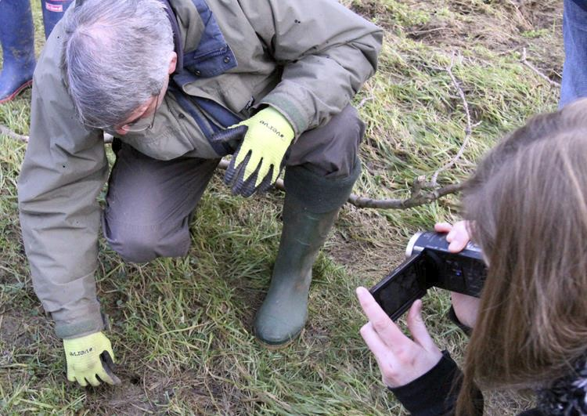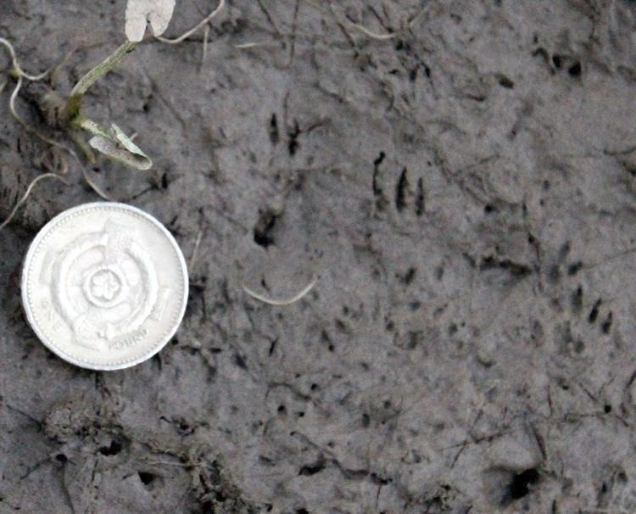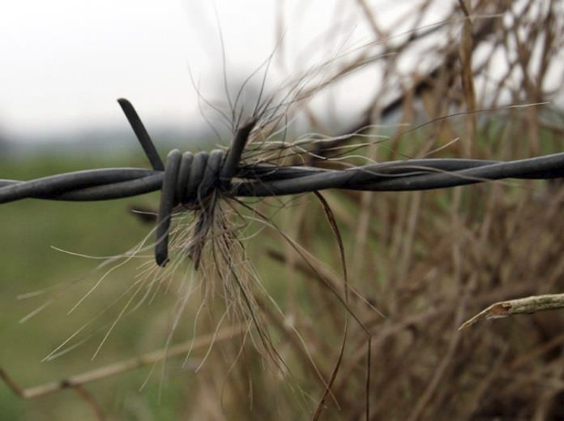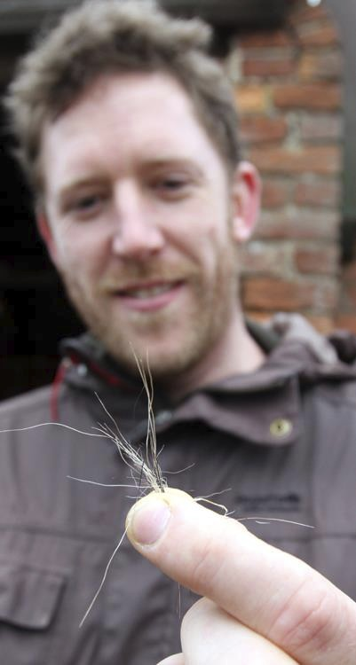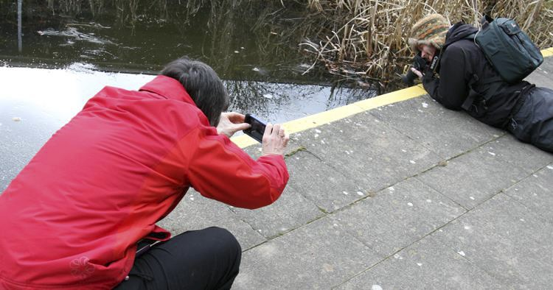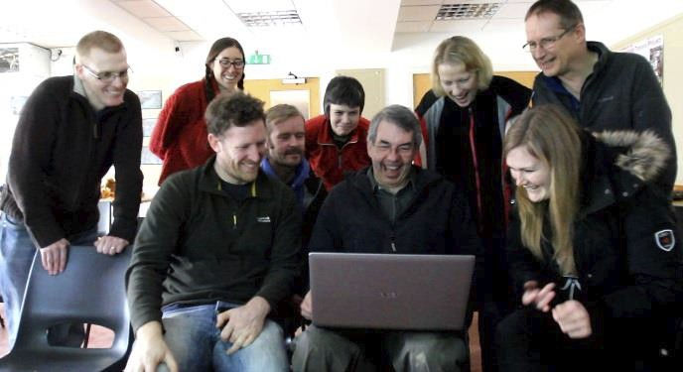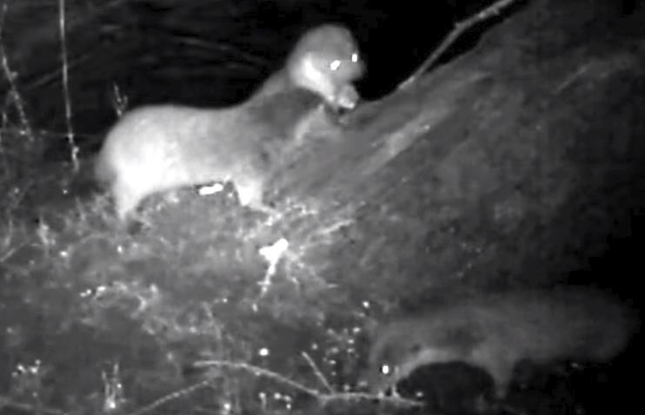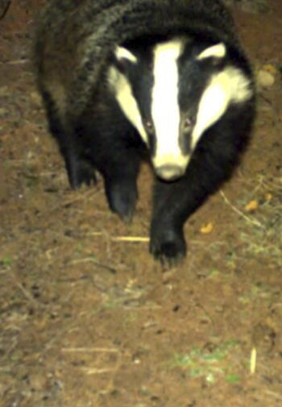

Shropshire Mammal Group Newsletter Issue 22

Alice Campion films Paul Wright as he investigates small mammal signs
outside a tiny hole.

Squirrel tracks from the Severn mud,
found when we retrieved the camera traps.

Andrew ‘Walkabout Lad’ Cutts takes a moment for some waterside
macro photography while Julie Burroughs sees the comic side of the image

Spring 2015

Badger hair caught on a fence at the back of Preston Montford.

Sheer delight on everyone’s faces as we see what is on the
camera traps!

Ladies and Gentlemen of the
Shropshire Mammal
Group… may we present not one, not two but
THREE otters on the
camera trap… THANK YOU so much,
Heritage Lottery Fund!

Stuart can
breathe much more easily now he’s
plucked those pesky hairs
from his nose.

“Where’s my hairs,
Edmunds?
Grrr…”

Follow us on Facebook at https://www.facebook.com/groups/shropshiremammalgroup/ We’re also on Twitter: @Shropsmammals
If you spot a mammal in Shropshire, please record it via bit.ly/SMGrecord or email Lorcán Adrain at SMGrecord@gmail.com Articles and photos for the next issue of the SMG Newsletter to Ric Morris, Editor, at ric_morris@hotmail.co.uk please



Shropshire Mammal Group Newsletter Issue 22 Spring 2015

A Talk with Gordon Buchanan by Andrew Barrett
On Tuesday 3rd March 2015 Mr Gordon Buchanan came to The Place, Telford, to give a talk entitled Gordon Buchanan - Lost Adventures
Gordon walked on stage and opened up some pictures he has taken over the years, wolves, bears with cubs, iridescent insects and breathtaking wild places. These pictures are beautiful, not only great quality but the subjects were outstanding. I’ll start by holding my hands up and admitting, yeah I’m jealous, what fabulous places he has been and things he has seen!
The talk was Gordon looking back through some of his trips, talking about his experiences and highlights and some of the behind the scenes; difficulties faced when filming wildlife.
We all know how difficult it can be to protect an area of countryside from development or industry, this is true from a new housing development in the village; to mass de-forestation for agriculture. Gordon has used his work through the Eden.tv to go to the Borneo Rainforest to try and protect the area. The Borneo Rainforest is being torn up to make way for palm oil plantations; this makes a monoculture habitat and is horrid for the eco-systems in the rainforest. So Gordon and a team which included a number of ecological experts and scientists went to the part of the rainforest not yet damaged to see what they could find. Make a record of the species that would be lost if the deforestation continued. They wanted to present their finding to the Borneo government to try and get protection for the rainforest. Which is exactly what they did, they showed how diverse the rainforest was and what damage the palm oil plantation was doing, though Gordon didn’t give any stats like species numbers. However as a result of their work a section of the Borneo rainforest now has legal protection from industry!

Gordon stopped the talk briefly here with a message for us all: Palm oil is devastating and it is used in everything.

If we took nothing else away from his talk he encouraged
“Look at the foods you buy, avoid palm oil!”

everyone in the room to avoid palm oil, even if it meant giving up your favourite biscuit until they remove that ingredient.
But as well as going to far reaches of the world well beyond where Western culture reaches, he loves filming here at home in the UK. His work in wildlife filming started when he was a young lad in Scotland, Nick Gordon the husband of his boss at the kitchen where Gordon worked, was a wildlife filmer and one day asked Gordon if he would like to assist him on a project in Sierra Leone. Gordon left school and worked with Nick for a number of projects including Brazil and Venezuela. Right place, right time. One photo he shared was of him sitting on his garden bench with a fox, Gordon says he has always had a love for Canidae and enjoys filming mammals most.

At the end of each section Gordon allowed for questions, a few caught my attention.
First he was asked his opinion on re-wilding Britain and bringing back the wolf, for which he is very keen- predicting that lynx will be back in this country successfully within 5 years and wolves within my lifetime! His comments were

“Scotland is only managed for two species: the red grouse and the red deer, it’s like a desert in terms of biodiversity”

…so he is keen to see more re-introduction of our native species.

Another question of interest was - What’s his opinion on the badger cull? Though he didn’t spend long on this question he is against the badger cull, his reason and explanation was based on financial problems; cost of the cull compared to the success rate.
Lastly I stuck around at the end, brought one of his prints and got to talk to him, and ask him a question. Back in
December 2014 on BBC2 they showed Snow Wolf Family and Me where Gordon went to the Arctic to spend some time filming a wolf family (again, jealous!) but there is always a bit of controversy when humans try to get close to wild animals. What effect would that have on the animals’ behavior, short and long term? Would that animal lose its fear of humans then run the risk of meeting humans and getting in trouble? I asked Gordon about this with the family of wolves he met.

Follow us on Facebook at https://www.facebook.com/groups/shropshiremammalgroup/ We’re also on Twitter: @Shropsmammals
If you spot a mammal in Shropshire, please record it via bit.ly/SMGrecord or email Lorcán Adrain at SMGrecord@gmail.com Articles and photos for the next issue of the SMG Newsletter to Ric Morris, Editor, at ric_morris@hotmail.co.uk please

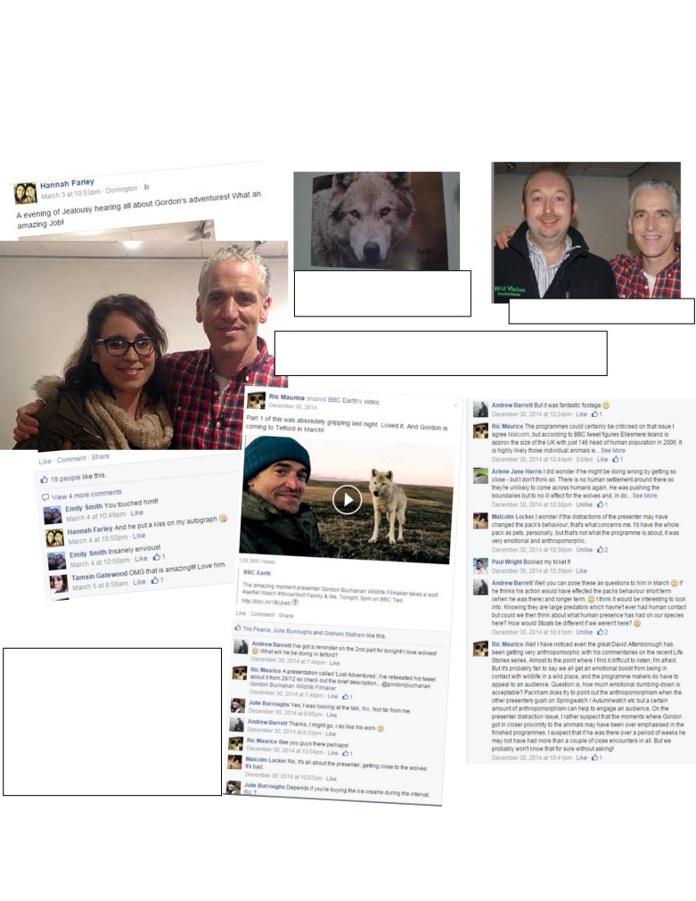

Shropshire Mammal Group Newsletter Issue 22 Spring 2015

He wasn’t concerned, those wolves were very unlikely to ever meet humans again as the land they are on is so sparsely populated. But it is a concern in some situation where the risk of meeting humans is higher.
Gordon has been on many adventures and is continuing on more, confirming at the talk he is going to film gorillas next year. He’s an excellent speaker and he kept the audience engaged with funny stories and jokes. I am glad I went to his talk and the print I brought (of an arctic wolf) is fabulous.

Gordon’s signed photograph of
the Arctic Wolf, which Andrew
bought. SMG’s Tris Pearce with Gordon.

Hannah Farley, formerly of Shropshire Wildlife Trust, poses for a picture with Gordon, much to the envy of 18 of her Facebook friends.

Andrew’s question to Gordon about the potential effects of human contact with the wolves echoes the airing of the same subject via the discussion thread on the SMG Facebook page, back in December 2014. Here’s a short selection of views…
Ric

Follow us on Facebook at https://www.facebook.com/groups/shropshiremammalgroup/ We’re also on Twitter: @Shropsmammals
If you spot a mammal in Shropshire, please record it via bit.ly/SMGrecord or email Lorcán Adrain at SMGrecord@gmail.com Articles and photos for the next issue of the SMG Newsletter to Ric Morris, Editor, at ric_morris@hotmail.co.uk please

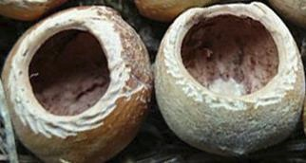

Shropshire Mammal Group Newsletter Issue 22 Spring 2015

Diary dates for forthcoming events by Paul Roberts, Events Organiser

Sunday 29th March 09:30 to 12:30
‘The Nutters’: SMGs Dormouse recorders monthly meet
Do you want to be a ‘Nutter’? Help us survey for nibbled nuts or dormice to help establish their distribution
throughout the hillsides of Llynclys. “The Nutters" the dormouse recorders for Shropshire Mammal Group are holding another nut hunt. We need as many people as possible so please tell your friends. If you want to come along then either contact Paul direct or accept the invitation on SMG’s Facebook page.
Meet at Porth Y Waen Band Hall, Llynclys SY10 8LS at 09:30.
A couple of neatly
nibbled Dormouse nuts.
___________________________________________________________
Saturday April 18th 09:30 to 12:00
Mammal trapping with Friends of Apley Woods
The traps will have been pre-set during the course of the previous week, so this is your opportunity to join the walk to find what mammals have been trapped. Martin Noble’s favourite field voles and woodmice are almost guaranteed, but who knows whether we’ll be lucky enough for a feisty yellow necked mouse or having to make do with a slug or two! Contact stuartedmunds@rocketmail.com or keep an eye out for the setting up of this event on the FOAW Facebook page.
Meet at Apley Park, Telford at 09:30.
__________________________________________________

Sunday April 19th 09.30-13.00
‘The Nutters’: Dormouse nut hunt
Details as above. Note later finishing time.
Meet at Porth Y Waen Band Hall, Llynclys SY10 8LS at 09:30.
__________________________________________________
Friday May 1st: Time & location to be confirmed Badgerwatch with Tris Pearce
Places are restricted due to the sensitivity of the event and potential disturbance from large parties. The first 6 names confirmed secure a place. Contact pjroberts1969@yahoo.co.uk. Or keep an eye out for the setting up of this event on the SMG Facebook page.

Location TBC
____________________________________________________________
Sunday May 17th 09.30-13.00 ‘The Nutters’: Dormouse nut hunt
Details as above.
Meet at Porth Y Waen Band Hall, Llynclys SY10 8LS at 09:30.
_________________________________________________________
A Preston Montford
badger making his second appearance in the
newsletter, still in search of his missing nasal hairs.

You may also be interested in the activities of the Ellesmere Water Vole Group who will be constructing mink rafts on April 18th and 25th at the Canal and Rivers Trust, Ellesmere SY12 9AA, as well as siting and checking them on later dates. Contact Caroline Savage on csavage@freeuk.com for details. If you require further information about any of the SMG events, please see the Events pdf which Paul uploaded to the SMG Facebook page on 21st March 2015 or email-pjroberts1969@yahoo.co.uk.

Follow us on Facebook at https://www.facebook.com/groups/shropshiremammalgroup/ We’re also on Twitter: @Shropsmammals
If you spot a mammal in Shropshire, please record it via bit.ly/SMGrecord or email Lorcán Adrain at SMGrecord@gmail.com Articles and photos for the next issue of the SMG Newsletter to Ric Morris, Editor, at ric_morris@hotmail.co.uk please
Stuart Edmunds

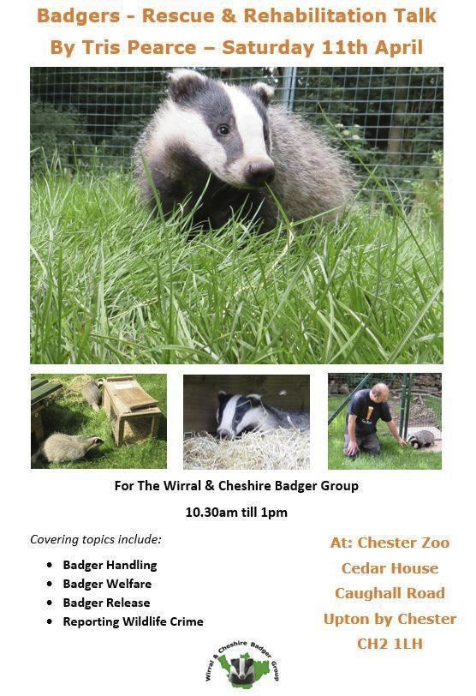

Shropshire Mammal Group Newsletter Issue 22

And finally…

Andrew contributed his Hare Whisperer poem and photos to SMG
Newsletter 21; his talk is not a SMG event
and neither will his exhibition be
exclusively mammal photography, but both will, I promise you, be very well worth a visit.

Spring 2015

Also worth a journey… but be warned that rumour has it you have to join the Wirral & Cheshire Badger Group to gain admittance!

With many thanks once again to everyone for the positive feedback received after Issue 21 and, as ever, to all the contributors who have generously supported my call for material. I hope that you enjoy this latest issue of your Newsletter! Please let me know your thoughts via Facebook or email; articles, photos, reviews and cartoons or topic suggestions for future issues will be welcomed. Best regards… Ric.

Follow us on Facebook at https://www.facebook.com/groups/shropshiremammalgroup/ We’re also on Twitter: @Shropsmammals
If you spot a mammal in Shropshire, please record it via bit.ly/SMGrecord or email Lorcán Adrain at SMGrecord@gmail.com Articles and photos for the next issue of the SMG Newsletter to Ric Morris, Editor, at ric_morris@hotmail.co.uk please

