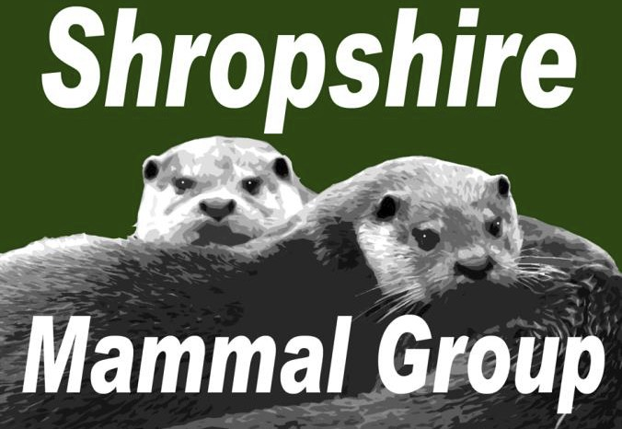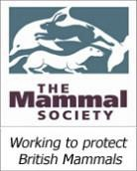
Newsletter
Issue 21: Winter 2014

Affiliated to the Mammal Society
WELCOME!
…to a new-look Shropshire Mammal Group quarterly newsletter, under a new editor, Ric Morris. I’d like to thank my

Published Quarterly Since 2009

CONTENTS:
Welcome from the new Editor 1
Contents 1

predecessor Holly Shingler for her patience and good Note from the Chair 2

humour with soliciting my own (usually last minute) contributions, and of course, her hard work in putting the newsletter together over the last two years. She is leaving the role due to other commitments but I hope that you’ll be a member of SMG for many years to come, Holly.
Hare Whisperer 3
“I’m going on an Adventure!” 4
-in Countryside Education
Badger vaccinations in Shropshire 5
National Otter Survey Workshop 6

Over future issues I plan to build on Holly’s Wild Vision Productions 6

achievements while bringing my own stamp to the newsletter. I am aware that a lot of our Group’s day-to-day news, comment and banter appears on our very vibrant Facebook page, and for that reason I’d like the Newsletter features to be a little more distinctive;
Mammal Eyewitness 7
…featuring Otters! and First Glimpse of the River Kings
List of Corporate Members 9
We’d love to hear from YOU! 10

perhaps covering issues in greater depth, or showcasing ‘Leveret’ - music review 10

articles which cover different issues. I’m also aware we may have members who don’t use social media at all. I didn’t myself, until a couple of years ago- I signed up to
Diary Dates & forthcoming events 11
Mammal Photography by Tim Preston 12

FB specifically to follow SMG, and now you can’t get me off it! And Twitter’s even better to be honest. So there will be plenty of social media snippets reproduced here as well, just to keep non-users ‘in the loop’. Elsewhere

in this issue there are some ideas for contributions for future issues so please feel free to have a look and send me something that you think may fit the bill! Please bear in mind that all views and opinions expressed in the Newsletter are and shall be those of the individual contributors and not necessarily reflective of Shropshire Mammal Group policy unless otherwise stated.
Best wishes for Christmas and the New Year, Ric Morris ric_morris@hotmail.co.uk
Remember! The deadline for entering the Mammal Society’s Mammal Photographer of the Year contest
is 15 February 2015! Full details on their website -
here!

Follow us on Facebook at https://www.facebook.com/groups/shropshiremammalgroup/ We’re also on Twitter: @Shropsmammals
If you spot a mammal in Shropshire, please record it via bit.ly/SMGrecord or email Lorcán Adrain at SMGrecord@gmail.com Articles and photos for the next issue of the SMG Newsletter to Ric Morris, Editor, at ric_morris@hotmail.co.uk please

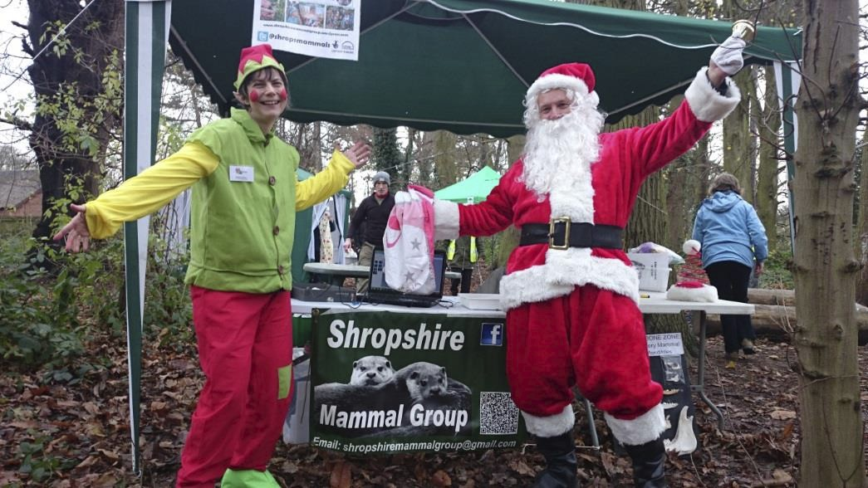

Shropshire Mammal Group Newsletter Issue 21 Winter 2014

Note from the Chair by Stuart Edmunds, SMG Chair

2014 has certainly been productive year for Shropshire Mammal Group. Thanks to a sterling effort from our committee and 100 members, we have far outreached our annual target of mammal records and thanks must go to Lorcán for keeping log of those many records. I must also thank Sara Pearce for her part in securing our first Heritage Lottery Fund award, which has allowed us to buy new camera traps, small mammal traps and a wealth of other recording equipment. This equipment will be used at events and surveys in 2015 and there will also be an opportunity for members to borrow camera traps and small mammal traps. I recently wrote a blog about the Hide’n’Squeak project for the Mammal Society’s 60for60 blog, which can be viewed at http://www.mammal.org.uk/60for60_weekly_blogs/hide-n-squeak

We have also received growing support from new corporate members this year, including Ricoh, The National Trust (Shropshire Hills), Meres and Mosses and most recently, the British Hedgehog Preservation Society. This will hopefully eventually lead to more employees of these organisations to find out more about recording mammals.

Overall, Shropshire Mammal Group has been involved in 16 events and surveys in 2014, many of which were held at sites like Prees Heath and Severn Valley Country Park. The aim is to continue this trend into next year, but focus more intensely on protected species and sites where we have no records at all. The National Hedgehog Survey, coordinated by PTES will continue and volunteers are still needed to survey 3 sites in the county which we were unable to cover this year. Our results this year discovered presence of hedgehogs at only 2 out of 6 sites surveyed. Those sites were all rural, so it would be very interesting to have a count of hedgehogs living in gardens in 2015, numbers of which are likely to be on the increase thanks to the increasing number of people creating wildlife-friendly outdoor areas.

All members are invited to attend our AGM on 24th January at Preston Montford Field Studies Centre, where Tris Pearce will be giving a talk about his experiences with bears in Alaska this year.

Hopefully we will see you there…the cake will be waiting!

Santa and all his little Apley
Wood elves, as well as the Shropshire Mammal Group Committee would like to wish all the SMG members and corporate members a very Merry Christmas and a prosperous and mammal-filled New Year!

Follow us on Facebook at https://www.facebook.com/groups/shropshiremammalgroup/ We’re also on Twitter: @Shropsmammals
If you spot a mammal in Shropshire, please record it via bit.ly/SMGrecord or email Lorcán Adrain at SMGrecord@gmail.com Articles and photos for the next issue of the SMG Newsletter to Ric Morris, Editor, at ric_morris@hotmail.co.uk please

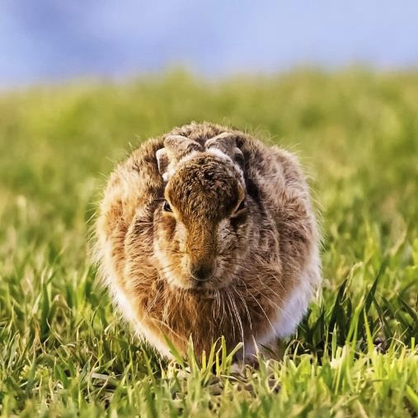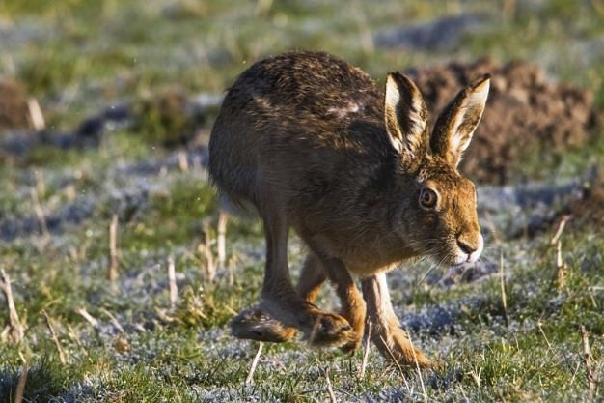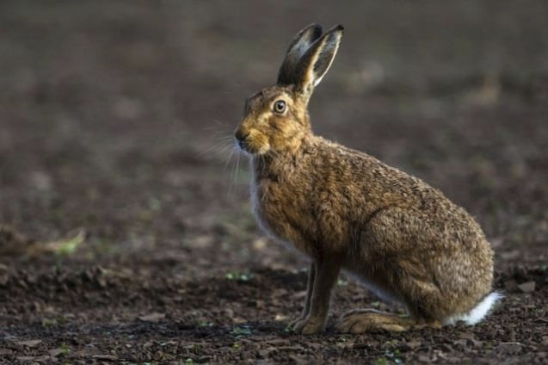

Shropshire Mammal Group Newsletter Issue 21 Winter 2014

Hare Whisperer Words and photos by Andrew Fusek Peters
Andrew is a Shropshire based author, poet, playwright and wildlife photographer, shortlisted for the British Wildlife Photography Awards 2014. Over the last year he has been tracking and photographing hares near his home in south Shropshire. I’m pleased to publish a poem of his, along with some of his superb hare photographs- Editor

This is my dawn, when the light is tinted low
As if the sun were leaning into day And but breathing the echo Of flame to leaven shadow
bring this early hour to a risen yeast if you too risk leaving dream,
to walk in a frost that has long forgotten winter, you might, if slow and tender,
be welcome to the feast.

Here are the hares and they are wild with greenery All of bubbling earth bursting through limb and paw As they leap, run perfect rings that were ritual Long before Stonehenge
As the female flies before, grass her sky
Gravity but an itch she has no need to scratch

Hare of the hind legs, first and greatest of pistons, Driven hare, heaving hare of the lollop, gainer of air With an ease it makes poets exhausted to watch
And what am I in this flummery, this yearly Catch and snatch can that soon shall lead to A flummox of paws, a head battering-ram
As the bucks duke it out for who shall have the pleasure, The moment, spirit, genetic,
And if fox does not have his red-furred way, beget
At last in the form as polished as shell, new life-leveret.

But for now, I am stick, tree, twig, tall, ignored
As hare after hare runs, no, sprints, no, as the peregrine falls in a stoop, So hare, horizontal, negotiates distance,
Finds the art of reducing it until he is whisker,
Amber of the eye, pressed pine sap of millenniums now jewelled and Found washed up on this furred shore
Almost in my face with grace At the last,
When I mistaken click, He hears, swerves,
Is by me, almost touching my boots,
Then sliding, gone, like down-dark tree roots To a low land only hinted at in
My tinted dreams as I shifted in my form Far, and oh far again before dawn.

Andrew Fusek Peters 2014

Follow us on Facebook at https://www.facebook.com/groups/shropshiremammalgroup/ We’re also on Twitter: @Shropsmammals
If you spot a mammal in Shropshire, please record it via bit.ly/SMGrecord or email Lorcán Adrain at SMGrecord@gmail.com Articles and photos for the next issue of the SMG Newsletter to Ric Morris, Editor, at ric_morris@hotmail.co.uk please

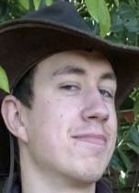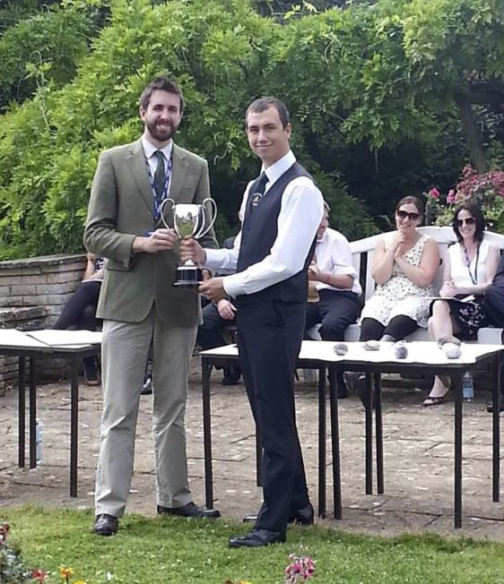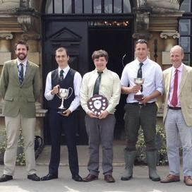

Shropshire Mammal Group Newsletter Issue 21 Winter 2014

"I'm going on an Adventure!"
- In Countryside Education by Andrew Barrett
I am a first year student at Harper Adams University, near Newport, Shropshire where I’m studying Wildlife Conservation and Natural Resource Management. I volunteer for Cuan House Wildlife Rescue, I’m a Cub Scout Leader, and a member of Shropshire Mammal Group. This is my story of how my love of the countryside and passion for mammals has guided me so far.

From a very early age, I loved being outdoors. I have been involved in scouting for 12 years and have visited Sweden, Denmark and
Madagascar in the last three years. Learning about the wildlife of these countries was fascinating and I came back from Sweden with a burning desire to work with a Wolf Conservation Group there.
My first major step into learning about the countryside was when I started at Wiltshire College Lackham to do a BTEC level 3 in Countryside Management. This was a two year extended diploma course, which had a fantastic diversity of units, ranging from practical estate management to the basics of ecology! A few of the modules I found to be exciting and essential for my continued education were: Introduction to Wildlife Ecology,
Farm Habitat Management, Woodland Habitat Management and Investigative Project which required me to do a dissertation like a research project during my second year. I was proud to have been presented with the Jack Ainslie Award for outstanding academic achievement.
It is still more common for people to do A levels to get to University, but my course at Lackham lead me perfectly on to the Harper Adams University course I am currently on.
Harper Adams has a great reputation and many contacts in the land based and agricultural industries. I have had the opportunity to attend several talks hosted by Harper Adams and given by experts and professionals. These, along
with advice from my tutors, have inspired me to volunteer with and join many specialist societies, including the national Mammal Society and the Shropshire Mammal Group.

By joining groups like these I will have the opportunity to go out with real local experts and experienced researchers to learn and assist with a variety of works. Everyone I have met has been very friendly and loved to share their knowledge. In November 2014 I went to an otter survey workshop run by Cardiff University, and In January 2015 I have booked onto a Brown Hare survey workshop, which I found through the Wiltshire Mammal Group. These are just some examples of what opportunities for learning are out there. Education is the key to understanding, working together and helping our planet and protecting all our furry friends!

Thanks Andrew for this informative article, and welcome to Shropshire Mammal Group; looking forward to meeting you on events and hearing more about your activities. More from Andrew on Page 5- Ed.

Follow us on Facebook at https://www.facebook.com/groups/shropshiremammalgroup/ We’re also on Twitter: @Shropsmammals
If you spot a mammal in Shropshire, please record it via bit.ly/SMGrecord or email Lorcán Adrain at SMGrecord@gmail.com Articles and photos for the next issue of the SMG Newsletter to Ric Morris, Editor, at ric_morris@hotmail.co.uk please

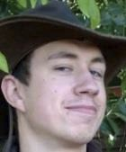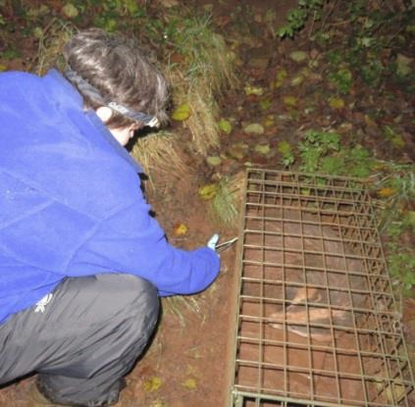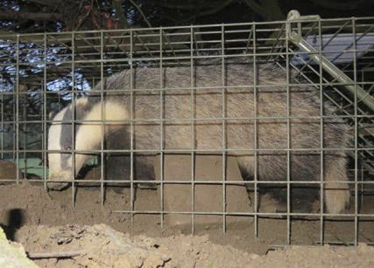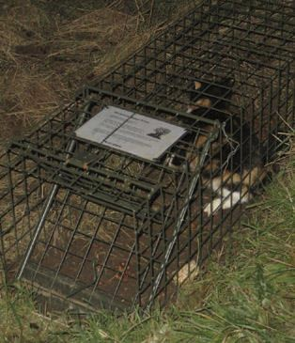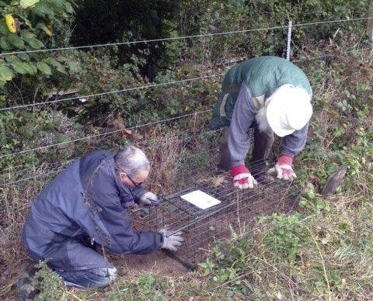

Shropshire Mammal Group Newsletter Issue 21 Winter 2014

Badger Vaccinations in Shropshire by Tris Pearce

A four year scheme to vaccinate badgers for Shropshire farms AT NO
COST TO THEM in Shropshire began this year run by Shropshire Badger Group, led by Tris Pearce, Jim Ashley & Lyn Louis, with much help from other members of the group too.

So what is it about?
It began with an offer to the first six Shropshire farms, to come forward and allow vaccination to take place on their land, then began the task of surveying the farms, this was done with willing volunteers from SBG. Then when the setts were identified and mapped, pre baiting began, this is feeding the area around the setts where traps are to be later placed. Trap digging-in occurred after this and then the pre-baiting continued for at least a week to allow badgers to get used to going in the traps. Traps are then set in an afternoon ready to catch that night (the traps do not hurt the badgers), in the morning (very early!) we then go and check the traps, do a welfare inspection on the animals caught and vaccinate by injecting the BCG vaccine via an intramuscular jab! The badger is then subject to a haircut, with a small patch of fur cut off the badger and stock marker spray applied (to tell us if it has
been caught the next day). This happens for 2 nights at each location only for welfare issues. The whole vaccination process is completed speedily and efficiently with the badgers in the cages remaining remarkably calm and unperturbed, with no signs of aggression or stress.
We also caught a cat, but obviously did not vaccinate it! It was released immediately but was not happy!
A few hurdles were met along the way, partly to do with timing, availability of maize nearby and also weather. But lessons were learnt and we are more confident for 2015.
Jim Ashley (Chairman) says “Standing in a field at dawn in the beautiful Shropshire countryside with the Shropshire Badger
Group Vaccination Team you cannot help but be impressed with the professionalism and enthusiasm of this dedicated group of volunteers.”

How it works: Not all of the badgers need to be caught. The aim is to establish a ‘herd immunity’ whereby only a proportion of the population need to be vaccinated to reduce their chance of infection and of passing infection on. Cubs are preferable for capture and vaccination. The principle is to try to make a difference and work with the farmers to tackle this awful disease in an effective and humane way. It is just a shame we can’t vaccinate the correct animal - Bovines!

Follow us on Facebook at https://www.facebook.com/groups/shropshiremammalgroup/ We’re also on Twitter: @Shropsmammals
If you spot a mammal in Shropshire, please record it via bit.ly/SMGrecord or email Lorcán Adrain at SMGrecord@gmail.com Articles and photos for the next issue of the SMG Newsletter to Ric Morris, Editor, at ric_morris@hotmail.co.uk please

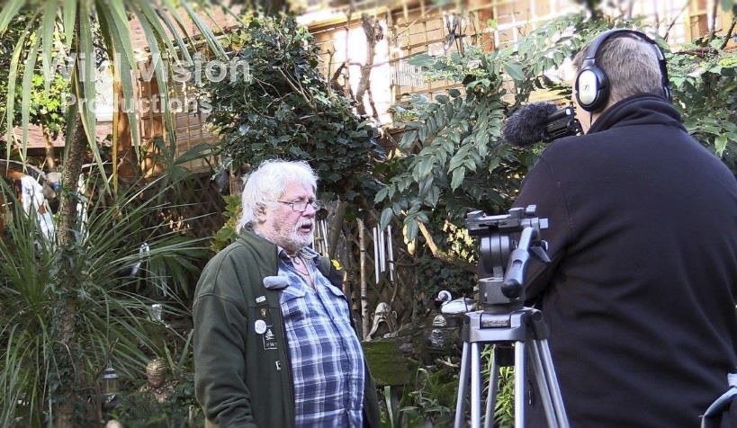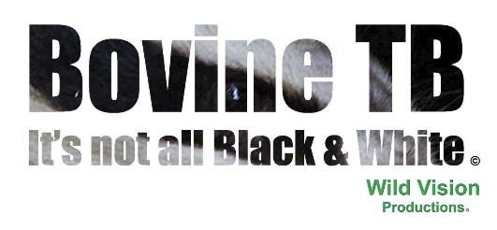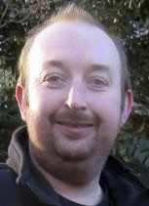

Shropshire Mammal Group Newsletter Issue 21 Winter 2014

National Otter Survey- Workshop by Andrew Barrett
On Sunday 30th November 2014 Cardiff University ran a free otter survey workshop in Newbridge-on-Wye so a few friends and I went along.

We started the day at 10:30, with a power point presentation explaining the project, talking about the
otters’ ecology, the food they eat and the changes to their diet over the years. The otter population is increasing in the UK, but the populations of their favourite prey, eels and salmonidae, has declined. What are they now eating? Is there any adverse effect on the otter from being forced to switch to less favoured prey? These are the question they are hoping to answer.
After the presentation we had two more activities to do; first we took a walk down to the local river with a member of the group who knew the area and the otters. We were looking for signs; we saw an otter holt that has been used for many generations, fresh spraint and what was left of the otters dinner, the head of a perch! We then headed back to the room which was full of microscopes. We had a go at searching for bones in spraint and identifying them to work out what the otter had eaten.
This was a fascinating day filled with learning and networking, meeting and talking to new people all who had a common interest.

Cardiff University Otter Project (CUOP) is a national scheme collecting otters found dead in England, Scotland and Wales for post mortem examination. As well as collecting dead otters, as part of their research they are collecting spraint to look at the hard part remains, the bones in them. They will analyse this information to look at the change in diets of the otters.
The project has some data of spraint which was gathered in the 1980’s and 90’s from a number of survey sites on rivers in Wales, so part of the project involves training volunteers to go out and collect spraint in 2015 which will be sent back to the otter team for analysis.
_______________________________________________
Wild Vision Productions by Tris Pearce

Tris Pearce and Tim Mitchell- a Salopian and a Yorkshireman- have formed Wild Vision Productions Ltd which
is able to provide a range of solutions in media and film for businesses and also as independent or freelance
wildlife film-makers! Both Tris and Tim are dedicated to wildlife and conservation and passionate about film
and photography. Wild Vision Productions are working on some very exciting original and fresh films for eventual broadcast. Recently they have worked with none 0ther than the great Bill Oddie and are also working on a documentary entitled “Bovine TB, it’s not all black & white”. They are
hoping to get the views of all sides (Vets, Farmers, Defra, NFU, Wildlife Groups, Campaigners and even some TV wildlife personalities) of this hot topic and even film inside the cull zone in 2015. If you want to be a part of this documentary film, then please get in touch with Tris via Facebook message or tris@pearce-environment.co.uk.

Follow us on Facebook at https://www.facebook.com/groups/shropshiremammalgroup/ We’re also on Twitter: @Shropsmammals
If you spot a mammal in Shropshire, please record it via bit.ly/SMGrecord or email Lorcán Adrain at SMGrecord@gmail.com Articles and photos for the next issue of the SMG Newsletter to Ric Morris, Editor, at ric_morris@hotmail.co.uk please

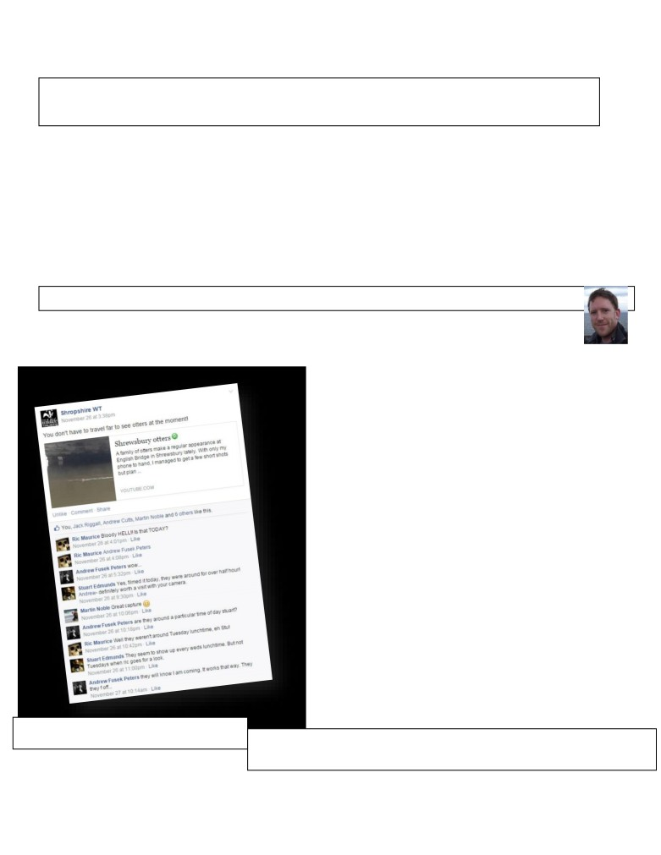

Shropshire Mammal Group Newsletter Issue 21 Winter 2014

Mammal Eyewitness- English Bridge Otters
Mammal encounter stories by various authors
Anyone who cared to glance over the parapet of the English Bridge in the centre of Shrewsbury during late November may have (and it is a very big, conditional, MAY) been rewarded by a view of one of Britain’s most charismatic mammals- the otter. Just a decade or so ago, the otter was a shy and elusive creature rarely seen in any situation where people were around, yet now thanks in part to cleaner rivers and a comparative resurgence in numbers, it’s not unusual to catch them on trail cameras or even to see them in broad daylight in certain secluded spots. But in the centre of a town like Shrewsbury? Well put it like this. Not everyone is lucky.
Here are a few eyewitness accounts- our own Stuart Edmunds, lucky Jack Riggall, a student mammalogist from Cheshire who made a special journey on spec after reading Stuart’s Facebook post, and er, a couple of other losers.

Otters! By Stuart Edmunds
Staff from Shropshire Wildlife Trust were delighted to not only get a glimpse of a family of otters (or a “romp”
to use the correct collective noun), but half an hour of viewing of the playful mammals swimming and feeding
in the River Severn below English Bridge in Shrewsbury. I had already missed out on watching the otters the week before, so when I received a phone call from colleagues to say the otters
were back, I dashed across town to avoid another missed opportunity. On arrival at the bridge, I was met with an excited crowd of onlookers from SWT and members of the public; all leaning precariously over the bridge wall, mesmerised by the rare site just 15 feet below them. As is always the case at these unexpected wildlife encounters, not one of us was equipped with a camera, but I managed to record some video clips of the experience.
When the otters eventually swam off upstream, a quick check under the bridge uncovered several otter prints; of an adult and two juveniles. Unfortunately, although they have been spotted since, several attempts by photographers (including our very own Ric Morris) to get a snap of one of the otters have ended in failure. The usually elusive mammals appear to have reverted to their elusive habits- even managing to evade the motion sensors of my camera traps on three occasions! To find out more about the resident otters and their behaviour, I have set up Otter Watch, encouraging Shrewsbury shoppers to report their otter sightings and I also recommend to any SMG members visiting Shrewsbury to keep one eye on the river as they cross the town’s bridges. There is probably no better place in Shropshire offering a more likely otter sighting!

How Stuart broke the news to the waiting
world, from the SWT Facebook account You can see Stuart’s mobile phone footage on YouTube here:
https://www.youtube.com/watch?v=MaRhl0pEGks&feature=youtu.be

Follow us on Facebook at https://www.facebook.com/groups/shropshiremammalgroup/ We’re also on Twitter: @Shropsmammals
If you spot a mammal in Shropshire, please record it via bit.ly/SMGrecord or email Lorcán Adrain at SMGrecord@gmail.com Articles and photos for the next issue of the SMG Newsletter to Ric Morris, Editor, at ric_morris@hotmail.co.uk please

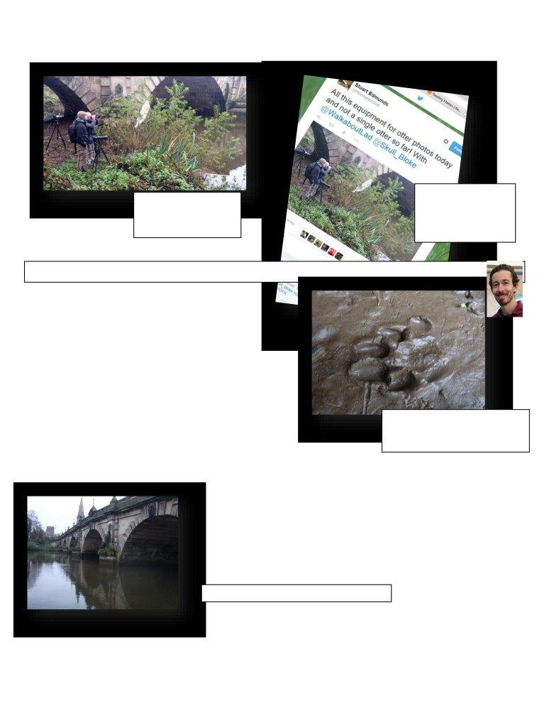

Shropshire Mammal Group Newsletter Issue 21 Winter 2014

Cruelly mocked by
Two losers hanging someone calling
around the bridge the themselves
following day, looking @PinemartensUK on
for some otter action. Twitter

First glimpse of the River Kings Words and photos by Jack Riggall

I’m currently based in Cheshire, and ventures across the county border are pretty rare, but on a free day recently I changed the Marbury Country Park bittern-centric plans of myself and a friend last minute to chase up a tip kindly shared by Stuart Edmunds in the Facebook group for SMG - a chance to see the river kings in Shrewsbury in broad daylight? Irresistible, as I had never seen them before, save for trailcam clips... but I would have gone regardless, of course!

Our timing couldn’t have been better - arriving at midday, and after popping into SWT HQ for a quick chat during which we were pointed in the direction of a potential spot for sightings,

we headed over English bridge, stopping to peer over the edge every couple of metres (just in case); then down the steps to the mud bank, and mere seconds passed before two surfaced
on the far side of the Severn playing and hunting, slowly moving under the bridge until they were lost from view in a tributary. The attempts to follow were without
Exciting otter print in the river silt under the English Bridge! Note the shape of pad, and the display of five toes.

result, but their footprints in the mud banks under English Bridge, along with the cathedral and the cafes, were entertainment enough for a couple of hours.
The experience was bliss, though my expectations were thrown out the window - why are they active at midday, when all the guides I’ve read say they are nocturnal? Why are they seemingly indifferent to the dogs, pedestrians and litter when I understood them to be shy and sensitive to their environment? I suppose I’ll leave the musings to the experts, for now, and finish these few notes by saying that along with the presence of grey wagtails and kingfishers the sightings were all shared with SWT for the database. Gotta love those databases!

There are otters in this picture (left)

Follow us on Facebook at https://www.facebook.com/groups/shropshiremammalgroup/ We’re also on Twitter: @Shropsmammals
If you spot a mammal in Shropshire, please record it via bit.ly/SMGrecord or email Lorcán Adrain at SMGrecord@gmail.com Articles and photos for the next issue of the SMG Newsletter to Ric Morris, Editor, at ric_morris@hotmail.co.uk please

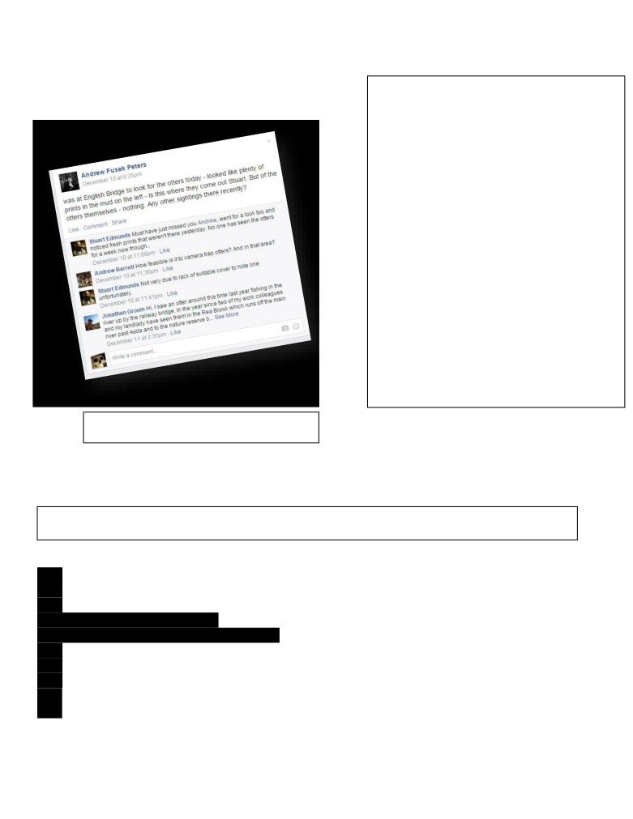

Shropshire Mammal Group Newsletter Issue 21

Thanks to Jack for his report. I have compiled some helpful lists to show exactly who has seen the otters in the vicinity of English Bridge and the Rea Brook - Ed.

Andrew disappointed by lack of otters (again); Jonathan Groom gives us all hope…

Winter 2014

List of people who have seen the ‘River Kings’ at or near English Bridge, Shrewsbury

*Stuart Edmunds… and his phone
*Jack Riggall
*Jonathan Groom, his colleagues and landlady (posted to Facebook)
*Most of the staff at Shropshire Wildlife Trust (except Ric Morris)
List of people who have not seen the ‘River Kings’ at English Bridge
¤= As far as we know

*The rest of the staff at Shropshire Wildlife Trust
*Ric Morris
*Andrew Fusek Peters
*Andrew ‘Walkabout Lad’ Cutts
*Stuart Edmunds’ trail camera

*Dame Judi Dench¤
*The Dalai Lama¤
*Barak Obama¤
*Prof Stephen Hawking¤
*Michael Fabricant¤
*Homer Simpson¤
*Elton John & David Furniss¤
*Benedict Cumberbatch¤- despite (allegedly) looking like an otter... rather than looking for one…

(Think that’s enough people now - Ed.)

____________________________________________________________________________________

Corporate Members of Shropshire Mammal Group
Shropshire Mammal Group is grateful to its corporate members for their support.
Field Studies Council - Preston Montford Field Centre Pearce Environment Ltd
Whitchurch Community Water Vole Project
- Ellesmere Branch
Shropshire Bat Group Ricoh Ltd
Meres and Mosses Landscape Partnership Scheme The National Trust (Shropshire Hills)
The British Hedgehog Preservation Society

Follow us on Facebook at https://www.facebook.com/groups/shropshiremammalgroup/ We’re also on Twitter: @Shropsmammals
If you spot a mammal in Shropshire, please record it via bit.ly/SMGrecord or email Lorcán Adrain at SMGrecord@gmail.com Articles and photos for the next issue of the SMG Newsletter to Ric Morris, Editor, at ric_morris@hotmail.co.uk please

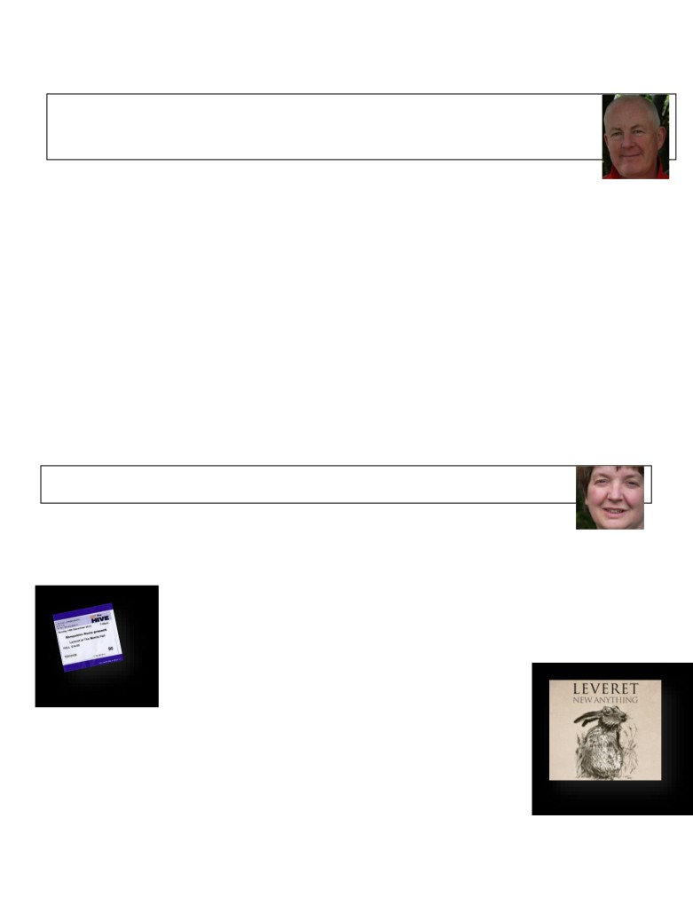

Shropshire Mammal Group Newsletter Issue 21 Winter 2014

We’d love to hear from YOU!
Ideas for newsletter contributions by Ric Morris
(Previously published on Facebook)
* New Member Notes. Have you recently joined our Group, say within the last year? What would
you like to see us doing as a group to improve your knowledge or enjoyment of our native mammals? Have you recently attended a live trapping event and perhaps got your first close look at a small mammal?
* Equipment review. Have you got a piece of mammal-watching kit, such as a particular type of live or camera trap, bat detector or even a pair of binoculars, a rucksack or a wet weather jacket which helps you when mammal watching in the field? We would like to hear why you chose this item in the first place and why you find it so indispensable (or so useless!) rather than just 'I like it' or 'don't buy this'.
* Book (or website) review. Got a good field guide, no matter how old it is? Found a really useful website, Facebook page or forum? Let's hear about it! TV programme reviews would also be appreciated.
* Eyewitness Encounter. Perhaps you've recently had a good sighting of a British mammal - not necessarily a rare or unusual one, but a short account of even a squirrel or rabbit exhibiting some interesting behaviour would be great. Or a great view of a fox in the headlights at night, a hedgehog in the garden, heaven forbid- a rat on the bird table, or joy of joys, otters playing around Shrewsbury's English Bridge, as seen in this issue! What did you see that grabbed your attention and stirred your imagination- whatever you want to tell us about, just to flesh out the simple record data that you would send to our mammal recorder Lorcán Adrain. Photos always appreciated!
* Education, education, education. Doing a conservation degree at Harper Adams, or studying at Walford? What advice would you give to prospective students about your course? Have you attended a Mammal Society training event, or some other one day or weekend course? Tell us what you think and why someone else might want to sample the event.
______________________________________________________
‘Leveret’- Live Music Review by Clare Boyes
Yes, we all know that a Leveret is a hare in its first year, but you might not know that Leveret is also the name of one of the most interesting and exciting folk bands around.
The group consists of Sam Sweeney on fiddle and viola, Andy Cutting on diatonic button accordion, and Rob Harbron on English concertina. The trio knew each other from playing in a number of top folk acts with singers (Jon Boden, Fay Hield, Full English) but soon realised that what they really enjoyed was playing tunes together. They decided to buck
the trend and play as an entirely instrumental group.

A short tour saw them visit Morris Hall in Shrewsbury just before Christmas. The concert was sold out weeks in advance, testament to their reputation as top class musicians. Those lucky enough to attend were treated to an acoustic concert ‘in the round’. After the interval the musicians swapped seats so that the audience had a different view!
The tunes, many of which are hundreds of years old, have not been formally arranged - rather they play each tune and see where it takes them. This leads to a fresh but relaxed sound and the musicians clearly
relished playing with the freedom this approach afforded them. The music swooped and soared
- joyous, yet with moments of great subtlety. The set included dance tunes, and a number of tunes which were penned by the musicians. The whole effect was simply mesmerising.
It will probably be a while until they next visit Shropshire, but in the meantime, their CD, ‘New Anything’ is released in January and is well worth buying. Oh, and the cover picture is a lovely line drawing of a hare - worth the album price alone! You can find out more about Leveret and hear clips of their music at www.leveretband.com.
Follow us on Facebook at https://www.facebook.com/groups/shropshiremammalgroup/ We’re also on Twitter: @Shropsmammals
If you spot a mammal in Shropshire, please record it via bit.ly/SMGrecord or email Lorcán Adrain at SMGrecord@gmail.com Articles and photos for the next issue of the SMG Newsletter to Ric Morris, Editor, at ric_morris@hotmail.co.uk please

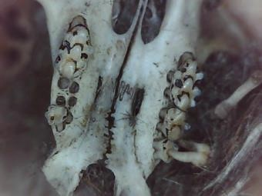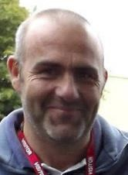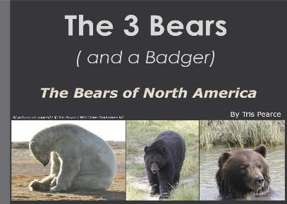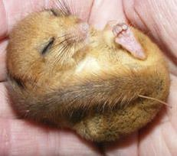

Shropshire Mammal Group Newsletter Issue 21 Winter 2014

Diary dates for forthcoming events
By Paul Roberts, Events Organiser

Sunday 28th December 2014 - 09:30 to 12:30 SMG Nutters Dormouse Event- ALL WELCOME!

Post-Christmas walkabout to look for dormouse signs and assess the habitat. We will also be looking at some trees and using our new endoscope for looking in cracks and rot holes for the elusive creature.
We intend going to the pub for a coffee/ drink afterwards.
Meet at Porth Y Waen Band Hall, Llynclys SY10 8LS at 09:30.
A Dormouse, n
showing his nu
Sunday 18th January 2015 9:30-13:00
Dormouse nest box installation/nut search

It is hoped that we will have 100 dormouse nest boxes ready to install in the woodlands surrounding Llynclys Quarry in time for the first dormouse get-together of 2015. We will also be looking for further physical signs of their presence in another previously unchecked part of the woodland.
Meet at Porth Y Waen Band Hall, Llynclys SY10 8LS at 09:30.
__________________________________________________________________
Saturday 24th January 2015 - 11:00-13:00
Shropshire Mammal Group AGM and Talk - ALL WELCOME!

We are holding the 2015 AGM at Preston Montford Field Studies Centre, Montford Bridge, Shrewsbury, SY4 1DX.
Bring

Tris Pearce has kindly offered to give a talk entitled “The 3 Bears (and a Badger)” about the bears which he has encountered, photographed and filmed whilst on a trip in Alaska. Preston Montford cake and drinks supplied.
__________________________________________________ 7th February 2015 - 10:00-13:00
Hide n Squeak showcase event! ALL WELCOME!
porri
Other
not be available. Except cake.

As you will have read elsewhere, SMG’s Hide ’n ’Squeak funding application has enabled the purchase of lots of marvellous new mammal recording equipment, and this event will provide an excellent opportunity for SMG members to put camera traps, endoscopes, nest box cameras and our USB microscope to the test. All are welcome to attend to see how technology and innovate equipment makes it easier and more efficient to observe and record our favourite mammals.

If you require further information about any of these events, then please contact Paul direct by email-

pjroberts1969@yahoo.co.uk.
Not even @Skull_Bloke has seen Apodemus molars in this much detail. Come
along and test out our new equipment for yourselves!

Follow us on Facebook at https://www.facebook.com/groups/shropshiremammalgroup/ We’re also on Twitter: @Shropsmammals
If you spot a mammal in Shropshire, please record it via bit.ly/SMGrecord or email Lorcán Adrain at SMGrecord@gmail.com Articles and photos for the next issue of the SMG Newsletter to Ric Morris, Editor, at ric_morris@hotmail.co.uk please

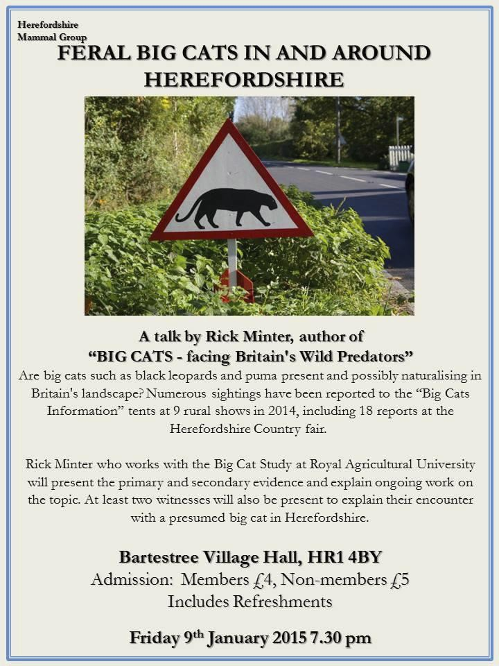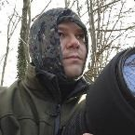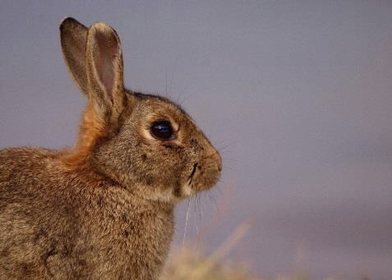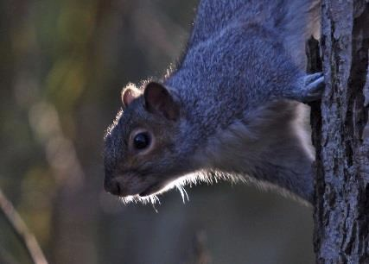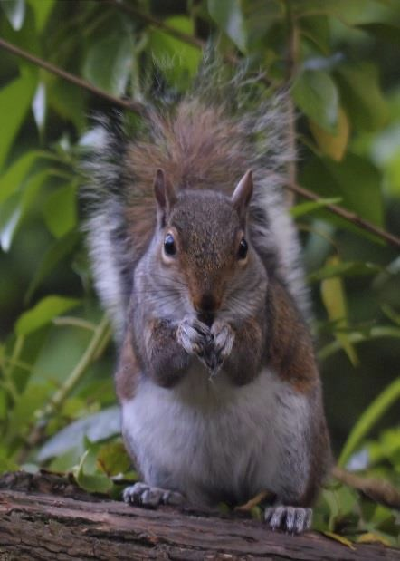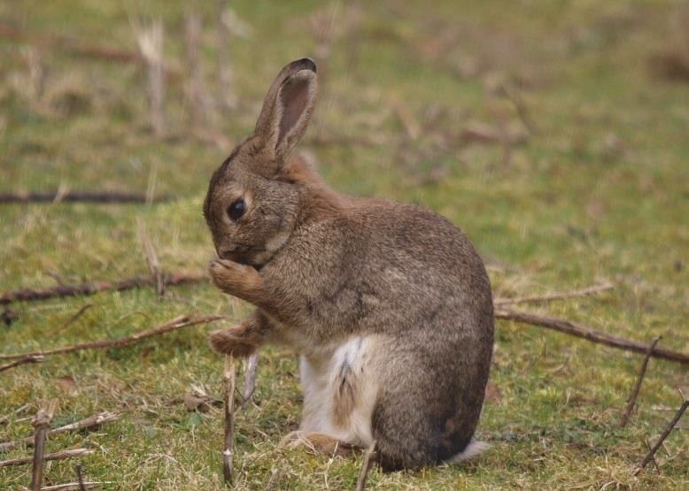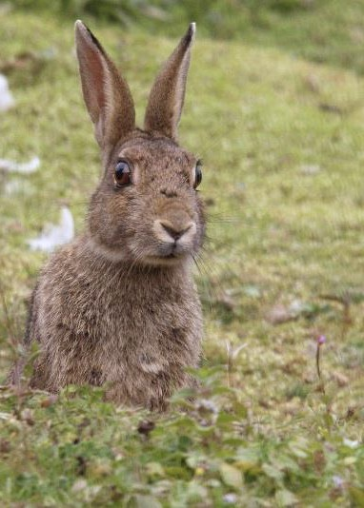

Shropshire Mammal Group Newsletter Issue 21 Winter 2014

And finally… an event for 9th January 2015 organised by our friends in Herefordshire Mammal
Group, which may be of interest! Mammal Photography by Tim Preston

Tim, from Dothill, Telford, has photographed these squirrels at Dothill NR and the rabbits at Venus Pool. Look forward to seeing more of your work in the newsletter in future, Tim. Meantime, check his Flickr page, here.
https://www.flickr.com/p hotos/33153464@N07/

And so, my first SMG Newsletter is complete and about to be published. I have relished putting this issue together very much, and my thanks go out to all the contributors who have generously supported my call for material, as well as the editors of all the previous issues. You could say Shropshire Mammal Group has now come of age with five years since its formation and 21 editions of the Newsletter. I hope that all members enjoy its contents, and of course, please do have a very happy Christmas and exciting New Year. Best regards… Ric.

Follow us on Facebook at https://www.facebook.com/groups/shropshiremammalgroup/ We’re also on Twitter: @Shropsmammals
If you spot a mammal in Shropshire, please record it via bit.ly/SMGrecord or email Lorcán Adrain at SMGrecord@gmail.com Articles and photos for the next issue of the SMG Newsletter to Ric Morris, Editor, at ric_morris@hotmail.co.uk please

