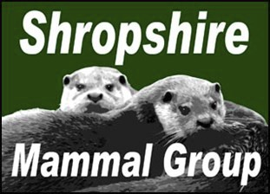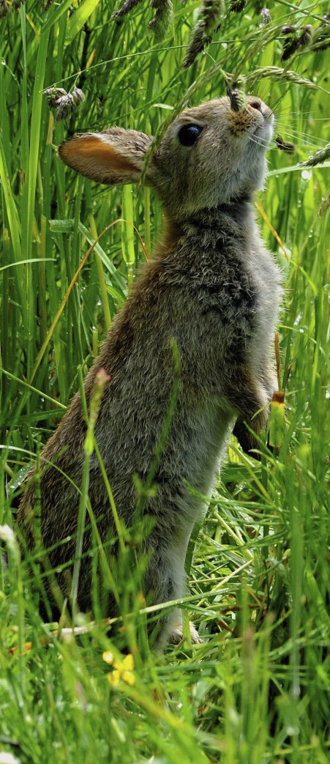

QUARTERLY Autumn 2014
Newsletter 20

Afflilated to the Mammal Society

CONTENTS

Mammal

A note from the Chair

recording
Shetland
Otters

Hide n Squeak

Events

The Great Nut Hunt
Corporate
members
2

4

6

7

8

9
It has certainly been a packed summer of mammal activity, with several survey events and walks taking place since the previous newsletter.
We started in May with our Severn Valley Mammal event at Severn Valley Country Park south of Bridgnorth. The park, which is managed by Shropshire Council had never been surveyed for small mammals and most of the mammal records made there consisted of otters, mink and deer sightings. Despite the most
torrential rain I have ever seen during a small mammal survey, a committed bunch of 17 showed up and stuck with it throughout to check 40 Tube Traps. Yellow-necked mice, bank voles, field voles, common shrews and wood mice
were all recorded.
Since then, we have run events and surveys at Bowbrook Allotments in Shrews- bury, a BioBlitz at Fordhall Farm (the first to be held there), a family day at Wall Farm and another Bioblitz at The Stiperstones. Another first for the group took place on 13th September when 17 members embarked on a journey by ca-
noe in search of mammals along the Montgomery Canal. The event was made possible thanks to Shropshire Paddlesport club who kindly allowed us to use a combination of their canoes and kayaks for the 8am start. Although no mam-mals were seen (this wouldn’t have been helped by the splashing created by the excited expedition party!), several otter spraints were located under each of the
bridges checked. It is our hope to return to the canal for a second time during the winter once the canal is closed to barge traffic, so anyone prepared for an
early start is welcome to come along.
In August, we welcomed the Meres and Mosses Landscape Partnership Scheme as corporate members of Shropshire Mammal Group and will look forward to working with the team to train more people in mammal recording in areas of north Shropshire. It has been a very productive summer and the schedule prom-ises to be just as packed going into the winter months. Paul Roberts will be lead-
ing surveys in search of dormice in the Llynclys area and volunteers are needed to assist Paul, plus for my dormouse nest box checks at Wenlock Edge in Octo-
ber. As always, all members are encouraged to join in with all surveys and events.

P a g e 2 N e w s l e t t e r 20

Mammal Recording in the County

By Lorcan drain
If anyone has any outstanding records, can you please email me (smgrecord@gmail.com) ASAP, as I am in the process of sending them off to SEDN. Many thanks.
When you cannot see a mammal.
Just because you cannot see a mammal does not necessary mean that none are in the area. Mammals can be very secretive nocturnal creatures that can move over large distances. Finding field signs and passing it on as a record is very important to a group like ours. We normally record field signs in the same way as visual signs, but the quantity is put down as 0.
From our records we can target areas to survey as opposed to picking an area and hoping for the best.
Essential kit: Some form of scale (L-square, ruler or a coin), camera/smart phone, hand lens, plastic bags and note book and pen. A photograph with some form of scale is very useful.
So what should we be looking for?
Signs of Feeding
• Nuts: Squirrels tend to break the nuts were as mice and voles make circular holes. Check using a hand lens if
you can see tooth marks and in what direction they go in.
• Pine cones: Squirrels will strip the cone to get at the seed leaving a ragged appearance. Mice will neatly
chew the cones.
• Vegetation: Look for feeding stations (small piles of vegetation). Most mammals turn their heads and chew,
resulting in a 45o cut. Length of the cut pieces reflects the mammal size.
• Gnawing: Bark on trees and branches, check height and direction of any teeth marks.
• Water: All mammals need water to survive, so check watercourses for entry/exit points. Don't forget to look
for footprints.
• Rosehips: Favoured by voles, they eat all the Rosehips and leave pile of seeds. Mice only eat the flesh and
leave the skin.
• Fungi: Rabbits, voles and mice will eat fungi, but also birds and slugs. Check for teeth marks.

Tracks
• Runs: Look to see if paths have been created in the grass/vegetation where the mammal has passed
through. look out for the size to get an idea of the mammal. Remember domestic dogs will create paths in popular location.
• Gaps: Check hedgerows for gaps, you can normally see runs going in and out of the gaps. Some mammals
will rest up and eat in these sheltered locations. Look out for bones.
• Hair: Caught in the bottom barbed wire on fences when mammals crawl under them. Badger hair can be
collected and put in a labelled bag.
• Footprints: Snow, river banks and muddy areas in fields are good places for prints. Make a note of size, num-
ber of toes, pads, claws. If you have more footprints you can check if they are front feet or back and meas-ure the stride.

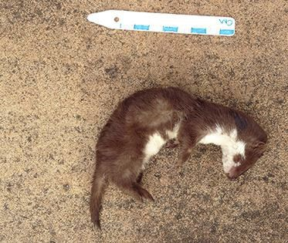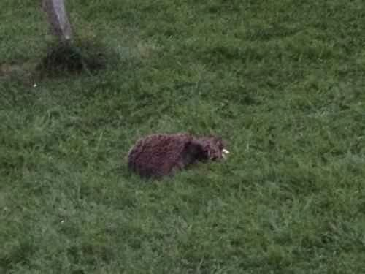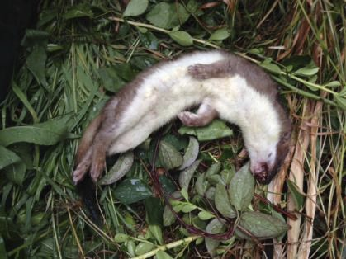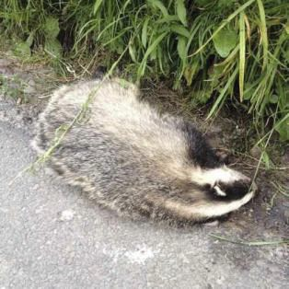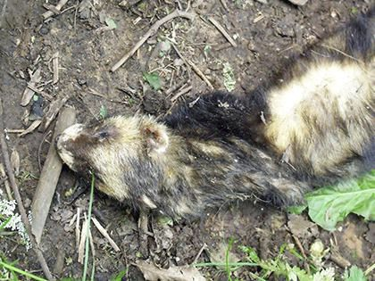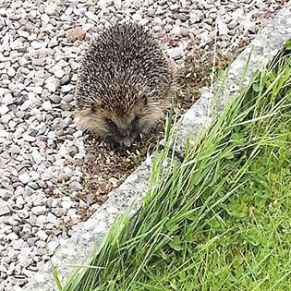

P a g e 3 N e w s l e t t e r 20

Latrines / scats
Check the shape, size and colour. If brave you can smell and see what contents it may have eaten.

Burrows
Size: Holes in the ground can be clues, but can be reused by other mammals. Look around trees and river banks.
Active signs: Look for signs of fresh digging, potential bedding in the area and the lack of cobwebs.
Molehills: Check if the soil is fresh. Sometimes you can see a hole that the mole has exited the burrow. Holes in river banks are also exit points for moles.

Remains of dead mammals
Bones: Foxes take food under hedgerows, decomposed remains. With skulls note the size, eye socket shape and teeth shape if available.
Bird pellets: Barn owl pellets can contain numerous small mammals that are eaten whole. Other bird pellets may contain whole skulls, but they tend to rip their food first.

Trail cameras
These can be left out in a secure location for any length of time and the images viewed later on. As the price comes down and the quality improves on these devices, they are becoming more useful in recording mammal behaviour.
So the next time you go for a walk, keep your eye out for signs and let me know.
Photos from our recorders

Price,Cath - Weasel - 9 June Breed, Andrew - Stoat - 12 July Cutts, Andrew - Badger - 2 July

Farnham, Catherine - Hedgehog - 28 June Polecat - Paul Wright - 15 May ne

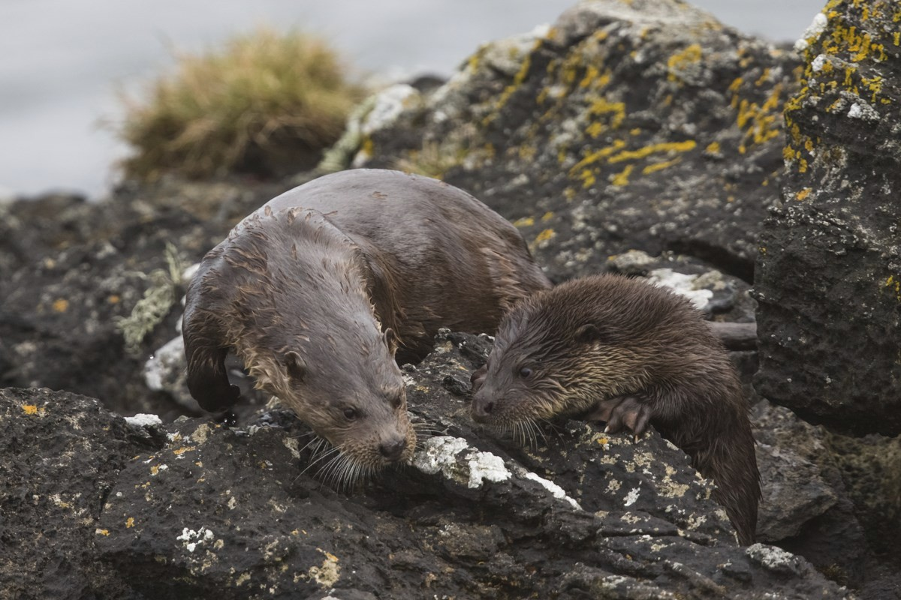

P a g e 4 N e w s l e t t e r 20

SHETLAND OTTERS

BY ANDREW FUSEK PETERS

I got up at four this morning, ready to drive across Shetland mainland in the thickest fog I’ve seen in years. I’m off to meet one of the great UK sea oter experts and photographers, Richard Shuck-smith. By the tme we hook up in a lonely car park at 5.45, visibility is a camera’s nightmare. He tells me I might as well go home, no otering today. But then we get natering, and before I know it, I’m back at his house drinking a welcome cup of tea and trying not to feel jealous of his amaz-ing underwater rigs and prize winning gannet and oter shots. Time performs its miracle and the fog, like tde, recedes. Suddenly Richard is excited. ‘We’re off!” and like a dog on the scent, we’re zooming in his van across the island. There are about 1000 oters on Shetland and Richard has studied and tracked them for years. To say he knows their habits and territories intmately is an understatement. Twenty minutes into our drive, the mobile goes and we swerve to a halt, only to hear that oters have been sighted in the voe {a long, inland bay that looks like a lake΃ opposite his house. We reverse and I am beginning to believe I might spot my first ever oter.

His mate Matt Doggett, yet another BWPA winner, has been out tracking a mother and cub through the foggy dawn and they are now resting on an island in the middle of the voe. We track round the edge of the water over the pebbly shoreline past houses and farms until we are opposite the island, then hunker down. Richard is constantly checking wind direction, to make sure they can’t sniff us out. Tripod is set up and soon I am crouching on a grassy knoll, looking at… well, nothing.

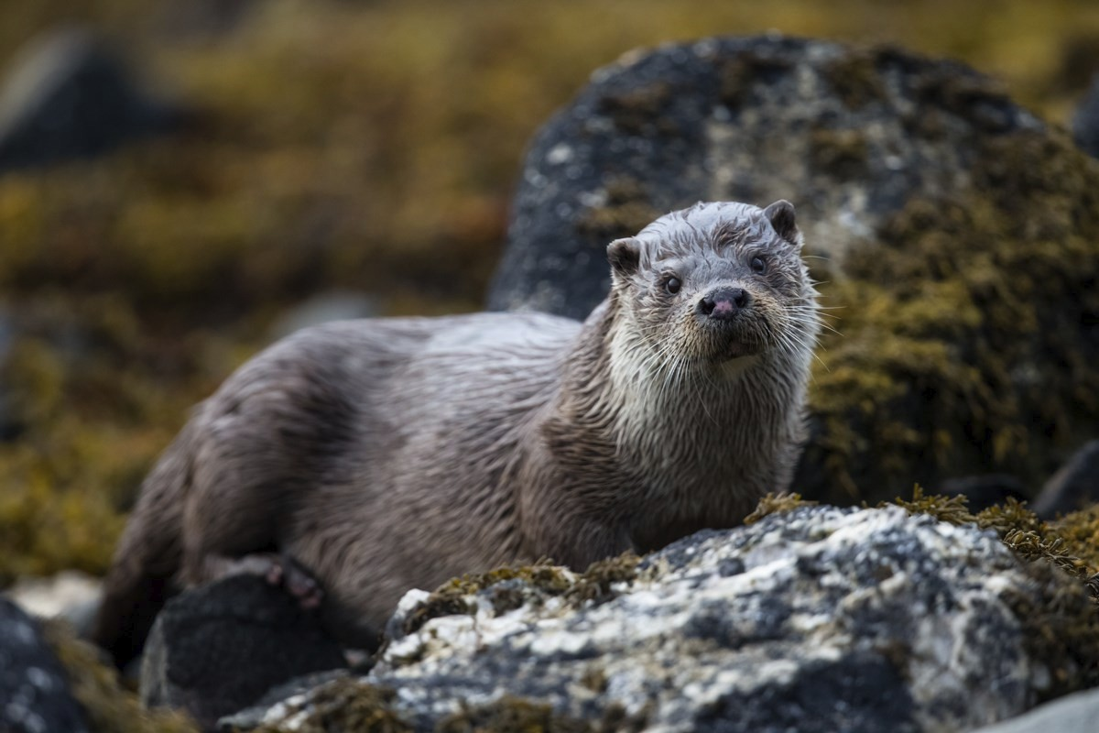

P a g e 5 N e w s l e t t e r 20

They are behind the rocks on the other side. This is where Richard assures me it’s all about pa-tience as the tide slowly rises to push them off the rocks. It takes a good hour but I don’t believe in anything until a small, brown slithery form comes off the rock and heads out to fish. Too far away even at 1000mm on my lens. But Richard knows their habits. He assures me they will swim straight towards us, to a tiny island only twenty feet away. He’s right, they do, I am blown away by fur, sleekness, ebony eyes, smooth movement and mother-cub intimacy.

And this is only half the day. A longer drive to a far distant voe up north where the lines of mus-sel farm betray industrial size interaction, we end up tracking a female from afternoon through to sunset. We watch her fish, roll in spraint, dive, play, work the shore line, rest up. We follow in a game of musical chairs. She dives and stays under for about twenty seconds, so we scramble over sharp rocks, then freeze as she comes up. Stop and start, for hours, getting ridiculously close. At one point, as we stand on a grass spraint patch, she comes up through the kelp and to within five feet of us. Richard has to gently hiss her back. His concern is for otter first, and no stress for her, and me second, out for my day of mammal delights. As evening falls, my last pic is a silhou-ette of her on the rocks.
Now, all I need it to find those river otters in a certain county closer to home. All help gratefully received and am so excited that Richard will be coming down for a two day ‘ottertastic’ trek this autumn.
Andrew Fusek Peters www.andrewfusekpeters.com
Disclaimer: please note that European Otters are protected under the Wildlife and Countryside Act 1981 and licence is required to disturb wild otters and their holts. Please see www.naturalengland.org for more details.

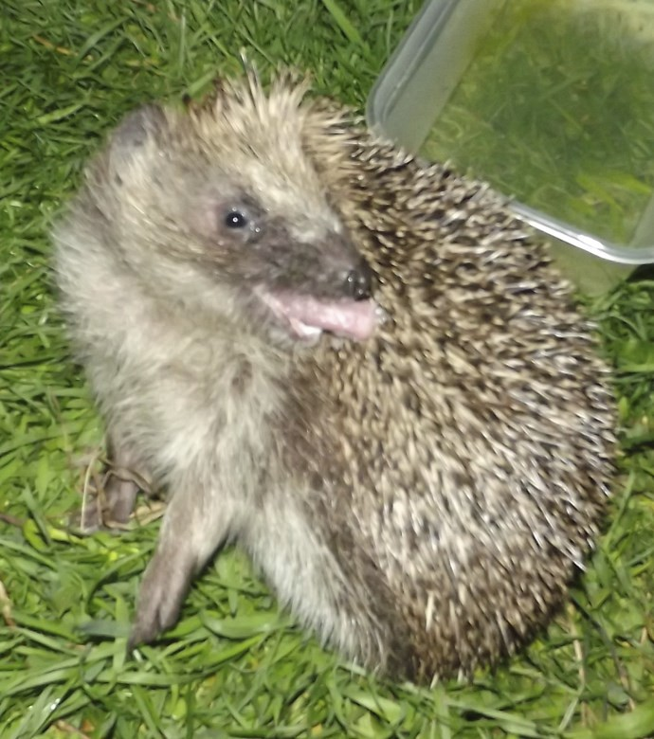

P a g e 6 N e w s l e t t e r 20

Hide n Squeak project up and running
In June, we were delighted to receive the news that a funding application to the Heritage Lot-tery Fund to run a new mammal project was successful. The Hide n Squeak project aims to en-courage more members of the public to become actively involved in mammal surveys and in using survey equipment. It will run until the end of January 2015, when we plan to have an end of project celebration at the Shropshire Wildlife Trust function rooms in Shrewsbury.
£6000 was awarded to cover the cost of equipment purchase to be used by members of Shrop-shire Mammal Group, including additional camera traps and hedgehog footprint tunnels. Also on the shopping list is an events shelter, which will benefit the group when we attend fairs and engagement events. In addition, we will be able to buy more specialist equipment such as dor-mouse nest tubes for local groups to use in identifying previously unrecorded dormouse sites.
The funding has been awarded based on an agreement for SMG to reach an ambitious target of 300 people through public engagement events and surveys, so with that in mind, we will be planning further events and surveys to run throughout the winter, including:

Dormouse surveys around Llynclys
Otter hunts along the Severn
Mammal tracks and signs in the field Camera trapping for large mammals

For more details, keep an eye on the Facebook page and group emails between now and No-vember.

P a g e 7 N e w s l e t t e r 20

Surveys and events this winter
Sunday 19th October
The Great Nut Hunt
Join Paul Roberts and “The Nutters” at Llynclys to search for the feeding remains that will indicate dormice are still present in the area.
Meet in Tregarthen Lane, Pant, Oswestry, Shropshire SY10 8LF at 9:30 . We will be finished by 13.30.
Friday 24th October
Using camera traps to record mammals
Part of the Hide n’ Squeak project, this session will involve walking the woodlands of Earls Hill in search of signs of deer, badgers, foxes and otters. Please email Joe.Penfold@shropshire.gov.uk to book your place and for more de-tails. A follow-up session will take place the following Friday to check camera trap
footage, both sessions will begin at 10am and will run until 12.30pm.
Tuesday 11th November
Mammal survey of Prees Heath
This Butterfly Conservation reserve is well known for its abundant insect life but little is known about the mammals there. A small mammal survey at 9.30am will help to get a clearer picture of the mammal presence until 12.00pm.
Sunday 16th November
The search for scat
Finding scats and droppings is an alternative way to collect mammal records. This ramble will aim to discover scats, latrines and droppings and teach members how to identify the origin of the scats found. 10.00am until 13.00pm.
Location to be confirmed!

What would you like to get involved in?
Are there any activities that you would like to do, as a group or individually? Please let us know by emailing shropshiremammalgroup@gmail.com

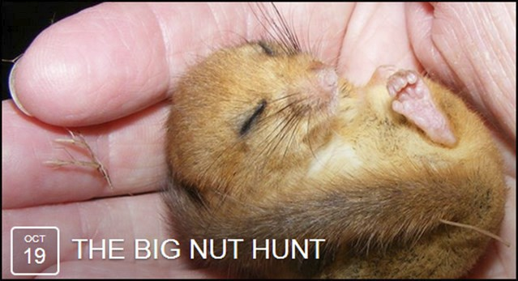

P a g e 8 N e w s l e t t e r 20

Take part in Big Nut Hunt and help save the endangered dormouse
Do you want to be a “Nutter”? Help us survey for nibbled nuts or dormice to help establish their distribution throughout the hillsides of LLynclys, Llanymynech and Pant. “The Nutters" the dormouse recorders for Shropshire Mammal Group are
holding the biggest nut hunt in the county.
Shropshires public survey to help save threatened hazel dormouse (Muscardinus avellanarius) organised by Shropshire Mammal Group in conjunction with the People’s Trust for Endangered Species (PTES), Shropshire Wildlife Trust, Lafarge
Tarmac and Montgomeryshire Wildlife Trust.
Throughout the winter months “The Nutters” are calling on the public to help
search the woodlands around Llynclys, Pant and Llanymynech for tell-tale signs of gnawed hazel nuts, to help determine the distribution status of this rare mammal and the health of our woodlands and hedgerows.
Meet in Tregarthen Lane, Pant, Oswestry, Shrop-shire SY10 8LF at 09:30 on the 19th October 2014͘
For more informaton email Paul Roberts: pjroberts1969@yahoo͘co͘uk



P a g e 9 N e w s l e t t e r 20

You can record records on our website at: bit͘ly/SMGrecord or email and photographs to: smgrecord@gmail͘com

Corporate Members
Shropshire Mammal Group is grateful to its corporate members for their support.

• Field Studies Council - Preston Montford Field Centre
• Pearce Environment
• Whitchurch Community Water Vole Project
• Shropshire Wildlife Trust - Ellesmere Branch
• Roberts & Son, Lower Wallop Farm
• Shropshire Bat Group
• Ricoh Ltd
• Meres and Mosses Landscape Partnership Scheme

