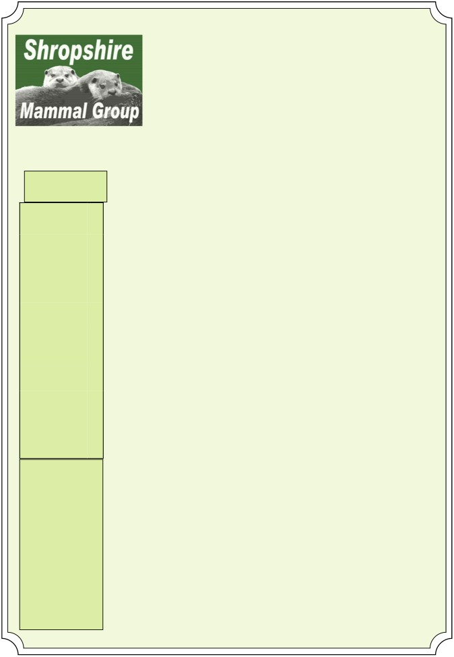

QUARTERLY Summer 2014

Newsletter 19

Afflilated to the Mammal Society

Inside this
Note from our Chairman.
Chairman Note 1
At last, summer has the highlight for many number of times, even
arrived and the survey was the appearance of giving an insightful talk
season is once again a family of foxes on the to SMG members
Water Vole Pro- underway. At the end camera traps, seen about his work with

ject

Mammal Re- cording

National
Hedgehog Sur- vey

Special
2

4

10
of May, the first group survey event of the
year took place at Wall Farm to give people a taster session of con-ducting mammal sur-veys in the field, using camera traps, footprint tracking plates and
small mammal traps. The results were very positive compared to the small mammal sur-vey conducted in 2013,
sheltering under a bridge during some of the heavy showers. Our next event takes place later this month and hopefully we will see some of you at the lovely Severn Valley Country Park near Bridgnorth where we hope to find more evi-dence of harvest mice. We also received some
otters over the years. Rob’s enthusiasm and commitment to re-cording mammals will be sorely missed but it would be Rob’s wish for anyone involved in mammology to con-tinue to work towards developing a better understanding of how wild mammals are
adapting to an ever-changing environment.

points of
interest:

• Volunteers NEEDED for
National
Hedgehog
Survey
with yellow-necked mice, bank voles, com-mon shrews, field
voles, wood mice and even a house mouse appearing in the 40 tube traps placed
around the farm. But
very sad news in May when it was an-
nounced that Rob Strachan had passed
away after a short bat-tle with an aggressive form of cancer. Since the group began, Rob offered support to us a
We welcome Ricoh Ltd of Telford as our latest corporate member this month and look for-ward to sharing sup-port with the team
over the coming years.



P a g e 2 N e w s l e t t e r 19

Newnes Brook Water Vole Project.
from the Shropshire Mam-
mal facebook page to the EWG, so please take a look.
On the 14th May 22 volun-teers attended a water vole surveyors training day. Paul Roberts gave a brilliant pres-entation about water vole ecology and their field signs.

Water Voles are one of Britain’s fastest declining Mammals. Their wetland habitats have been de-stroyed, or damaged and remaining water vole
populations have be-come fragmented so that populations are no
longer viable. Water voles are also a particular favourite snack of Mink. Luckily for Shropshire water voles appear to be doing reasonably well in the North of the County. Since 2006 Whitchurch Community Water Vole Group’s surveys have shown that the
Whitchurch - Whixall area continues to be a national hotspot for wa-ter voles.
There were also records of water voles in the
Ellesmere and North-wood area. The Environ-ment Agency confirmed that water voles were living along the Newnes Brook and at a couple of
pools between Ellesmere and Duddleston Heath a
couple of years ago. The size and resilience of this popula-tion is not known, so the New-nes Brook Water Vole Project was started.
Newnes Brook Water Vole Project
I work as a Biodiversity Officer for the Environment Agency. Together with the Meres and Mosses Landscape Partner-ship, RSPB and some very wel-come help from Paul Roberts of the Shropshire Mammal
Group, I have set up the New-nes Brook Water Vole Project. The idea of the project is to find out how big the Ellesmere Water Vole population is and to enhance habitat in the area to make the Ellesmere water voles more resilient.
Ellesmere Water Vole Group A key aim for the project is to find out where and how many water voles there are. 25 vol-unteers have formed The
Ellesmere Water Vole Group. The group have their own
facebook page and even their own art work, thanks to Cath Price from Shropshire Wildlife Trust. A link has been set up
Then the afternoon was spent spotting field signs at nearby pools and practising a survey along the Newnes Brook. We were kindly al-lowed to descend upon Trevor and Sue Taylors pools which are a haven for wildlife, including water voles. Trevor and Sue have done such a fantastic job of looking after the pools that Countryfile recently filmed the water voles there. The Ellesmere Water Vole Group is gradually surveying the Newnes Brook. We are counting latrines, burrows and feeding piles and re-cording habitat details in 50m stretches. The surveys will tell us where the water voles are and will give us some indication of the size of the population. The sur-veys can be repeated in the future to see how well the water voles are doing.

The following picture: Alex Grant and Amanda Bevan surveying Newnes Brook at Cricket.

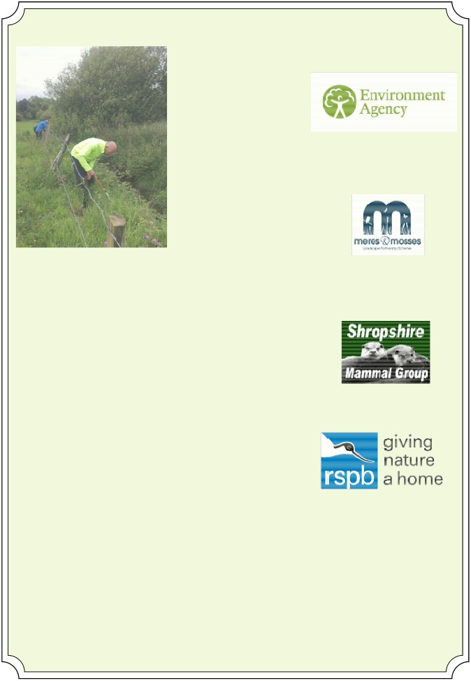

P a g e 3

Habitat Enhancement The Newnes Water Vole Pro-ject has also applied for landfill tax credit funding from the SITA Enriching Nature Pro-gramme to undertake habitat work. If the bid is successful (we are due to find out on the 24th June) then we will build water vole banks and plant up a large lake that had been cre-ated by a Farmer from blocked field drains. The project will also fence
500m of the Newnes Brook too prevent livestock poaching and provide a 6m strip of buffered habitat for the water voles.
The Ellesmere water vole group have surveyed 120m of the Newness Brook, tributary ditches and a new pool at this location. The fencing is cur-rently barely more that 50cm from the waters edge and the ditches are heavily poached by cattle. The surveys found a to-tal of 15 latrines, 140 burrows,
1 footprint and 93 feeding

N e w s l e t t e r 19

piles. Latrines and footprints seem to be hard to find. This may be because the surveys have followed heavy rain
showers and the vegetation is now high, so they are diffi-cult to spot. Could it also be that the number of water voles in the area is low and that they have large territo-
ries, because the fenced strip of habitat is narrow? If you have any theories then let me know. Paul and I were
very lucky to see a water vole swim across the ditch along this stretch in early May.

Water vole surveying If anybody is interested in joining the Ellesmere Water Vole Group please get in touch with myself
(07802534130, csav-age@freeuk.com) or Cath Price at Shropshire Wildlife Trust.
If you have any useful sug-gestions and tips for our pro-ject then again please get in touch.

Caroline Savage.

P a g e 4 N e w s l e t t e r 19

Mammal Recording in the County.
The importance of recording sightings with your County recorder.
Today with lots of different requests and methods for recording mammal sightings. It is even more important to record your sighting via the county recorder, as this is the start of the flow of informa-tion to various organisations.

County recorder è Shropshire Ecological Data Network è National Biodiversity Network

Records are passed onto the county recorder from various sources: iRecord, emails, websites,
spreadsheets, verbally and even scraps of paper. The county recorder takes various things into ac-count before making a decision to either validate the record or reject it. You may get an email ask-ing for further information to clarify certain bits of data like the grid reference or confirmation of the location before your record is validated.
We pass our valid records on twice a year to the next level (The Shropshire Ecological Data Net-
work) along with other Shropshire recording groups, to build up a bigger picture within the county. The data for the county is then passed on to the National Biodiversity Network where all the data is grouped together for the United Kingdom.
An interactive map is available on the NBN website at: https://data.nbn.org.uk/imt
As a local group we respect records flagged up as sensitive that the recorder does not wish to have passed on but are happy that we can use them internally.
Unfortunately some organisations bypass this data flow and pass unverified information directly onto the NBN. This means that valuable data is lost to both the county recorder and the SEDN. These records are not validated, so some doubtful entries get onto the NBN database. Hopefully at some point in the future this loophole will be fixed.

How is all this data used
One new potential use of the data is due to the increase in planning applications and changes
within councils. They are looking at the possibility of using existing records as a trigger to indicate that the area should be checked before planning permission is granted. They are currently looking at BAP mammals and phase 1 habitat vegetation.
The data allows us to produce maps for easy visualisation of the record locations within the county and this lets us target areas to survey.
As a local group we are looking to produce an atlas of mammals in Shropshire in the form of a book, and this would include species and density maps. More information on this in a later newsletter.

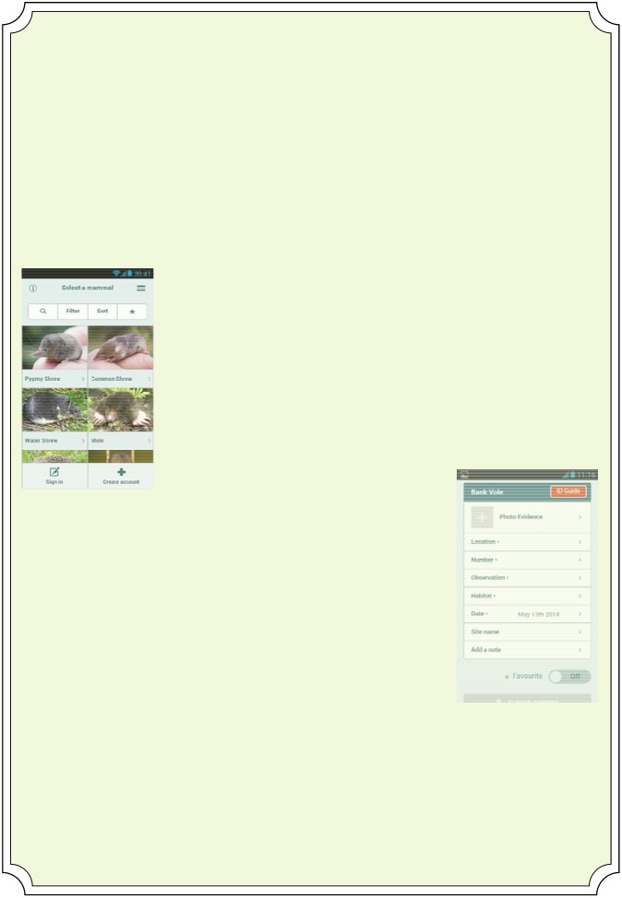

P a g e 5 N e w s l e t t e r 19

Anyone who has emailed (smgrecord@gmail.com) me a spreadsheet would have received back a map showing their sightings as a reference.
A new way to monitor Mammals
Mammal.Tracker
This is the new application for Apple or Android phones and tablets and has been produced for the Mammal Society. Data is entered for a record and you can attach a photo to help with the verifica-tion. This is then sent on to iRecord where the record can be verified by the county recorder and passed along the established data flow route.

The initial screen lets you select the mammal by clicking on a photo. A sort feature and filter option are available. You can scroll through the pictures until you see the one you want.

Once you see the picture that looks right you simply press on the picture to get to the data entry screen.
At the bottom of the screen you have an option to sign into an existing iRe-cord account or create a new account.

This is the data entry screen , the first option is the red button ID Guide that brings up a new screen describing the mammal, a distribution map and similar mammals (see the screen shots below).

Photo evidence: take a photo via a camera or use a saved file.
Location: Use the current gps location or you can select one from a map. Number: select from a range of numbers.
Observation: select from a range of observations. Habitat: select from a range of habitats. Date:
Optional fields are :-Site name:
Add a note:

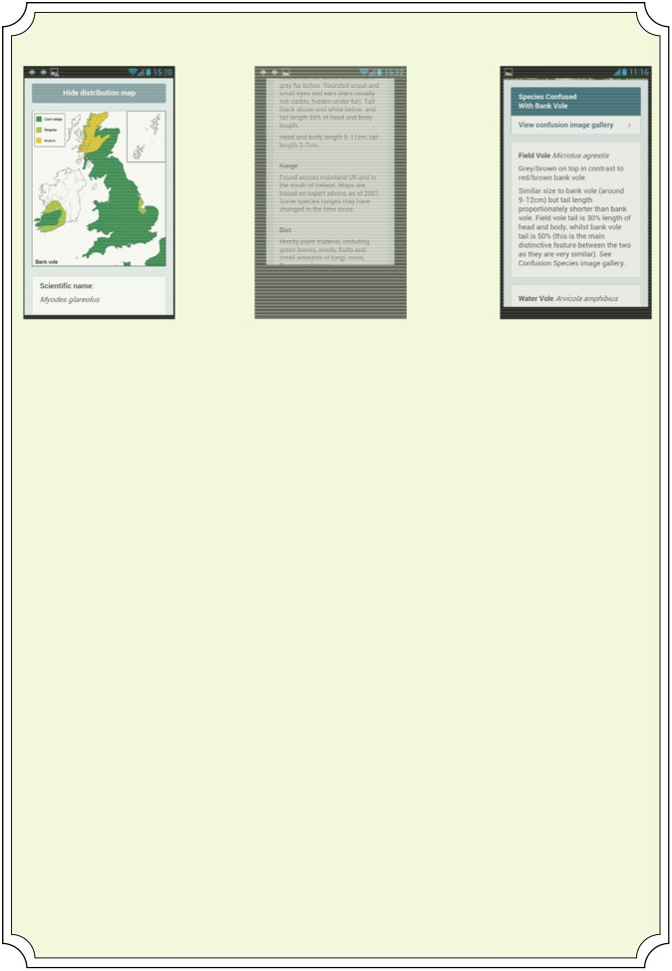

P a g e 6 N e w s l e t t e r 19

Distribution Map Identification info Similar species

I have raised two issues with them. The date format is displayed as month,day,year for example May 13th 2014. I have asked if they can use the format from the devices settings. The second point is that the location is sent to iRecord as latitude/longitude. Any records entered onto iRecord directly are held in GB ordnance survey format of SJ494128.
Due to the small number of records currently going through I am currently converting the date and grid reference into the standard format.
So if you have an Android smart phone or an Apple phone or even a tablet/iPad then conceder go-ing to the store and doing a search on mammal.tracker and installing it on your device.
As more ways of recording onto different platforms and systems are developed, then the role of the county recorder will change. It will not be the case of recording and verifying the records but will include the added role of filtering out duplications, as different people will potentially record the sightings from the same event.
So my next project will be to filter records within a 10 day period within 2 miles radius for similar mammals.

Rabbits in Shropshire
Rabbits are a typical under recorded species in Shropshire, most people think that because they are common they do not need to record them as someone else would have submitted a record. As you can see from the latest map we have lots of areas that have no rabbit records, can you fill in the gaps?

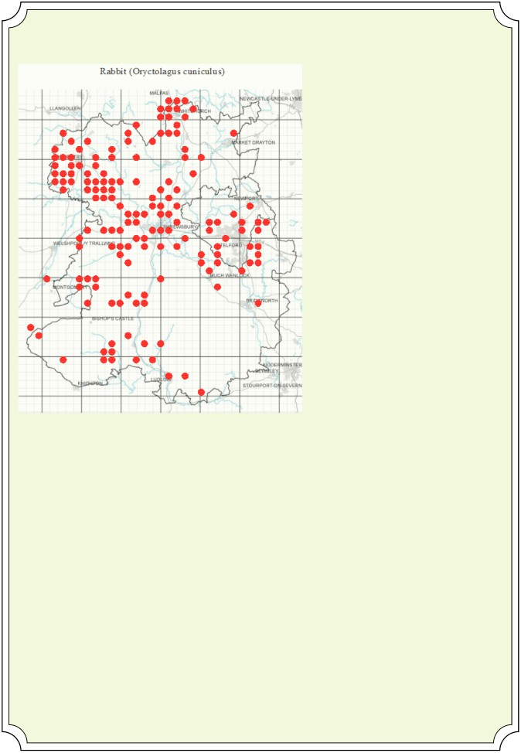

P a g e 7 N e w s l e t t e r 19

Would you like to get involved?

As a group we have always actively encouraged the training of local groups with the skills and
knowledge that will enable them to carry on and organise activities within in the county at a local level. This also includes the load of equipment and expert support, if needed. We have run successful small mammal trapping sessions in the past and recently started Hedgehog surveys and are introducing Hazel dormice surveys.

What would you like to get involved in? Do you have any activities that you would like to get in-volved with either as a group or individually.
Please let us know by emailing shropshiremammalgroup@gmail.com

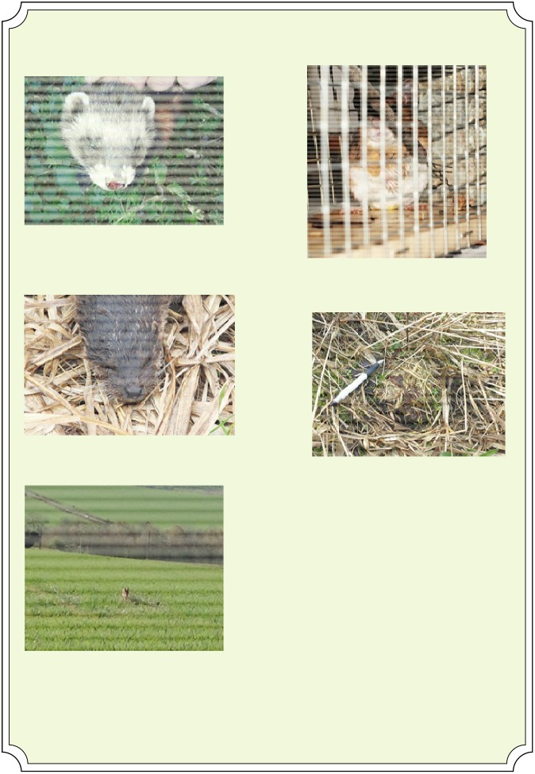

P a g e 8

Photos

Balmer, Dawn - Polecat - 15 March 2014.

Dyer, Clive - Otter - 24 March 2014.

Ball, Joyce - Brown Hare - 23 April 2014 .

N e w s l e t t e r 19

WECWG - Yellow-necked mouse -
23 March 2014 .

Rebecca Clews-Roberts - Harvest Mouse -
29 March 2014.

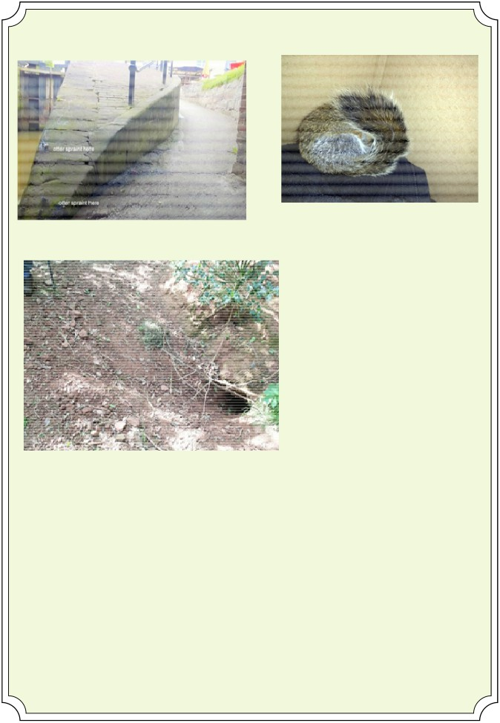

P a g e 9 N e w s l e t t e r 19

Carter, Tracey - Squirrel - 6 May 2014.
Long,Kate - Otter Spraint- 2 May 2014.

Wright, Paul - Badger sett - 15th May 2014.

You can record records on our web site at: bit.ly/SMGrecord
or email and photographs to: smgrecord@gmail.com

Lorcan Adrain

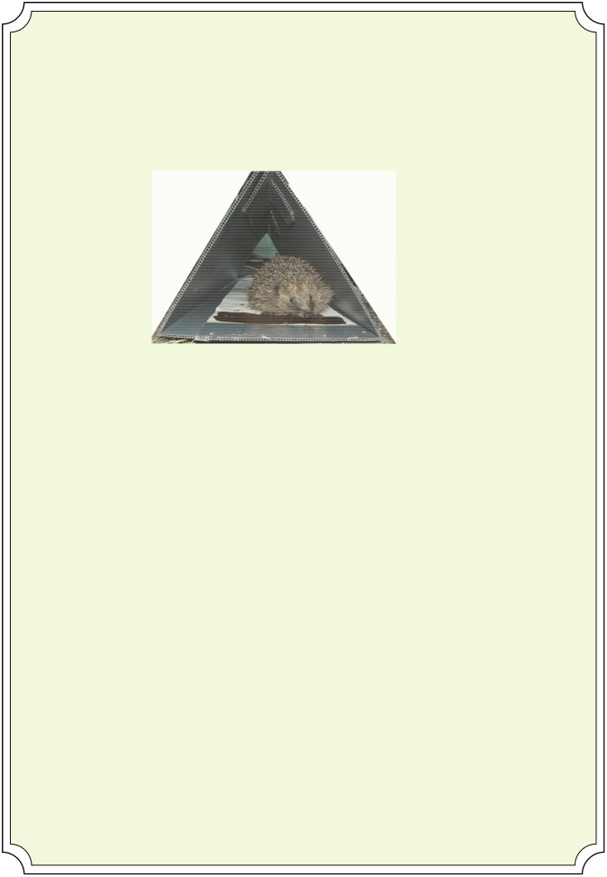

P a g e 10 N e w s l e t t e r 19

Volunteers needed: National Hedgehog Survey.
People’s Trust for Endangered Species is launching a National Hedgehog Survey this year and Shropshire Mammal Group is keen to contribute as many records as we can.

A pilot study by Nottingham Trent University, the University of Reading and The Mammal Society demonstrated that footprint tunnels were a reliable survey tech-nique for hedgehogs. Now, the University of Reading and Nottingham Trent Uni-versity, in collaboration with People’s Trust for Endangered Species and British Hedgehog Preservation Society are conducting a National Hedgehog Survey, which aims to map the occupancy of hedgehogs across England and Wales and to further investigate the relationship with badgers. The plan is to sub-sample na-tional badger sett survey squares and conduct hedgehog tunnel surveys in those squares. 400 sites have been selected across the country, with seven of those lo-cated in Shropshire and we are seeking volunteers to help with the survey effort over the next two years.
A site survey involves the deployment of 10 hedgehog footprint tunnels in a des-ignated 1km square area, which need visiting once a day for five days. Footprint tunnels, a map of survey sites and associated equipment (bait, protocol etc) can be supplied to all volunteers. If you are able to offer your help to monitor one of the Shropshire sites, please email stuarte@shropshirewildlifetrust.org.uk and more information and a selection of locations can be sent for you to choose from.
Stuart Edmunds.

P a g e 11 N e w s l e t t e r 19

Please keep an eye on our website, Facebook page and Twitter to see what events and surveys we have coming up!

Thank you to everyone who contributed!

If you are interested in contributing to future newsletters, please send entries to:
holly.shingler@btinternet.com by Sunday 14th September 2014.

Corporate Members
Shropshire Mammal Group is grateful to its corporate members for their support.
• Field Studies Council - Preston Montford Field Centre

• Pearce Environment

• Whitchurch Community Water Vole Project

• Shropshire Wildlife Trust - Ellesmere Branch

• Roberts & Son, Lower Wallop Farm

• Ricoh Ltd of Telford

