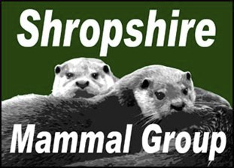

QUARTERLY

Spring 2014

Newsletter 18

Afflilated to the Mammal Society

Chairman’s Note
INSIDE

THIS
ISSUE:

Conservation of 3- Red Squirrels 5

Mountain Hare
The survey season is now upon us and a schedule of training events has been set to encourage more people to record their
mammal sightings. However, we still need lots of help with running surveys for priority species too; dormice and polecats being key ar-eas of focus in 2014. After the poor weather last year, which led to the postponement of several surveys, survey activities may occa-sionally happen with only a short amount of notice to members if the weather is looking suitable. We will email out news of surveys

Day

Mammal Re-cording in the
County

Rodent Bones

A trip to Wild- wood!

Harvest Mice

Mad March
Hare

Dormouse
Tubes
5

6-
7

8-
10

11
-
12

12
-
15

15
-
16

17
as they come up and as always, for those members using Face-book, survey dates will also be posted in the SMG group page.
On one last note, it was great to see our small group getting not one, but two articles in the spring edition of the Mammal Society’s Mammal News. The group’s profile is likely to be given a further boost at the forthcoming Mammal Society Spring Conference
where Ric Morris and myself will be speaking to 150 delegates about mammal work in Shropshire and of course…Ric’s bone col-lection! The conference takes place at Aston University in Birming-ham over the weekend 4th - 6th April and tickets are still available from www.mammal.org.uk

Continue onto the next page to see what excitement we have in store for the up & coming
Shropshire Mammal Group events and surveys 2014...

P a g e 2 N e w s l e t t e r 1 8

Saturday 12th April
Stretton Hedgehogs
Church Stretton
Continuing Gareth Parry’s work with the Strettons Area Community Wildlife Group to re-
cord presence of these increasingly elusive mammals.
Date TBC when access has been agreed
Hide ‘n’ squeak in Darwin’s Garden
Darwin’s Garden, Drinkwater Street/ Darwin Street, Shrewsbury
This will be the first survey of the site that Darwin himself used to wander around during his
childhood.
Sunday 25th May
Wall farm camera trapping and mammal tracks and signs
More details to follow!
Kynnersley, Telford, TF6 6EQ
Friday 27th and Saturday 28th June
Mammals of Severn Valley Country Park
Setting up camera traps and tube traps the night before. There was a harvest mouse re-
cord made at the park recently, so there is potential for finding our first Tube Trap caught
Shropshire harvest mouse. Camping on the park is possible.
Sunday 6th July
Mini bioblitz - Bowbrook Allotments
B4386, Shrewsbury, Shropshire SY3 5BT
Emptying small mammal traps and checking hedgehog tunnels at this conservation friendly
allotment.
Saturday 26th and Sunday 27th July
Mammals of Apley Woods
Although there are many bat records from the woods there are few records for small mam-
mals. A small mammal trapping session will hopefully uncover records of voles and yellow-
necked mice.
Saturday 16th and Sunday 17th August
Fordhall Bioblitz
This will include small mammal trapping and bat detecting, amongst other recordings of
plants and birds. SMG members are invited to come along to help to check tube traps,
hedgehog tunnels and camera traps.
Saturday 23rd August
Stiperstones Bioblitz
The Bog Visitor centre, Stiperstones
Emptying traps and looking for mammal signs on the day. Natural England event taking
place over bank holiday weekend. There will be beetle and dragonfly recording taking
place.

P a g e 3 N e w s l e t t e r 18

Conservation of Red Squirrels.
Samatha Rigg.
Red squirrels Sciurus vulgaris (reds) have been in the UK since the last ice-age how-ever their numbers have been declining in the UK for several years now mainly due to the introduction of the invasive grey squirrels (greys), which are better able to live in most broadleaved and mixed woodland areas than the red squirrel (Petterson and Pepper, 1998, pp. 1-5). The grey squirrels came from America nearly 130 years ago and brought with them the devastating impact of squirrel pox virus which is unfortu-nately lethal to red squirrels but not the greys as they carry and spread the virus. Al-though habitat fragmentation may have also played a part in the decreased number of native red squirrels as it removes their breeding and resting grounds therefore jeop-ardises their future. By 1940 the grey squirrel had occupied large areas of the UK and slowly replacing the native red squirrels. Now only one hundred and forty thousand red squirrels are left in the UK.
Red squirrels are protected under the Wildlife and Countryside Act 1981 (W&CA) and the Wildlife (Northern Ireland) Order 1985, which makes it an offence to intentionally kill, injure, take or sell the animal, or damage, destroy or obstruct access to its nesting place. Grey squirrels are not protected and their release or introduction is prohibited (Petterson and Pepper, 1998, pp. 1-5).
One of the earlier methods of conserving the red squirrels was issued by the Govern-ment which encourages a continued overall expansion of woodland of all types. Broadleaved and mixed broadleaved/conifer woodlands gave us many benefits for wildlife, landscape and recreation as well as timber (Petterson and Pepper, 1998, pp.
1-5). However, more trees and woodland areas would further encourage grey squirrel expansion not just the red, especially where beech, oak or chestnut are planted. Red conservation will therefore require difficult choices about the types of woodland and wildlife we want and the method to which we use. To be successful red squirrel con-servation projects will usually need to be sustained indefinitely over large areas, often involving many landowners which may not always be willing the help with the conser-vation as it will have an impact on their land.
There has been a lot of professional and volunteer habitat surveys carried out on vari-ous mixed woodland areas all over the UK which has aimed to indicate areas pre-ferred by reds squirrels and areas that have the potential for habitat improvement to favour reds. The main methods of surveying used are traps such as the hair-tube sur-vey trap, which are baited pipes which catch hairs from the backs of small mammals that run in and out of the tube, and time-area observation counts. Together with moni-toring of red and grey populations, these surveys carried out will provide information on habitat use, population dynamics and where overlap with grey squirrel populations occurs (Petterson and Pepper, 1998, pp. 1-5). Monitoring is important to provide data which may highlight future problems for the red squirrels.
The only currently legal and recommended grey squirrel control methods in red areas

P a g e 4 N e w s l e t t e r 18
are shooting and live-capture cage trapping, however the trapping my also capture red squirrels not just the grey so these have to be checked and monitored on a regular ba-sis. In the past ten years it has been proven that if the grey squirrels are removed from an area then the red squirrels will eventually return. For example Anglesey in North Wales, a decade ago grey squirrels had overrun the island leaving only 30 individual red squirrels against around thirty thousand greys but with the proper control and sup-port from various conservation organisations, grey squirrels have now been virtually removed from the island and the number of red squirrels have been slowly increasing in that area (Rsst, 2013). However the reintroduction of red squirrels into areas where grey squirrel population need to be regulated and controlled very carefully to make sure the number of reds do not decline once again. Red squirrels are slowly being re-introduced where they can return to their former range with great success if the local conditions are favourable for them. Many areas where reds have been successfully reintroduced, such as Anglesey, and where there has been a good level of control over grey squirrels has shown just how quickly the red squirrel population can dis-perse to the rest of the UK from a successful area.
In many woodland areas where reds are now inhabiting, maintaining a suitable age structure and diversity of the trees and shrubs in that area, with grey control where needed, will always be under threat from the grey squirrels, and more extensive habi-tat improvement to many of the woodland area should be planned.
Conservation efforts in the UK to help the red squirrels have been growing in response to the decline and loss of our native squirrel and many groups and individuals includ-ing woodland owners and managers are involved. The fight for our native red squirrels against the invasive grey squirrels is slowly getting easier and there is much more reds around in the UK than there was ten years ago, however the amount of attention and time for conservation of the reds is still needed and different methods are still be-ing investigated.
Red squirrels are still abundant in parts of Scotland and Ireland with isolated popula-tions in Wales and the north of England. The Vincent Wildlife Trust is undertaking re-search on the red squirrel through its MISE project. There are thought to be only three significant red squirrel populations left in Wales: on Anglesey, Clochaenog Forest in North Wales and in the mid Wales forests. The Trust is engaging in surveys and moni-toring the distribution and status of red squirrels in these areas, as well as raising
awareness of what can be done to conserve these populations.
There is a tenuous theory that pine martens are helping the increase of red squirrels. In Ireland a national squirrel survey suggested that the normally invasive grey squirrel had gone into decline in the Irish midlands, which was anecdotally attributed to an in-crease in European pine marten, Martes martes, range and numbers (Sheehy and Lawton 2014). The Shropshire star June 11, 2011 reported to sightings near the canal in whitchurch but with pine martens on our borders in north west shropshire we may be seeing red squirrels in oswestry yet!

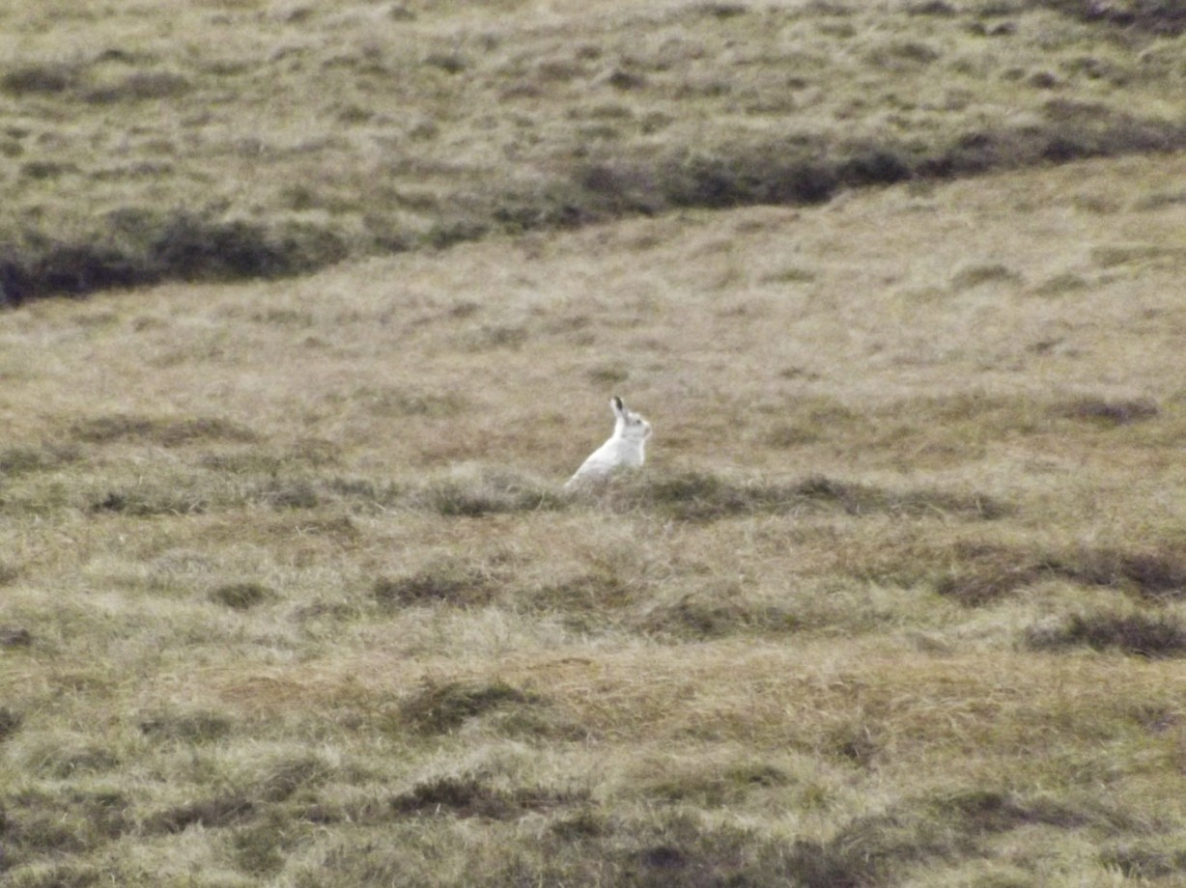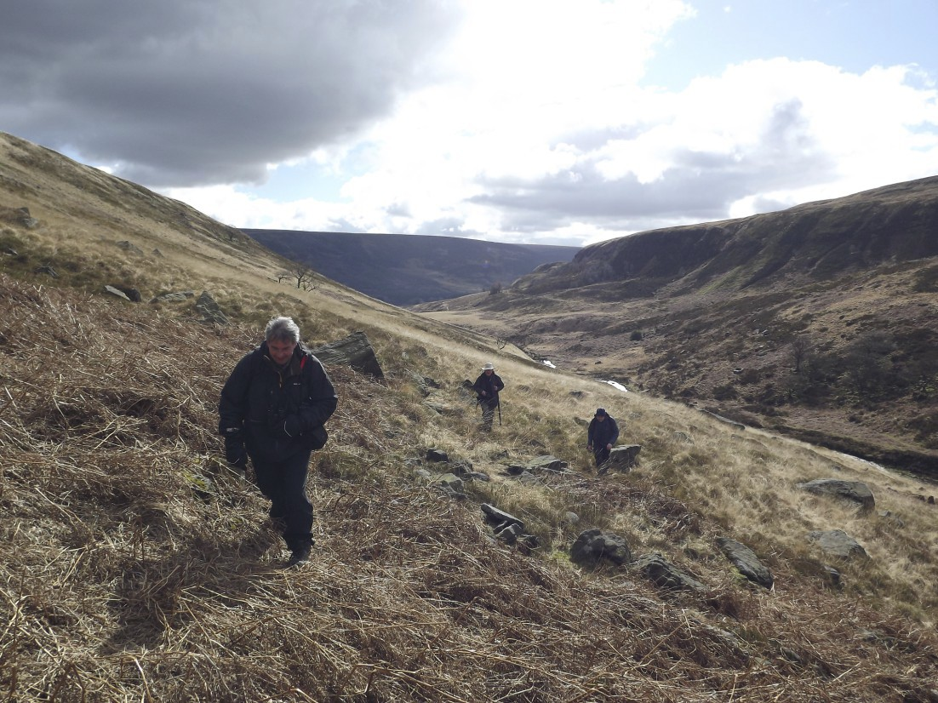

P a g e 5 N e w s l e t t e r 18

Bibliography
Beer, A. 2013. Dawn of the Red. BBC Wildlife, Iss. 31 pp. 48-54.
Petterson, G. and Pepper, H. 1998. Red Squirrel Conservation. [PDF] rgh: pp. 1-5.
Available through: Forestry Commission http://www.forestry.gov.uk/pdf/fcpn5.pdf/$file/ fcpn5.pdf [Accessed: 15 Oct 2013].
Rsst. 2013. Home | Red Squirrel Survival Trust | RSST. [online] Available at: http:// rsst.org.uk/ [Accessed: 13 Oct 2013].
Sheehy,E and Lawton,C. Population crash in an invasive species following the recov-ery of a native predator: the case of the American grey squirrel and the European pine marten in Ireland
Biodiversity and Conservation March 2014, Volume 23, Issue 3, pp 753-774

Mountain Hare Day.
Stuart Edmunds.
Shropshire Mammal Group members joined forces with members of Derby-shire Mammal Group on Sunday 23rd of March in search of a species of mammal that we don't find in Shrop-shire. Mountain
hares were introduced on the moor-lands of Derbyshire in the 19th cen-tury and continue to survive in sus-
tainable numbers. Smaller than
Brown Hares, Mountain Hares are easily recognisable by their winter pelage, which turns white during the
winter to camouflage the hare from
the eyes of predators.
Our 6 miles trek up through val-leys and off-trail over tussocks and sedge was rewarded with a close encounter with an impres-sive hare, which left the comfort of it's "form" just a few metres in front of us.
Thanks go to Derbyshire Mam-mal Group for guiding us an a tiring but very enjoyable wander.

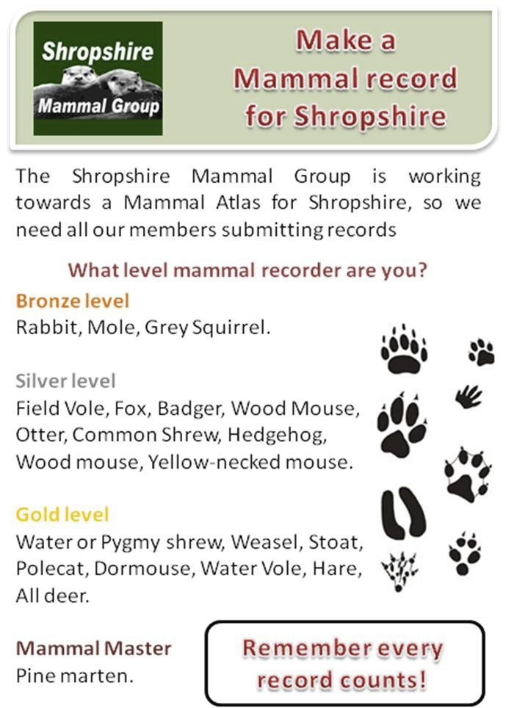

P a g e 6 N e w s l e t t e r 18
Mammal Recording

At the time of writing this we have just over 4,700 records that have been submitted by 783 different people/organisations covering 38 species of mammals in Shropshire.
Winter is the time of year when searching for mammals in the UK is not at its most ac-tive and is ideal for getting all you records together. Over the past month I have been very busy collating the data. A big thanks to everyone who has submitted records in the past.
Records for the top 10 species Records received by the top 10 recorders
Otter 825 Dawes, Allan 333
Dormouse 485 Parry, Gareth 265
Mole 365 Ashton, Barbara 221
Badger 355 Monie, Malcolm 207
Water vole 347 Uff, Caroline 199
Brown Hare 335 Edmunds, Stuart 165
Polecat 301 Boardman, Pete 152
Rabbit 227 Horne, Rob 152
Fox 217 Mackintosh, John 126
Wood mouse 211 Reid, Alan 114
Changes to field signs methodology
From recent work on testing mammal scat, the feedback has been that what was reported to come from a specific mammal turned out to give a false results. It has been agreed that as a group, we will still except scat/droppings as a legitimate field sign, but hold these records in-ternally until more information is available.
Congratulations to the following who have
achieved the new level awards in the Shropshire Mammal Atlas recording scheme.
Bronze
Adrain, Lorcan Ashton, Barbara Bradley, Mr
Clarke, John Dawes, Allan Edmunds, Stuart
Fowler, Keith Mackintosh, JohnMarshall, Peta
Mileto, Robert Mitchell, Jay Monie, Malcolm
Morris, Richard Parry, Gareth Pearce, Tristam
Richards, Jayne Wrench, Dan
Silver
Edmunds, Stuart Mackintosh, John
Gold
None
Photos
Since the last newsletter, a few photos have been submitted to support records.

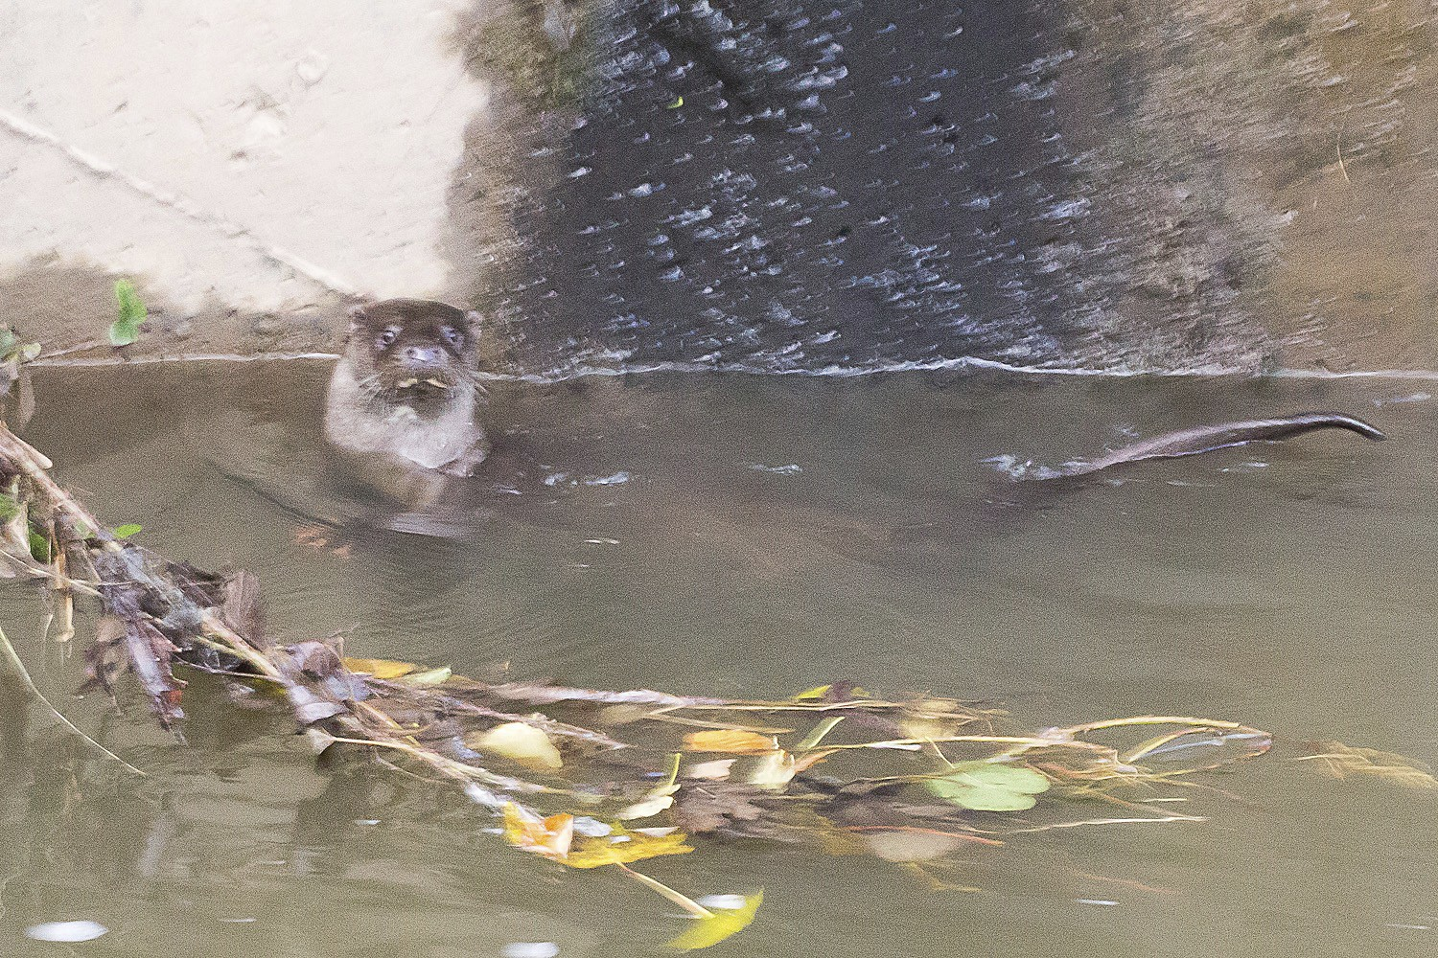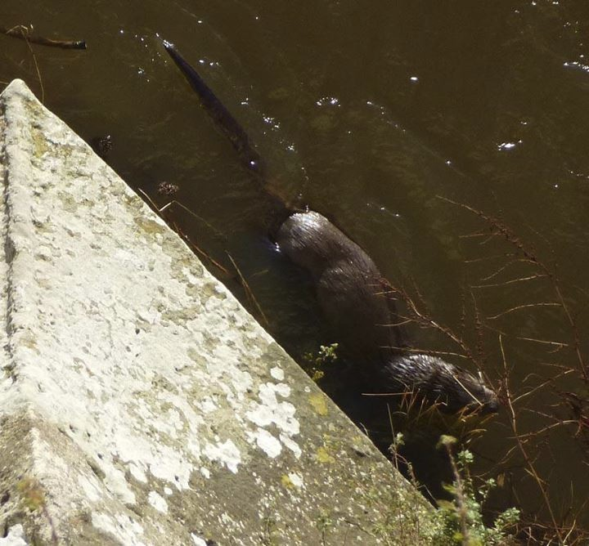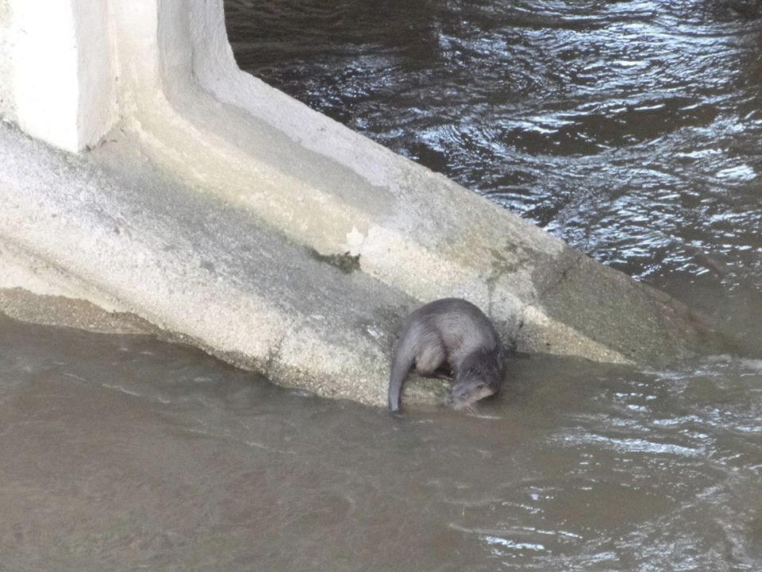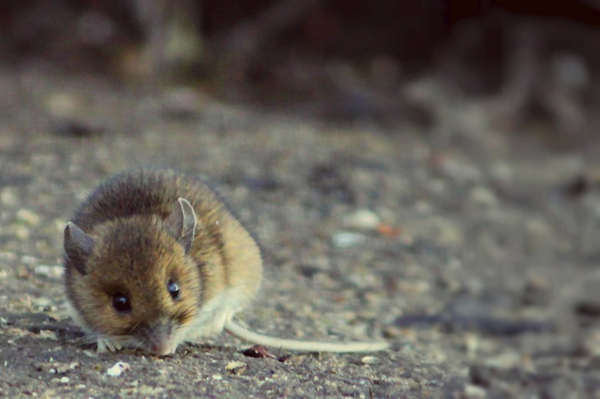

P a g e 7 N e w s l e t t e r 18

Otter - Ed Poval -
Radbrook - 19 - Nov 2013

Otter - Mark Duffill - Atcham - 24 Dec 2013

Danni Painter - Wood Mouse -
23 Jan 2014

You can record records on our web site at bit.ly/SMGrecord or email and photographs to: smgrecord@gmail.com

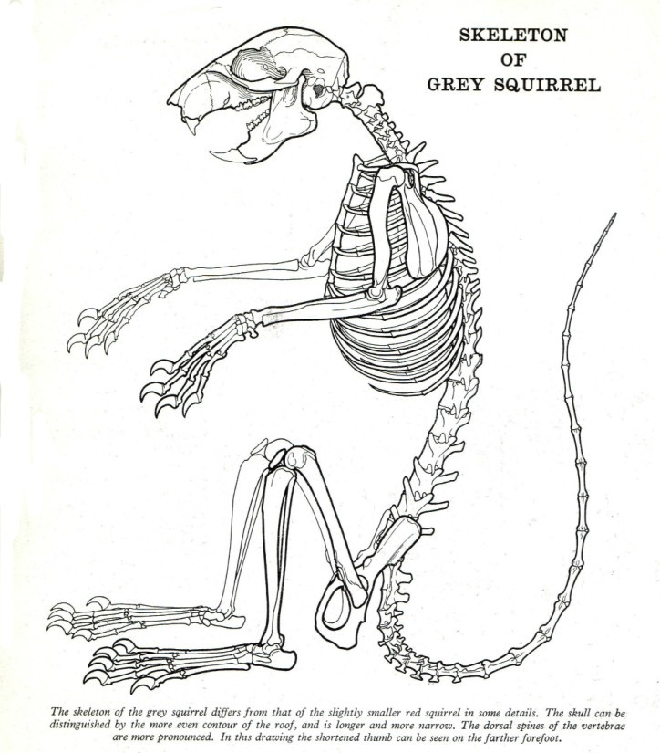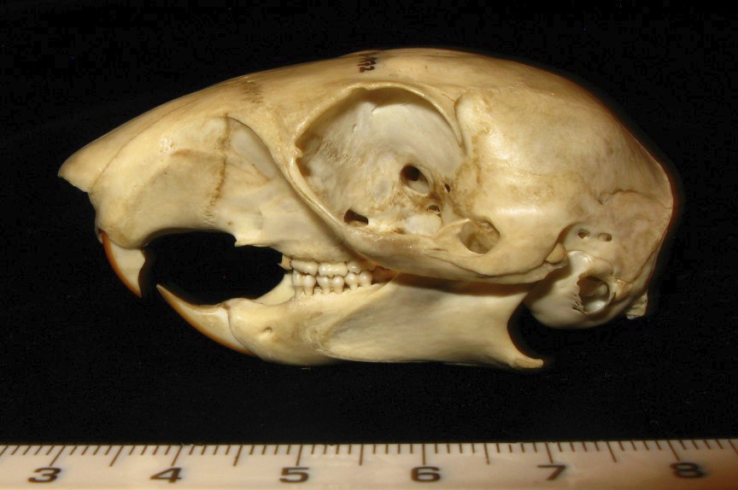

P a g e 8 N e w s l e t t e r 18

Rodent Bones of the Family Sciuridae (and Gliridae).

Ric Morris.
Excluding the very recently reintroduced beaver and the now exterminated coypu, the grey squirrel Sciurus carolinensis and the indigenous red, Sciurus vulgaris are the UK’s largest widespread members of the order Rodentia. The red squirrel is, of course, not now found in Shropshire; the nearest populations of any significant size are probably Anglesey and Formby, Lancashire. Thanks to the co-operation of Tony Parker, Assistant Curator of Vertebrate Zoology at the World Museum Liverpool, I re-cently had the opportunity to examine and photograph some red squirrel bones and skulls and compare them against the larger bones of the grey.

The two species are obviously closely related, sharing as they do, the same genus.
Consequently the bones and skulls are superficially very much alike, with the most ob-vious difference being the smaller size of the red. The skeletons of both species are lightly built for agility amongst the trees, the limb joints are described by Shorten (1962) as ‘versatile’ (whatever that means!) and the hands and feet are proportionally large in comparison to the rest of the skeleton. It is also claimed that the dorsal spins on the thoracic vertebrae of S. carolinensis are more pronounced, and this can be seen to some extent in the full skeleton illustrations by Joanne C Webb which appear in the Shorten booklets from the Sunday Times ‘Animals of Britain’ series.
In terms of the skulls, both species have the same dental formula of i1/1; c0/0; p2/1; m 3/3. The incisors carry a coat of orange enamel on their anterior surfaces. The first upper premolar is a single peg and overall the cheek teeth have a white enamelled look to them, which is more similar to rats and mice than the ridged zig-zag appear-ance of vole molars. Both Sciurus species have a very sharp post orbital process above and behind the orbit or eye socket, and this is much more pronounced than on any other rodent. When extracted, the cheek teeth all leave clearly defined root holes as opposed to the open root cavities of the voles. All cheek teeth save the first premo-
Grey Squirrel Skeleton

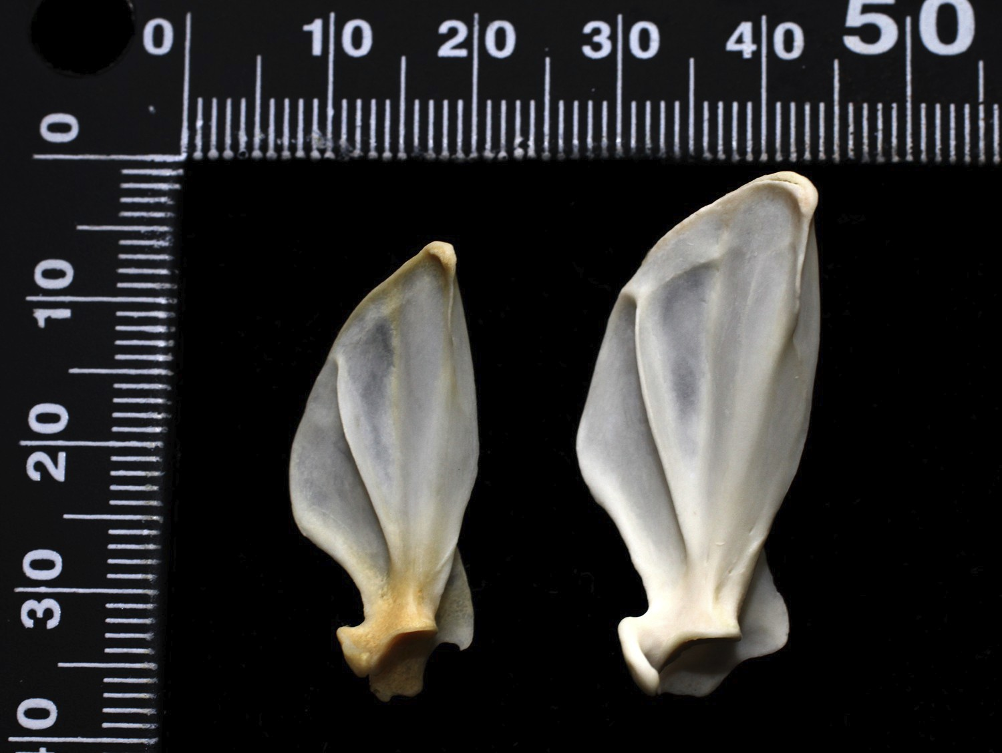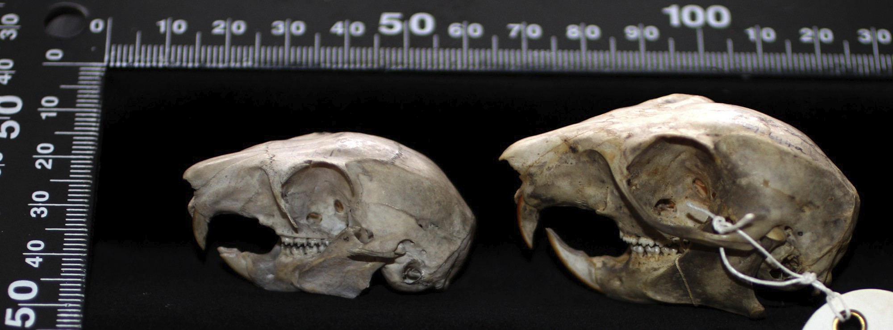

P a g e 9 N e w s l e t t e r 18
lar are multi-rooted. The lower incisors of the red squirrel may appear shorter and less prominent than those of the grey.

Red & Grey
Squirrel Skull Comparison

Grey squirrel skulls are larger, up to 65mm in length compared to the reds which are generally around 50mm, not exceeding 54mm. The nasal bones can sometimes be missing in damaged skulls but they are another useful diagnostic point, being over 17mm in the grey and under 16mm in the red. Their anterior ends protrude beyond the incisors in both species. The muzzle appears proportionally shorter and less prominent in the red than the grey, and the overall appearance of the skull itself is notably rounder in the red than the grey’s more flattened cranial surface.
As can be seen from the accompanying photographs, the scapulae of both species have a ‘false spine’ on the ventral aspect, i.e. that side of the shoulder blade which lies against the top of the ribs and the thoracic vertebrae. As far as I am aware, this is unique amongst British mammals.

Red & Grey Scapulae

This is really the most distinctive and unusual single feature of the post-cranial skele-ton, but it is worth mentioning the slender and slightly curved ilium bone (the long stalk of the P-shaped pelvic bone assembly),
and the egg shaped obturator foramen. The long bones are generally more slender and gracile in the red than the grey, but both species have well developed muscle attachments at the top of the femur and along the whole shaft of the humerus.

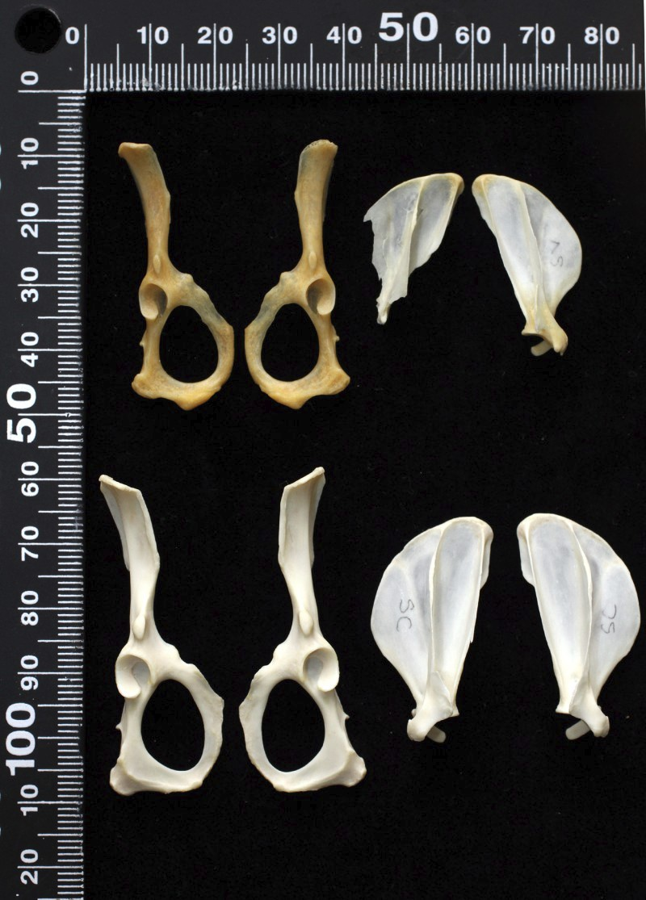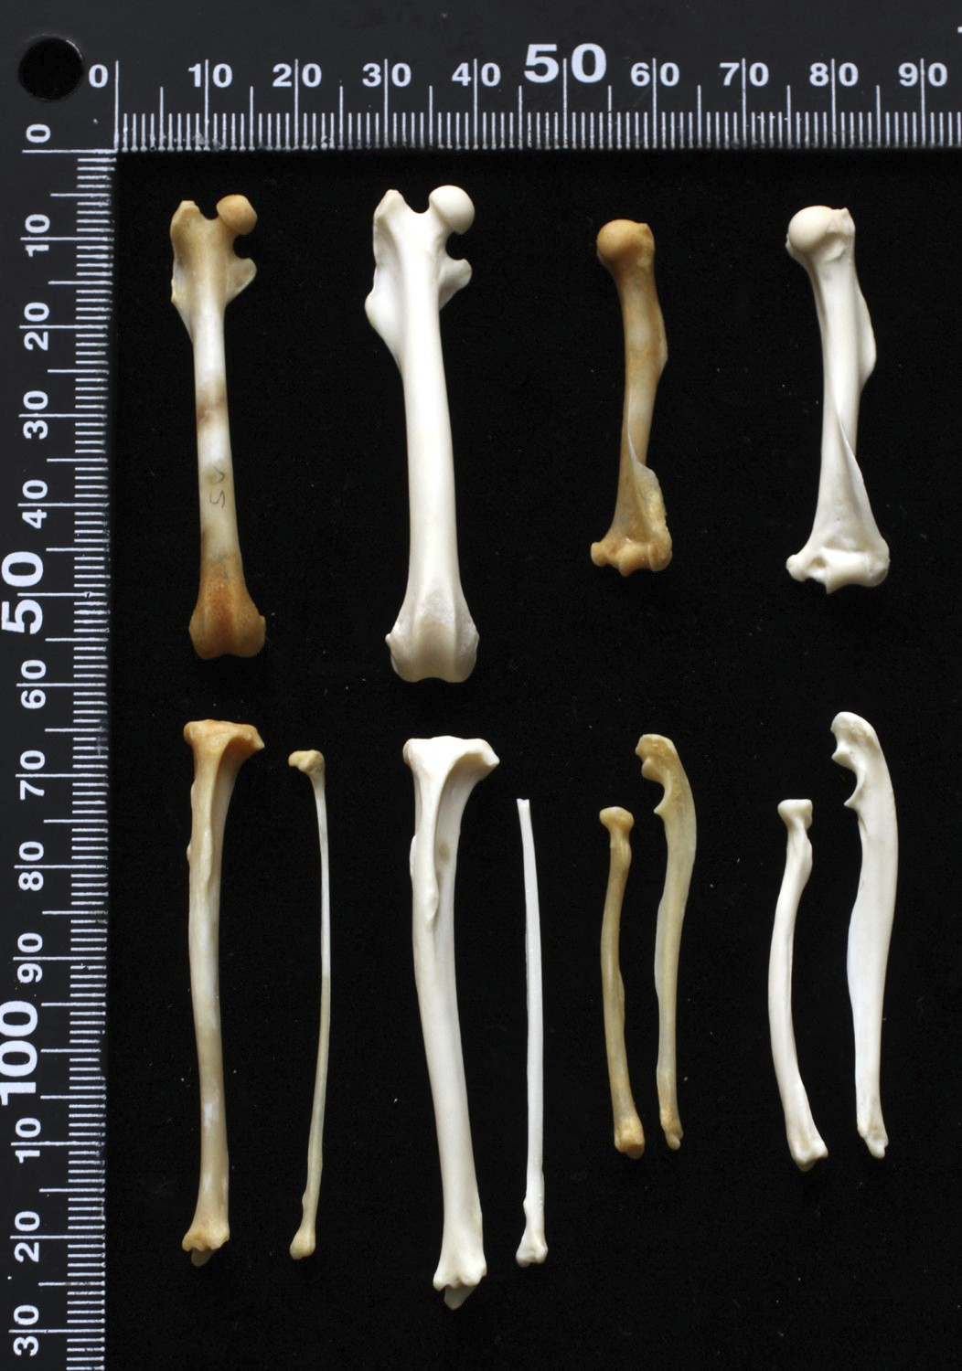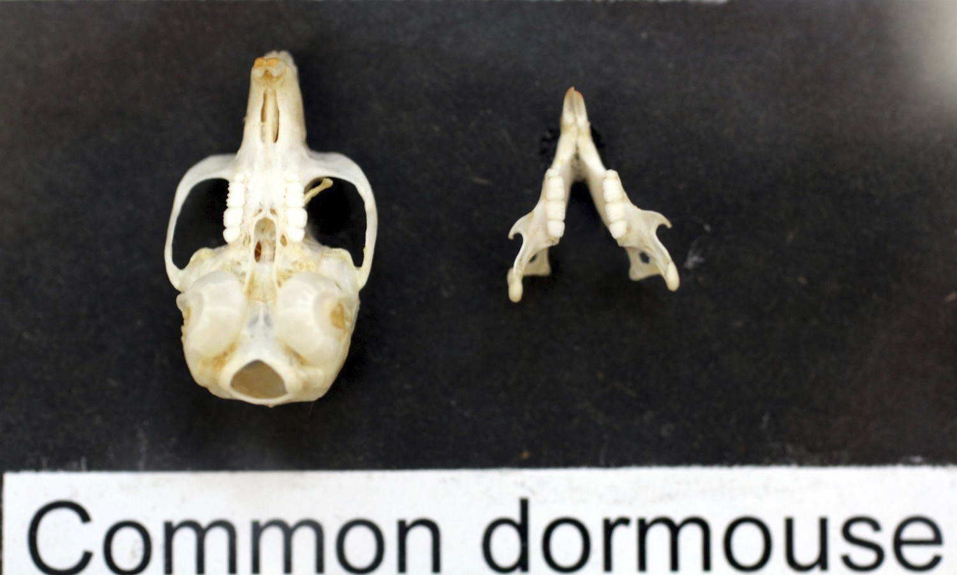

P a g e 10 N e w s l e t t e r 18

***
I’ve still not had the opportunity to closely examine dormouse bones so can only say briefly that the skeleton of the common or hazel dormouse Muscardinus arvellanarius is similar in size and appearance to the Muridae mice, and the skull also resembles that of a Muridae mouse except for proportionally larger ear capsules (tympanic bul-lae) and a detail of the angular processes at the posterior ends of the mandibles, which are sometimes holed and turned-out. The dental formula is i1/1; c0/0; p1/1; m3/3. The anterior molar is the largest of the cheek teeth, all of which exhibit trans-verse ridges.
The edible dormouse Glis glis is not found in Shropshire but the skull is nearer to rat size
than the common dormouse. The dental formula is the same as that of the common dormouse. There are no Rat- tus style ridges on the cra- nium; the whole skull appears very broad in relation to its length
and again has very large tympanic bullae and a strongly built cheek bone, or zygo-matic arch. Lawrence and Brown (1967 and 1973) show a photograph of represen-tative bones from an owl pellet analysis which includes the right mandible of an edi-ble dormouse alongside rat mandibles, and it can be seen that they are a similar size. They can however be differentiated from Rattus sp. by not only the presence of a premolar but by examination of the root cavities. Glis displays seven holes in a line as distinct from the multi-rooted pattern seen after extraction of the rat’s three molars.
Red (top) Grey (Below)
pelvis & scapula
Dormouse Skull

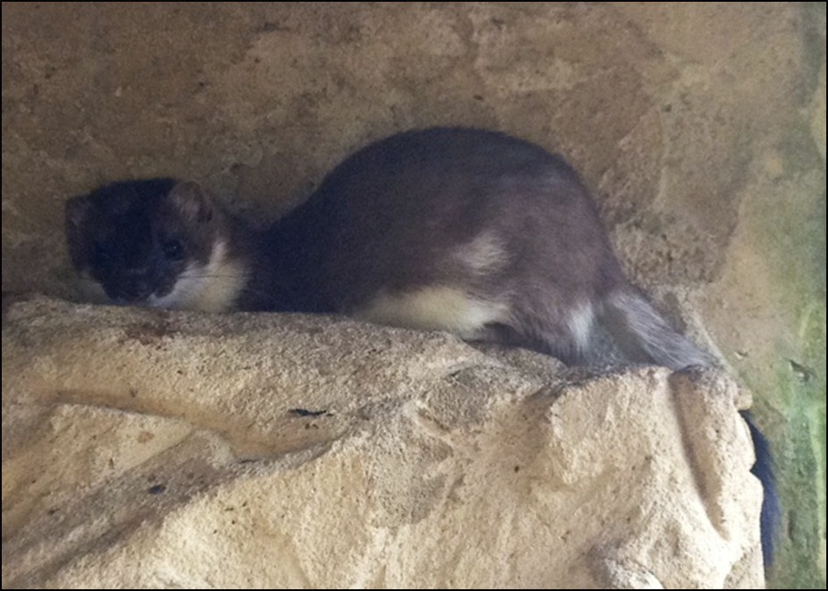

P a g e 11 N e w s l e t t e r 18

A trip to Wildwood!.
Hannah Farley.
I was recently lucky enough to embark on a work related trip down to Herne bay,
Kent, where in the most unlikely place on the edge of an industrial estate stands a 40 acre ancient woodland full of British Wildlife past and present. This woodland belong to the Wildwood Trust which houses over 200 native animals from Beavers, Lynx and Wolves to Badgers, Pine Martens and Red Squirrels, making them a fantastic place to visit to tick of some of those more tricky species to spot.
After spotting them on an episode of Countryfile I thought it would be a brilliant place to visit. Many of the animals have ended up there as a result of being rescued for ex-ample one of the highlights of my trip was meeting two almost friendly Badgers which were found by the Kent Badger Group abandoned as cubs and brought to Wildwood to be hand reared and housed. For most of the week I was with the Keeper team getting stuck in with daily routines, this mainly involved cleaning and feeding but al-lowed me to get closer to some of these wonderful creatures, which included Noodle the Red Deer, a very loud stoat, two fat little Dormice and Yorkie the Pine Marten.
As well as the keepers I spent time with the education department and the conserva-tion team. The conservation teams main responsibility is the breeding programs they have many successful ones. The main one being in the “Vole yard” a fantastic cap-tive breeding program for Water Voles. Many of which they were contracted to trap and breed while development works was being done next to or on their habitat so not to disturb them, they breed them and when the work is finished and their habitat re-stored release the same blood line. Others are for breed and release in areas which have perfect habitat for Water Vole populations but appear to have a small or non
existent population. They also have a Dormouse, Water Shrew and Harvest mouse breeding program which have brought years of successful breed and release cycles.
If you are ever down that way I would definitely recommend a visit as it is a British Mammal junkies heaven!

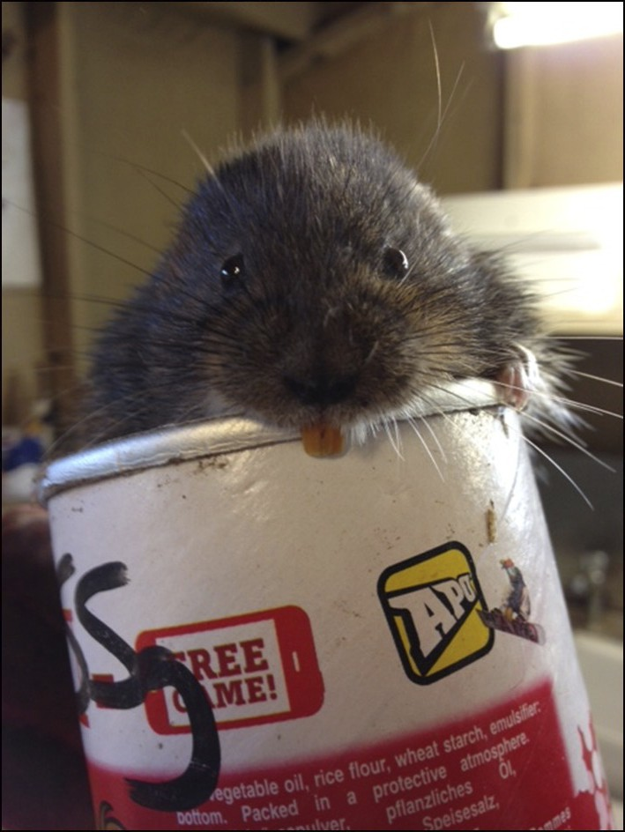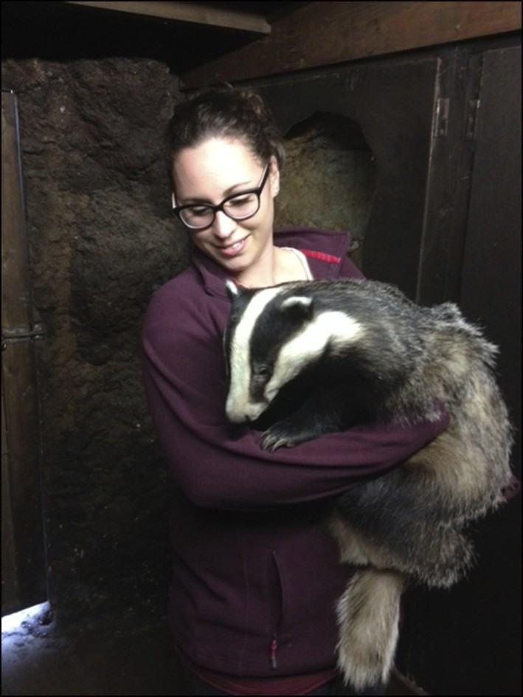

P a g e 12 N e w s l e t t e r 18

“Salopian Harvest Mice”.
Martin Noble.
As I’m sure many of you are well aware The Mammal Society (TMS) have embarked on another national survey in order to track down the elusive little harvest mouse (Micromys minutus).

This survey, being undertaken during the winters of 2013 and 2014, will build upon the data gathered during the previous surveys carried out in the 1970s and 1990s. In an attempt to ensure that the county was well re-corded this time around we are endeavouring to co-ordinate the survey effort through the Shropshire Mammal Group (SMG). This will allow us, on a local scale, to identify where we need to concentrate more effort in terms of both actual surveys and indeed training for volunteers before they undertake the survey.

In an effort to corral as many county volunteers as possible I emailed all SMG members back in October 2013, as well as all the dedicated Telford West Wildlife Group (TWWiG) volunteers, to alert everyone to the pro-posed surveys. Those interested in adding to the national effort were asked to firstly register their interest with the Project Officer at TMS (harvestmousesurvey@themammalsociety.org)
and then secondly to let me know (martincnoble@icloud.com) so that the SMG could get a feeling for the level of interest locally. Out of the 90+

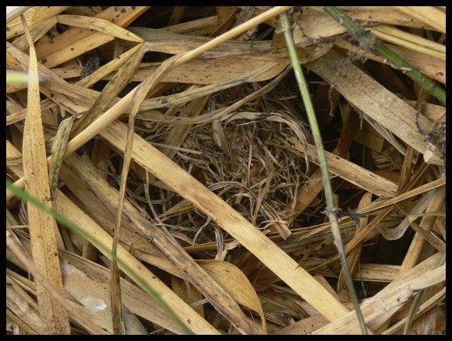

P a g e 13 N e w s l e t t e r 18

emails I sent to SMG members I had 7 people express an interest; coupled with the 7 responses from the 30 TWWiG emails meant that we had at least
15 surveyors across the county.
Obviously getting out and surveying for these special, yet very elusive, mam-mals is not everyone’s cup of tea but at least we were able to gauge the level of interest and thus appreciate the size of the challenge facing us. It is safe to assume though that those 15 do not represent the total number of surveyors who will be out and about searching through the decaying vegeta-tion for those tiny little nests.

Once you ‘get your eye in’ the different structure of the nests
make them stand out relatively clearly from surrounding vege-tation.

One of the difficulties in trying to coordinate activities such as this through a single point is that not all surveyors are mem-
bers of the SMG or TWWiG; people might be members of TMS but not nec-essarily of SMG and we know that not all SMG members are members of TMS (although the group does offer a discount now to anyone wishing to take out membership of both SMG & TMS!!)….thus we will inevitably end up with other interested individuals or groups taking part in the survey through-out the county who are not aware of the attempt to channel all reports through the SMG.

However…..irrespective of where or how people hear about the survey, the most important part is the taking part. And of course the submission of any records too!!! Historically Shropshire has not had many records of Micromys minutus, indeed the County Recorder currently only has 11 historical records in his database: 1997 (1), 2004 (1), 2005 (1), 2009 (2), 2011 (4) and 2012
(2).

As far as we know though there were at least a further two records added as a result of the most recent TMS survey carried out just before Christmas last year….one from Luke Neal (Shropshire Wildlife Trust) of Meres and Mosses

P a g e 14 N e w s l e t t e r 18
fame and one from an SMG member in Shrewsbury (thank you Caro-line!). If anyone else has come across any signs then please do let Lor-can know!
The TMS survey follows very strict protocols in terms of when and
where you undertake the survey….essentially you are allocated a 10 x
10 km square (usually very close to your home address) by the TMS Project Coordinator and are then asked to visit that area ONCE only in either November/December 2013 or November/December 2014 and un-dertake ONE search at TWO sites within that square. You can either walk along a 200m transect in suitable habitat and search a 2m strip along it or you can select four small patches if a 200m transect is not appropriate. In order to ensure that the data is comparable with previ-ous surveys it is essential that surveyors’ stick strictly to the very clear instructions provided upon registration with TMS.

This does mean, of course, that there will be many disappointed survey-ors out there….not only are these creatures rare and patchily distributed but their signs are very hard to spot too. And in order to comply with the protocols if you don’t find any signs you cannot continue elsewhere until you do find some….it is just as important for us to know what we’re not finding as it is to know what we are finding!!

Of course that is not to say that we (both SMG and TMS) are not inter-ested in your ‘occasional records’, that is those that you come across in the normal course of wandering around this wonderful county of ours….be it when surveying for other species or simply spotting their tell
-tale signs when out and about. Once again please submit any such sightings to our County Recorder, Lorcan Adrain at smgre-cord@gmail.com.

If there is anyone else out there who would like to get involved then
please do let us know; it would be amazing if we could get every tetrad in the County surveyed but appreciate this is a (very) long shot! Bearing in mind that we are now working towards gathering as much data as possible in preparation for the County Mammal Atlas we really would appreciate as much help as possible.
For those of you who might welcome a little training before going out to survey on your own then there will be more training sessions arranged later this year so please keep your eyes peeled for details of those nearer the time.

P a g e 15 N e w s l e t t e r 18
The author following in the illustrious footsteps of
a renowned mammalogist during an impromptu training session in some ideal harvest mouse habitat.

Please do take a look at the TMS website for further details about the national survey (http://www.mammal.org.uk/harvestmouse_survey) and feel free to drop me a line if you would like to discuss things at a more local level (martincnoble@icloud.com).

Thank you to Diane White (TMS) for being the project lead for this round of surveys and to Derek Crawley (Staffordshire Mammal Group) and Simone Bullion (Suffolk Wildlife Trust) for sharing their knowledge of harvest mouse ecology and survey techniques with me.

And finally a great big thank you to all past, present and future survey-ors and submitters of records!!
Mad March Hare.
Stuart Edmunds.
March is a favourite month for many a wildlife spotter; migrating birds begin to return to the UK and some mammals begin to awaken from a winter-long slumber. It is also a key month in the lifecycle of the brown hare Lepus europaeus as they begin their annual courtship.
Hare courtship at a glance doesn’t appear to be a courtship at all; more a violent
match between two heavyweight boxers. Healthy female hares become the focus of attraction from feisty males and unlike in many species, it isn’t actually the male hares that instigate the violent procedures to attract the attention of a female. In the hare world, it is the female that begins the match. Competing males regularly be-come over amorous and the “mad march hare” is actually the female, beating back the hoards of over-affectionate males. It is also thought that the “boxing” of the fe-male, which continues against numerous individuals, is the female testing the strength of prospective mates to make sure that the strongest candidate is selected.
Arable fields offer the best opportunity to view these otherwise nocturnal animals during the spring. Hares live above ground in open country, usually hiding in long grass to escape predators, but once disturbed they rely on outrunning their ene-mies. They reach speeds of 45 miles an hour, making them Britain's fastest land animal. This survival strategy is evidently very successful for the hare as records show that ancient ancestors of hares were around at the time of the dinosaurs.

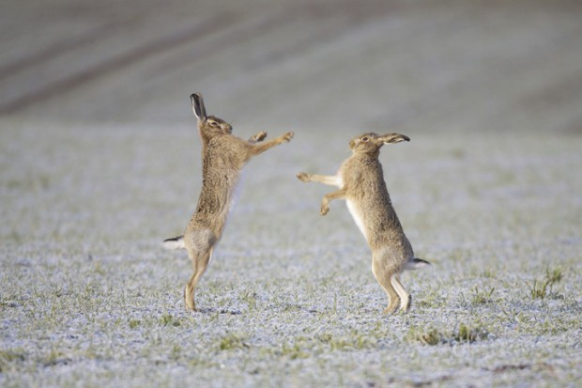

P a g e 16 N e w s l e t t e r 18
It is estimated that the national hare population has plummeted by 80% in 200 years due to a number of factors, including loss of hay meadows, agricultural intensifica-tion and use of pesticides. By far the largest impact on the population of hares in England is persecution as there is still a demand for hare meat in London’s restau-rants. During the annual hunts in East Anglia, which contains a large proportion of the national population of hares, it is estimated that a third of the national population is wiped out on a yearly basis. For a species of mammal producing small broods and suffering from a loss of suitable habitat, there is little chance of making a notice-able recovery unless they are given protection. In Scotland, hares are now benefit-ting from a closed season to allow the population recovery time, yet south of the border, it is still legal to shoot hares all year round.
In Shropshire, there appears to be good distribution of hares in suitable habitat, both in the lowlands and uplands despite their BAP priority species status. The Long Mynd is often a good place to view hares throughout the year, but the best places to get a good view of boxing hares are the stubble fields of the north Shropshire plains. Shropshire Mammal Group is monitoring hare numbers in Shropshire this year, so if you see a hare, please report the sighting to SMGrecord@gmail.com.

P a g e 17 N e w s l e t t e r 18

Dormouse tubes at Llynclys
Stuart Edmunds.
On Monday 10th March a group of 8 SMG members met at Porth-y-waen car park to take a wander to a site where last July we installed 40 dormouse tubes at Llynclys nature reserve. Last year, while conducting a scat search with Conservation Dogs, I found evidence that dormice inhabit the woodland around Upper and Lower Butch-ers quarries, which contains a mixture of tree species such as hawthorn and hazel. It was my hope to install the tubes to encourage dormice to use them as summer nests, though this type of tube was originally designed as a hair tube trap; lined with sticky tape to take hair samples of any small mammals to enter them. However, in
several locations elsewhere in the UK, dormice not only entered the tubes, they also chose them as nesting sites to use during the breeding season!
Other than the usual dormouse nibbled hazel nuts lying around the woodland floor, dormouse evidence usually comes in the form of a summer nests, which tend to be made of stripped and woven honeysuckle bark and insulated with fresh green leaves. It was this evidence that we expected to find when checking the Llynclys boxes, but on this occasion none of the tubes held any evidence of dormouse visita-tion. They have been out for a relatively short period, so I intend to revisit the site in early autumn…and finding the tubes should be much easier next time around as we now have GPS coordinates and maps to show the position of each tube!

Corporate Members
Shropshire Mammal Group is grateful to its corporate members for their support. Pearce Environment Ltd

Roberts and Son, Lower Wallop Farm

Shropshire Wildlife Trust Ellesmere Branch

Field Studies Council Preston Montford

Whitchurch Water Vole Project

