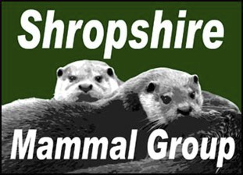

QUARTERLY

Winter 2013

Newsletter 17

Afflilated to the Mammal Society

CHAIRMANS NOTE:
INSIDE

THIS
ISSUE:

NOTE FROM THE CHAIRMAN

VWT LAUNCH PINE MARTEN
FEASIBILITY SURVEY:

VWT POLECAT SURVEY UNDER-
WAY:

MAMMAL RE-CORDING IN THE
COUNTY:

REGIONAL SEMI- NAR SUCCESs
Galloway trip and sightings

THREE SHROP-SHIRE PHOTOG-
RAPHERS

EVENTS

1

2

3

4

5-6

6-
11

12
Membership
During 2013, membership numbers have risen to over 105 and I would like to welcome all of our latest members to the group. This increase has been helped in part by the number of events to train and enthuse
people to become involved with our survey efforts. And partly to do with the recruitment efforts of Martin Noble during this year’s events in Tel-ford! There will be the opportunity for people to renew their member-ship at the AGM on January 18th.
Change of recorder
We lost a key member of the committee this year, when Gareth Parry moved away from Shropshire to work for Gloucestershire Wildlife Trust. Gareth’s efforts to encourage people to send in their records have been monumental and his presence on the committee will be greatly missed. Thanks to Gareth for all his hard work. Replacing Gareth as county re-corder is Lorcan Adrain, who has very kindly offered to take over. Lor-can will now be recording all of our sightings and will be supported by verifiers when records of commonly mistaken mammals come in.
Stuart Edmunds.

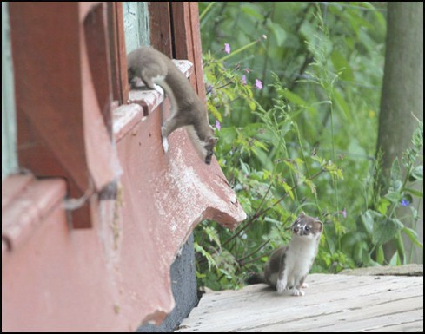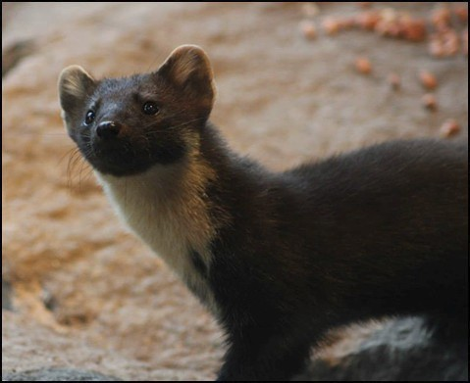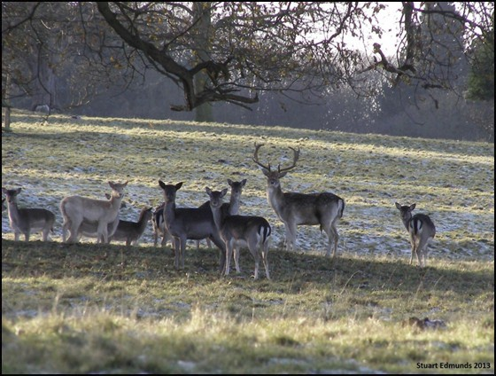

P a g e 2 N e w s l e t t e r 17

VWT LAUNCH PINE MARTEN FEASIBILITY SURVEY:

Pine marten records are still coming in but are usually proven to be misidentified polecats or
stoats (as shown in the top picture, taken on the Herefordshire border by a member of the Teme Valley Wildlife Group). However, a positive report was made this month in north Herefordshire when a member of staff from Vincent Wildlife Trust viewed a marten for long enough to allow
him to make a definitive identification.
Vincent Wildlife Trust have commissioned a survey to ascertain whether or not it is feasi-ble to release pine martens in southern Eng-land to bolster any possible relict popula-tions. There has been growing support for the notion of building a population of pine martens, based on the research taking placein Ireland which points to a link be-tween increasing pine marten numbers and decreasing grey squirrel population. The non native grey squirrel, although popular with many people, causes millions of pounds worth of damage to native woodlands and coniferous plantations and control methods have so far been unsuccesful in preventing population growth. If it is proven that grey squirrel numbers could be reduced by the release of these arboreal predators, it is very possible that martens could be released within 3 years. So there is a very real chance that a mammal that was once com-mon throughout England and Wales will once again (with a helping hand) make a very welcome return to our landscape.
Stuart Edmunds.
MAMMAL PHOTOS:
If you have any interesting mammal photographs you would like to share with us, please email them to shropshiremammalgroup.org.uk and we will make sure that the best are included in fu-ture newsletters. This photo of an impressive Fallow stag was taken a few weeks ago around the base of the Wrekin.

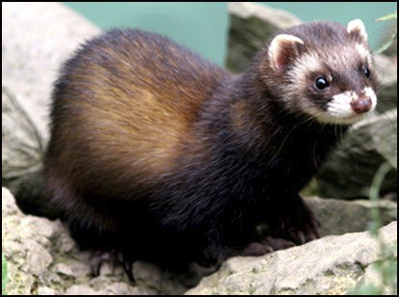

P a g e 3 N e w s l e t t e r 17

VWT POLECAT SURVEY UNDERWAY:
The Vincent Wildlife Trust has launched its next national polecat survey, to run from 2014 to 2015, and needs your help to gather up-to-date information on the current distribution of the polecat in Britain.
The polecat is a native British mammal and a member of the mustelid (weasel) family, which includes otter, stoat and weasel. Polecats are generally dark in colour with a striking mask-like pattern of dark and light fur on the face. The polecat is closely related to the ferret and es-caped or feral ferrets may breed with wild polecats to produce wild polecat-ferret hybrids, which are generally
paler in appearance than true polecats. Polecats are mainly nocturnal and solitary and the most common evidence of their presence is the bodies of animals killed on roads.

The polecat population suffered a severe decline due to historical persecution and became con-fined to mid-Wales by the early 20th century. The population slowly recovered during the 20th century and polecats are now widely distributed in Wales and central England, with outlier popula-tions in northern England and Scotland. This recovery was documented by distribution surveys carried out by The Vincent Wildlife Trust in the 1990s and 2004-2006.
The Trust is keen to receive any records of polecats, polecat-ferrets or feral ferrets, dead or alive, from anywhere in mainland Britain. Ideally, records should be validated by photographs to allow the animals to be identified. The Trust will also be collecting muscle samples from carcasses for genetic analysis, to investigate hybridisation between polecats and polecat-ferrets.
Stuart Edmunds.

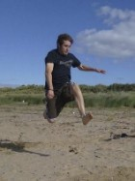

P a g e 4 N e w s l e t t e r 17

MAMMAL RECORDING IN THE COUNTY:
With Gareth Parry moving away from Shropshire to take on his new role as Head of Community Programmes with the Gloucestershire Wildlife Trust, we wish him all the best in his new role and future.
It has been a pleasure helping Gareth out on a few projects His knowl-edge and planning skill's will be missed.
Gareth took on the role of County Recorder last year replacing John.

I have been asked to take over the position as County Recorder. The first thing I needed to do was to create a new email address that can be used purely for records. Can you please make a note of smgre-cord@gmail.com and update your email with this new address.
If you can email your mammal records or anything record related to the new address that would be very helpful. I will reply to all emails acknowledging that the records have been received by the Shropshire Mammal Group. If you do not get a reply within 5 days, please contact me (see below).

2014 is looking to be a busy year for recording mammals in the UK and not just Shropshire.
The Mammal Society are looking to run a harvest mouse survey and continuing with the bait tube survey's.
The People's Trust for Endangered Species (PTES) are looking at doing polecat surveys as well as the current planned work on hazel dormouse.
The Shropshire Mammal Group will be taking part and organising our own events across Shrop-shire.
More information will be available in the newsletter when activities have been finalised.

Contact Information:

Lorcan Adrain Little Grove
3 Church Meadows Whitchurch
Shropshire SY13 1PY
Tel: 01948 662944 email: smgrecords@gmail.com

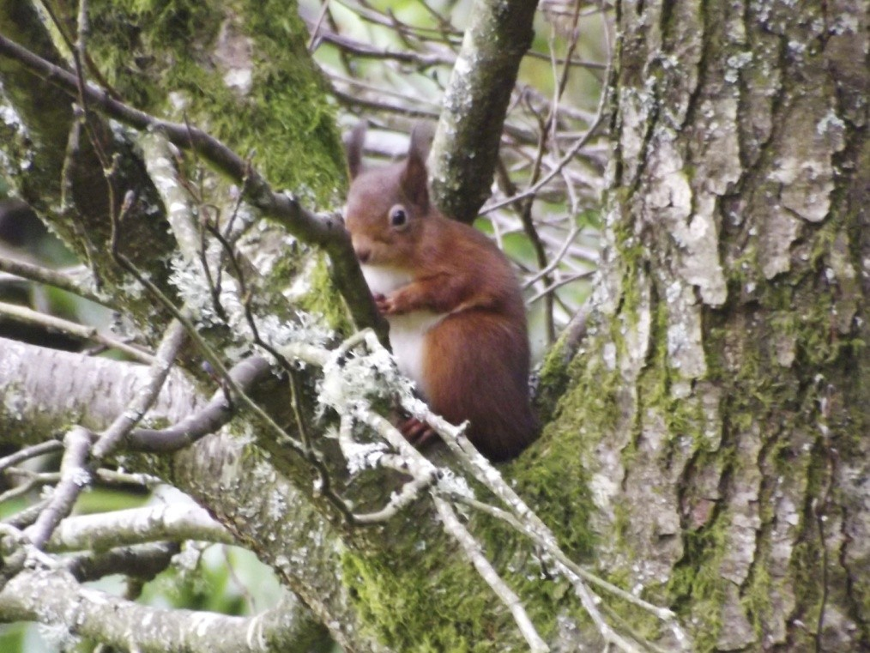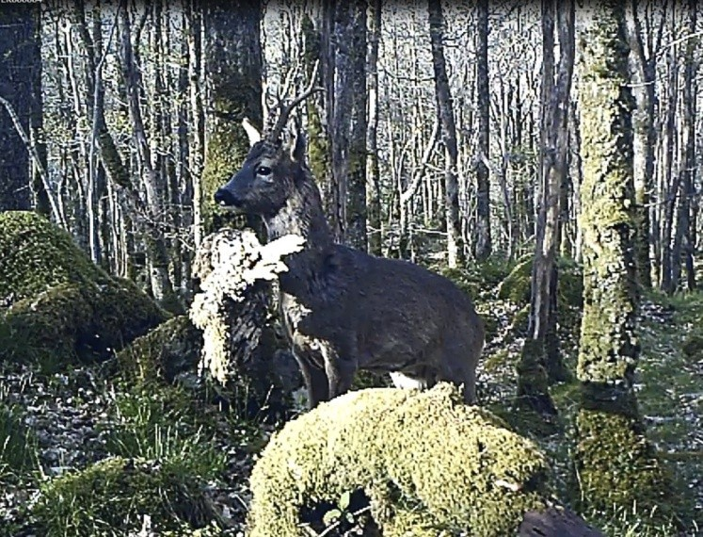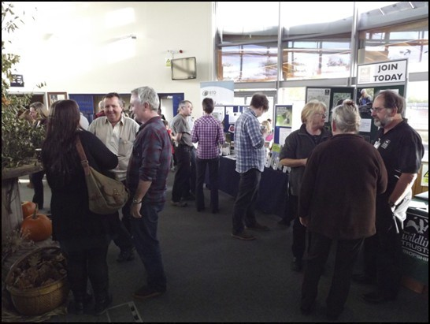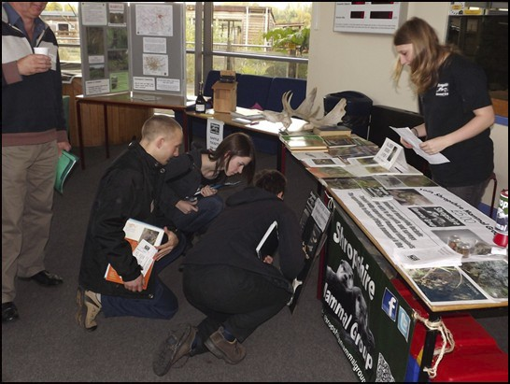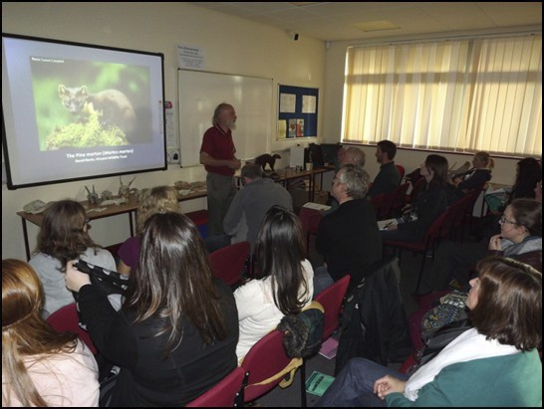

P a g e 5 N e w s l e t t e r 17

REGIONAL SEMINAR SUCCESS:

On November 2nd, we hosted the Mammal Soci-ety’s Regional Seminar at Walford Campus and had impressive turn out of almost 100 people on
the day. The speakers varied from our very own Malcolm Monie, Ric Morris and Paul Roberts to Vincent Wildlife Trust and Shropshire Wildlife
Trust staff. Tris Pearce gave a thought-provoking view of the current badger situation in England and very kindly sponsored the event. Special
thanks go to Tris and Paul O’hagan at Walford
College, whose support for the seminar helped to
make the day a huge overall success.
Stuart Edmunds.
GALLOWAY TRIP & SIGHTINGS

P a g e 6 N e w s l e t t e r 17

GALLOWAY TRIP & SIGHTINGS CONTINUED:

With a busy schedule of talks set to promote the pine marten project to encourage people to
keep their eyes open and report their sightings, I took a trip to Galloway forest park in early win-ter with the aim of obtaining more pine marten film. One of the key aims of my talks increase correct identification of pine martens as few people outside of the conservation field are unfa-miliar with these elusive carnivores. By showing camera-trap footage of martens, I can demon-strate how martens look and move, in comparison to other mustelids.
Galloway forest is the nearest known pine marten stronghold to Shropshire, with sightings com-mon and several installed den boxes in use by martens. With advice from Johnny Birks and staff at the Forestry Commission base in Newton Stewart, I deployed 6 camera traps in known marten territories and experimented with a number of different baits and lures to increase the probability of enticing a marten in front of one of the cameras. Several fresh marten scats in the area around Penninghame Wood indicated definite presence, so I had great hope of returning to find several marten clips. The population density of martens in that area means that statisti-cally, the chances of getting a camera clip of a marten would be considerably higher than here in Shropshire!
Despite this advantage, after 4 nights of recording, nothing more than young Red deer buck
(see photo) and the inevitable wood mice had triggered the cameras and taken advantage of a free feast. This was despite the fact that less than 10m from one of the cameras, an extremely fresh marten scat was found. This attempt at gaining video footage of wild martens indicates just how elusive these creatures are, in addition to their avoidance of human activity in areas where they have traditionally been persecuted. So, four days of searching for Martes martes in an area that they definitely inhabit resulted in no footage and acted as a good indicator to just how difficult martens are to find. A close encounter with a lovely red squirrel did however make up for the lack of pine martens on this occasion!
Stuart Edmunds.

THREE SHROPSHIRE PHOTOGRAPHERS & FIFTY YEARS OF THE WILDLIFE PHOTOGRAPHER OF THE YEAR COMPETI- TION:
I pushed open the door of the musty little second hand bookshop and stepped inside out of the spring sunshine. Blinking in the gloom, I looked around for the natural history section and tut-ted silently to see it filled with pet-care books. There was an oversize shelf at the top with some larger format hardbacks, probably on cats and horses. As I turned my head to the right to read the spine titles, a thin glossy black dust jacket printed with bold white block capitals caught my eye: WILDLIFE PHOTOGRAPHER OF THE YEAR PORTFOLIO ONE. I’ve always been interested in fine photo books, so reached up for it.

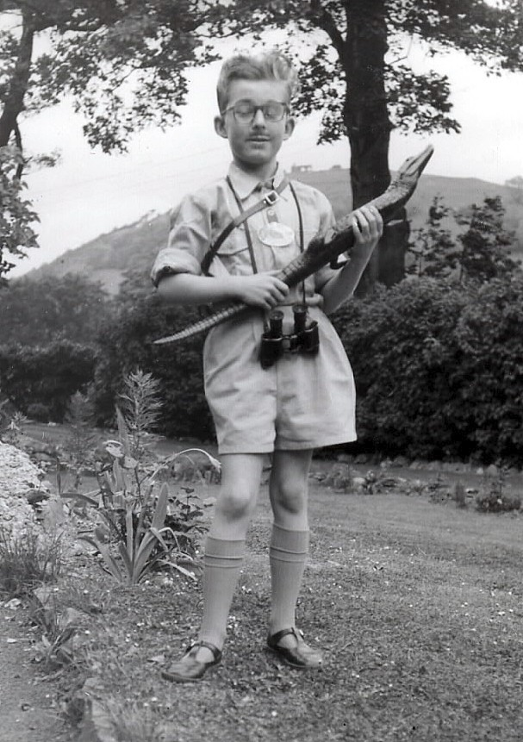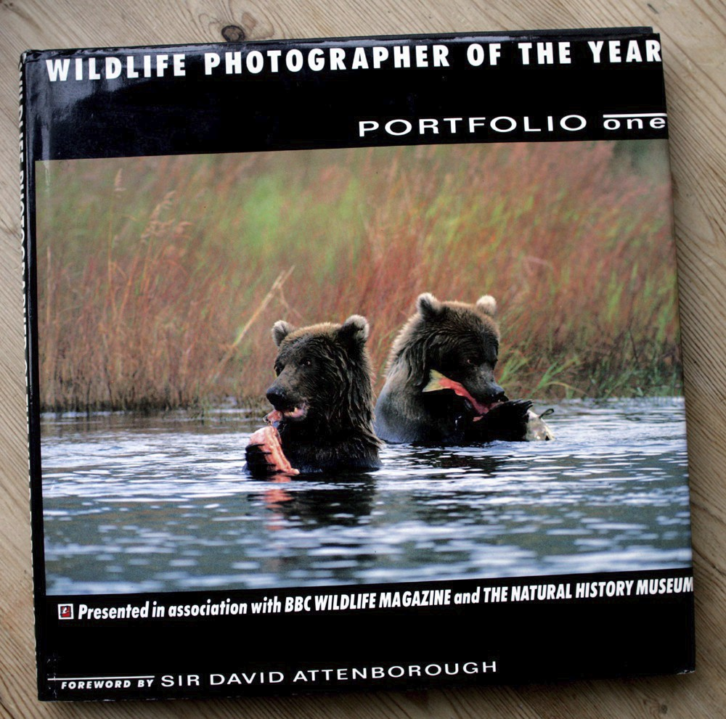

P a g e 7 N e w s l e t t e r 17

Flicking through its pages, I remembered many of the photos from a BBC Wildlife magazine
which I’d bought a few years earlier, which included a pull-out supplement of the winning images from 1991. For some reason it had completely escaped my attention that such a delicious hard-back, chock full of the same images, had even been published.
A wallet-challenging £7.50 changed hands a few moments later and although not realising it at the time, I was on the way to a collecting obsession.
2014 will see the fiftieth Wildlife Photographer of the Year competition. Inaugurated in 1965 by Animals magazine, whose editor-in-chief was the Belgian naturalist and film maker Armand Denis, this remained a small scale contest restricted to readers of the magazine for almost 20 years. Animals had been first published in January 1963 as a glossy weekly and my family bought it regularly for its first year or so, but by 1965 we were no longer regular readers. The

The author dressed as TV presenter and Animals magazine Editor-in-Chief Armand Denis; Fancy dress contest, Llangollen Garden Fete, June 1966. Second prize winner - ten shillings
(50p)! Photo - Cecil Morris.
magazine had name changes over the years; to Wildlife in the mid-60s when it became a monthly, and again dur-ing the 1980s when it evolved to the now fa-miliar BBC Wildlife. It

was at about this time that I resumed regular interest in the results of the Wildlife Photographer of the Year competition, and I have a string of the winners’ supplements going back to 1984 and many from earlier years, as well as a full set of the highly collectable port-folio books; regular birthday and Christmas presents over the years, augmented by bootsale, charity shop and eBay purchases. For a while in the mid-2000s, the majority of the first ten Portfolio titles
were fetching well in excess of their cover prices (originally between £17.50 and £25) on eBay. By 2008 you could expect to pay up to, and sometimes in excess of £300 - £350 for Portfolios 1,
3 and 5 and over £100 for Portfolio 10. The most expensive copy I ever saw advertised was a Portfolio 1 which had been signed by Sir David
Attenborough, also the author of that year’s
Foreword - a snip at £1200! Then came the fi-nancial crash, and values plummeted, but Port-folio 3 remains hard to find and has held value well. A mint Portfolio 1 copy will still reach £120
WPOTY Portfolio 1 - the collectable
first edition of the first published Portfo-lio has its title in block capitals on cover and spine, but the more commonly found second and subsequent editions of Portfolio 1 have the book title in an italic typeface to match the later Portfo-lios 2 to 9.

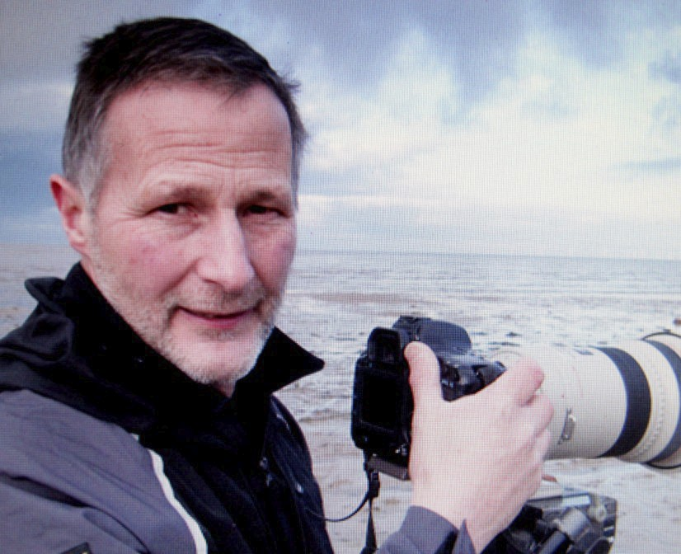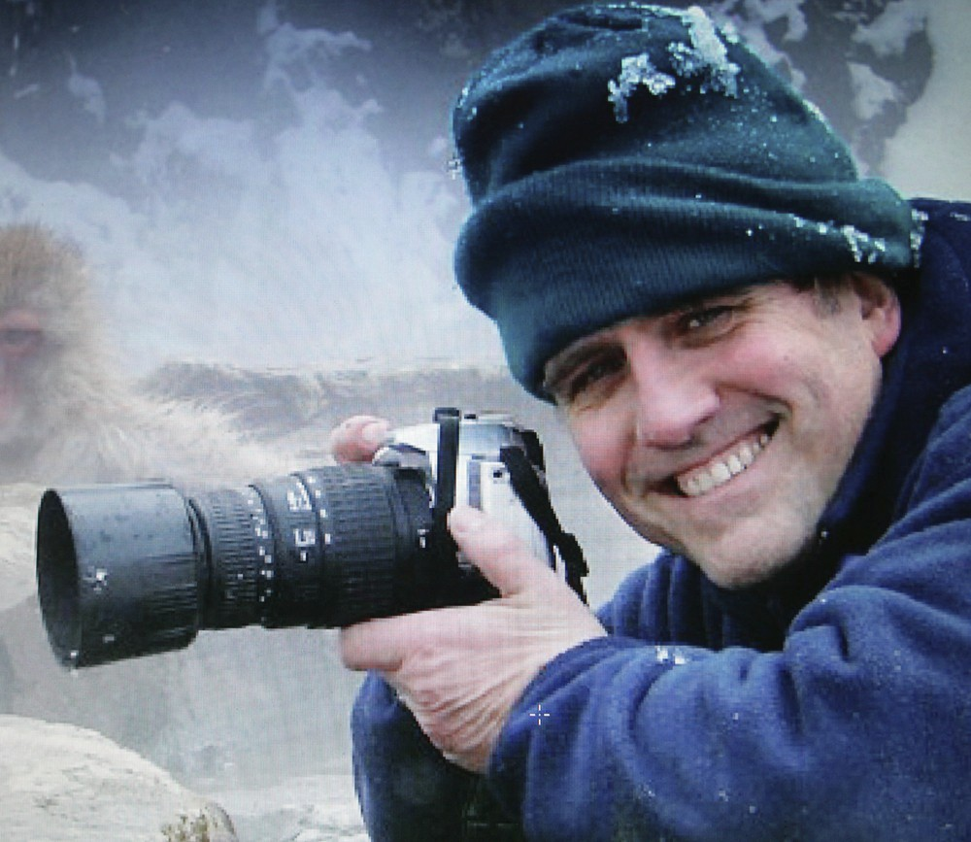

P a g e 8 N e w s l e t t e r 17

with the right bidders. The magazine supplements are surprisingly collectable as well, and they often include judges’ and photographers’ short comments about the images which do not appear in the Portfolio books.

Shropshire photographers have enjoyed some significant recognition in the competition, and
many readers will recall the well-deserved success of Ben Osborne in 2007, when he carried off the overall winner’s title with a spectacularly abstract mud-bathing elephant image. I remember checking the BBC website during my lunch break on the October day that the results were an-nounced and seeing Ben’s name beneath the winning image. I mentally flashed back to a chance meeting with him in Shrewsbury Sainsbury’s when we’d chatted and he told me, in his usual modest, off the cuff manner, “I’ve got an elephant image that I’m rather pleased with; I think I might enter it in a competition and see how well it does”.
Ben Osborne; Overall Winner, Wildlife Photogra-pher of the Year 2007. Ben recalls that at that year’s Winners’ Ceremony the young Hungarian photographer Bence Máté (Eric Hosking Award 2007 and 2010, plus Overall Winner 2010) used a copy of Portfolio 17 as a giant autograph book, getting all the photographers present to sign
against their pictures. Photo - Ben Osborne.

I spoke to Ben again recently for this article, and he reminded me that he had entered the contest several times during the 80s and 90s, achieving some solid success. His 1985 Animal Behaviour: Birds category winner featured a heavily blood-stained giant petrel scavenging on a fur seal car-cass, taken in South Georgia. This had been his first ever entry and he recalls that he was in the Antarctic at the time of the winner’s ceremony and had sent his dad to collect his award!
Another Shropshire connected photographer who achieved category wins in the early days was Mike Leach. Mike has lived in Telford and near Oswestry in the past, although he is now a Staf-fordshire resident. He remembers that as well as a category win in the late 70s and a runner up in 1980, his initial success had been with his very first entry in 1976, depicting a female rook feed-ing its young while the male looked on. That year the overall title was taken by Dennis Green from The Wirral, who won again in
IMike Leach is a multiple category winner, runner up and commended award holder for WPOTY competi-tions between 1976 and 1985. He holds an Honor-ary Doctorate of Science from Nottingham Trent Uni-versity and is the author of 26 wildlife books includ-ing The Wildlife of Shropshire, The Secret Life of
Snowdonia and The Ones that Worked. His latest is The Wildlife of Christmas. Photo - Mike Leach.

P a g e 9 N e w s l e t t e r 17

Ruabon Mountain in North Wales.

Green was actually one of two disgraced former winners, as in 2000 he was convicted of the pos-session of protected birds eggs and all his images lodged with the RSPB photo library were re-moved from use.
The second disgraced winner was 2009’s José Luis Rodriguez, who was found to have taken his ‘Storybook Wolf’ image of a tame animal in a wildlife park in Spain. By this time the rules of entry had been significantly tightened since the early days and the use of captive animals was ex-pressly excluded, unless clearly declared as such. He too was stripped of his title.
Both Mike and Ben acknowledge that their high profile success opened doors for them. Both had the BBC on their CVs anyway; Mike due to wildlife filming and Ben thanks to still photography for the Attenborough-linked blockbusters Life in the Freezer, The Blue Planet and Planet Earth. “The contest’s link with the BBC opens a lot of doors for photographers - it carries weight and kudos,” agrees Mike, who also remembers the day that the 1985 winners were announced. “I was listen-ing to the radio while driving home and the Radio 4 announcer gave the name of the overall win-ner [Charles Summers] and said that all the winning images were published in the current BBC Wildlife issue. ‘Go and buy this magazine,’ he’d said! ‘But my absolute favourite is the kestrel on the motorway bridge!’ I couldn’t believe it - that was my picture, and by the time I got home, the phone was going mad, mainly from the throwaway remark of the announcer!” In fact, some ill-
informed opinions had been expressed at the time that it was a tame bird, but Mike is keen to put the record straight: “Fortunately I had a sequence of pictures, including one of the bird just before landing, where you can see it is wild”. His picture that year was actually taken on the A442 in Tel-ford Town Centre, and he was runner-up in the Urban Wildlife class to one Chris Packham, who had positioned his camera in an open-bottomed dustbin to photograph a scavenging fox!
A third Shropshire photographer who was commended by WPOTY was the late Danny Beath, who received a Highly Commended award in 2004 with a subtly lit image of porcelain fungus growing on Nesscliffe Hill; this image is published in Portfolio 14. Some years before his sudden and very tragic death in January 2013, he told me that it was highly unlikely that any photogra-pher could hope to win the overall title with a plant or insect image and that the surest guarantee of success was still to shoot African wildlife. “You should know this - you’ve got all the portfolios!” he joked ruefully as he sat on my living room floor with the books spread out in front of him.

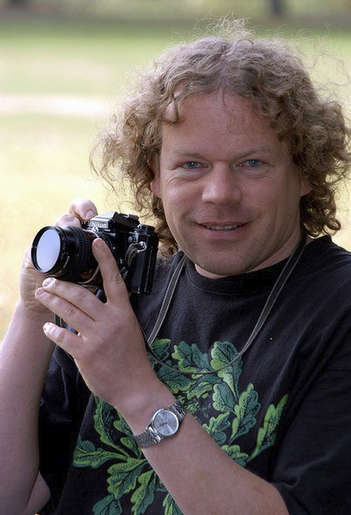

P a g e 10 N e w s l e t t e r 17

Dr Danny Beath (1960 - 2013) was Highly Com-mended in the In Praise of Plants category in WPOTY 2004. He liked to describe himself as ‘a blue butterfly in a field of browns’ and believed that the artistic insight of his Asperger’s Syn-drome gave him a huge advantage in his photo-graphic career. Certainly no one has ever photo-graphed the Shropshire landscape with more consistent insight and skill. Photo - Judy Main-waring.

There was something in what he claimed - elephants in particular have maintained a consistently high profile, with the 1993, 2002, 2007 and 2013 winners all featuring spectacular elephant im-ages. However, in 2010, the incredibly talented young Hungarian photographer Bence Máté took the overall title with a radically different photograph of leaf-cutter ants in silhouette, taken in the Costa Rican rainforest - ironically a subject treatment and an environment with which Danny was very familiar. Danny was proud of his WPOTY award and he went on to enjoy much more suc-cess in other contests - he took the First Prize in the 2010 National Insect Week photographic
contest with ‘Emerging Crane Fly’, as well as a Category Winner and a Commended in the same contest. He had numerous category winning and commended images published in Holiday Pho-tographer of the Year, International Garden Photographer of the Year and Wanderlust Travel Photographer of the Year portfolio books from 2006 onward. The world heard that Danny had posthumously won the 2012 Wanderlust landscape title (“The big one!”) when, by a cruel twist, the contest results were announced on the day of his funeral in February 2013.
Ben and Mike both agree that the technical standard of the WPOTY entries has increased enor-mously since the early days. “If you entered some of the old stuff [the early winners’ photos] into the new competition, you wouldn’t get anywhere at all!” Mike chuckles. “The new standard is so good, so impressive. Wildlife photography was a speciality back then - people didn’t travel exten-sively and they didn’t have the kit. But ordinary people have good equipment now, they travel to the Masai Mara and Antarctica on holiday. A lot still depends on the category you enter. Birds
and mammals are enormously popular whereas underwater work is still very specialist, depend-ing on photographer’s skill and the very best underwater equipment.”

P a g e 11 N e w s l e t t e r 17

Ben goes on. “In the early days, [a subject like] birds in flight, for instance would be all hand held, manual exposure, manual focus, and no digital! You had to be totally in charge of your equip-ment - no flash technology, no wi-fi remotes, no camera traps. But artistically, I’m not sure the standard has really advanced. Photographers like Frans Lanting [Overall Winner 1991] and Jim Brandenburg [overall winner 1988 and Chairman of the Judging Panel since 2012] have produced consistently beautiful images over the years - Jim in particular has a very creative eye - so I doubt the appreciation of beauty has changed, although to me there seems much more emphasis on pin-sharpness now.

We can only begin to imagine how the technical standards might improve over the next fifty years of this prestigious contest. Entries have grown from just a few hundred in the 1960s to over 32,000 in Ben’s winning year of 2007. The 2013 contest attracted almost 43,000 entrants. Com-petition is at its fiercest, and it is quite possible that another major challenge in the future will be to find sufficiently unspoilt environments in which to take the photographs. It seems depressingly likely that many of the charismatic species which we can now commonly enjoy may be just a memory by the hundredth competition in 2064. But as species adapt to man’s own environment, creative photographers should still be able to document that progress with ingenuity and skill, and it seems certain that the competition will play an ever increasing part in raising awareness of the crucial importance of wildlife and the natural world to the human race.

With thanks to Ben Osborne and Mike Leach.
This article is dedicated to the memory of Dr Danny Beath, BSc. PhD., 1960 - 2013.
Ric Morris



1981 with a superb shot of a female merlin in flight, taken on
P a g e 12 N e w s l e t t e r 17

We would like to wish you all a very Merry Christmas & a Happy New Year!

Shropshire Mammal

Group events and surveys 2013.

• 18th January 2014 - AGM. To
be held at Preston Montford Field Centre. Starts at 9:30am
for tea and coffee with busi-ness commencing from 10am.
The meeting will be followed by a talk or a workshop, fur-ther details to be confirmed!

• Keep an eye on our website
and Facebook page for further projects, surveys etc starting
in the new year!
Corporate Members
Shropshire Mammal Group is grateful to its corporate members for their support.
• Field Studies Coucil - Preston Montford
Field Centre
• Pearce Environment
• Whitchurch Community Water Vole Pro-
ject
• Shropshire Wildlife Trust - Ellesmere
Branch
• Roberts & Son, Lower Wallop Farm
• Shropshire Bat Group
Next Committee Dates:
Monday 3rd February 2014 Monday 7th April 2014
NB meetings will start at 7pm

