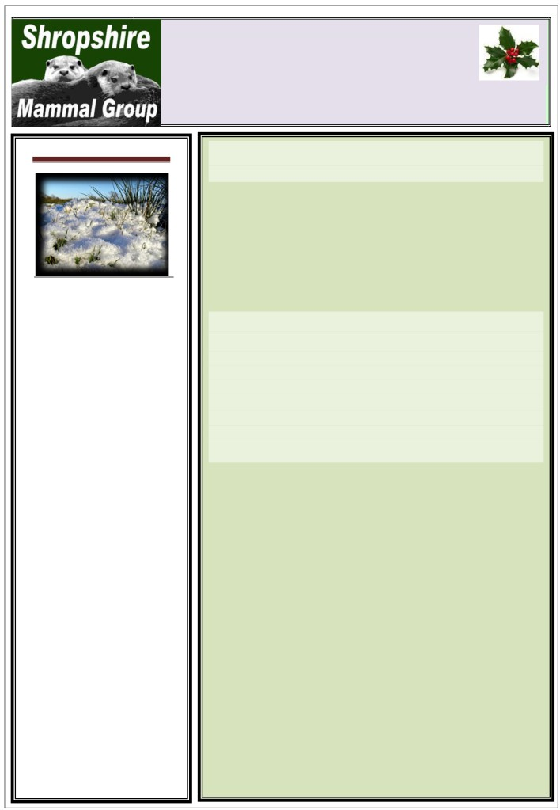

Quarterly
Newsletter 13

Affiliated to the Mammal Society
Winter 2012

Shropshire Mammal Group Events

Shropshire Mammal Group AGM
The meeting will be followed by a talk by Marina Pacheco, CEO of The Mammal Society and a walk around the
grounds of Walford Campus.
10am-1pm Saturday 19th January

Contents

Page 2 Hares and Myxo

Page 3 Can someone find me a field mouse?

Page 4 What the cat dragged in...

Page 5 Bat Skeletons
Page 6 Mammal Box Page 7 BioBlitz Review

Page 8 Sniffing at Shelve

Page 10 Walk at Lower Wallop Farm

Page 11
Note from Chair Tube Traps
Contacts
The Harris Centre, Walford Campus, Baschurch.

Whitchurch Carnivore Survey
With Dr Gareth Parry
Only one more date remains for the carnivore surveys and your help is still needed!
10am-1pm on the following date:
Saturday 26th January 2013
Meet at Greenfields Nature Reserve Car Park (SJ 532 415)

Happy Valley Riparian Mammals
Habberley Brook is sandwiched between Pontesbury and Earl’s Hill and it is possible that otters inhabit the area. SMG will lead a 3 mile circular walk to
check on camera traps, footprint trays and mustelid traps.
ALL LEVELS OF EXPERIENCE WELCOME
24th Feb 2013 10am-1pm

Peak Mountain Hares
A day in the Peak District with Derbyshire Mammal Group for a close encounter with a species not present in Shropshire.
24th March 2013
Places are limited so booking is essential, email us if you are interested in coming along.

Mammals of Catherton Common
Join Shropshire Mammal Group, as we survey for water shrews, common shrews, yellow-necked mice and bank voles. This reserve was purchased by Shropshire
Wildlife Trust in 2009 and has great potential for small mammal surveys.
ALL LEVELS OF EXPERIENCE WELCOME
27th April 2013 10am-2.30 pm

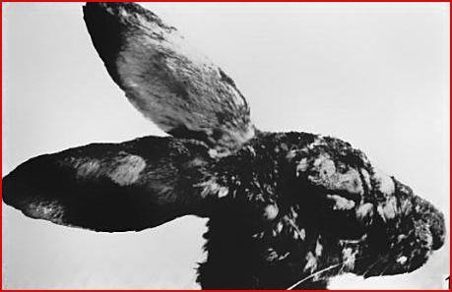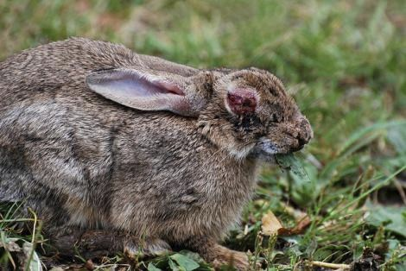

Myxomatosis in Hares (Lepus europaeus)
Myxomatosis was first found to be present in the UK in 1953 and spread through the rabbit (Cuninculus oryctolagus) population like wildfire, killing an estimated 98% of British wild rabbits. The disease, which is a viral infection spread through fleas and by close physical contact, was first identified in Uruguay in 1896. With its devastating effects on South American rabbit populations, the disease was introduced intentionly into the Australian rabbit population twice, both in the 1930s and 1950s, with the intention of eradicating a non-native species from fragile habitats. The Australian trials proved to be a mild success, but rabbits were twice able to bounce back from the brink thanks to their incredibly high breeding rate. The virus was introduced to rabbits in France in 1952 and showed up in Britain just a year later, though it was never proven whether the disease had been introduced here through a underground planned programme.
Whether or not brown hares could contract Myxomatosis has been much debated and many of the people I have enquired with were unable to give a conclusive answer. The wild hare population in Britain has reduced dramatically in recent years, partly due to continued hunting, but increasingly thanks to a loss of suitable habitat as farming techniques change and evolve. Hares also have species-specific diseases to deal with, the most common disease in hares being Brown Hare Syndrome, which is closely related to rabbit hemorrhagic disease and is fatal to any individual unlucky enough to contract it. In March 2011, there was an outbreak of Tularaemia in the brown hare population of France which was spread by biting insects such as ticks and fleas. Both of these diseases display similar symptoms of open sores, ulcers, lesions on the cheeks and face of infected animals; all of which are symptoms commonly associated with Myxomatosis.
Myxomatosis has been reported in hares in England as recently as October and infected animals were photographed in Lincolnshire back in march. In fact, a record of a hare displaying symptoms of myxi was made in Shropshire near to the Cheshire border. However, after consultation with the vet responsible for euthanising the animal, the suspected hare was actually confirmed as a rabbit.
It was only by looking back to a book dedicated to the Myxomatosis virus published in 1967 that I was first able to find confirmation that the virus could definitely infect and kill brown hares. There are actually several strains of the virus,
the most virulent being the Californian strain (Fenner 1967). In 1957, French biologists Jacotot, Vallee and Virat tested live virus on 13 hares in laboratory conditions. Of the 13, 100% survived and showed no physical signs of infection but did show to have developed antibodies against the virus. Despite this research, a dead wild hare autopsied in France in the 1960s tested positive for Myxomatosis (see pic 1). Whether or not this animal had been killed by a more virulent strain was not confirmed.
The photos of hares in Lincolnshire taken this year displaying symptoms of myxi apparently confirmed that the virus could well have spread into our hare population, however without medical examination and with symptoms of Brown Hare syndrome being physically similar, it is not guaranteed that British hares do now face the additional threat of a disease which was only thought to affect rabbits. We know that hares can contract the virus, but not all individuals will die as a direct result; genetics and environmental factors (agrochemicals and gm crops) could play a role in ascertaining the mortality rate.

So to summarise, it is more than likely that brown hares, as well as rabbits can still contract Myxomatosis but in my opinion, the virus doesn’t offer a serious threat to the Lepus europaeus population in the UK at present. Unlike rabbits, who live in densely populated warrens where diseases can quickly spread, hares tend to live a more solitary lifestyle and are not quite susceptible to a virus which is spread by close social contact. However, more research is still needed to help us to understand the Myxomatosis threat in the UK. If you see a hare displaying symptoms of myxi (the most common
being facial ulcers/growths and general lethargy which usually allows us to approach an individual very close), please send me the details and I will attempt to investigate all reports in order to gain more insight into whether our hares are facing another threat in addition to those already faced by a rapidly declining species.
Stuart Edmunds

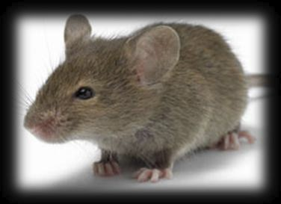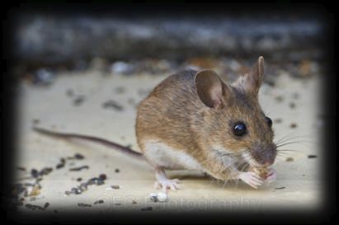

Can someone find me a Field mouse? Gareth Parry
I have discovered two common consequences of being a mammologist. Firstly, inexplicable bags of dung are often thrust into your hand, accompanied by an eager anticipation of what rare species may have produced said excretion. The second, and perhaps more pleasant outcome, is that people like to share their mammal stories with you. I enjoy hearing people joyfully describe the time a weasel shot out in front of their car, or when they saw a Hare whilst walking the dog. I have even come to terms with people who tell me stories of spotting otters, although admittedly there is always a tinge of jealously. It can be a great source of records, if you pin down the date, location and are confident of the identification.
There is one regular story that puzzles me, because it is about a mysterious creature called the Field mouse. I thought I had have been fortunate enough to encounter most of Britain’s small mammals (Skomer vole and Scilly Shrew aside); however, I have never managed to catch a glimpse of a field mouse. Have I been missing out or is there a more straightforward explanation to this enigmatic mouse.
Delving into the internet demonstrates that it is not just Shropshire that is rife with stories of Field mice. It is a popular subject on wildlife websites and public nature forums. One national newspaper has a story about an incredible field mouse, which pulled itself from the raging torrents of the River Irthing in 2009. The story is accompanied by photographs of the ordeal, revealing that the star is in fact a Wood mouse (Apodemus sylvaticus). As I explore other articles, blogs and comments, I discover that the Wood mouse is repeatedly the doppelganger for the Field mouse. Further investigation exposes that an alternative common name for the Wood mouse is the Long-tailed field mouse. Does this solve the mystery? Am I just a pernicious scientist, intolerant of people who choose to use a different common name to the one accepted by Mammologists?
I’ll admit that when listening to tales of Field mice, I gently probe around in order to establish the creature’s true identity. Often it is a Wood mouse, however, at other times it turns out to be a Yellow-necked mouse, Harvest mouse, Field vole or even a Dormouse. So it is not simply a case of assuming that all field mice are A.sylvaticus. It appears to be a generic term, inconsistently applied to small rodents other than Brown rat (Rattus norvegicus) and House mouse (Mus musculus). The true identity of the field mouse varies between people, causing a bit of a headache for mammal recorders.
The strength of the field mouse enigma reveals something quite fascinating, which is the poor knowledge of Britain’s small mammals among the general public, even in amateur nature enthusiasts. Excluding geographically isolated species, sub-species and invasives, there are just twelve small mammals that are likely to be encountered in the UK (Table 1). Most can be distinguished relatively easily on appearance alone, so it is concerning that misidentification creeps in so often. In terms of mammal conservation this is particularly problematic when Field voles or rats are mistaken for Water voles and when Wood mice are mistaken for Harvest mice.

Common name | Scientific name
Common shrew | Sorex araneus
Pygmy shrew | Sorex minutes
Water shrew | Neomys fodiens
Bank vole | Myodes glareolus
Field vole | Microtus agrestis
Water vole | Arvicola amphibious
House mouse | Mus musculus
Wood mouse | Apodemus sylvaticus
Yellow-necked mouse | Apodemus flavicollis
Harvest mouse | Micromys minutus
Hazel dormouse | Muscardinus avellanarius
Brown rat | Rattus norvegicus
Both the Shropshire and UK mammal atlases are currently being prepared, so it is important to improve public familiarity with our small mammals. But how do you get people interested in small brown ‘mouse-like’ things when there are lots of colourful, exotic and exciting species on television. I believe the most important weapon in our arsenal is small mammal trapping. Bringing people face to face with these creatures is an invaluable experience that etches on the mind. It can illustrate the diversity of Britain’s small mammals, demonstrate the differences between them and make people think twice when they spot one for themselves.
This Field mouse conundrum also highlights the importance of scientific names. Mammologists use scientific names considerably less often than botanists, entomologists and mycologists, probably due to the comparatively lower number of mammal species. Perhaps this has contributed to the ambiguity of small mammal identification, where generic names are used interchangeably between different species.
Spot the difference: The House mouse Mus
musculus (left) is under-recorded in Britain: please let us know if you have seen any in the county. Wood mice Apodemus sylvaticus (right) are often mistaken for House mice but
are easily distinguishable by their white underside, larger eyes and lighter fur.

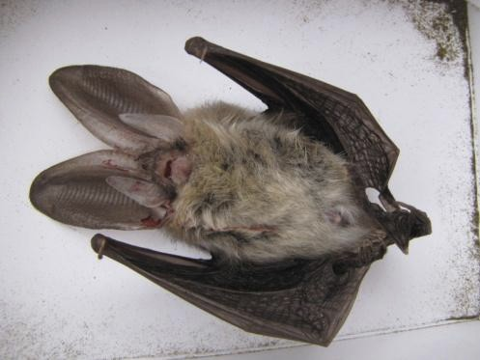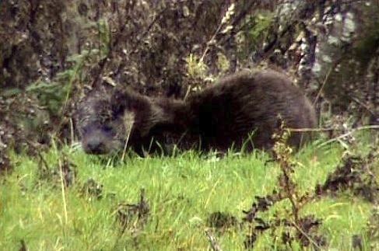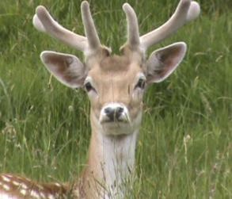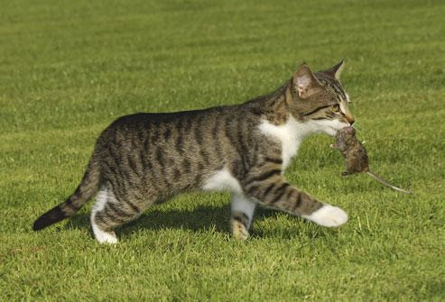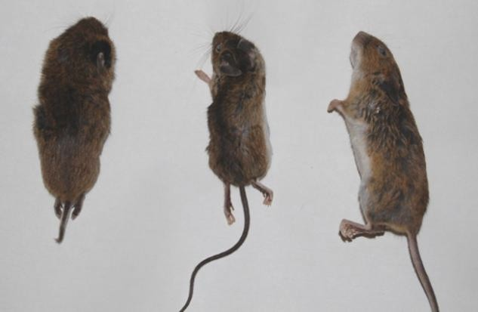

Let us know what the cat dragged in!
As a group, one of our main aims is to collect as much mammal data in Shropshire as we can. This often involves liaison with landowners and organisations to allow ourselves access to information collected by other parties. But in addition to this, we still rely heavily on members of the public to report their mammal sightings to us. This could be a sighting of an otter on a brook while you are out walking your dog or even footprints of a mystery animal whose footprints you may have discovered in a mud patch. There is however another way of tracking mammal distribution in the county and it is often considered a contentious issue. Many of our members own cats. There are an estimated 8.8 million cats in the UK at present, of which 800,000 are classed as feral. According to the RSPB, cats are responsible for
catching around 275 million prey items a year, with mammals estimated to be making up 69% of that prey. A colleague of mine has been recording everything that her cat Jonesie has brought in since September and the range of mammals has been very surprising, with house mice and yellow-necked mice being the most common captures, followed by field vole, bank vole, and common shrew. The most surprising find was the appearance of a brown long-eared bat that Jonesie had sat patiently waiting for by a roost for 3 hours (cats are ambush predators and have highly tuned hearing for detecting small mammals as they roam/fly around in the darkness of night).
At a glance, this news is both startling and to many a nature
lover; distressing to say the least. However, it is an issue which will live with us as it would be very unlikely that I could convince all cat owners to keep their pets locked in each night, thus depriving them of the activities they are so perfectly adapted to performing. So, I would like to turn a positive into a negative: if small mammals are being dragged in by cats, it only seems right that we should be making a record of the species killed or caught. We cannot victimise cats for their behaviour, particularly when considering that they have been bred and kept by humans for centuries as a way of controlling “pests” in town and country. It is unfortunate that cats are not selective about their prey but it does seem apparent that cat
characteristics and behaviour vary greatly and not all cats actually hunt and kill prey when given the opportunity. But if you are the owner of a particularly skilled cat and do often receive small mammals as gifts from your pet, please send us a record, or photos of the mammals. The data will be used solely to record small mammal distribution, rather than as an assessment of the affect of cat predation of small mammal populations in Shropshire.
Photos.
Top: Cat carrying small mammal prey.
Above right: Small mammal specimens captured in the Worthen area during one week in December (From left: Field Vole, Wood Mouse and Yellow-necked Mouse). A cat’s drive to hunt is one of instinct and not caused by hunger: a well fed cat is just as likely to hunt.
Left: A Brown Long-eared bat captured in October. Cats are
often seen waiting in ambush outside bat roosts and flight paths and use their paws to “bop” them to the ground as they fly past.

SHROPSHIRE MAMMAL PHOTOS!

If you have any photos of mammals in the wild that you would like to share, post them on the Shropshire Mammal Group or Twitter page! The best photos shared will be used in future newsletters for any members without access to the web pages to enjoy.

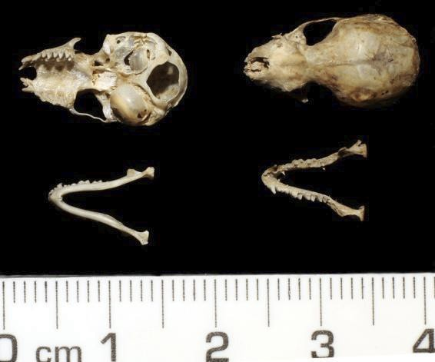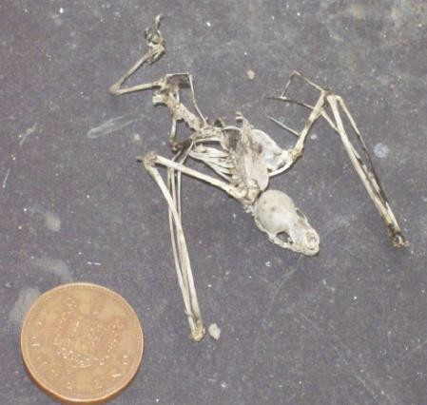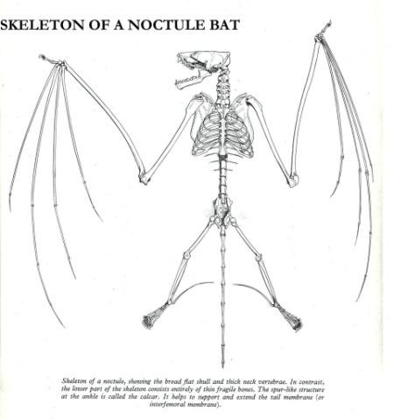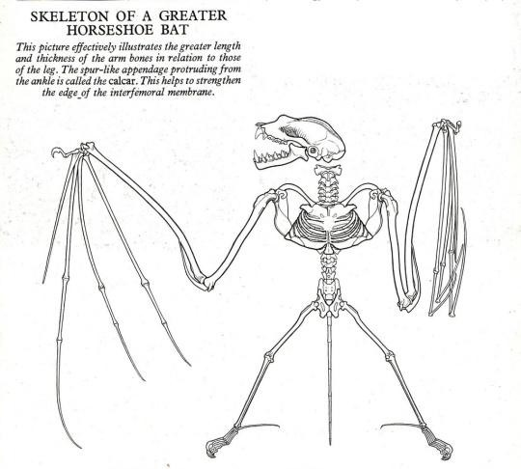

BAT SKELETONS
This month I want to discuss a few of the distinctive features of the skeletal anatomy of the Order Chiroptera
- bats in plain English. Ancient folklore considered them to be flying mice- Shakespeare mentions ‘rere-
mice’ in A Midsummer’s Night’s Dream - and some fruit bat species are also known as Flying Foxes, but the
skeletons of our bats bear no resemblance to either Rodents or airborne Carnivora.
In fact, UK bats fall into two families - the Rhinolophidae and the Vespertilionidae. In simple terms, these
are the two Horseshoe bat species versus the rest.

The skulls of all UK bat species exhibit a deep rounded concavity at
the tip of the muzzle in the area where we would expect the incisors
to be normally located. In the Vespertilionids the premaxillae bones
to which the incisor teeth are attached are located either side of the
concavity, however in the case of Rhinolophids, the premaxillae are
extremely delicate and stalk-like, protruding from the centre of the
concavity and carrying incisors on their tips. In horseshoe bat skulls
found in owl pellets these are generally missing, and the same may be
true of any skulls which have undergone any rough handling, or over-
aggressive invertebrate action during decay.
Even without these stalk-like premaxillae, it is, however,
straightforward to tell a damaged Rhinolophid skull from a
Vespertilionid by virtue of another distinctive feature; both of the Rhinolophid species have two bulbous
projections on the snout, which are absent in the members of the Vespertilionidae.
Photo top left: Greater Horseshoe Bat. Note the ulna bone found in the Rhinolophid skeleton, in contrast to the
Vespertilionid, with the corresponding absence of the fibula in the lower hind limb.
Above: Plecotus species. The deep rounded concavity in the front of the muzzle is clearly visible in these photos. I
attributed identification to (Brown) Long Eared Bat (Plecotus auritus) at the time of collection in September 1981, as
there were mummified remains of immense ears attached to the bones, but I wasn’t in a position to rule out the then
fairly recently described Grey Long Eared Bat, Plecotus austriacus!
Above middle: Bat Bones. Kate Long’s photograph of a Vespertilionid bat skeleton found near the Welsh coast in 2009
clearly shows the long radius and metacarpals, both of which features confirm that this could not belong to a member
of any other Order of mammal than the Chiroptera.
Above right: Noctule Bat. The largest of the UK bats, the skulls of Noctule, Leislers and Serotine bats have a very flat
topped appearance to the muzzle and cranium, while the smaller Vespertilionids have a steeper slope to the frontal
bones and a more rounded cranium.
Elsewhere in the skeleton, the most distinctive feature is the extreme fragility, coupled with the
extraordinarily long bones of the lower arms (radius / ulna) together with very slim metacarpals and
phalanges which support the wings - the equivalent of human palm and finger bones. In some species a
single metacarpal bone can be as long, or longer than the head to tail measurement of the whole animal.
There is a comprehensive guide around every aspect of a Pipistrelle bat skeleton on Jake McGowan Lowe’s
excellent ’Jake’s Bones’ blog at http://www.jakes-bones.com/2012/07/my-pipistrelle-bat-skeleton-and-
my.html
Some species have modified cervical vertebrae to enable them to have sufficient neck mobility to look
around them while hanging upside down. The Noctule Bat artwork shows the very strong and powerful
neck. Note also the characteristically shaped scapulae and the fused pelvic and sacral assembly at the base
of the spine, which is another diagnostic feature of bats, common to all species, but which is also shared
with the Mole.

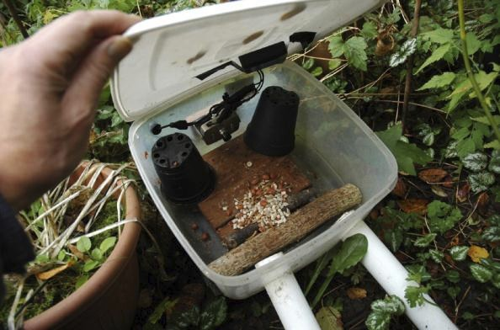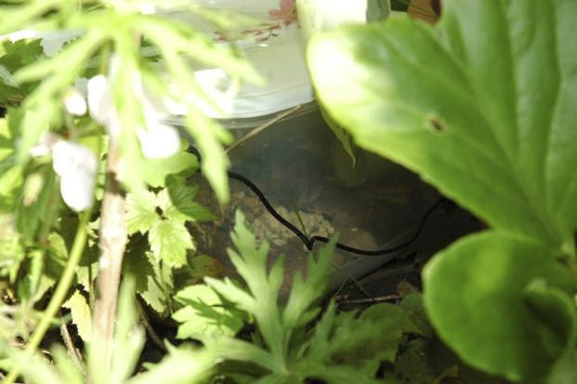

I mentioned the lower arm bones above - in fact this leads me to another distinctive feature which can aid identification to family level. The Vespertilionid bats have only one bone in the lower front limb, which some authorities identify as the radius, while it is possible to distinguish two bones in the proximal end of the Rhinolophid limb which become fused as they move towards the wrist. Conversely, the opposite seems to be the case in the lower hind limb; the Rhinolophids lack a fibula behind the tibia, or shin bone, although the bone is present in the Vespertilionids (and helpfully visible in one of Jake’s photographs). The skeleton artworks provide clarification of this.
There is an excellent detailed set of bat skull artwork for the majority of species in Lawrence and Brown’s Mammals of Britain; Their Tracks Trails and Signs (1st ed. 1967 / 2nd ed. 1973), and this is the best identification guide I can recommend. Don’t forget that you can see larger versions of the artwork and my Plecotus skulls (which I hasten to add that I collected in Ampthill, Bedfordshire in 1981) on my Flickr page at www.flickr.com/SMG_Skullboy. Finally please note that bat species are protected in law, and possession of any bones or bodies other than historically collected specimens requires appropriate licensing, as described by Jake in his blog post!
Ric Morris December 2012
Next Committee Meetings:

4th February 2013
8th April 2013
All meeting held at Shire Hall, Shrewsbury.
Mammal Box

Inspired by an episode of Springwatch, we decided to construct our own mammal box. We used a nest-box camera mounted inside a large semi-transparent plastic cake-box with an
opaque top.

The camera bracket was secured through the plastic side into a small block of wood. The transmitter was fixed [pointing in the appropriate direction] to the inside of the lid with duct-tape. The camera and transmitter are powered by a single 12v low voltage supply through a hole in the side of the box. This had to be large enough to accommodate the low-voltage connector. The hole was plugged with some plastic foam to keep it water-tight. The flower pots were added to prevent camera-shy animals from hiding in the corners.

A flat piece of untreated wood was placed in the box along with a
couple of small logs. A mixture of peanuts, sunflower seeds, suet pellets and mealworms can be used as bait and placed in the centre of the box. Some of this would fall between the logs and thus give the visitors a chance to excavate for food.
Access to box was provided by two pieces of 40mm waste pipe, approx 30cm long, inserted through holes cut in the side opposite the camera. A tight fit is needed to keep the tubes firm and exclude rain. This was achieved by drawing round the end of the pipe and then cutting the hole out carefully with a craft knife.
We sited the box just outside our kitchen window under plenty of plant cover. It was placed on two bricks with the tubes sloping down to prevent water entry.
It was late June when we first set up the box and within twenty-four hours we had observed our first visitors. Within a few days wood mice, bank and shrews were seen. We knew that we had wood mice and bank voles since both species visited the nearby bird feeder, but we had never seen a shrew in the garden before, alive or dead.
We have monitored the box using a television screen in the kitchen

which has made cooking and washing-up much more entertaining.

Wood mouse in the mammal box

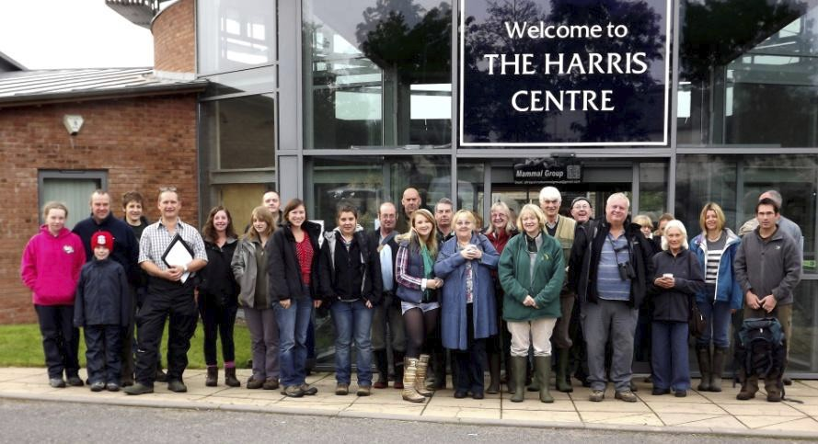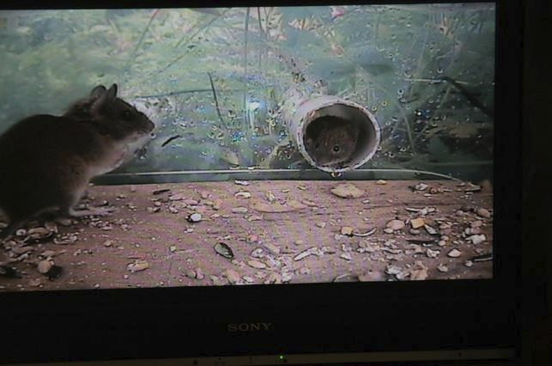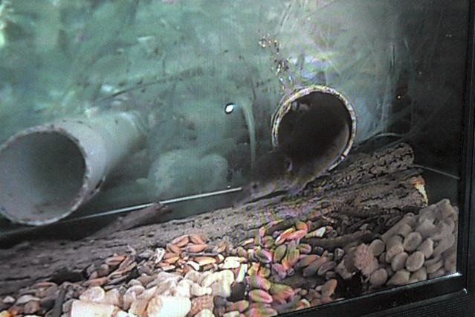

Young bank vole approaches a wood mouse Common Shrew
We have also connected a recorder and left it running overnight. Eight hours of recording has produced anything
between one and five hours of mammal activity plus the occasional giant slug. There is always a lot of munching and it takes a lot of editing to select the interesting behaviour that occurs when several small mammals are in and out of the box. We have seen a family of four wood mice in there together feeding quite happily, but generally, unrelated individuals or different species are not at all tolerant of each other.

The camera kit was well worth the investment. We have learned a lot but also had endless hours of entertainment.
Malcolm and Anne Monie
Bio-blitz Weekend
By Holly Shingler
When I first heard about the bio-blitz weekend I thought it was an excellent event for people from all backgrounds to actively get involved in recording wildlife. In particular, I thought that it couldn’t have come at a better time as I had recently graduated from university and the more hands-on experience I could get, the better! As a non-member and someone who had never attended anything run by the Shropshire Mammal Group before, I didn’t really know what to expect on arrival and thankfully, I was instantly made to feel like
part of the team. I got stuck-in with helping to set up stalls and was roped in by Paul Roberts to sell some raffle tickets and talk about our lovely little guests… the Harvest Mice. They were sent to stay with Uncle Paul for a couple of days from Chester Zoo and their cuteness attracted a lot of attention, in particular, those with cameras but sadly they just weren’t fast enough with their clicking!
I was exciting to get stuck in with the workshops as they were crammed with interesting and engaging information, not to mention run by experienced, industry people.
Stuart Edmunds kick-started the weekend off with an insightful talk into Mammal Tracks and Signs which looked into what to keep your eyes peeled for such as burrows, track marks, nibbled stems, and of course, droppings. It allowed me to think a lot more about the distinctive marks that are left behind by different creatures and how these marks could in fact lead to the identification of such creatures. Sue Mclamb talked to us about Dragonflies and Damselflies, obviously not mammal orientated, but interesting non-the-less. She talked about identification techniques, and for someone who has never known the difference between the two species it was exciting to be able to take my new found knowledge out into the field when she took us for a jolly around to the campus pools.
During Sue’s talk another was taking place which was lead by Mark Duffell who spoke about identifying water flora, sadly I could not take part in this class as it ran alongside Sue’s talk.
Carl Griffin, from Ricoh, gave a presentation which looked at how active Ricoh are within the world of conservation. During my time at Harper Adams University College I had met a different Ricoh employee who had given a presentation detailing what the company do as a whole, so it was interesting for me to hear a little more about the involvement of the Telford branch, especially in regards to what they do with the Shropshire Wildlife Trust.

Rob Parry’s talk about the Welsh Beaver Project was fascinating. Rob gave us a lot of information about their history, ecology, and behaviour as well as the re-introduction of the species into Wales. Jim Ashley talked about the bTB vaccination. At the start of the talk he clearly stated that he was not going to talk about bTB, he just wanted to talk about the science and the facts about both the cull and the vaccination. It was nice to hear the facts without someone being biased towards the subject. Ric Morris spoke about mammal bones, it was interesting to hear the facts about certain species and their bones, and in particular what you may or may not find in certain mammals so as to identify them, such as Shrews who do not have cheek bones.
Kate Long, Lorcan and Rosie discussed the Whitchurch Water Vole Project which suggested reasons as to why the population is in decline and they also went into detail about the tracks and signs that they leave behind. They also showed video footage of water voles interacting.
Once all of the workshops had come to an end on Saturday, the Shropshire Mammal Group members ran a session on small mammal trapping. This involved placing traps across a signification proportion of the Walford College campus. I believe the main species which everyone was looking for was the Yellow-necked mouse. The trap would be collected and the findings analysed the following morning. During the evening the Shropshire Bat Group hosted a bat walk, I found it a very interactive session and was ever so happy when we got to see a Daubenton’s bat flying across the top of one of the pools as well as to identify a Long-eared bat with the use of a bat detector.
Sunday started off with all of us going out to see how many traps had been set off during the night and to see if we managed to trap anything. I believe all of the findings will be made available to members once Paul Roberts has written his report on our findings.
Johnny Birks, Chairman of the Mammal Society, gave a talk on “Why are we neglecting our smaller Mustelids?”. I found this talk very insightful and though provoking. As of late, all we seem to hear about are Badgers and that is predominantly negative, but nothing is ever said about any other mustelid, especially when it comes to identifying population numbers.
Louise Wilson gave a presentation and demonstration about Conservation Dogs. For me this was one of the highlights of the weekend as I had never thought about the use of dogs within conservation and species surveys. In particular, I found the work she had done in order to help identify the impact of wind turbines on bats was fascinating. She had trained one of her dogs, who used to work as a corpse sniffer dog, to find bat carcasses and the fact that he could track down several species of bat was just mind-blowing. Louise identified facts which showed that dogs are more successful at finding species and their tracks, this is shown in the following figures: dogs have a 96% chance of finding carcasses compared to humans who have an 11% chance! To me that was an amazing fact to help put the significance into perspective.
Finally, Gareth Parry finished the day off with a workshop about Otter Spraint Analysis. This involved working with microscopes and identifying the diet of otters. I have to say I wasn’t very good with my bone identification… I had to call upon Gareth for assistance many times! But other than that it was a very interesting workshop.
Overall the weekend was insightful, interesting, engaging as well as interactive. I have found it an incredibly useful experience to add to my CV as it has allowed me to gain some hands-on experience which my CV was in desperate need of.
I would like to finish off with thanking everyone who put in the time and effort to organise the event, and of course, everyone who attended. Thank you!
Sniffing Around Shelve
I’m sure there is an infinite number of puns I could use in this article, given the circumstances but I will resist all temptation, and simply report that on October 27th, we conducted an exciting survey of woodland at Shelve, trying out Luna’s (Conservation sniffer dog) extraordinary ability to detect marten scats. This location, near the Stiperstones NNR, is an area which has been reported to harbour Pine Martens, and has been surveyed by (human) SMG members in the past.
Louise and Luna had last been seen in action at the Walford College BioBlitz, demonstrating Luna’s unique skills. Given Stuart’s determination to confirm the presence of martens in Shropshire, Louise was a most valuable contact to make, and she has kindly agreed to keep in touch with our group, offering us the facility to survey sites at reasonable cost, and locate scats quicker and more accurately than ever before (as well as to provide Stuart with a regular supply of genuine Pine Marten scats- previously used for training Luna- on which he is enjoying sharpening his own olfactory skills!)
Luna did not disappoint on the day, searching enthusiastically through areas inaccessible to humans, and it was a privilege to watch Louise’s skilful handling and direction of her canine companion. In all, 10 scats

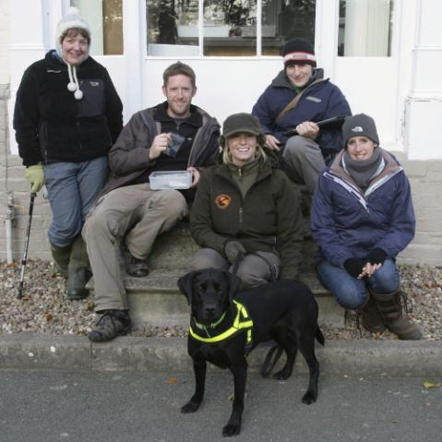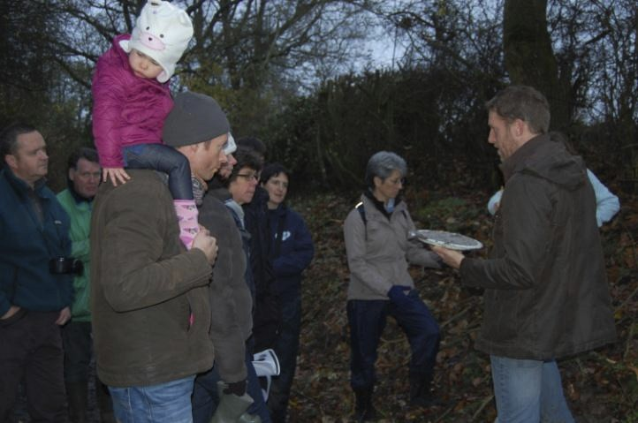

were found, a significant improvement over the last visit when just 4 were located. DNA tests have subsequently shown that 6 of these proved to be fox; and no DNA could be recovered from 4. This is in no way a disappointment, in that these particular scats were somewhat old and weathered; the important thing is that they have not been positively identified as a different
species. Overall mammal records for the morning at Shelve were: Fox, badger, grey squirrel, rabbit, wood mice, bank vole and even a water shrew was spotted in broad daylight!
In the afternoon we adjourned to the Preston Montford area, were we were joined by Clare Jowett. A garden where unverified sightings have been made in the past was carefully searched by Luna and members, but nothing definitive was discovered. We also had a sniff round down by the river and a good scout around the Field Centre grounds, but alas no definite ‘hits’ for Luna.
We ended the afternoon with a group photo outside the centre; Ric not pictured (behind the camera again!)
SMG Family Walk at Lower Wallop Farm
A warm welcome on a cold day awaited SMG members and guests at Lower Wallop Farm near Westbury, for a family walk and mammal track workshop, courtesy of Angus Roberts. Also in attendance was Sara Bellis, of the iSpot nature observation forum, with her son Harry and overall a healthy number of young naturalists, all keen to see tracks and signs of the mammal fauna of this remarkable organic arable farm.

Torrential rain during the previous night had filled the
streams and flattened and blurred any small mammal tracks in the vicinity of the farmyard and down the lane, but there were several superb tracks which had not been at all affected; these being a set of laminated printouts of specimen footprints which Stuart had previously fixed to waymarker posts along the walk. The younger children had great fun guessing and identifying the mammals to which the tracks belonged, and extra interest was excited by the thrilling finds of
squirrel tracks in a prepared clay bed which Stuart had also tucked under a hedge in the hope that something would stop by to make its mark.
A couple of bank vole holes were seen, appropriately enough in a mossy bank along the roadside, and a little later, some mole hills in the fields. nother highlight for the children was ngus’s discovery of a couple of Barn Owl pellets and Ric Morris was on hand to assist in identification of small bones discovered when these were carefully teased apart. Field Vole (Microtus agrestis), Wood / Yellow necked mice (Apodemus spp. - difficult to distinguish from skull remains alone!) and Common Shrew (Sorex araneus) skulls were all found inside the pellets.
Light began to fail as we moved down towards the brook, but Paul Wright had a good sighting of a buzzard sitting on a fence a hundred metres or so away; this flapped lazily off after a few moments. Otter signs had been seen in the past in the area of the brook but unfortunately anything remaining had been swept aside by the overnight rain.
Walkers and the families returned to the Farm to enjoy hot chocolate all round. The bonfire was not entirely co-operative, despite all best efforts, but that didn’t dampen the enjoyment of the day one little bit.
Many thanks to Angus and and family for hosting this family friendly event.
Ric Morris

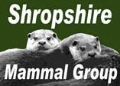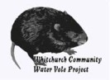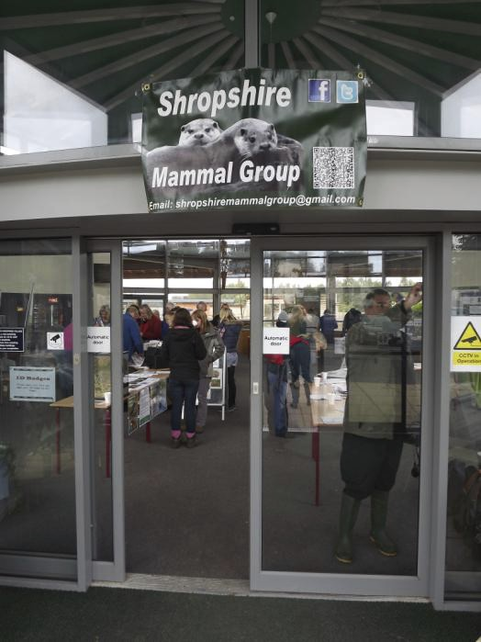

From the Chair
Growing the Group

2012 has seen a fifty percent increase in the paid-up membership of the group which now stands at 89. There are also 72 “members” on Facebook quite a few of whom are not yet subscribers. The increases are in no small part the result of the September Bioblitz at Walford, the Pine Marten survey and other high profile activities. A big thank you to everyone involved in organising these. Another result has been much closer working with The Mammal Society. Not only is the Marina Pacheco, the Chief Executive coming to speak at our AGM next month, but you can now obtain a joint membership of the two organisations at a £3 reduction compared to the separate subscriptions. Finally, we have been invited to host next years Mammal Society Autumn Seminar. Shropshire is definitely on the mammal map!
Malcolm Monie
16 December 2012

Tube Traps
The new alternative small mammal traps, the Tube Trap has now been approved by the Mammal Society’s research committee for use in small mammal surveying. Shropshire Mammal Group have been testing the new traps and have found them to be just as effective as Longworths, for a fraction of the price. Not only are Tube Traps working well for mammal monitoring, they also offer the advantage of improved insulation when compared to metal traps and I have noted a 2.5 degree temperature difference between the two trap types when left out prepared overnight. We plan to purchase more in 2013.
Tube traps are available for purchase from:

sales@bioecoss.co.uk (01603 767891)

Corporate Members
Shropshire Mammal Group is grateful to its corporate members for their support.
❖ Field Studies Council - Preston Montford Field Centre
❖ Whitchurch Community Water Vole Project
❖ Shropshire Wildlife Trust Ellesmere Branch  Lower Wallop Farm
Links to Websites

Shropshire Bat Group

Contacts

Chairman: Malcolm Monie 01948 663069 Secretary: Clare Jowett 01938 570418
Membership Secretary: Clive Dean 01743 367024
Treasurer: Pauline Mackintosh 01584 861688 Events & Newsletter Editor: Stuart Edmunds 07917 055143 Shropshire Mammal Recorder: John Mackintosh 01584 861688

Committee members:
Alan Reid, Simon Poulton, Gareth Parry, Lorcan Adrain, Paul Roberts

Shropshire Mammal Group email

