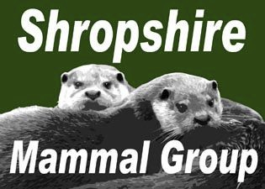

Quarterly
Newsletter 8

Affiliated to the Mammal Society
September 2011

Contents
Shropshire Mammal Group events 1
Articles
Shropshire Pine Martens? 2 Opal Events 4
Review of SMG events 5
Introductions and
Extinctions 6

Water vole Study 8

Contacts
Links

Other Events of interest

Talks by John Mackintosh Wednesday 26th October
“Brown Hares and Other Foreigners”
Caradoc and Severn Valley Field Club at the SWT
11am

Shropshire Wildlife Trust- Bridgnorth Branch
Monday December 5th
"The Whitchurch Water Vole Project - voles and
volehunteers"
Bridgnorth Library
7.45pm
An illustrated talk by Anne & Malcolm Monie
Please contact Malcolm for details
Shropshire Mammal Group events

Talk by Alan Reid - Roe deer ecology and their incessant move north

Wednesday 21st September, 7.30pm start
Uffington Village Hall- east of A49 Shrewsbury bypass. The hall is in Church Road, just north of the church and the turning for Mill Lane
Grid Ref SJ528139, Postcode SY4 4SQ

Nut Hunt
Saturday 29th October, time tba
Wenlock Edge area- venue and meeting point tba

Other Event Dates for your Diary!

Mini-mammal monitoring at Melverley Farm and Greenfields nature reserves
November
As part of the Mammal Society's National Small Mammal Monitoring Scheme, surveys will be carried out at two
Shropshire Wildlife Trust reserves near Whitchurch during the first two weeks of November. This will employ Longworth traps and involve several visits to each site. Shropshire
Mammal Group members will be welcome to join in either for the whole programme or on a drop-in basis. Full details will be sent nearer the time to those who are interested. If that is you, then please contact Lorcan Adrain
LAdrain@nacrol.co.uk 01948 662944.

Annual General Meeting
Saturday 14th January 10am Uffington Village Hall
Speaker: John Morgan of the Shropshire Bat Group

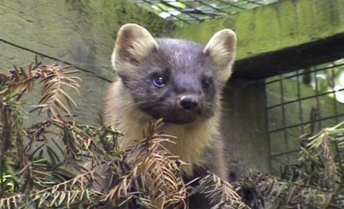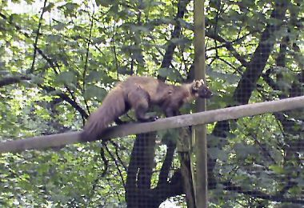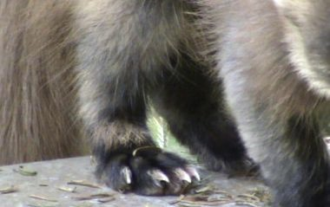

2

Shropshire Pine Martens?

The Pine Marten (Martes martes) is a secretive and fascinating mammal, being Britain’s second rarest carnivore after the Scottish Wildcat. They belong to mustelids family, so are related to badgers, weasels and polecats and despite their large size, can remain hidden from human eyes for the duration of their 8 year lifespan.

Pine Martens can be distinguished from other members of the mustelid family by their distinct physical
appearance. The fur is chocolate brown in colour from head to the tip of the tail, being broken only by the telltale creamy white “bib” which is found on the throat and upper breast. Their pelage tends to appear lighter in the summer months during their annual moult, so it is the winter months, when they are in full dark pelage, that people are most likely to see them (and of course when there are less leaves on the trees to hide them).

Martens average a length of 68cm from nose to tip of the tail, which is roughly the size of the average
domestic cat. Their movement is however very different from cats and is often described as bear-like when they are seen on the ground. The running gait can be likened to a hop, with fore and hind feet held together in pairs. But it is their ability to effortlessly sprint vertically up trees and along narrow branches that really makes pine martens stand out from other mustelids. This is possible thanks to semi-retractable claws that can grip even the smooth bark of beech and birch trees. Compared to their relatives, the paws appear disproportionately large and distinctive but amongst the marten’s other elusive signs, tracks are rarely seen in the UK unless there is a cover of snow on the ground. Their tree climbing ability is made even easier by the long, bushy tail which is used for balance when running along branches or scaling large pines.

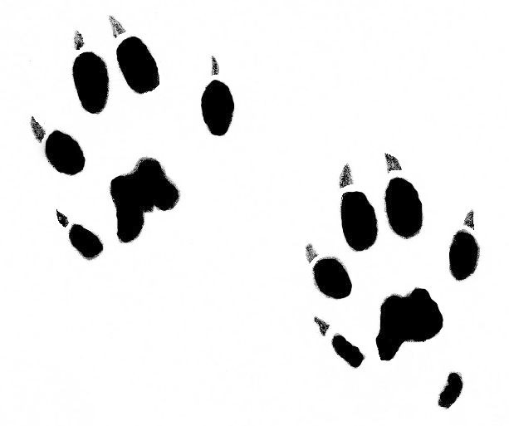

3

Pine Martens are generally associated with forest habitats and in Scotland they always appear to inhabit the vast areas of Caledonian wilderness where pine forests remain intact. Contrary to common belief, populations In Northern Ireland have now been discovered on open areas of moor land with sufficient scrub cover to provide protection, so it would appear that they have the ability to adapt to alternative habitats if there is food available. Martens were heavily persecuted for their fur for centuries in England and Wales and this combined with the loss of their preferred habitat led to what was thought to be complete extinction during the war years. During that time, much of England’s woodland was felled for use in construction and ammunition boxes, leaving martens with nowhere to hide or hunt.
Recently, Pine Marten evidence has been discovered in mid and north Wales and these animals could be the remnants of original Welsh populations, which may have bred with escapees from fur farms in the 1960s. Individual pine marten movements have been tracked across 50kms in Scotland, so if they are capable of traversing similar distances south of the border, it is more than likely that the Welsh population has begun an eastward spread into the Marches. Having visited several potential sites in South Shropshire, I have discovered potential woodland habitat with enough food and tree cover to support martens. There are large, untouched areas of private forest, full of small birds and grey squirrels and sections which are surrounded by tracts of bilberry-covered moor land; wild berries being another important part of the marten diet.
With the exciting news that pine marten have been confirmed in Wales in mind, it seemed to me to be the perfect time to begin a survey of potential habitat in Shropshire to see if Pine Martens have been living under our noses without us even noticing. The aim of the survey is to discover first and foremost whether or not pine martens are living in Shropshire’s forests, through searching for physical evidence. There have been a number of credible sightings in the county and upon further investigation, these sightings have generally been in, or in close proximity to forest and moor land. It is important to follow up any reported sightings with site assessments and I have been spending time looking for evidence of marten presence in areas close to those sightings. The evidence can come in the form of paw tracks, scat or prey remains, with scats being the easier signs to spot as they tend to be left on clear areas such as tree stumps or fallen trees above ground level (this is done not for territorial marking, but to make potential mates aware of their presence). Because scats and prints can easily become confused with polecats, the best way to be 100% that we have found pine marten scat is to have any possible scats analysed for marten DNA. DNA testing could also help us to discover if any potential Shropshire martens are related to the welsh populations, which would allow researchers to map the possible re-colonisation of these mammals across the UK.

Marten paw prints (size varies up to 65mm long)
To increase the chances of finding marten evidence, I would like to encourage others to get involved with the survey. Looking for a pine marten in Shropshire has been compared to searching for a needle in a group of very large haystacks and doing that alone could prove to be an impossible task. Between now and the winter, I will be conducting site surveys, scat hunts and visits to areas where reported sightings have taken place. If you are interested in learning how to identify marten signs (scats, prints and habitats) and would like to join in, please contact me on the email address below. You can also report possible sightings in the county to the same address, the Shropshire County Council Biodiversity team or Shropshire Mammal Group. And of course, for those who are interested to find out the results of the survey, but don’t like the idea of walking through scrub and undergrowth for a day, I will make sure that any findings are recorded in forthcoming issues of the Mammal Group newsletter.
Stuart Edmunds, contact: stuartedmunds@rocketmail.com

4

OPAL events - Magnificent voles and the Harvest mouse hunt

The Shropshire Mammal Group is now affiliated to the Mammal
Society

Click the logo to visit the society’s website
The first events supported by the group’s OPAL grant have now taken place. August 13th saw members beat a path
through some rather tall Miscanthus grass, in order to check our new Longworth traps. Each trap was deployed alongside a baited hair tube, suspended in the stalk zone. Although the traps were empty the hair tubes encouragingly garnered a number of potential rodent hairs. Theses hairs will be

INCLUDEPICTURE "http://www.mammal.org.uk/components/com_virtuemart/shop_image/category/resized/Membership_49cb95
to an elusive harvest mouse. We also searched the stalk
zone for nests, and although we didn’t find any nests, I am

Bones & skulls ID
Stuck on the ID of a mammal bone or skull? One of our
members, Ric Morris is willing to help.
FaceBook

The Mammal Group is on FaceBook. Click the link below to visit the FaceBook
site. You will need to register with FaceBook to
contribute to this group. http://bit.ly/SMG_FaceBook
Next Committee Meetings
Monday 3rd October Tuesday 6th December
Shirehall 7.15pm
If you have something you would like the committee to discuss or have ideas for future
events please contact the Secretary Clare Jowett 01938
570418.
Remember, it’s your mammal group!
pleased to report that we all found our way out of the field, eventually! The traps and hair tubes will be deployed at other sites over the next two months. Check your emails for
opportunities to join in.

August 20th saw a public Water vole day at Chirk Bank, with a fascinating talk by the Ann and Malcolm Monie. This was
followed by a discussion, over a cup of tea with chocolate biscuits and shortbread. We then ventured down to the Shropshire Union Canal, where there have been several Water vole sightings in recent years. Upon inspection, we
discovered an abundance of Field voles, but sadly, we did not find any live voles or fresh field signs. However, one keen
eyed member spotted a skull which proved to be from a Water vole. The general consensus was that the habitat would benefit from some management, which could be
achieved should voles be located. One of our members Paul Roberts has just begun a Water vole project in this area,
which is being funded by the Peoples Trust for Endangered Species. Hopefully, this project will track down some vole populations and look at ways to safeguard them.
Gareth Parry

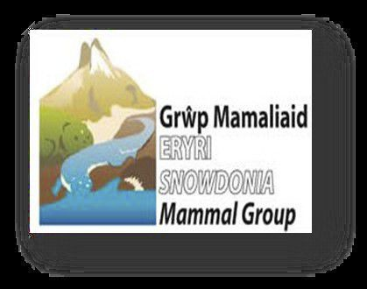

5

Review of SMG Events
Saturday 2nd July 2011 - Tetrad Survey in Brown Moss area

Three members recorded evidence from eight different mammal species [fox, badger, squirrel, field vole, bank vole, wood mouse, mole and rabbit]. As well as exploring Brown Moss itself, the team visited a restricted byway near Ash Parva with lots of coppiced hazel. Nuts opened by wood mice, bank vole and squirrel were found. Thanks to Malcolm for organising.
Saturday 4th June 2011 - Tetrad Survey in Baggy Moor area

Eight members recorded evidence from eight different mammal species, none of which had previous records for this tetrad. Once again, thanks to Gareth for organising this event.
SMG member makes p2 of Mammal News

Congratulations to SMG member Stuart Edmunds for making p2 of The Mammal Society's newsletter "Mammal News" with an item about his pine marten survey.

The Mammal Society
Regional Seminar
12th November 2011, 9.45am- 16.30pm Brambell Building, Bangor University

This Regional Seminar, hosted by Snowdonia Mammal Group and supported by The Mammal Society, will bring together local and national mammal experts, professionals and enthusiasts to network and catch up on the latest developments in mammalogy.

Speakers include:
Derek Yalden - The Mammal Society Pete Turner - Waterford Institute of Technology Kate Williamson - Snowdonia Mammal Group Penny Lewns - The Badger Consultancy Anita Glover - University of Leeds

Presentations include:
North Wales Coastal Otter Studies Mitigation Measures for Badgers Dormice in conifer forests
BAP work to support Hare popualtions Non invasive methods in Mammal Ecology

Workshops include:
Mini Mammal Monitoring Wildlife Film-making Bat Detector Workshop Mammal Tracks and Signs Anabat Slope Analysis & Repairs

Registration costs include tea / coffee & lunch
You can book either by calling Alex on 023 80237874, completing the attached form or online at
www.mammal.org.uk

6

Exits and Entrances
This is a brief look at those British mammals that have become extinct and the new ones that have appeared. It is a topic that has quite a few controversial aspects because most of the changes, both gains and losses, are the result of human activity. We are to blame for most of the extinctions and responsible for virtually all the introductions and if an introduced animal becomes problematical we are faced with the decision of what if anything is to be done about it. In addition humans have throughout made major changes to the environment altering the fortunes of the other mammals that live here.

Native Mammals
Before it is possible to have an “introduction” there has to be a concept of a native and the one that is normally used is defined by two major geological events, the end of the last ice age and the separation of the British Isles from mainland Europe. The ice age had lasted for some 30,000 years with many changes in severity, and this part of the continent was occupied by a variety of arctic and sub-arctic mammals such as the Condover Mammoths. Then 9000 ago the climate changed remarkably quickly. The summer temperature here jumped 9℃ in only 50 years so the cold adapted species that were present such as Lemmings and Reindeer would have found it very uncomfortable and the impact on vegetation probably disrupted food supplies. The mammals that survived the change together with those that found their way here before the next dramatic geological event, our separation from mainland Europe, make up what we know as our “Native Mammals”.
Extinctions
It is perhaps not appropriate to class animals which moved off to more appealing areas of the same land mass as extinctions, but those that disappeared later were either deliberately targeted or lost as collateral damage in other human activities. Brown Bears are thought to have gone before the end of the Roman period, at least partly as a result of hunting and Lynx disappeared soon after probably mostly as a result of extensive deforestation. Wolves had gone from England by the beginning of the 14th century almost certainly as the result of hunting. They were particularly disliked by royalty because of their taste for deer, the property of the King.
Beavers were for a long time seen as a resource providing food, fur and useful bones, but
they found themselves on the wrong side of Tudor “Acts for the Preservation of Grayne” that also accounted for a lot of Hedgehogs and other notable pests of cereals! The last record is from Yorkshire in 1789.
Near Misses
Many of the smaller predators nearly followed their larger relations into extinction and the 19th Century saw Polecat and Pine Marten on the brink, mostly to preserve game birds for shooting. Habitat change has put Hazel Dormouse and Harvest Mouse in danger and in combination with an introduced species, American Mink, has brought Water Vole close to extinction. The Black Rat was almost completely displaced by the Brown Rat in a few years at the beginning of the 18th Century.
Introductions
The other side of the coin from extinction is the appearance of new species and most of these have been deliberate, but accidents have also happened. The rats both spread from Asia and hitched lifts across the Channel and House Mice and Harvest Mice happened in the same way. Although human motivation is often mixed the remaining introductions can be categorized by what seems to be the main reason for bringing them in. So some were introduced as food, some because it was fashionable and some to produce fur also of course related to fashion.

7
Food: Fallow Deer were established by the Normans and used as food, if only for a limited section of society and Rabbits were also brought in by them and farmed in warrens as a source of food and fur. Brown Hares which were present in the Iron Age may be an import in the same category, but there is a much quoted comment by Julius Caesar that when he arrived the British had Brown Hares, but did not eat them. Fashion: The 19th Century saw a wave of exotic introductions by major landowners that are becoming problematic. Sika Deer are possibly the most serious as they interbreed with an important native species Red Deer in an exact parallel to the well known Ruddy Duck/Spanish White Headed Duck problem. There is a programme to eliminate Ruddy Duck, but not Sika. Muntjac and Chinese Water Deer were also brought in and are also spreading and having an impact on conserved vegetation. So far the Fat Dormouse is only a problem to some households in the Chilterns, but the role of Grey Squirrels in hastening the demise of our Red Squirrel is well known.
Fur: Fur farming became very popular after the First World War and Musk Rat, Coypu and American Mink were all imported and all got out or were released. It was realised that escaped Musk Rats in other parts of Europe were doing a vast amount of damage and they were removed by an intensive trapping programme. One of the largest populations was on the River Severn in Shropshire where 2720 were caught in four years. After some initial hesitation Coypu were also removed so that two introductions quite quickly became extinctions.

Bats
Bats are something of a special case. Their flying ability means that they can arrive without help and although there are 18 resident species there are several others that appear from time tom time. Accidents again also occur as a Savi’s Pipistrelle turned up in a punnet of nectarines! Bats also differ from other groups because there have been several additions to the British list recently and these are due to advances in technology. Species that have probably been here for a long time are being found because bat detectors have improved.
Reintroduction
Control of alien species is a controversial subject, but the increasingly promoted schemes for reintroduction of extinct natives also generate considerable opposition, as is shown with the current trial of Beavers in Argyll. The re-establishment of major predators such as Lynx and Wolf, not surprisingly, generates worries about loss of livestock and attacks on humans. The risks are probably less than supposed. In 2006 120 Swiss lynx were reported to have killed no more than 15 sheep. Attacks on humans, where wolf and lynx are indigenous, are very rare. Large populations of non predators can also have their downside. In the period 2003 - 2008 there were 34,026 deer/vehicle collisions in Great Britain and twenty people
died.

One native, extinct since the 16th Century, has reintroduced itself. Farmed Wild Boar have escaped and established several thriving colonies.
John Mackintosh

Booked published by Shropshire Mammal Group member!

One of the SMG members, Andrew Allot has just completed his New Naturalist book ‘The
Marches’ - which is published on 1st September by Harper Collins. It describes thirteen themes in the natural history of the Marches, one of which is the mosses (Meres and Mosses). The book is available in either paperback or hardback and the cheapest way to buy it is on online. Please contact Andrew for any further information aja@shrewsbury.ac.uk.

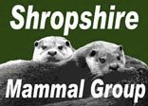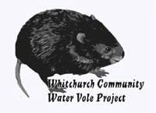

8
The Llangollen canal corridor water vole study
The study is a British Waterways project, funded by the Peoples Trust for Endangered Species Mammal internship. The funding enables students and future conservationists to work on a specific Mammal related project supported by the organisation and their university or college.
The Llangollen canal runs 46 miles from Llantyslio Bridge near Llangollen to Hurleston Junction where it joins the Shropshire Union Canal. Recently in 2009 UNESCO credited an 18 kilometre length with World Heritage status due to its engineering feats of two aqueducts. The World Heritage Site occupies an area of land covering the counties of Shropshire in England and Wrexham and Denbighshire which are in Wales.
There have historical records of the presence of water vole throughout the WHS: however the species has disappeared from many of its historic locations therefore the status of the species is unclear within the site and its buffer zone.
The aim of this project is to establish the status of the water vole on the canal and within the WHS buffer zone; to undertake a habitat assessment for the WHS and buffer zone, to establish the suitability of habitat within the area for water voles; and identify and implement habitat enhancements. Other objectives include liaising with landowners, providing support and advice for habitat management, and supporting agricultural land owners in the process for entry into Environmental Stewardship Schemes.
Paul Roberts- SMG Member

Committee Matters- From the Chair
This is Charlotte’s last newsletter as editor. She is moving from the area to take up a post with the
Yorkshire Dales National Park. On behalf of members, I would very much like to thank Charlotte for her excellent work not only in putting together a series of very interesting editions of the newsletter, but also in co-ordinating the events programme. We wish her well in Yorkshire but we shall miss her cheery presence on the committee.
Your committee has decided to try holding next January’s AGM on a Saturday morning [either 14th or 21st]. We thought that in the depth’s of winter in Shropshire, this might be preferred by members to turning out on a Monday evening. Let us know what you think.

There is of course, a connection between the previous paragraphs! There will be a vacancy on the
committee and an opportunity for someone else to take on the newsletter. If you are interested, or know someone who might, please let us know. There is no real need for the newsletter editor to be a member of the committee; it can all be done by email. Either contact one of the committee directly or simply email shropshiremammalgroup@gmail.com .

Malcolm Monie September 2011

Corporate Members
Shropshire Mammal Group is grateful to its corporate members
for their support.

❖ Field Studies Council - Preston Montford Field Centre
❖ Whitchurch Community Water Vole Project
❖ Shropshire Wildlife Trust Ellesmere Branch
Links to Websites

Shropshire Bat Group

Contacts
Chairman Malcolm Monie 01948 663069 Secretary Clare Jowett 01938 570418 Membership Secretary Clive Dean 01743 367024 Treasurer Pauline Mackintosh 01584 861688
Events & Newsletter Editor: Charlotte Mullard 07841 373621
Shropshire Mammal Recorder John Mackintosh 01584 861688 Committee members:
Alan Reid, Simon Poulton, Gareth Parry Dan Wrench 01743 252529
Shropshire Mammal Group email

